***Name - Akriti Choudhary***

***Roll number- 2005776***

***Section- cse25***

***Date - 8/2/2022***

***WT LAB4***

**1. Write a class file – box with three data members(length, width, height) and a method volume() . Also implement the application class Demo where an object of the box class is created with user entered dimensions and volume is printed.**

import java.util.*;

class box{

double length,height,width;

double volume()

{

return (length*width*height);

}

}

class demo

{

public static void main(String[] args)

{

box b=new box();

Scanner sc=new Scanner(System.in);

System.out.println("Enter the dimensions of the box");

System.out.println("Enter the length of the box");

b.length=sc.nextDouble();

System.out.println("Enter the width of the box");

b.width=sc.nextDouble();

System.out.println("Enter the height of the box");

b.height=sc.nextDouble();

System.out.println("Volume of the box is "+b.volume());

sc.close();

}

}

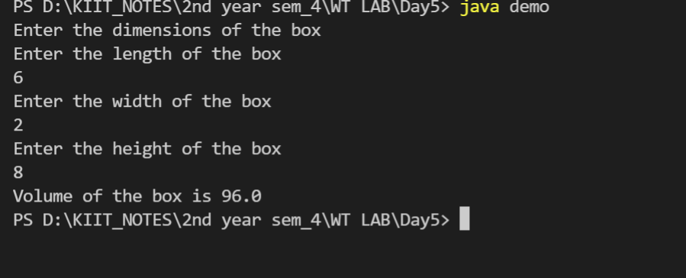

**2.Write a program in Java to define a class Rectangle having data member: length and breadth; to calculate the area and perimeter of the rectangle. Use member functions to read, calculate and display.**

import java.util.*;

class cal {

public static void read() {

Scanner sc = new Scanner(System.in);

System.out.println("Enter the length");

int l = sc.nextInt();

System.out.println("Enter the width");

int b = sc.nextInt();

calculate(l, b);

}

public static void calculate(int l, int b) {

int area = l * b;

int peri = 2 * (l + b);

display(area, peri);

}

public static void display(int area, int peri) {

System.out.println("Area = " + area + "\nPerimeter = " + peri);

}

}

public class rectangle {

public static void main(String[] args) {

cal ob = new cal();

ob.read();

}

}

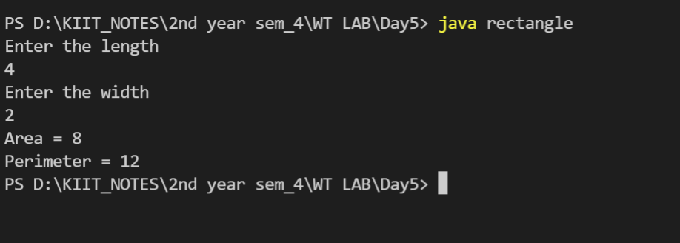

**3. Write a program in java to input and display the details of n number of students having roll, name and cgpa as data members. Also display the name of the student having lowest cgpa.**

import java.util.*;

public class student {

String name;

int roll;

double cgpa;

void input() {

Scanner sc = new Scanner(System.in);

System.out.print("Enter name: ");

name = new Scanner(System.in).nextLine();

System.out.print("Enter roll: ");

roll = sc.nextInt();

System.out.print("Enter cgpa: ");

cgpa = sc.nextDouble();

}

void display() {

System.out.println("Name: " + name + "\nRoll: " + roll + "\nCGPA: " + cgpa);

}

public static void main(String args[]) {

System.out.print("Enter number of students: ");

Scanner sc = new Scanner(System.in);

int n = sc.nextInt();

student ob[] = new student[n];

for (int i = 0; i < n; i++)

ob[i] = new student();

for (int i = 0; i < n; i++)

ob[i].input();

for (int i = 0; i < n; i++)

ob[i].display();

double min = ob[0].cgpa;

int p = 0;

for (int i = 1; i < n; i++) {

if (ob[i].cgpa < min)

p = i;

}

System.out.println("Student with lowest cgpa is: " + ob[p].name);

sc.close();

}

}

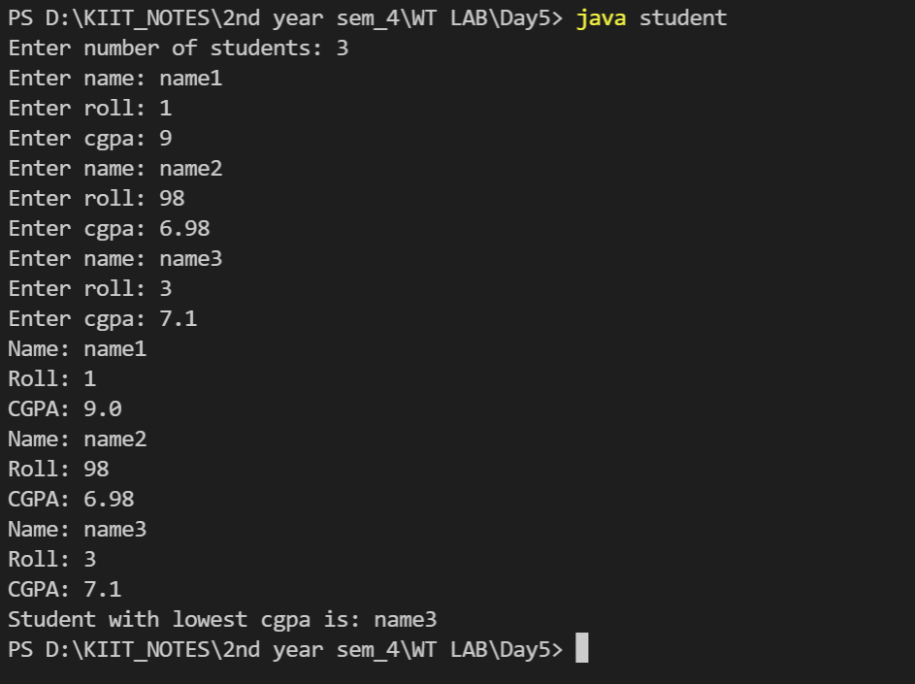

**4. Write a program to calculate area according to user input, whether it is circle, square or triangle (Menu Driven).**

import java.util.Scanner;

public class area

{

public static void main(String args[]) {

Scanner in = new Scanner(System.in);

System.out.println("Enter your choice: ");

System.out.println("c - to calculate area of circle");

System.out.println("s - to calculate area of square");

System.out.println("r - to calculate area of rectangle");

char choice = in.next().charAt(0);

switch(choice) {

case 'c':

System.out.println("Enter the radius of circle: ");

double r = in.nextDouble();

double ca = (22 / 7.0) * r * r;

System.out.println("Area of circle = " + ca);

break;

case 's':

System.out.print("Enter the side of square: ");

double side = in.nextDouble();

double sa = side * side;

System.out.println("Area of square = " + sa);

break;

case 'r':

System.out.print("Enter length of rectangle: ");

double l = in.nextDouble();

System.out.print("Enter breadth of rectangle: ");

double b = in.nextDouble();

double ra = l * b;

System.out.println("Area of rectangle = " + ra);

break;

default:

System.out.println("Wrong choice!");

}

}

}

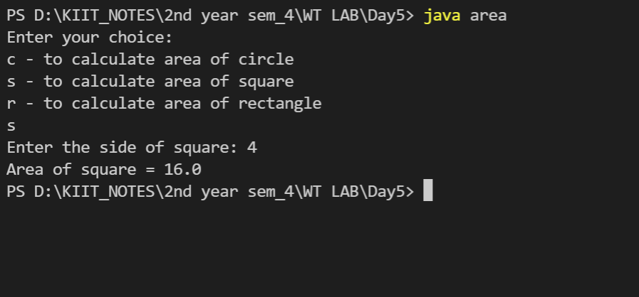

**5. Write a program in Java to define a class Number with appropriate data members and member functions to input n number of integers and swap the biggest and smallest elements. Use member functions read(), swap() and display().**

import java.util.*;

public class Number {

int n;

int a[];

void input() {

Scanner sc = new Scanner(System.in);

System.out.print("Enter size of array: ");

n = sc.nextInt();

a = new int[n];

System.out.print("Enter elements: ");

for (int i = 0; i < n; i++)

a[i] = sc.nextInt();

sc.close();

}

void swap() {

int p1 = 0, p2 = 0, max = a[0], min = a[0];

for (int i = 0; i < n; i++) {

if (a[i] > max) {

p1 = i;

max = a[i];

}

if (a[i] < min) {

p2 = i;

min = a[i];

}

}

a[p1] = min;

a[p2] = max;

}

void display() {

for (int i = 0; i < n; i++)

System.out.print(a[i] + " ");

System.out.println();

}

public static void main(String args[]) {

Number ob = new Number();

ob.input();

System.out.println("Before swapping");

ob.display();

ob.swap();

System.out.println("After swapping");

ob.display();

}

}

