***Name - Akriti Choudhary***

***Roll number- 2005776***

***Section- cse25***

***Date - 15/2/2022***

***WT LAB5***

**1 ) Write a program in Java to define a class Rectangle having data**

**member: length and breadth; to calculate the area and perimeter of the rectangle. Use constructors and member functions to read, calculate and display.**

import java.util.*;

class findRectangle {

public static void main(String arg[]) {

Scanner sc = new Scanner(System.in);

System.out.println("Enter Length of the rectangle:");

int l = sc.nextInt();

System.out.println("Enter breadth of the rectangle:");

int b = sc.nextInt();

Rectangle rect = new Rectangle(l, b);

System.out.println("Length = " + rect.length);

System.out.println("Breadth = " + rect.breadth);

System.out.println("Area = " + rect.getArea());

System.out.println("Perimeter = " + rect.getPerimeter());

}

}

class Rectangle {

int length;

int breadth;

Rectangle(int length, int breadth) {

this.length = length;

this.breadth = breadth;

}

double getArea() {

return length * breadth;

}

double getPerimeter() {

return 2 * (length + breadth);

}

}

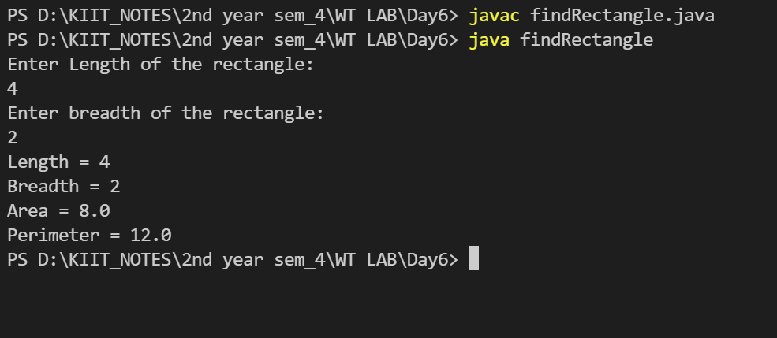

**2)Write a program which will overload the area () method and**

**display the area of a circle, triangle and square as per user choice and**

**user entered dimensions.**

import java.util.Scanner;

public class area {

public static void main(String args[]) {

Scanner sc = new Scanner(System.in);

System.out.println("Enter the radius of circle: ");

double r = sc.nextDouble();

double ca = Ar(r);

System.out.println("Area of circle = " + ca);

System.out.print("Enter the side of square: ");

int side = sc.nextInt();

int sa = Ar(side);

System.out.println("Area of square = " + sa);

System.out.print("Enter the base and height of triangle: ");

int b = sc.nextInt();

int h = sc.nextInt();

double a = Ar(b, h);

System.out.println("Area of triangle = " + a);

}

public static double Ar(double r) {

double ca = (22 / 7.0) * r * r;

return ca;

}

public static int Ar(int side) {

int sa = side * side;

return sa;

}

public static double Ar(int b, int h) {

double sa = 0.5 * b * h;

return sa;

}

}

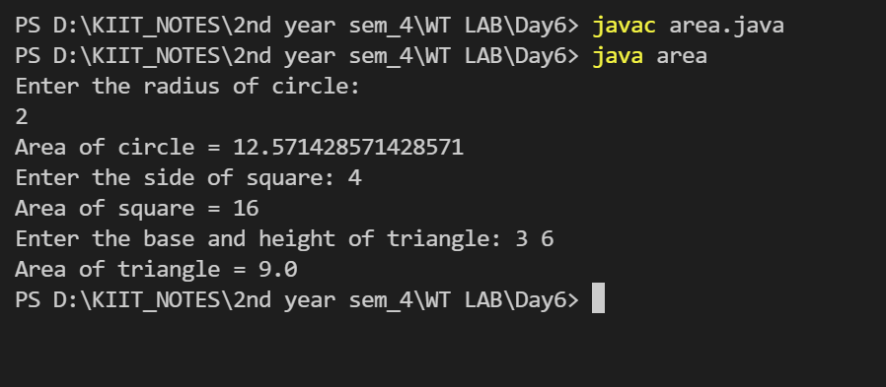

**3 ) A plastic manufacturer sells plastic in different shapes like 2D**

**sheet and 3D box. The cost of sheet is Rs 40/ per square ft. and the**

**cost of box is Rs 60/ per cubic ft. Implement it in Java to calculate the**

**cost of plastic as per the dimensions given by the user where 3D**

**inherits from 2D.**

import java.util.*;

public class q3 {

public static void main(String args[]) {

Scanner sc = new Scanner(System.in);

System.out.println("Enter the side of cube");

int cb = sc.nextInt();

System.out.println("Enter the side of square");

int sq = sc.nextInt();

Shape3D obj = new Shape3D(sq, cb);

obj.displayCube();

obj.displaySquare();

}

}

class Shape2D {

int cost_square = 40;

int tot;

int sqa;

Shape2D(int sq) {

sqa = sq;

}

void displaySquare() {

tot = (int) sqa * sqa * cost_square;

System.out.println("Cost of square plastic = " + tot);

}

}

class Shape3D extends Shape2D {

int cost_box = 60;

int cub;

Shape3D(int sq, int cb) {

super(sq);

cub = cb;

}

void displayCube() {

tot = (int) cub * cub * cub * cost_box;

System.out.println("Cost of square plastic = " + tot);

}

}

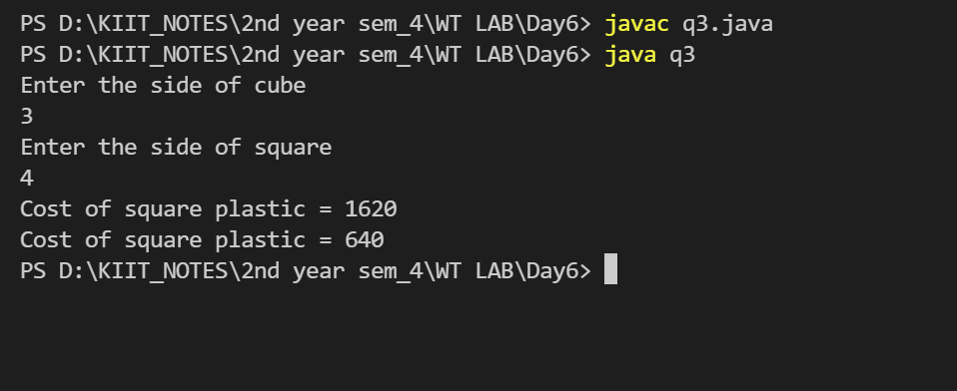

**4 )Write a program in java to define a class Shape which has data**

**member “area” and a member function showArea(). Derive two**

**classes Circle and Rectangle from Shape class. Add appropriate data**

**members and member functions to calculate and display the area of**

**Circle and Rectangle.**

import java.util.*;

class Shape {

int area;

void showArea() {

System.out.println("Area = " + area);

}

}

class circle extends Shape {

int r;

circle(int radius) {

r = radius;

area = (int) (22 / 7.0) * r * r;

}

}

class rectangle extends Shape {

int length;

int width;

rectangle(int l, int b) {

length = l;

width = b;

area = l * b;

}

}

public class test {

public static void main(String args[]) {

Scanner sc = new Scanner(System.in);

System.out.println("Enter length and width of the recatngle");

int l = sc.nextInt();

int b = sc.nextInt();

rectangle ob1 = new rectangle(l, b);

ob1.showArea();

System.out.println("Enter radius of the circle");

int r = sc.nextInt();

circle ob2 = new circle(r);

ob2.showArea();

}

}

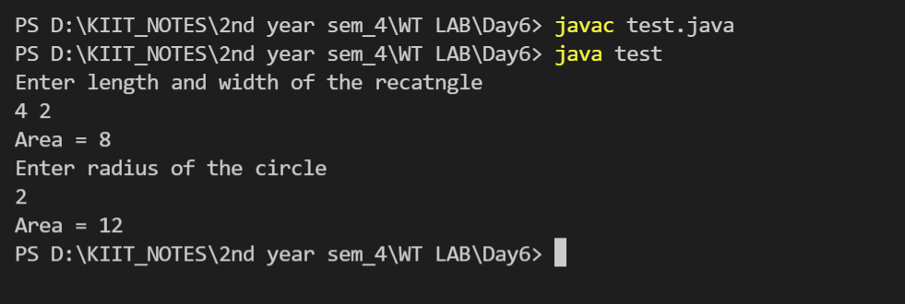

**5 )Write a program in java using inheritance to show how to call**

**the base class parameterized constructors from the derived class using**

**super. Consider the base class is “Shape2D” for rectangle and define**

**subclass “Shape3D” for cube.**

import java.util.*;

public class q5 {

public static void main(String args[]) {

Scanner sc = new Scanner(System.in);

System.out.println("Enter the side of cube");

int side = sc.nextInt();

Shape3D obj = new Shape3D(side);

}

}

class Shape2D {

int len, wid;

Shape2D() {

len = 0;

wid = 0;

}

Shape2D(int l, int b) {

len = l;

wid = b;

System.out.println("Area of rectangle = " + (l * b));

}

}

class Shape3D extends Shape2D {

int s;

Shape3D() {

s = 0;

}

Shape3D(int side) {

super(4, 2);

s = side;

System.out.println("volume of cube = " + (side * side * side));

}

}

