***Name - Akriti Choudhary***

***Roll number- 2005776***

***Section- cse25***

***Date - 22/2/2022***

***WT LAB6***

1. **A plastic manufacturer sells plastic in different shapes like 2D sheet and 3D box. The cost of sheet is Rs 40/ per square ft. And the cost of box is Rs 60/ per cubic ft. Implement it in Java to calculate the cost of plastic as per the dimensions given by the user where 3D inherits from 2D.**

import java.util.*;

public class q1 {

public static void main(String args[]) {

Scanner sc = new Scanner(System.in);

System.out.println("Enter the side of cube");

int cb = sc.nextInt();

System.out.println("Enter the side of square");

int sq = sc.nextInt();

Shape3D obj = new Shape3D(sq, cb);

obj.displayCube();

obj.displaySquare();

}

}

class Shape2D {

int cost_square = 40;

int tot;

int sqa;

Shape2D(int sq) {

sqa = sq;

}

void displaySquare() {

tot = (int) sqa * sqa * cost_square;

System.out.println("Cost of square plastic = " + tot);

}

}

class Shape3D extends Shape2D {

int cost_box = 60;

int cub;

Shape3D(int sq, int cb) {

super(sq);

cub = cb;

}

void displayCube() {

tot = (int) cub * cub * cub * cost_box;

System.out.println("Cost of cube plastic = " + tot);

}

}

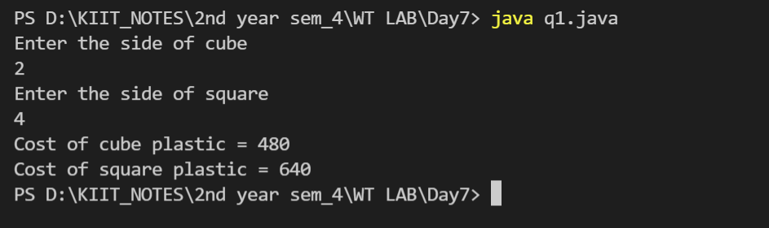

1. **Illustrate the execution of constructors in multi-level inheritance with three Java classes – plate (length, width), box (length, width,height), wood box (length, width, height, thick)**

import java.util.*;

public class q2 {

public static void main(String[] args) {

Scanner sc = new Scanner(System.in);

System.out.println("Enter length , width , height and thickness");

int l = sc.nextInt();

int w = sc.nextInt();

int h = sc.nextInt();

int t = sc.nextInt();

Woodbox obj = new Woodbox(l,w,h,t);

}

}

class plate {

int length=0 , width=0;

plate(int l , int w)

{

length = l;

width = w;

System.out.println("Class Plate constructor is called :\nlength = "+length+"\nwidth = "+width);

}

}

class box extends plate {

int height;

box(int l , int w , int h)

{

super(l , w);

height = h;

System.out.println("Class Box constructor is called :\nlength = "+length+"\nwidth = "+width+"\nheight = "+height);

}

}

class Woodbox extends box {

int thick;

Woodbox(int l , int w , int h , int t)

{

super(l , w, h);

thick = t;

System.out.println("Class WoodBox constructor is called :\nlength = "+length+"\nwidth = "+width+"\nheight = "+height+"\nthick = "+thick);

}

}

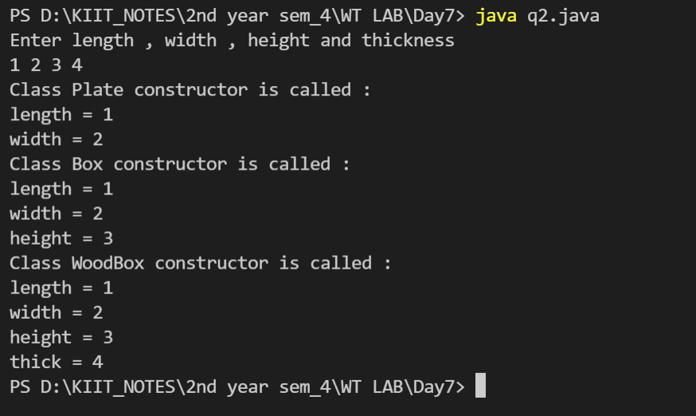

1. **Program creates a superclass called Shape that stores the dimensions of a two-dimensional object. It defines a method called area () that computes the area of an object. The program derives two subclasses from Shape. The first is Rectangle and the second is Triangle. Each of these subclasses overrides area () so that it returns the area of a rectangle and a triangle, respectively.**

import java.util.*;

public class q3 {

public static void main(String[] args)

{

Scanner sc = new Scanner(System.in);

System.out.println("Enter the length and width of rectangle");

int l = sc.nextInt();

int w = sc.nextInt();

rectangle obj1 = new rectangle(l,w);

obj1.area();

System.out.println("Enter the length and heigth of triangle");

l = sc.nextInt();

w = sc.nextInt();

triangle obj2 = new triangle(l,w);

obj2.area();

}

}

class shape

{

int dim1 , dim2;

shape()

{

dim1 = 0;

dim2 = 0;

}

public void area()

{

int are = 0;

System.out.println("Area = "+are);

}

}

class rectangle extends shape

{

int len , wid;

rectangle(int l , int b)

{

len = l;

wid = b;

}

public void area()

{

int are = len * wid;

System.out.println("Area of rectangle = "+are);

}

}

class triangle extends shape

{

int len , height;

triangle(int l , int h)

{

super();

len = l;

height = h;

}

public void area()

{

int are = (int) (len * height * 0.5);

System.out.println("Area of triangle = "+are);

}

}

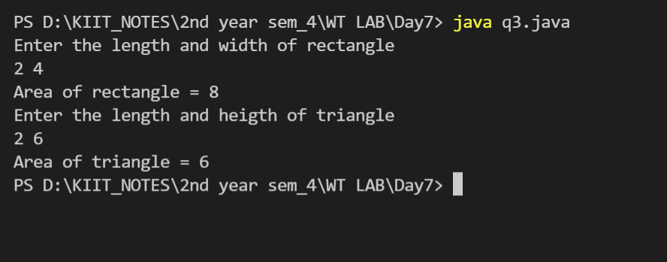

1. **Implement Program 3 using Dynamic Method Dispatch.**

import java.util.*;

public class q4 {

public static void main(String[] args)

{

Scanner sc = new Scanner(System.in);

shape obj ;

System.out.println("Enter the length and width of rectangle");

int l = sc.nextInt();

int w = sc.nextInt();

rectangle obj1 = new rectangle(l,w);

obj = obj1;

obj.area();

System.out.println("Enter the length and heigth of triangle");

l = sc.nextInt();

w = sc.nextInt();

triangle obj2 = new triangle(l,w);

obj=obj2;

obj.area();

}

}

class shape

{

int dim1 , dim2;

shape()

{

dim1 = 0;

dim2 = 0;

}

public void area()

{

int are = 0;

System.out.println("Area = "+are);

}

}

class rectangle extends shape

{

int len , wid;

rectangle(int l , int b)

{

len = l;

wid = b;

}

public void area()

{

int are = len * wid;

System.out.println("Area of rectangle = "+are);

}

}

class triangle extends shape

{

int len , height;

triangle(int l , int h)

{

super();

len = l;

height = h;

}

public void area()

{

int are = (int) (len * height * 0.5);

System.out.println("Area of triangle = "+are);

}

}

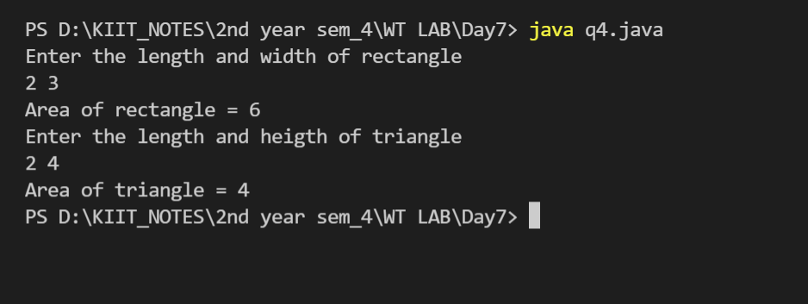

1. **Write a program in java using inheritance to show how to call the base class parameterized constructors from the derived class using super.**

import java.util.*;

public class q5 {

public static void main(String[] args) {

Scanner sc = new Scanner(System.in);

System.out.println("Enter a number");

int num = sc.nextInt();

B obj = new B(num);

}

}

class A {

int a;

A(int num) {

a = num;

System.out.println("Base class parameterized constructor called");

}

}

class B extends A {

B(int num) {

super(num);

System.out.println("Derived class parameterized constructor called");

}

}

