REPORT -18thJUNE2026
Title:
EchoBoard – A Full-Stack MERN Blog Platform
Description:
EchoBoard is a full-stack blogging platform built using the MERN stack (MongoDB, Express, React, Node.js), where writers can share stories, vlogs, and daily updates. It supports user authentication, public/private posts, threaded comments, likes, follower/following profiles, full-text search with category filters, and a complete admin panel for managing users, posts, and comments. The platform is fully responsive and designed for a smooth content-sharing experience between writers and readers.

2. Objectives
The primary objectives of EchoBoard are:
- To provide a platform for users to publish and manage blog posts.
- To implement secure user authentication and authorization.
- To allow interaction through likes, comments, and follower systems.
- To provide public and private visibility options for posts.
- To enable administrators to monitor and manage platform activities.
- To offer efficient search and filtering capabilities.
- To create a responsive and user-friendly interface.

Key Features
- JWT-based authentication (signup, login, logout)
- Create, edit, and delete posts with cover image upload
- Public or private post visibility
- Threaded comments with replies
- Like/unlike posts
- Public profiles with followers/following
- Admin panel with full control over users, posts, and comments
- Full-text search and category-based filtering
- Fully responsive UI across devices
Tools & Technologies:
Frontend
- React 19 with React Router v7
- Tailwind CSS v3
- Axios (API requests)
- React Icons
- Moment.js (date formatting)
- React Helmet Async (SEO/meta tags)
Backend
- Node.js with Express.js
- MongoDB with Mongoose 8 (ODM)
- JWT (JSON Web Token) for authentication
- Multer for image/file uploads
- bcryptjs for password hashing
- express-validator for input validation
Development & Testing Tools
- Visual Studio Code (development environment)
- MongoDB Compass (database management and inspection)
- Postman (API testing and documentation)
- Git & GitHub (version control)

REST API Endpoints
Authentication
Method | Endpoint | Access
POST | /api/auth/register | Public
POST | /api/auth/login | Public
GET | /api/auth/me | Private
PUT | /api/auth/profile | Private
Posts
Method | Endpoint | Access
GET | /api/posts | Public
GET | /api/posts/my | Private
GET | /api/posts/:id | Public
POST | /api/posts | Private
PUT | /api/posts/:id | Private
DELETE | /api/posts/:id | Private
POST | /api/posts/:id/like | Private
Admin
Method | Endpoint | Access
GET | /api/admin/stats | Admin
GET | /api/admin/users | Admin
DELETE | /api/admin/users/:id | Admin
PUT | /api/admin/users/:id/restrict | Admin
PUT | /api/admin/users/:id/promote | Admin
GET | /api/admin/posts | Admin
DELETE | /api/admin/posts/:id | Admin
GET | /api/admin/comments | Admin
DELETE | /api/admin/comments/:id | Admin
The echoboard database contains collections: users, posts, and comments. The users collection stores fields such as name, username, email, hashed password, avatar, bio, role, isRestricted status, followers/following arrays, and timestamps.

Screenshot 1: Home Page
Explanation:
Displays all public blog posts with categories, author information, and search functionality. Users can browse content without logging in.

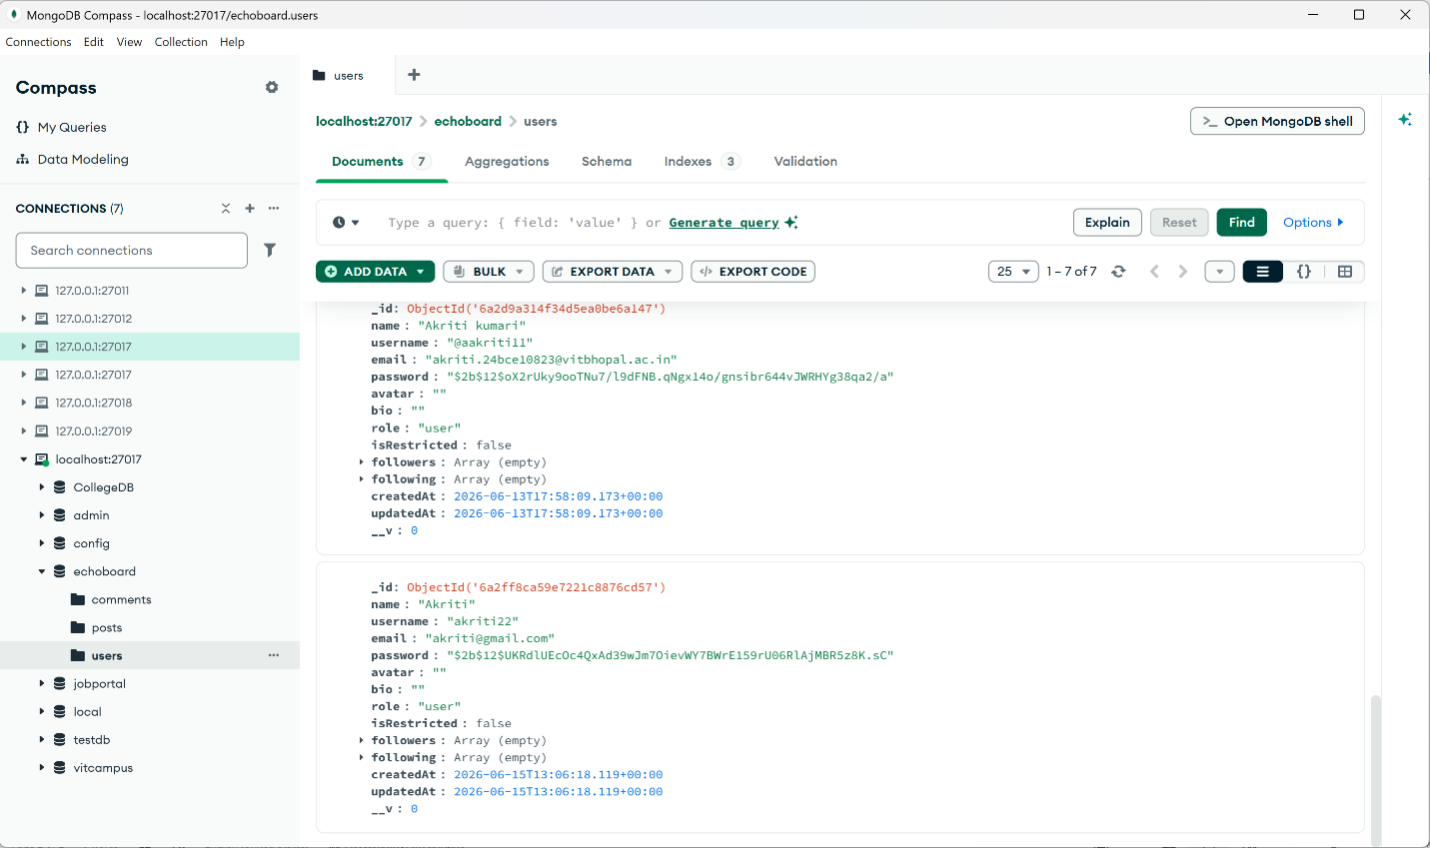

Screenshot 2: User Registration Page
Explanation:
Allows new users to create an account by providing personal details and credentials.

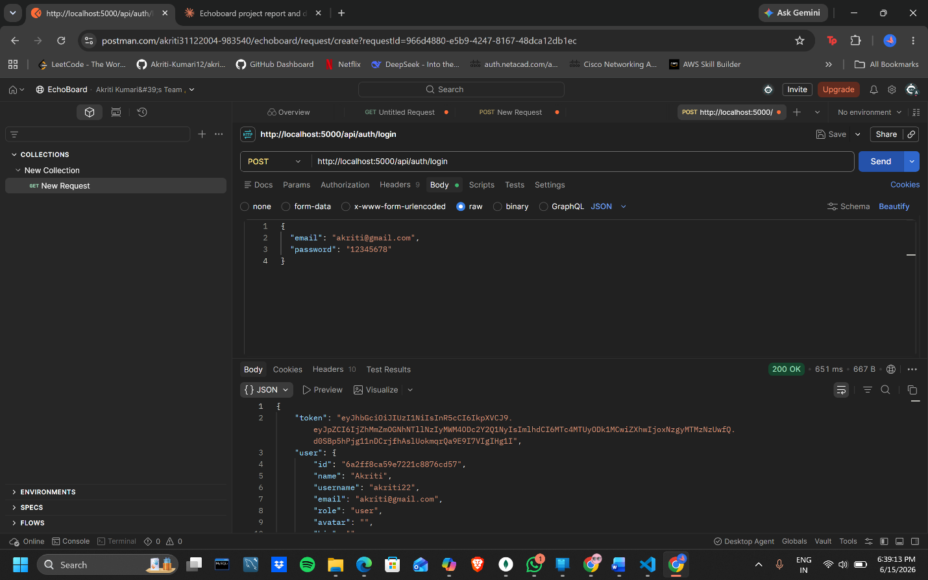

Screenshot 3: Login Page
Explanation:
Provides secure authentication using email/username and password.



Screenshot 4: Create Post Page
Explanation:
Enables authenticated users to write blogs, upload cover images, select categories, and choose visibility settings.

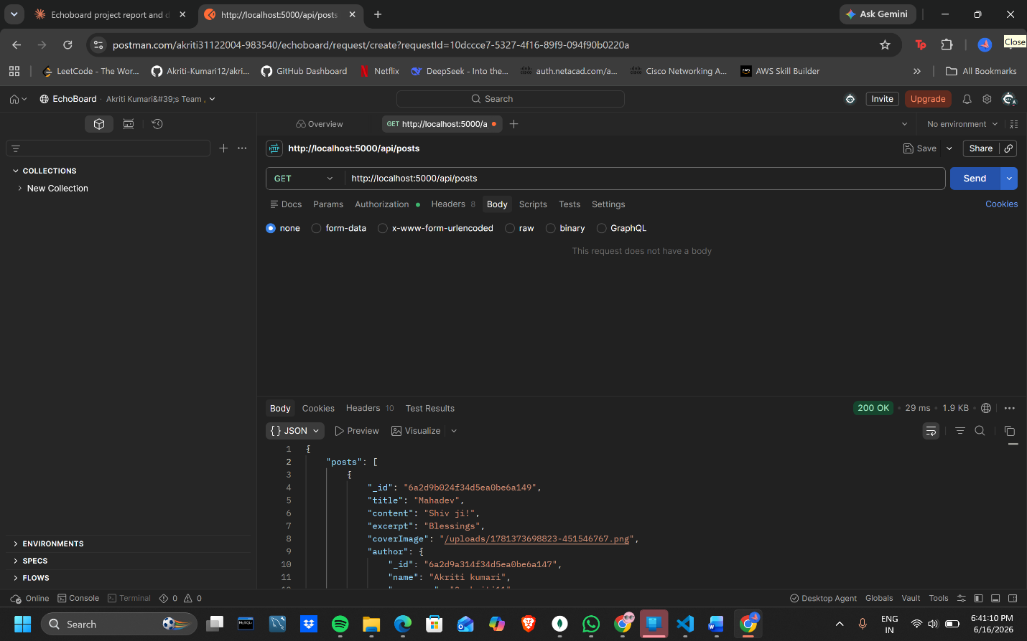
Screenshot 5: Blog Details Page
Explanation:
Displays complete blog content, comments, likes, and interaction options.

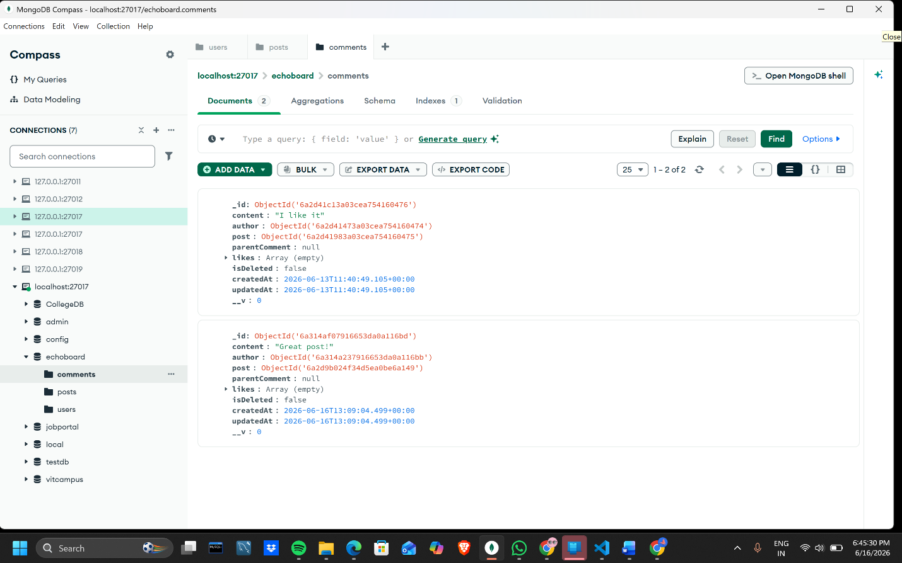

Screenshot 6: User Profile Page
Explanation:
Shows user information, followers, following count, and all posts created by the user.

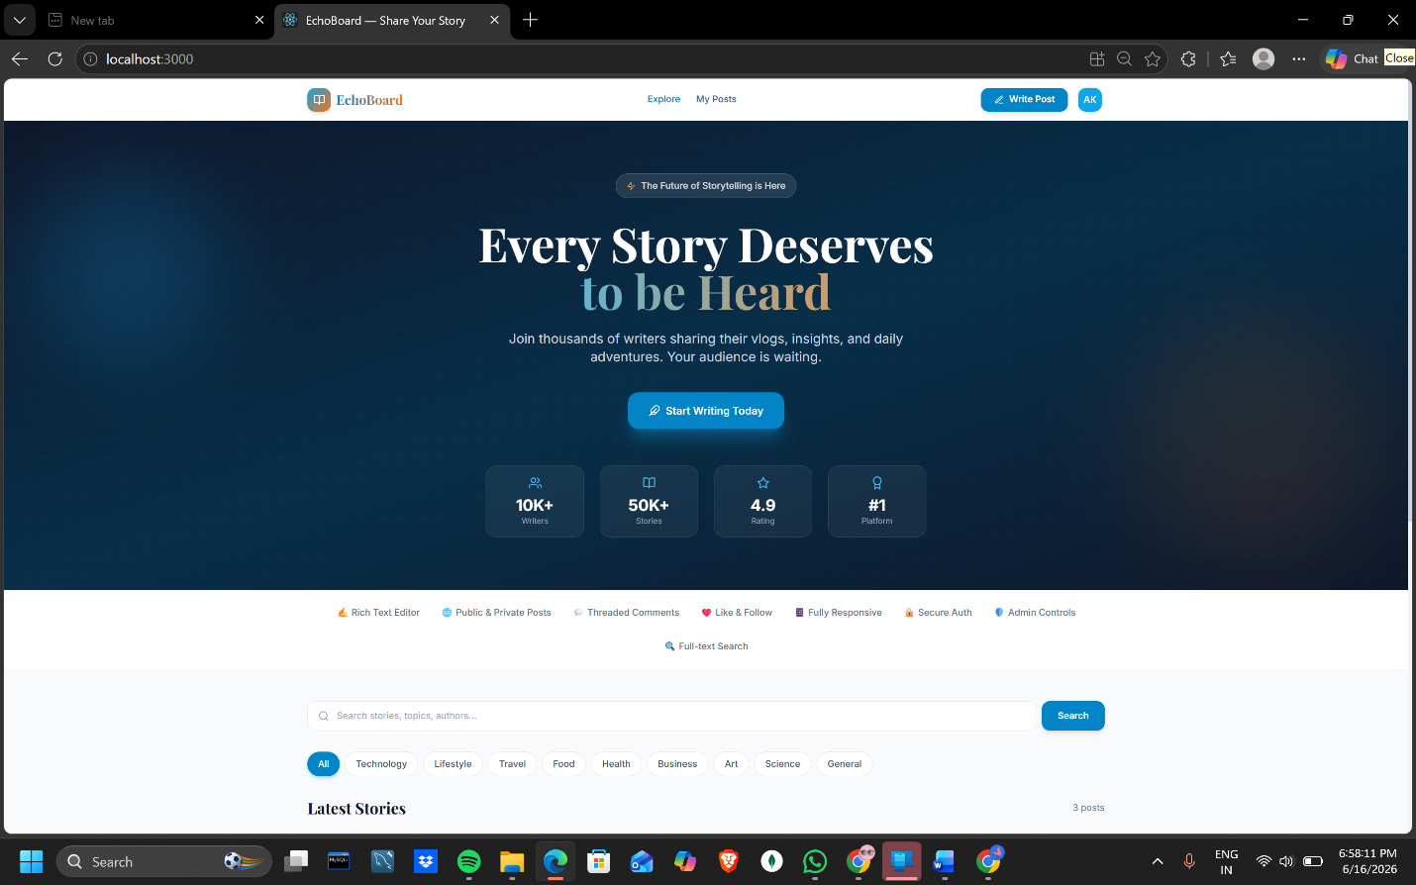
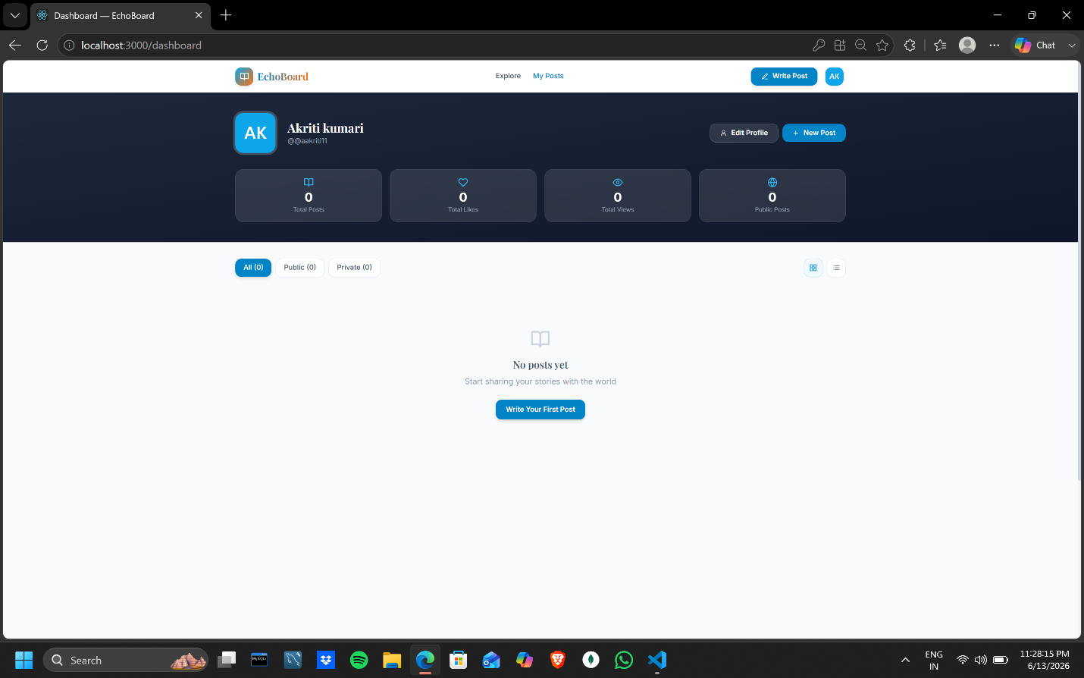

Outcome
The EchoBoard project successfully achieved all intended objectives. The platform provides a complete blogging ecosystem where users can create and manage content while interacting with other members through comments, likes, and follower relationships.
Major outcomes include:
- Successful implementation of JWT-based authentication.
- Secure user management system.
- Fully functional blog creation and management features.
- Responsive user interface across multiple devices.
- Efficient search and category filtering system.
- Complete administrative control panel.
- Optimized database structure using MongoDB and Mongoose.
- Enhanced user engagement through social features.

Conclusion
EchoBoard is a feature-rich blogging platform developed using modern MERN stack technologies. The application successfully fulfills the requirements of a professional content-sharing platform by providing secure authentication, blog management, social interaction features, and comprehensive administrative controls.
The project strengthened knowledge of React, Node.js, Express.js, MongoDB, REST APIs, authentication mechanisms, database design, and full-stack application development. Future enhancements may include real-time notifications, messaging, blog analytics, AI-powered content recommendations, and cloud deployment for large-scale usage.
Result: The project was completed successfully and met all planned objectives and functional requirements.

