**Creating Secure and Smart IoT Devices for Fun & Learning**

**Overview:**

The lab provides quick and easy methods of creating secure smarts devices which can be used for imparting Arduino development and security concepts in a fun manner.

**Smart Devices Description**:

The IOT devices which attendees will develop are basic wifi/ Bluetooth home controller, RFID locks, Beacons, anti-theft devices using Arduino. A bonus- the created devices will help attendees to understand basic security flaws trending in IOT device and how to mitigate them.

•             **Hardware Used**: NODEMCU 1.0 ESP 8266, Wires, LED, REES52

•             **Software Used:** Arduino 1.12(latest)

•             **OS Used**: Linux/Windows

•             **Other Technologies**: Cloud Server

**Highlights of the workshop:**

1.           Making audience familiar with Arduino and NodeMCU chip.

2.            Basics of Arduino coding

3.            Develop and exploit small IOT applications using Arduino (Embedded C)

4.            Discussion on Remediation and securing the devices

**Device 1: Basic Home Controller- WIFI**

Circuit Diagram: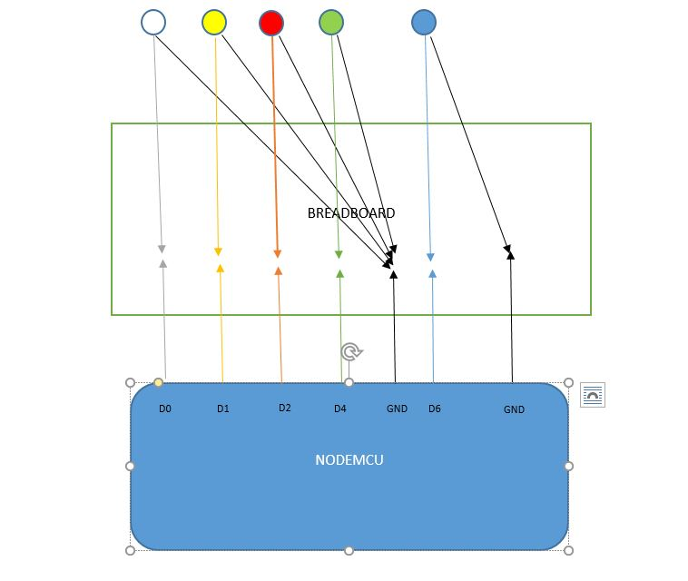

**Purpose:** A very basic WIFI home controller, it controls small appliances. The device can be controlled by website hosted from NodeMCU server.

**Vulnerability:** Wait for lab!

**Device 2: Home Controller using Relay**

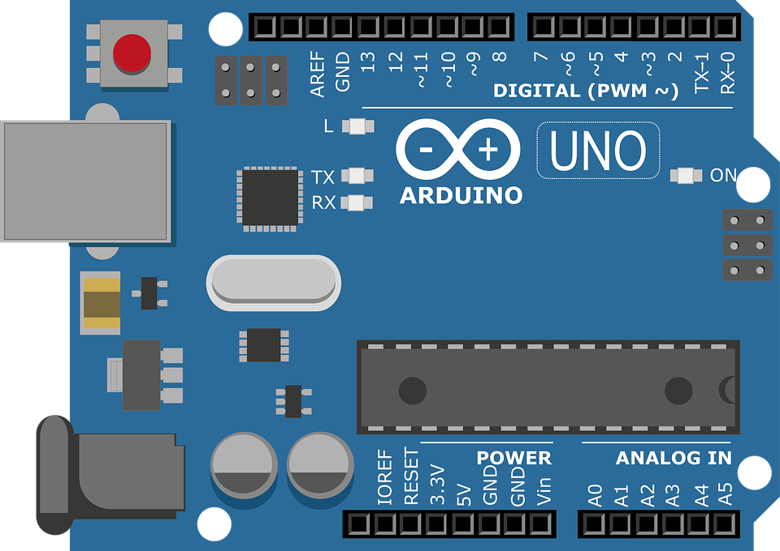

BULB

RELAY

HC -05

GND

R2 R2

COM

NC

NO

VCC

RX

TX

GND

VCC

**Purpose:** A little advance Bluetooth home controller which can control home appliances. The device can be controlled by website hosted from an Apache server. No need to move a bit for switching on the lights. Save yourself from over expenditure on expensive smart controllers.

**Vulnerability:** Wait for lab!

**Device 3: RFID Locks**



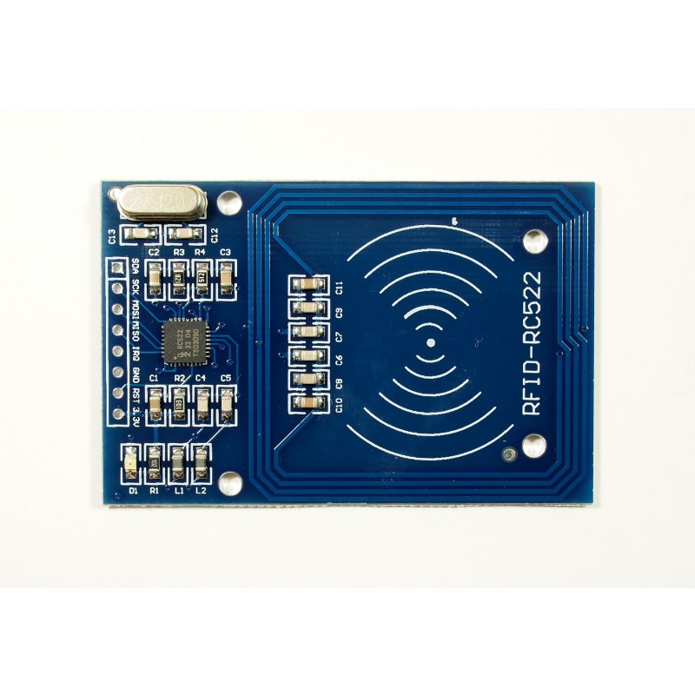

Buzzer

**Purpose:** Make your own RFID controlled Door lock with minimal efforts. Stop unwanted people from entering your secret getaway place!

**Vulnerability:** Wait for lab!

**Device 4: Anti-Theft Device**



IN

BUZZER

GND

GND

OUT

VCC

PIR Sensor

**Purpose:** Hate realizing your chocolates getting stolen when you are not at your desk, nab the thief by your homemade smart anti-theft device.

**Vulnerability:** Wait for lab!

**Device 5: Making Arduino work as Beacon-**

**Purpose:** Not able to capture attention of viewers for your booth, use this DIY Arduino beacon to notify them about your beautiful innovation.

Currently working on the development and code.

**Vulnerability:** Wait for lab!

**Takeaway**- Smart Devices have become a part of our day to day lifestyle, however security remains the biggest concern in the development and the usage of these devices. In this lab participants will learn to create their own smart and secure IoT devices using Arduino. These devices can be used by the participants in their day to day life. For information on code snippets- <https://github.com/Akriti-S/smart_devices.git>