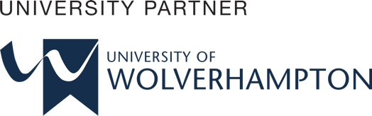

Academic Skills and Team-based Learning(4CI018)

Report Writing

<Individual Report>

# 

Student Id : np03cs4a220202

Student Name : Akriti Kumari Dev

Group : <L4CG5>

Lecturer : Mr. Dipesh Shrestha

Word Count : <1448>

Submitted on : <2023-01-12>

# 

**Abstract**

The purpose of this report is to discuss the advantages that Fuse Machine will experience after hiring graduates from the Herald College Kathmandu, as well as why this company should think about doing so. In this report we can see the courses taught at the college that aid in the projects undertaken by the company and services supplied by the company. One will be able to comprehend the justifications for and advantages of hiring graduates from this college after reading this study.

.

**Table of Contents**

1.Introduction 1

1.1. University of Wolverhampton 1

1.2. Herald College Kathmandu 2

2.Body 3

2.1 Fuse Machines 3

2.2 Curriculum of University of Wolverhampton 4

2.3Curriculum Distribution of HCK 6

3. Universities in the UK Vs Nepal 7

3.1Nepali University 7

3.2 Foreign University 8

4. Critical Analysis 8

5. Future Relation 9

6.Conclusion 10

7.References 11

**Table of Figures**

**Figure 1:Logo of University of Wolverhampton** 1

**Figure 2: Logo of Herald College Kathmandu** 2

**Figure 3:Curriculum Distribution of University of Wolverhampton (BCS)** 5

**Figure 4 :Curriculum Distribution Of BSC(Hons)Computer Science** 6

# 1.Introduction

Among all major renowned IT companies in Nepal, Fuse Machine Nepal private limited is also one of them. This company was established in 2013 and although its headquarters are in New York, it also has operations in the Dominican Republic, Canada, and Nepal. Fuse Machine is a provider of enterprise AI facilities and solutions that helps underprivileged organizations find AI education, products, and jobs (Fuse Machine, 2022). It employs 50 to 55 new employees as it is a US-based company with over 300+ people, making it a relatively large corporation.

## 1.1. University of Wolverhampton

**Figure 1:Logo of University of Wolverhampton**

The Wolverhampton University, which is located at city of Wolverhampton, was established in 1827. Over 380 undergraduate and graduate courses are available. The University of Wolverhampton, which was chosen because of the universities cutting-edge technology, is enthralling to more than 23000 students. The Uni of Birmingham is ranked number 601 globally. Additionally, technological, analytical, industrial, as well as basic curriculums had been created for the library. It is associated with a number of foreign universities, Herald College Kathmandu being one among them (University of Wolverhampton, 2022).

## 1.2. Herald College Kathmandu

**Figure 2: Logo of Herald College Kathmandu**

Herald College Kathmandu, being one of the esteemed British campuses in Kathmandu, was founded in 2016.This college is situated at Naxal, Bhagwati Marg. The institution is associated with University of Wolverhampton, UK for undergraduate certificate and it gives the finest UK University education with affordable fees. It offers undergraduate degree in both IT and Business. Herald College teaches students in different methods i.e., LTW format (Lecture, Tutorial and Workshop that facilitates understanding for students (Herald College Kathmandu, 2022).

# 2.Body

## 2.1 Fuse Machines

As the CEO of Fuse Machines, Sameer Maskey, a graduate of a Colombian University, arrived in Nepal six years earlier. He sought up three people who could work with mathematical formulas (Nepali Times, 2017) from Kathmandu institutions. A global organization called Fuse Machines is committed to developing cutting-edge artificial intelligence (AI) applications. Fuse Machines assists businesses in identifying possibilities where AI may be used to transform and expand their operations (Topio Networks, 2022).

Some of the projects of Fuse Machine are listed below:

* EHR/Diagnosis Automation
* Mental Health App
* Conversational Robot for Kids
* Health and Wellness
* Software Customization Tool

The manpower company is demanding for their projects are:

* Python Developer
* Software Engineer (Back End)
* UI/UX Designer
* DevOps Engineer
* QA Engineer
* Data Engineer
* Software Engineer (JavaScript)

## 2.2 Curriculum of University of Wolverhampton

The University of Wolverhampton offers the following computer science courses:

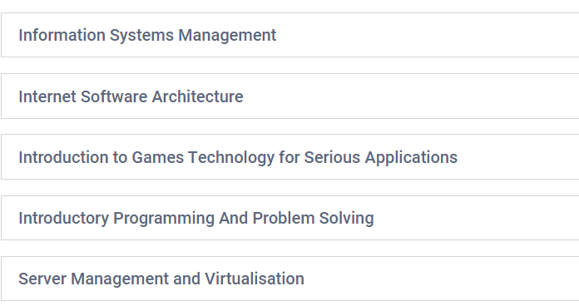

**Figure 3:Curriculum Distribution of University of Wolverhampton (BCS)**

## **2.3Curriculum Distribution of HCK**

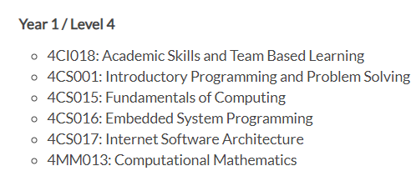

**Figure 4 :Curriculum Distribution of Herald College Kathmandu**

Consequently focus of the modules for this associate degree program is indeed artificial intelligence. Building a solid foundation for computer science is facilitated throughout the first semester. The basics of internet architecture and programming for embedded systems are covered in more detail in the second semester. A key component of studying artificial intelligence is computational mathematics. They research collaborative development and object-oriented programming. The final module of the year is entrepreneurship and professionalism. Students learn where and how to construct a professional assignment in this subject. This course gives students the skills they'll need to find employment after graduation. Practical information that can be used in everyday circumstances is the goal of every module. You can enter the field of computers right away with the help of this BIT course, which serves as a great steppingstone (Herald College Kathmandu, 2023).

# 3. Universities in the UK Vs Nepal

The duration of the course load is one of the most important differences between institutions in Nepal and the UK. Obtaining a bachelor’s degree in science normally takes three years in the United Kingdom, but four years to accomplish one in Nepal. It used to take three years to complete university studies in Nepal, but from 2012 AD, the program was changed to a four-year course (Tribhwan University, 2023). The United Kingdom is home to some of the most renowned universities in the world, and its graduates are truly capable of competing on a worldwide scale (Study In The UK, 2020).

## 3.1Nepali University

By establishing the first institution, Tri-Chandra College, in Nepal in 1918, the country's history of higher education officially began. It was only the university which came in function until 1985. After that, the council admitted to the idea of a system of multiple universities, and Mahendra Sanskrit University was founded. (University Grants Commission, 2018). Kathmandu, Purbanchal, and Pokhara Universities were eventually founded.

## 3.2 Foreign University

Numerous colleges in Nepal are affiliated with foreign universities, including the British College, Islington College, and Herald College Kathmandu etc. The courses that these colleges offer are based on the course modules of the universities to which they are attached, and they typically last between three and four years. Instead of emphasizing theory, they just pay attention to practical knowledge. There are requirements for theoretical modules in some module components.

# 4. Critical Analysis

The presence of Fuse Machines is global. They recruit across the globe for engineers and data analysts. Approximately 200,000 data analysts are expected to be needed in the US during the next five years, with the bulk of them working in the government. For Nepal's young and exceptional learners, Fuse Machines provides a range of possibilities.

1. Python Developer- Beginning with the first semester, courses in Herald College Kathmandu concentrates on programming languages like Python and Java. The students are offered various programming language-related coursework, coding challenges, and workshop projects, all of which allow them to enhance their knowledge of the particular programming language. As time goes on, the college offers a variety of programs linked to the Python programming language that aid students in becoming productive Python developers.
2. Software Engineer (JavaScript)- There is a web technology curriculum in the first semester that teaches individuals about CSS, HTML, and JavaScript. They place a greater emphasis on JavaScript, which improves individual knowledge and prepares them for the future. Various programs are held to help students improve their knowledge and become professional software engineers (JavaScript).
3. UI/UX Designer- In HCK, there are various communities that supply students with ideas for designing, presentations, podcasts, and so on. Students in the UI/UX designing community are taught about designing icons and buttons, making logos, and anything else related to UI/UX design. They also hold several design-related programs that will assist them in becoming well-trained designers.
4. DevOps Engineer- The objective of the Herald College Kathmandu course is on programming languages, along with designing and other external concepts. The major objective of the development platform in Herald College Kathmandu is to present alumni about basic and intermediate knowledge of testing and designing.

# Future Relation

Herald alumni and the IT AI-related enterprise Fuse Machine will continue to have a robust and mutually beneficial cooperation in the future. The technical expertise, problem-solving abilities, and flexibility of Herald graduates will be highly sought after given the quick development of technology and the expanding significance of AI in the industry. In addition, Herald will ensure that its graduates are prepared to meet the changing demands of the sector by investing in continual learning and improvement. The innovative approach of the organization and the graduates' combined experience will help both parties succeed and expand. The likelihood is high that this collaboration will continue to be an invaluable resource for the graduates and the business in the future.

# 6.Conclusion

# Overall, we can say that due to their skill at communicating any subject to a big audience, bachelors are a good fit in this regard. Indeed, Fuse Machines is seeking recent graduates with the capacity to handle huge amounts of data and analyze it. Graduates from Wolverhampton could contribute significantly to the company if hired. For every open position at Fuse Machines right now, graduates of Wolverhampton are fully qualified. Graduates will be qualified for any possible AI-related employment opportunities as the field is now in a state of bloom.

I would like to recommend Fuse Machine as a consultant for them to demonstrate interest in Herald College Graduates. The students are skilled at working in a team and are also adept at solving problems and coming up with original solutions. Additionally, they are equipped with the skills required for every job vacancy now. In their final year, graduates are required to complete one year project that can be used as expertise for any maker role. Future requirements and projects can be completed by Herald alumni as the course is revised annually. Hiring graduates of Herald is unquestionably a smart move because the courses covered there correspond to the work requirements at Fuse Machine.

# 7.References

1. Fuse Machine, 2022. *fusemachines.com.* [Online]   
   Available at: https://fusemachines.com/about/  
   [Accessed 09 January 2023].
2. Herald College Kathmandu, 2022. *Herald College Kathmandu.* [Online]   
   Available at: https://heraldcollege.edu.np/about  
   [Accessed 15 December 2022].
3. Herald College Kathmandu, 2023. *bachelors-in-computer-science.* [Online]   
   Available at: https://heraldcollege.edu.np/bachelors-in-computer-science  
   [Accessed 05 January 2023].
4. Nepali Times, 2017. *Nepali Times.* [Online]   
   Available at: https://www.nepalitimes.com/here-now/natural-intelligence/  
   [Accessed 22 December 2022].
5. Study In The UK, 2020. *uk-education-system-guide.* [Online]   
   Available at: https://www.studying-in-uk.org/uk-education-system-guide/  
   [Accessed 04 January 2023].
6. Topio Networks, 2022. *Topio Networks.* [Online]   
   Available at: https://www.topionetworks.com/companies/fusemachines-553f68d0b6a9b6dc550019ad  
   [Accessed 19 December 2022].
7. Tribhwan University, 2023. *www.tuiost.edu.np.* [Online]   
   Available at: https://www.tuiost.edu.np/programs  
   [Accessed 06 January 2023].
8. University Grants Commission, 2018. *www.ugcnepal.edu.np.* [Online]   
   Available at: https://www.ugcnepal.edu.np/frontpage/20  
   [Accessed 05 January 2023].
9. University of Wolverhampton, 2022. *university-of-wolverhampton-4037.* [Online]   
   Available at: https://www.prospects.ac.uk/universities/university-of-wolverhampton-4037  
   [Accessed 19 December 2022].