`

**Embedded System Programming**

**(4CS016)**

**Automatic Fan**

University Id : 2329584

Module Leader : Subash Bista

Lecturer : Raj Pradhan

Student Name : Akriti Kumari Dev

Group : L4ACG5

Word Count : 2500

Sumbission Date : 2023-05-20

**Abstract**

This mini-project report depicts the making of an automatic fan by recording the surrounding temperature. To measure the outside temperature, the system uses temperature sensors and a microcontroller named Arduino. The fan speed is automatically adjusted to provide a pleasant atmosphere based on the temperature data. The Arduino IDE is used to generate the software, and the hardware setup includes connecting the Arduino with a breadboard, temperature sensors, and a dc motor with a fan attached to it. With the help of easily accessible materials, this project presents an affordable and efficient approach to automatic temperature management. The report provides much detail regarding the project's schematics, programming, and circuit diagrams.

**Acknowledgement**

I would want to convey my deepest appreciation to the embedded systems module leader and team for giving the students the chance to create such fascinating projects. This coursework provided a fantastic environment for growing my knowledge on a variety of subjects. The institution has been very helpful in assisting us with all the chores necessary to accomplish this project successfully. I also desire to amplify my deepest appreciation to The University of Wolverhampton for allowing me to conduct this important research.

**Table of Contents**

**1.** **Automatic Fan:** 1

**2.** **Materials Used in the Project:** 2

**2.1. Arduino UNO:** 2

**2.2.** **Breadboard:** 3

**2.3.** **LCD:** 3

**2.4.** **DC Motor:** 4

**2.5.** **Jumper Wires:** 5

**2.6.** **Resistor:** 5

**2.7.** **Temperature Sensor:** 6

**3.** **Working Principle** 6

**4.** **Circuit Diagram and Fritzing Schematic** 7

**5.** **Code** 7

**6.** **Testing** 7

**7.** **Conclusion** 7

**8.** **References** 9

**Table of Figures**

**Figure 1: Arduino UNO** 3

**Figure 2: Breadboard** 4

**Figure 3: LCD (16X2)** 5

**Figure 4: DC Motor** 6

**Figure 5: Jumper Wires** 7

**Figure 6: Resistors** 8

**Figure 7: Temperature Sensor (LM35)** 10

**Figure 8: Circuit Diagram** 12

**Figure 9: Fritzing Schematic** 12

**Figure 10:Testing of Arduino** 17

**Figure 11:Testing of LCD 1** 18

**Figure 12:Testing of LCD 2** 19

**Figure 13:Testing of Dc motor** 20

**Figure 14:Testing of resistor** 21

**Figure 15:Completed project after testing.** 22

# **Automatic Fan:**

This small auto fan related project takes advantage of the flexibility and adaptability of the Arduino platform to create a smart fan system that can adapt to changing ambient temperatures. This unique Arduino project focused on temperature recording allows you to control fan speed by monitoring the recorded ambient temperature. The main purpose of this little project is to develop a fan that automatically adjusts its speed depending on the ambient temperature. By integrating numerous components such as temperature sensors, Arduino UNO, breadboards, DC motors, fans, and more, the system provides an easy-to-use and effective way to maintain a comfortable environment.

# **Materials Used in the Project:**

## 

## **2.1. Arduino UNO:**

The Arduino electronics platform is a fusion of open-source hardware and software. When an electric motor is activated, an LED is illuminated, or information is shared online, Arduino boards can interpret various inputs such as light detected by a sensor, a user's interaction with a button, or a message on a social media platform. Over the years, an extensive array of projects, spanning from uncomplicated household gadgets to intricate scientific instruments, have utilized Arduino as their central processing unit. Revolving around this open-source framework, a global community of creators has amassed, comprising students, enthusiasts, artists, coders, and professionals. Through their collective efforts, an immense wealth of knowledge has been accumulated, readily accessible and highly beneficial to both novices and experts alike.

The Arduino program is user-friendly for beginners, while proficient users can still personalize it according to their needs. It operates seamlessly on Mac, Windows, and Linux operating systems. Educators and students utilize it to fabricate low-cost scientific instruments, demonstrate principles in chemistry and physics, or embark on programming and robotics education. Designers and architects employ it to construct interactive prototypes, while musicians and artists experiment with it for installations and the development of new musical instruments. Arduino serves as an essential tool for acquiring new knowledge and skills. Since the designs for Arduino boards are accessible under a Creative Commons license, proficient circuit designers have the freedom to create their own iterations of the module, expanding and enhancing its capabilities. Even novice users can construct a breadboard version of the module to grasp its functioning and save costs (Arduino.cc, 2023).

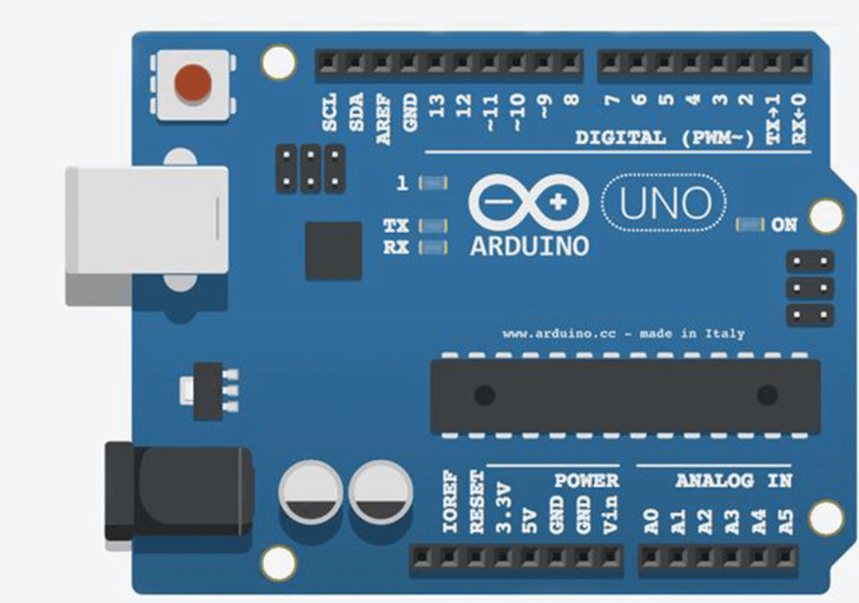

**Figure 1: Arduino UNO**

## **Breadboard:**

A breadboard serves as a platform for constructing or prototyping circuits. It provides a solderless method of assembling components and establishing connections on the board. By physically placing and securing parts or wires in the designated holes, the breadboard handles the electrical connections internally. Its ease of use and rapidity make it ideal for swift and straightforward circuit prototyping. However, breadboards are less suitable for complex or high-frequency circuits.

As mentioned previously, a breadboard offers the advantage of quick and temporary circuit setup for testing purposes before transitioning to a more permanent configuration to evaluate its functionality. It proves beneficial for beginners and creators in constructing standalone projects or integrating with development boards such as Arduino, Raspberry Pi, Launchpad, Beagle Bone, and similar platforms. Breadboards are available in various sizes to accommodate projects of different scales. Moreover, they are cost-effective, along with their accompanying components. If the goal is to enhance project durability, it is easier to transition from a breadboard to protoboard or PCB, compared to the challenges associated with working directly with those boards (CircuitBread, 2019).

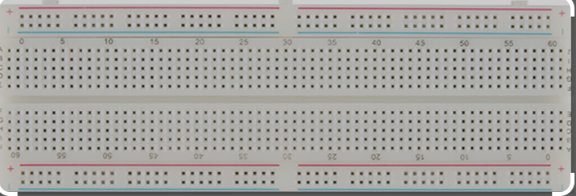

**Figure 2: Breadboard**

## **LCD:**

The Liquid Crystal Display, commonly known as LCD, is a specialized electronic display component extensively employed in various circuits and devices like smartphones, calculators, computers, televisions, and other electronic gadgets. LCDs are particularly well-suited for showcasing information using seven-segment and multi-segment light-emitting diodes. The key benefits of utilizing this module include its affordability, straightforward programming, ability to incorporate animations, and the freedom to display customized characters and unique visual effects without any limitations.

The LCD module boasts several noteworthy features. It operates within a voltage range of 4.7 to 5.3 volts, ensuring compatibility with standard electronic systems. With two rows available, it enables the display of up to 16 characters, facilitating the presentation of ample information. In terms of power consumption, it demonstrates efficiency by utilizing a mere 1 mA of current when operated without backlighting. The LCD's versatility is further enhanced by a 58-pixel grid, allowing the creation of any desired character or graphical element. Supporting alphanumeric characters, this LCD excels in displaying letters and numbers, catering to a wide range of applications.Additionally, these LCDs are available with blue and green backlighting choices, enabling visual customization to suit specific preferences. As a captivating feature, the LCD module can also showcase an array of randomly generated characters, adding a touch of dynamicity to its display capabilities. Collectively, these characteristics make the LCD module a versatile and valuable component in various electronic devices and systems (EL Pro Cus, 2023).

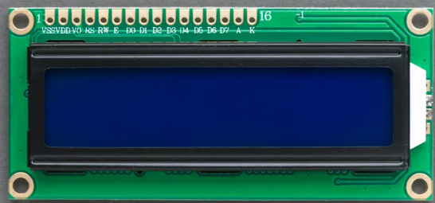

**Figure 3: LCD (16X2)**

## **DC Motor:**

A DC motor, also referred to as a direct current motor, operates through the principles of electromagnetism. The functioning of an electric motor relies on the interaction between a conductor carrying electric current and an external magnetic field. When the conductor's magnetic field interacts with the external field, it experiences a force that is directly proportional to the strength of the external field and inversely proportional to the current in the conductor. This force causes the conductor, acting as an armature, to undergo rotational motion, thereby converting electrical energy into mechanical energy. The key concept exploited in the operation of a DC motor is that a current-carrying conductor placed in a magnetic field encounters a force, resulting in rotational movement. The practical implementation of a DC motor involves incorporating an armature, which acts as the conductor, and field windings that generate the necessary magnetic flux.

The input for a brushless DC motor is in the form of current or voltage, and its output is in the form of torque.Fundamentally, a DC motor consists of two primary elements. The stationary component, referred to as the stator, contrasts with the rotating component, known as the rotor. In relation to the stator, the rotor undergoes rotational motion. The rotor of the DC motor consists of windings that are electrically connected to the commutator. When power is supplied, the rotor begins to rotate, gradually aligning itself with the field magnets of the stator. As the rotor aligns, the brushes move forward to the next set of commutator contacts and activate the corresponding winding. The rotation of the rotor causes the magnetic field to flip, resulting in the reversal of current flow through the winding. This reversal of current direction propels the rotor to continue its rotational motion (El Pro Cus, 2023).

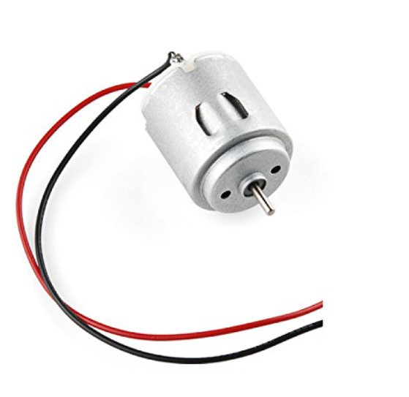

**Figure 4: DC Motor**

## **Jumper Wires:**

Jumpers, which are often compact metallic connectors, serve the purpose of establishing or breaking connections within electronic circuits. These connectors possess multiple contact points that govern the operation of circuit components on a circuit board. They play a crucial role in configuring computer devices like the motherboard. Jumper wires, which consist of electrical cables with connector pins on both ends, are employed to establish connections between two points in a circuit without the need for soldering.

Jumper wires are available in various colors, but these colors do not carry any inherent significance. The color of the wire serves as a mnemonic aid to remember the connections between different elements, but it does not affect the functionality of the circuit. In essence, a red jumper wire and a black jumper wire hold the same value and can be used interchangeably without any impact on the circuit's operation. The primary purpose of assigning different colors to jumper wires is to facilitate organization and make it easier to identify specific connections, rather than introducing any functional distinctions based on the wire color (Wiltronics, 2023)

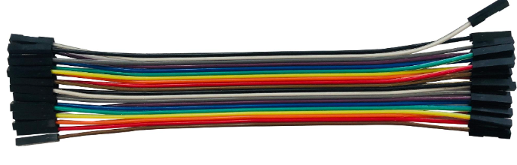

**Figure 5: Jumper Wires**

## **Resistor:**

A resistor is a non-active electrical device that impedes the flow of electricity. They are present in almost all electronic and electrical circuits. Resistance is quantified in ohms (). An ohm signifies the resistance that arises when a resistor encounters a one-volt (V) decrease in voltage across its terminals, while a current of one ampere (A) traverses through it. The magnitude of current passing through the resistor is contingent on the voltage disparity between its terminal ends.

Resistors serve a multitude of purposes. Several instances include voltage partitioning, thermal production, circuit matching and loading, gain adjustment, and establishment of time intervals. Resistivity values are offered for them covering a vast range, spanning in excess of nine orders of magnitude. They can be incredibly small, less than a square millimeter in size, catering specifically to electronic applications. Additionally, resistors can even be utilized as electric brakes, effectively dissipating kinetic energy from moving trains (Ee power, 2020).

**Figure 6: Resistor**

## **Temperature Sensor:**

The LM35 is a temperature sensor that provides an analog output voltage proportional to the temperature being measured. It offers the convenience of direct temperature readings in Celsius without the need for additional calibration circuitry. The LM35 demonstrates a sensitivity of 10 mV per degree Celsius, meaning that its output voltage increases linearly with temperature. For example, an output voltage of 250 mV corresponds to a temperature of 25 degrees Celsius.

With its three-terminal design, the LM35 is specifically designed to accurately measure ambient temperatures within a wide range from -55 degrees Celsius to 150 degrees Celsius. Compared to thermistors, the LM35 surpasses in accuracy, ensuring more precise temperature measurements. This makes the LM35 a reliable choice for applications where accurate temperature monitoring is critical, such as in climate control systems, industrial processes, and scientific experiments. Its direct temperature output, simplicity of use, and enhanced accuracy contribute to the widespread adoption of the LM35 as a dependable temperature sensor (Electronic Wings, 2023).

**Figure 7: Temperature Sensor (LM35)**

# **Working Principle**

The LM35 temperature sensor is utilized to acquire real-time temperature readings, which are then utilized to regulate the speed of a fan. This control mechanism ensures that the fan operates at a higher speed when the temperature is elevated and stops when the temperature decreases. The rotational speed of the fan is directly proportional to the temperature data obtained from the LM35 sensor.

To provide the user with a comprehensive overview, the temperature measurements in Fahrenheit and the fan speed in percentage are conveniently displayed on an LCD module connected to an Arduino. This display enables users to easily monitor the temperature variations and corresponding fan speed adjustments. The code controlling the fan speed can be modified by adjusting the minimum and maximum temperature values to suit specific requirements or preferences.

The working principle behind this system is based on temperature feedback control. As the LM35 sensor continuously measures the ambient temperature, the obtained temperature values are processed by the Arduino. The Arduino then interprets these values and determines the appropriate fan speed setting. When the temperature rises above 30 or equal to 30 , the Arduino increases the fan speed proportionally, allowing for effective cooling. Conversely, when the temperature drops below 20, the Arduino gradually decreases the fan speed or stops it altogether to conserve energy.

This temperature-controlled fan system offers numerous benefits, including efficient temperature regulation, reduced energy consumption, and protection against overheating. By dynamically adjusting the fan speed in response to temperature changes, the system ensures optimal cooling performance while maintaining a suitable operating temperature range.

# **Circuit Diagram and Fritzing Schematic**

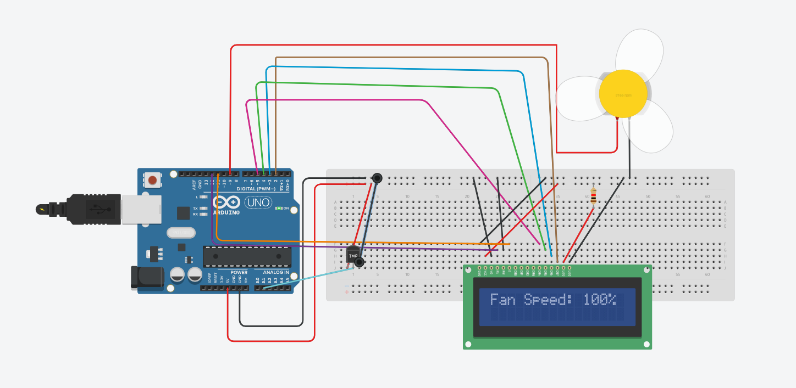

**Figure 8: Circuit Diagram**

**Figure 9: Fritzing Schematic**

# **Code**

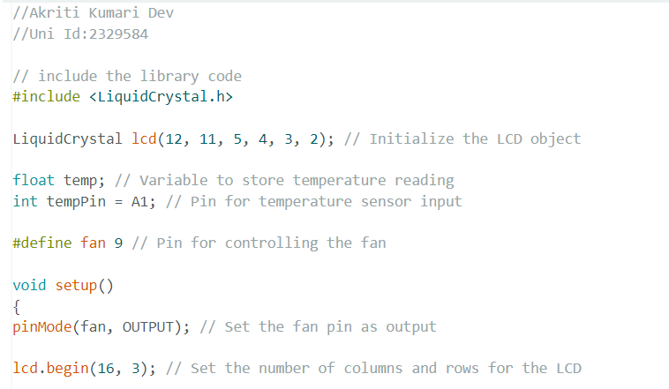

# **Testing**

Initially, the working of Arduino Uno was tested to see if it works without error or not. Then the required code was compiled and uploaded without any errors.

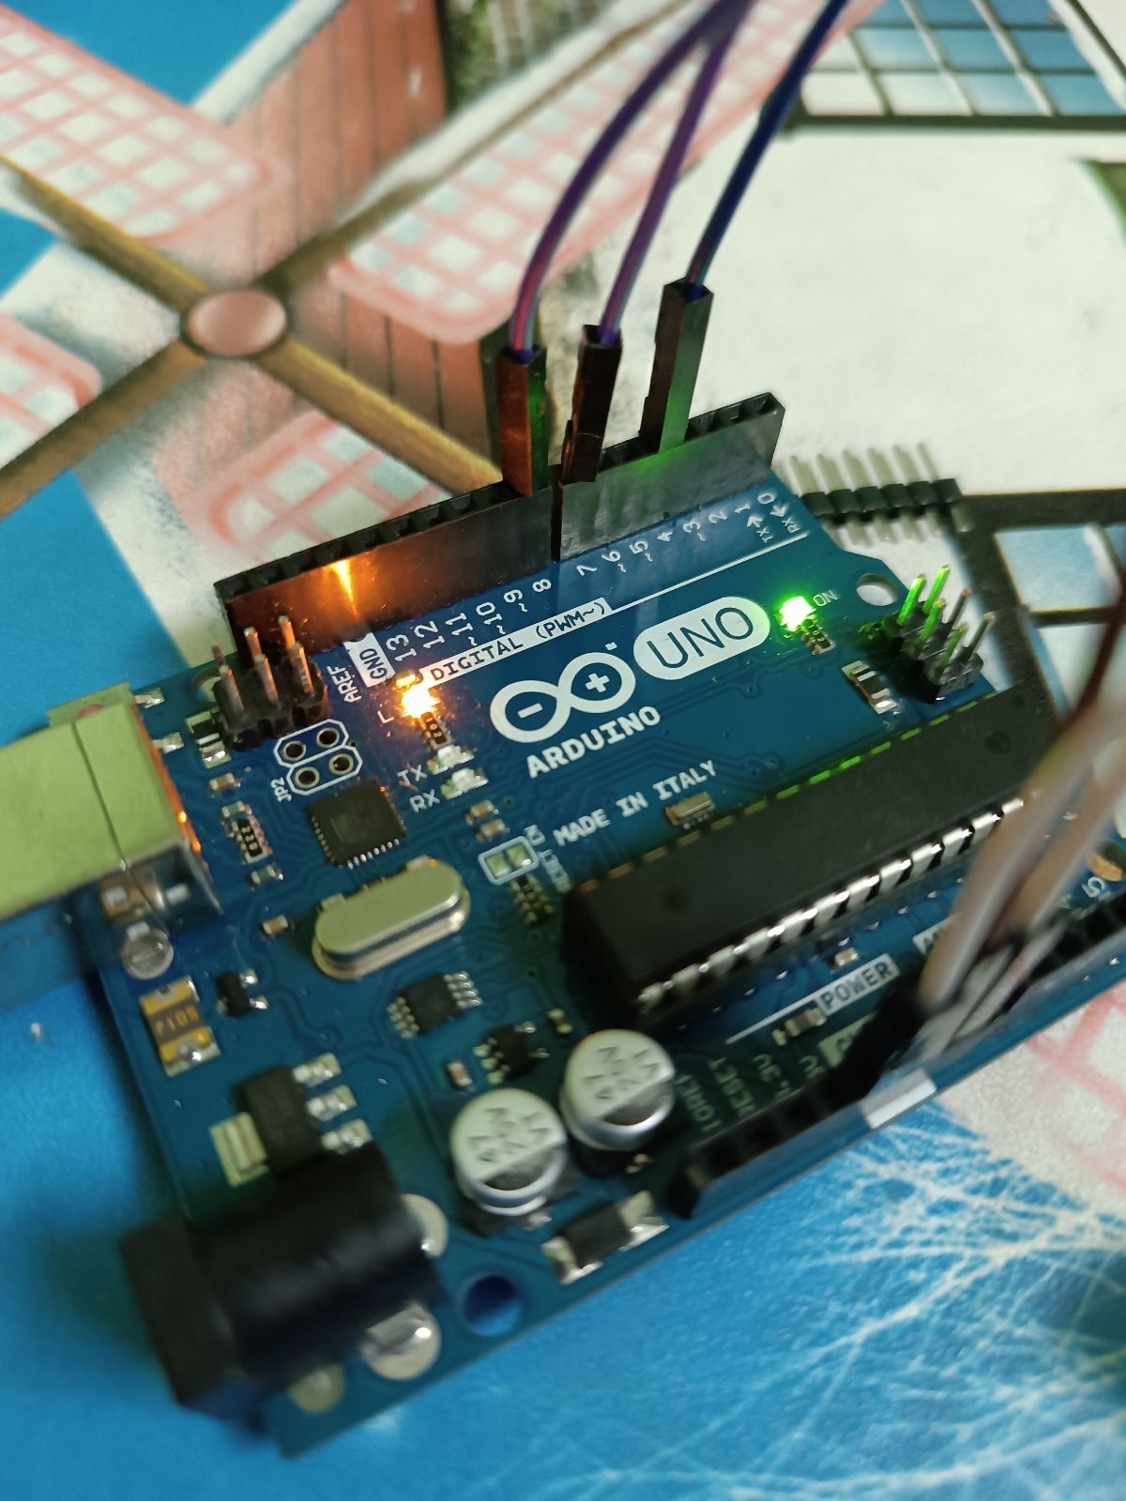

**Figure 10:Testing of Arduino**

Then, the LCD 16x2 was tested to see if it shows data in the display. After testing the LCD worked expected and got expected results which is shown below:

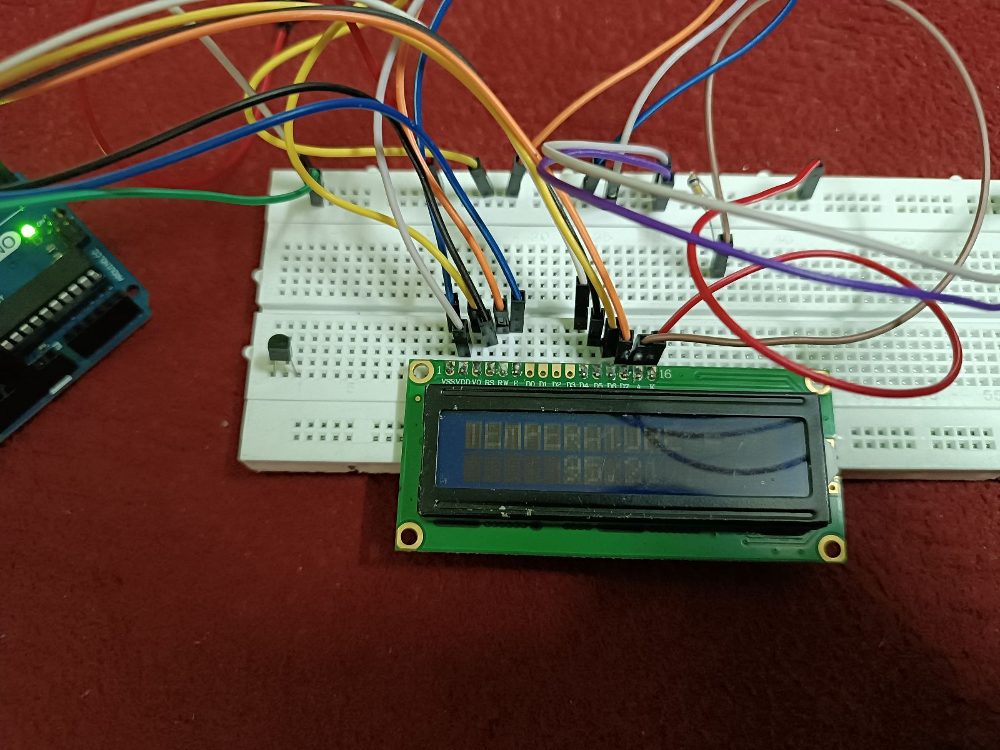

**Figure 11:Testing of LCD 1**

**Figure 12:Testing of LCD 2**

DC motor was tested considering the wires to see if it is connected to the correct ports and to see if the motor works as expected. The DC motor was also error free. The small green colored fan was attached to the DC motor.

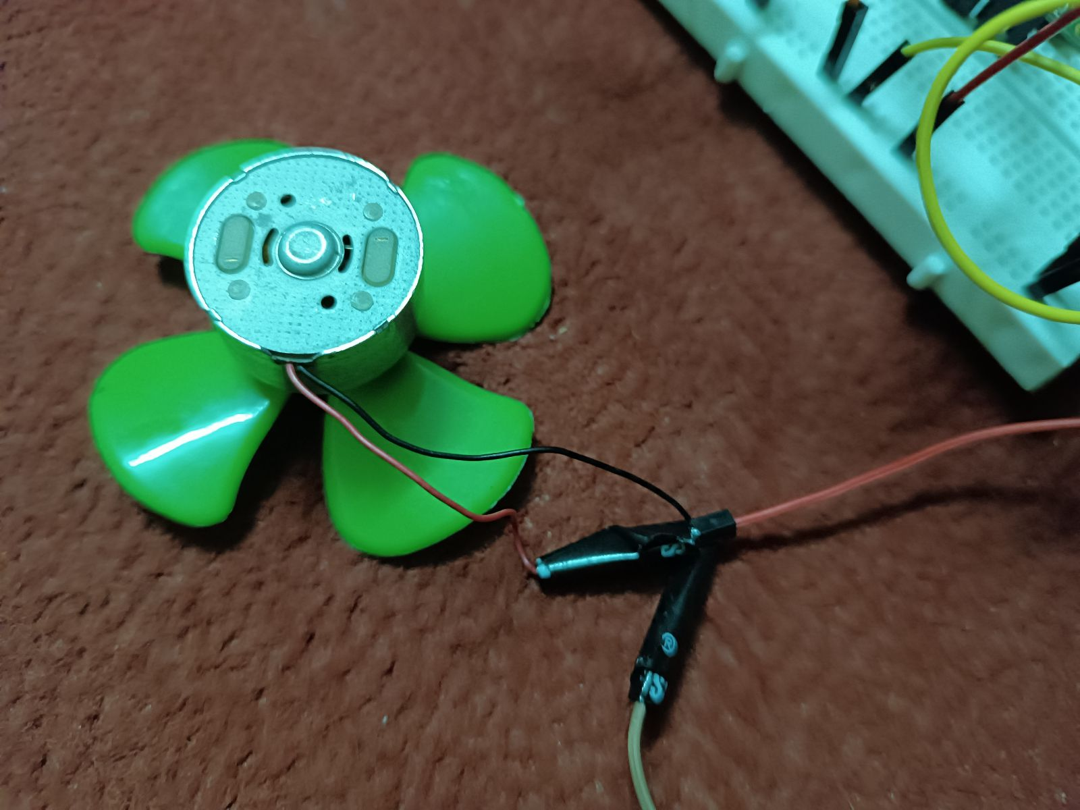

**Figure 13:Testing of Dc motor**

The value of resistor was checked with the help of multimeter and the resistance was found to be 284 ohm.

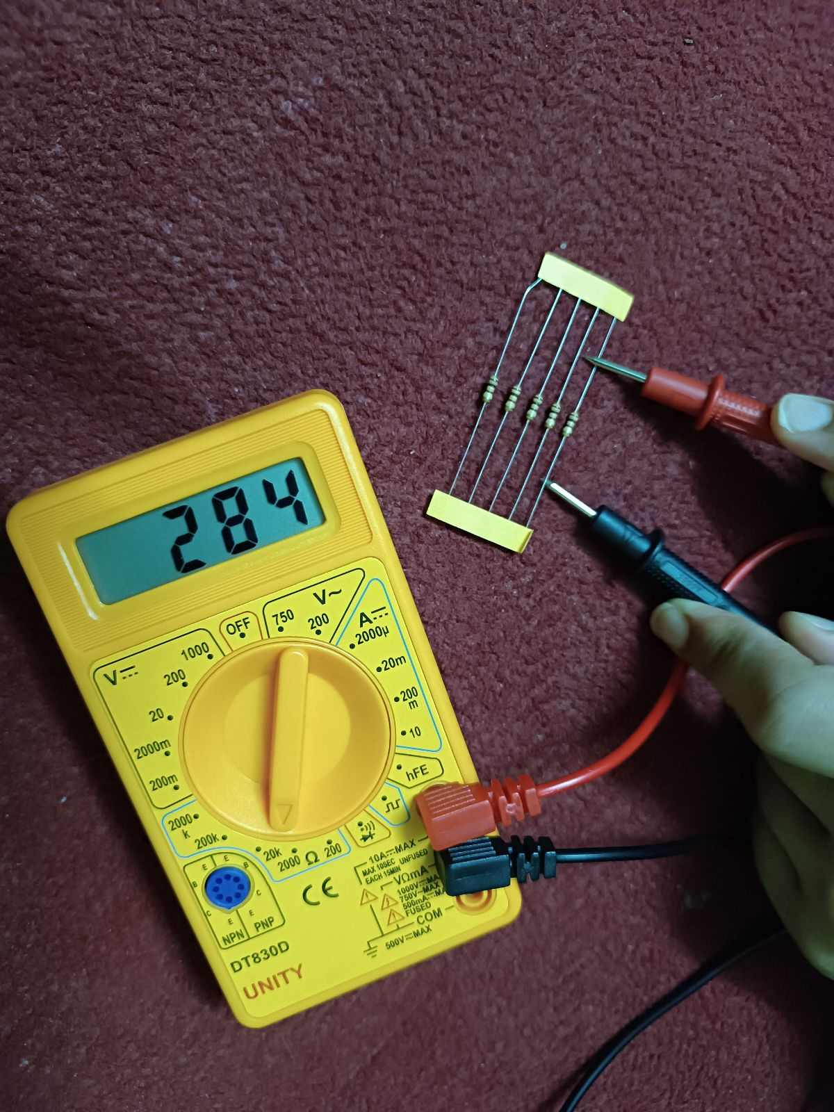

**Figure 14:Testing of resistor**

After the project was completed by connecting the jumper wires and all the necessary components, the code was uploaded to the Arduino board and the data displayed was tested according to the surrounding temperature and it came out correctly. The fan moved at a 100% speed when the temperature was above 30 degrees Celsius.

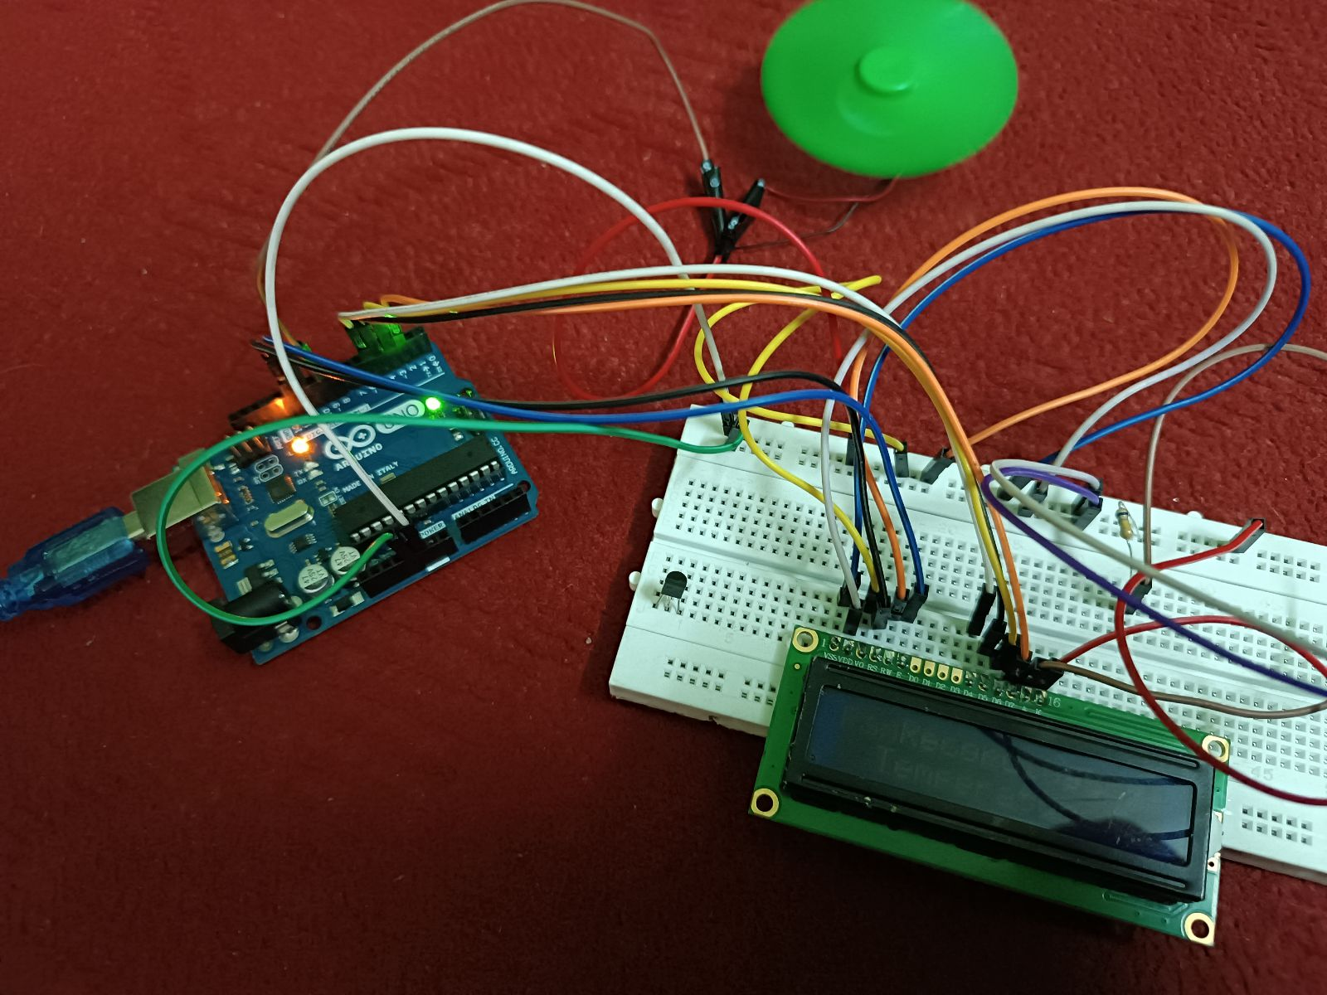

**Figure 15:Completed project after testing.**

# **Conclusion**

In conclusion, the automatic fan project leveraging Arduino technology offers a useful and effective method of regulating fan speed based on ambient temperature. This project exemplifies the flexibility and adaptability of the Arduino platform by including elements such the LM35 temperature sensor, Arduino UNO, breadboard, DC motor, and fan.

The LM35 temperature sensor, which provides real-time temperature data, is the foundation of the project's operations. The Arduino will analyze these readings and change the fan speed as needed. As temperatures rise, fan speeds increase to ensure efficient cooling. However, when the temperature drops, the fans either stop or slow down. This technology has many advantages such as better temperature control, energy savings and protection against overheating. The ability to dynamically adjust fan speed as temperature changes ensures a comfortable environment while saving power.

Users may easily check temperature measurements in Celsius and fan speed in % thanks to the LCD module's connection to the Arduino. This convenient interface's user-friendly design improves convenience and offers real-time feedback on changes in temperature and fan speed. The project also emphasizes the importance of additional parts, including as breadboards, jumpers, resistors, and LCD displays, in the development and operation of electronic circuits. These parts help the system's overall performance and dependability.

People can obtain knowledge of temperature feedback control systems, sensor integration, and Arduino programming by comprehending and putting this automatic fan project into practice. The Arduino platform can be modified to meet unique needs and tastes because to its versatility. The automatic fan project, in its entirety, demonstrates the potential of Arduino technology in developing intelligent devices that react to environmental conditions. The project is a useful tool for people looking to improve comfort, energy efficiency, and temperature control in a variety of contexts due to its simplicity, efficacy, and applicability.

# **References**

1. Arduino.cc, 2023. *whats-arduino.* [Online]   
   Available at: https://docs.arduino.cc/learn/starting-guide/whats-arduino  
   [Accessed 10 May 2023].
2. CircuitBread, 2019. *what-is-a-breadboard.* [Online]   
   Available at: https://www.circuitbread.com/ee-faq/what-is-a-breadboard#:~:text=A%20Breadboard%20is%20simply%20a,to%20make%20circuits%20without%20soldering.  
   [Accessed 07 May 2023].
3. Ee power, 2020. *what-is-a-resistor.* [Online]   
   Available at: https://eepower.com/resistor-guide/resistor-fundamentals/what-is-a-resistor/  
   [Accessed 16 May 2023].
4. EL Pro Cus, 2023. *cd-16x2-pin-configuration-and-its-working.* [Online]   
   Available at: https://www.elprocus.com/lcd-16x2-pin-configuration-and-its-working/  
   [Accessed 10 May 2023].
5. El Pro Cus, 2023. *dc-motor-basics-types-application.* [Online]   
   Available at: https://www.elprocus.com/dc-motor-basics-types-application/  
   [Accessed 09 May 2023].
6. Electronic Wings, 2023. *lm35-temperature-sensor.* [Online]   
   Available at: https://www.electronicwings.com/sensors-modules/lm35-temperature-sensor  
   [Accessed 14 May 2023].
7. Wiltronics, 2023. *what-are-jumper-wires.* [Online]   
   Available at: https://www.wiltronics.com.au/wiltronics-knowledge-base/what-are-jumper-wires/  
   [Accessed 05 May 2023].