**Name=Akriti Kumari Dev**

**Instruction:**

Complete all questions in **1 hour.**

1. The table below shows the Truth table of Half Subtractor, write SOP expression for difference and borrow and design the circuit using Logsim.

| A | B | Difference | Borrow |
| --- | --- | --- | --- |
| 0 | 0 | 0 | 0 |
| 0 | 1 | 1 | 1 |
| 1 | 0 | 1 | 0 |
| 1 | 1 | 0 | 0 |

**SOP expression for difference-A’B+AB’**

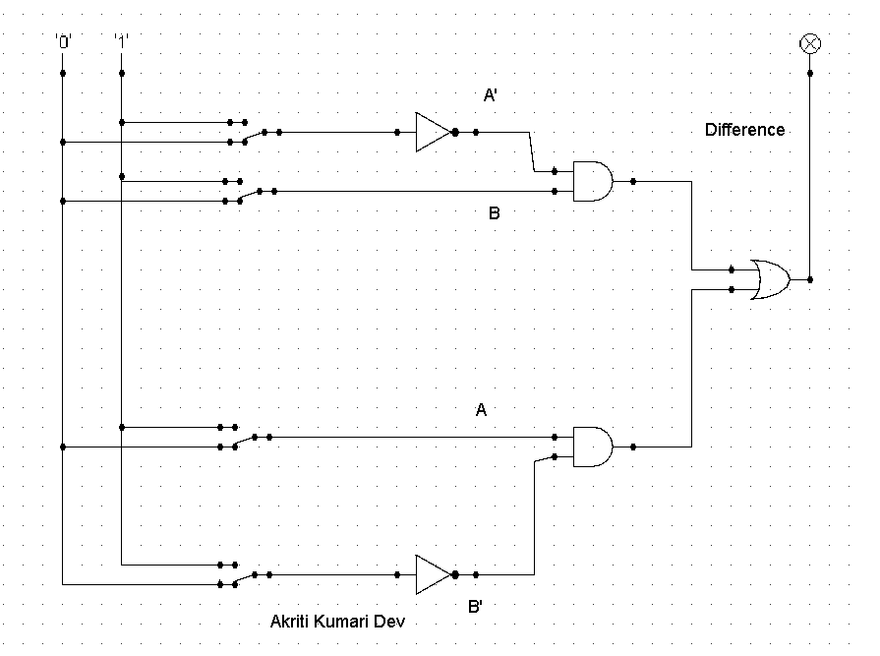

**SOP expression for borrow-A’B**

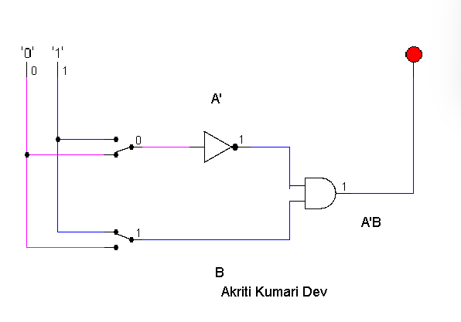

*Insert your Gif image here.*

1. Design 2:4 decoder using logsim and Construct Truth table.

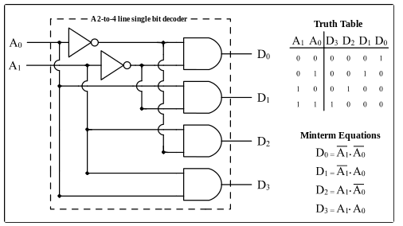

| A1 | A0 | D3 | D2 | D1 | D0 |
| --- | --- | --- | --- | --- | --- |
| 0 | 0 | 0 | 0 | 0 | 1 |
| 0 | 1 | 0 | 0 | 1 | 0 |
| 1 | 0 | 0 | 1 | 0 | 0 |
| 1 | 1 | 1 | 0 | 0 | 0 |

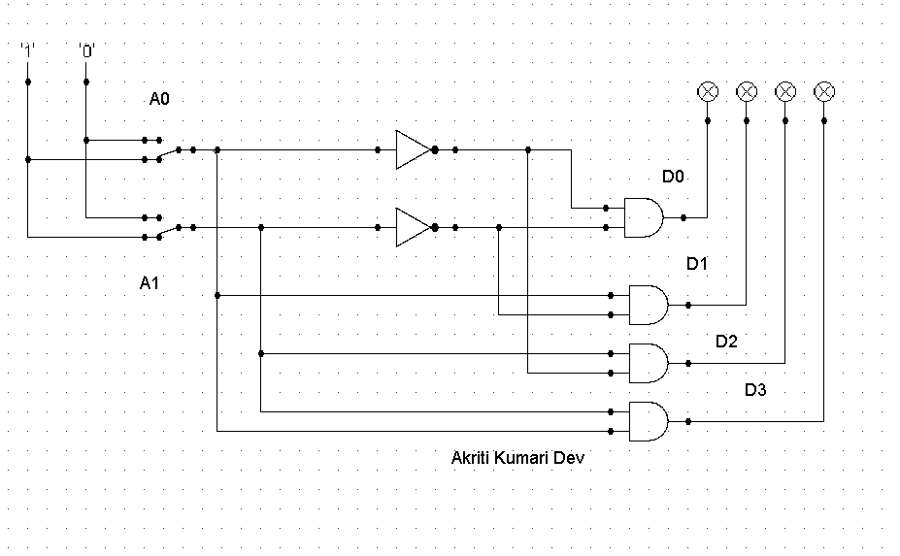

Mintern Equations:

D0=A1’A0’

D1=A1’A0

D2=A1A0’

D3=A1A0

1. Draw the following simple ALU circuit using Logsim and describe the outputs when instructions are 1 and 0.

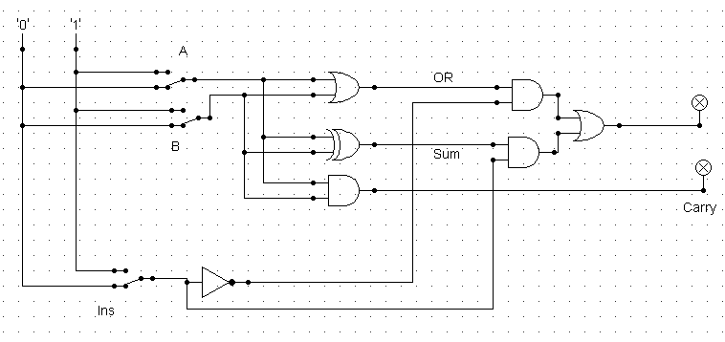

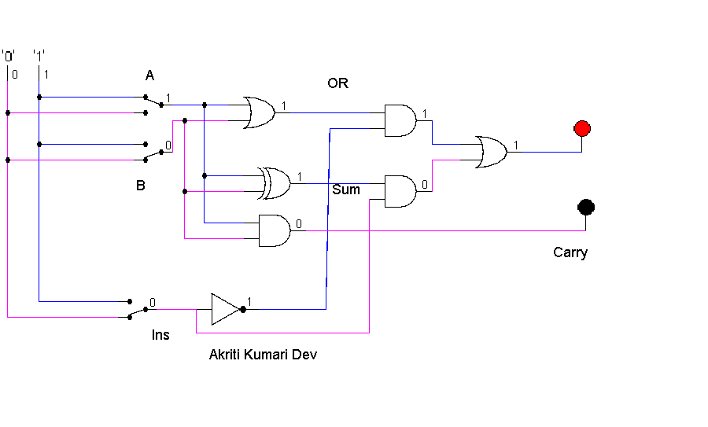

| A | B | ins | OR | Carry |
| --- | --- | --- | --- | --- |
| 0 | 0 | 0 | 0 | 0 |
| 0 | 0 | 1 | 0 | 0 |
| 0 | 1 | 0 | 1 | 0 |
| 0 | 1 | 1 | 1 | 0 |
| 1 | 0 | 0 | 1 | 0 |
| 1 | 0 | 1 | 1 | 0 |
| 1 | 1 | 0 | 1 | 1 |
| 1 | 1 | 1 | 0 | 1 |

In the above given table we can see for 0R,Carry the value is 0,0 when both input is 0,1 and ins is 0.For 0r,Carry the value is 0,0 when both input is 0,0 and ins is 1. For 0R,Carry the value is 1,0 when both input is 0,1 and ins is 0.For OR,Carry the value is1,0 when both values are 0,1 and ins is 0,1. For OR,Carry the value is 1,0 when both input is 1,0 and ins is 0. For the value of OR,Carry is 1,0 when the inputs are 1,0 and 1. For the value of OR,carry is 1,1 when both inputs are 1,1 and ins is 0. For OR,Carry the values are 0,1 when both inputs are 1,1 and ins is 1.

1. Write short notes on the following topic:
2. ALU

=An electronic circuit that performs both arithmetic and logic operations commonly is known as arithmetic logic unit (ALU). Mathematician John von Neumann came up with the plan of ALU in 1946. Probably he was the first human to obtain that all computers must perform key arithmetic at a minimum. He understood that it was possible to have a circuit that functioned those applications in particular.

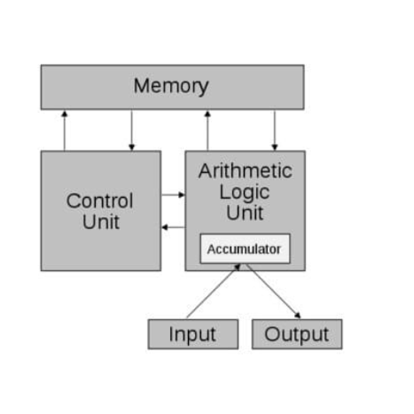

ALU represents the fundamental building block of the central processing unit (CPU) of a computer. Most of the operations of a CPU are performed by one or more ALUs, which load data from input registers. The Control Unit tells the ALU what operation to perform on that data and the ALU stores the result in output register. A register is a small amount of storage available as a part of a CPU. Basically, the ALU has direct input and output access to the processor controller, main memory (random access memory or RAM in a personal computer) and input/output devices. Inputs and outputs flow along an electronic path that is called a bus. The ALU performs simple addition, subtraction, multiplication, division, and logic operations, such as OR and AND. The memory stores the programs instructions and data.

Pros of ALU

It has a high range of accuracy and can perform on a very large set of instructions. There is no memory wastage with ALU and has no sensitivity issues. They minimize the logic gate requirements, are less expensive and their methods are very easy to master and implement other processors methods on the computer.

Cons of ALU

Memory space should be definite else bugs would occur in our computer. With the ALU, floating variables have more delays and the designed controller is not easy to understand.

1. Decoder

=A decoder is a device that generates the original signal as output from the coded input signal and converts n lines of input into 2n lines of output. An And gate can be used as the basic a high output only when all inputs are high. A typical application of a line decoder circuit is used to select among multiple devices. In simple words, the decoder performs the reverse operation of the encoder. At a time, only one input line is activated for simplicity. The produced 2N-bit output code is equivalent to the binary information.

Decoder accepts coded binary data as its input. The decoder generates an active output signal in response to the coded data bits. The operation performed is complex. There are various types of decoders which are as follows.

2-to-4-line decoder: In the 2-to-4-line decoder, there is a total of three inputs, i.e., A0, and A1 and E and four outputs, i.e., Y0, Y1, Y2, and Y3. For each combination of inputs, when the enable 'E' is set to 1, one of these four outputs will be 1. The block diagram of the 2-to-4-line decoder is given below.

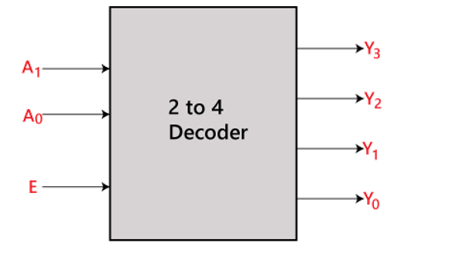

3-to-8-line decoder:

The 3-to-8-line decoder is also known as Binary to Octal Decoder. In a 3-to-8-line decoder, there is a total of eight outputs, i.e., Y0, Y1, Y2, Y3, Y4, Y5, Y6, and Y7 and three outputs, i.e., A0, A1, and A2. This circuit has an enabled input 'E'. Just like a 2-to-4-line decoder, when enable 'E' is set to 1, one of these four outputs will be 1. The block diagram of the 3-to-8-line encoder is given below.

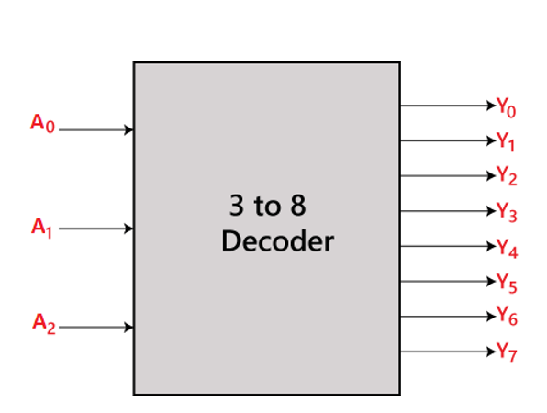

4-to-16-line decoder:

In the 4 to 16 line decoder, there are a total of 16 outputs, i.e., Y0, Y1, Y2,…, Y16 and four inputs, i.e., A0, A1, A2, and A3. The 3-to-16-line decoder can be constructed using either 2 to 4 decoder or 3 to 8 decoders. The block diagram of the 4-to-16-line decoder is given below.

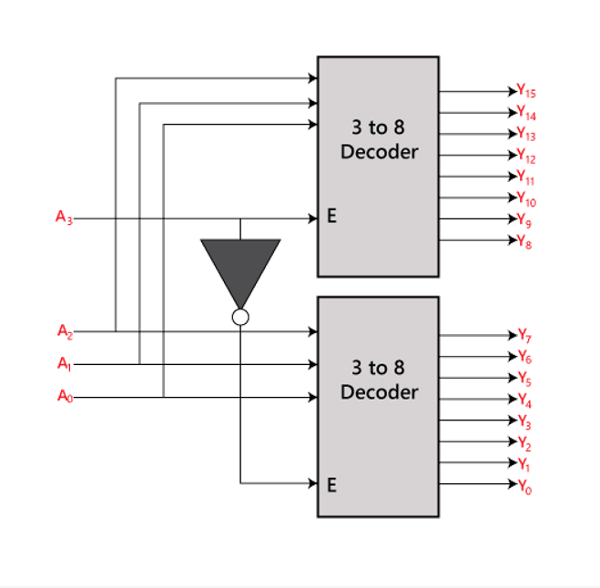

1. Multiplexer

=Multiplexer is a combinational circuit that has a maximum of 2n data inputs, ‘n’ selection lines and a single output line. One of these data inputs will be connected to the output based on the values of selection lines. Since there are ‘n’ selection lines, there will be 2n possible combinations of zeros and ones. So, each combination will select only one data input. Multiplexers are also called mux. The multiplexer is used to perform high-speed switching and is constructed by electronic components. Multiplexers, or MUX’s, can be either digital circuits made from high-speed logic gates used to switch digital or binary data or they can be analogue types using transistors, or relays to switch one of the voltage or current inputs through to a single output. Multiplexers are not limited to just switching a number of different input lines or channels to one common single output. There are also types that can switch their inputs to multiple outputs and have arrangements of 4-to-2, 8-to-3 or even 16-to-4 etc. configurations. The multiplexer is a very useful electronic circuit that has uses in many different applications such as signal routing, data communications and data bus control applications. Multiplexers are sometimes referred to as “data selectors”, as they select the data to the line.

