**Instruction:**

Complete all questions in **1 hour.**

1. Draw the logic diagram of the following gates using logsim and complete the

Truth tables.

1. AND

| **A** | **B** | **A.B** |
| --- | --- | --- |
| **0** | **1** | **0** |
| **1** | **0** | **0** |
| **0** | **0** | **0** |
| **1** | **1** | **1** |

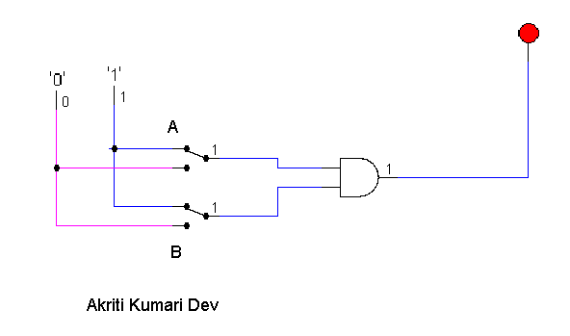

[Insert your gif image here]

1. NOR (do the same as in Q No a for all of the following

| **A** | **B** | **(A+B)’** |
| --- | --- | --- |
| **0** | **0** | **1** |
| **1** | **0** | **0** |
| **0** | **1** | **0** |
| **1** | **1** | **0** |

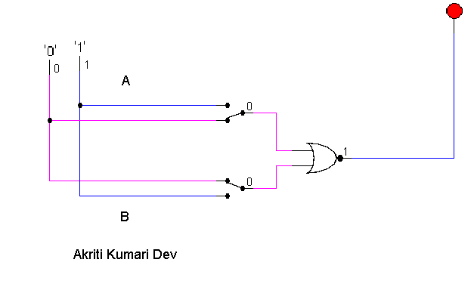

1. OR

| **A** | **B** | **A+B** |
| --- | --- | --- |
| **0** | **0** | **0** |
| **1** | **0** | **1** |
| **0** | **1** | **1** |
| **1** | **1** | **1** |

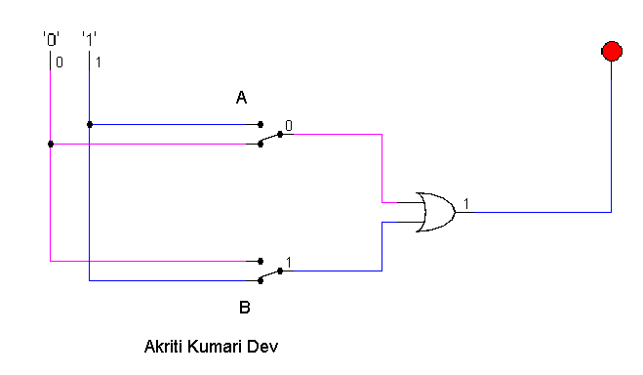

1. NAND (using NOT and AND)

| **A** | **B** | **(A.B)’** |
| --- | --- | --- |
| **0** | **0** | **1** |
| **0** | **1** | **1** |
| **1** | **0** | **1** |
| **1** | **1** | **0** |

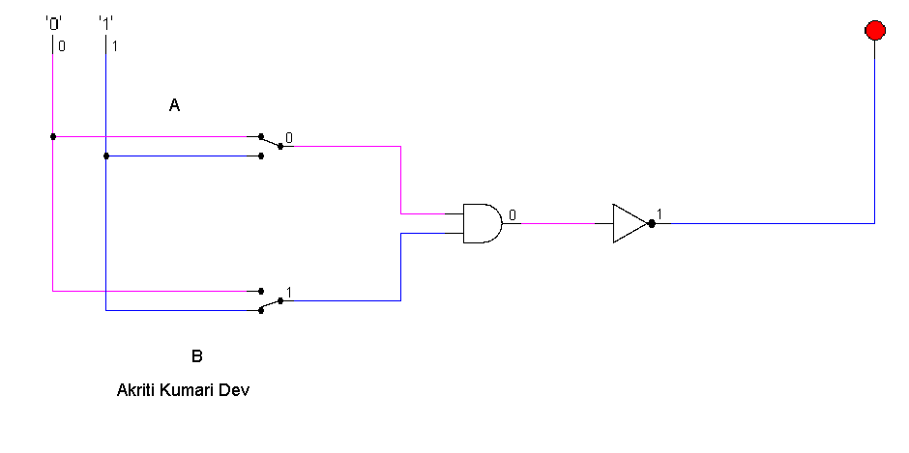

1. XOR using AOI

| **A** | **B** | **A’B+AB’** |
| --- | --- | --- |
| **0** | **0** | **0** |
| **0** | **1** | **1** |
| **1** | **0** | **1** |
| **1** | **1** | **0** |

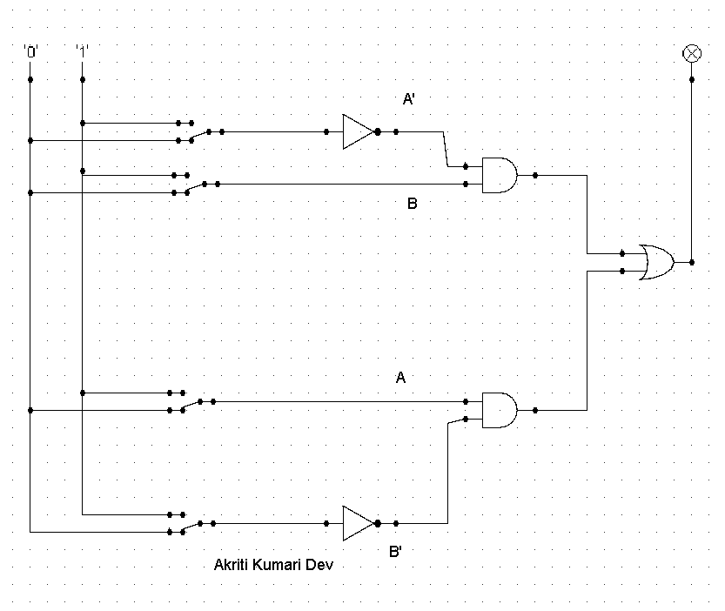

1. Use LogSim to build the equivalent circuit for the following Boolean equations.

Prove that the expressions are equivalent by computing truth table.

$!\left(A+B\right)=!A.!B$

| A | B | !(A+B) | !A . !B |
| --- | --- | --- | --- |
| 0 | 0 | 1 | 1 |
| 0 | 1 | 0 | 0 |
| 1 | 0 | 0 | 0 |
| 1 | 1 | 0 | 0 |

[Insert your gif image here]

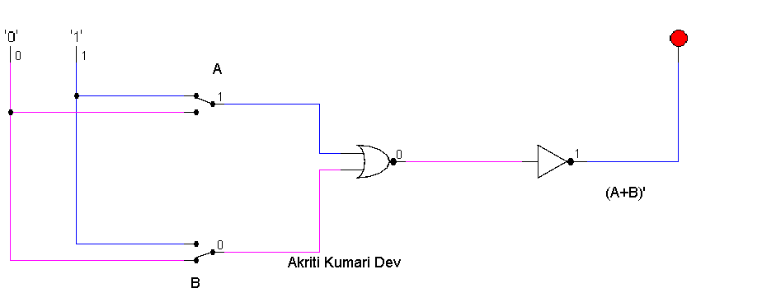

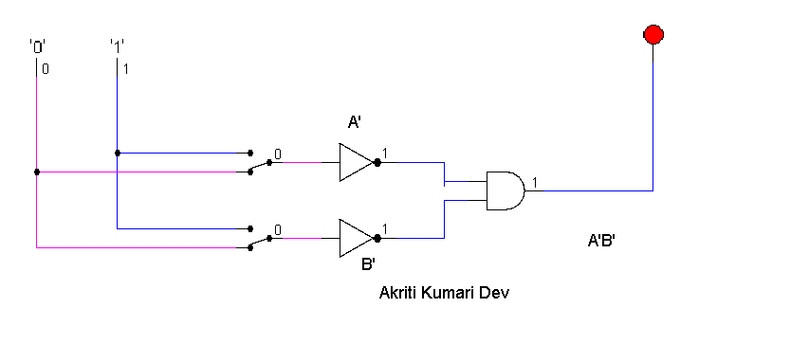

1. Draw the following circuit of half adder using LogSim.

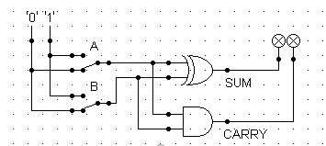

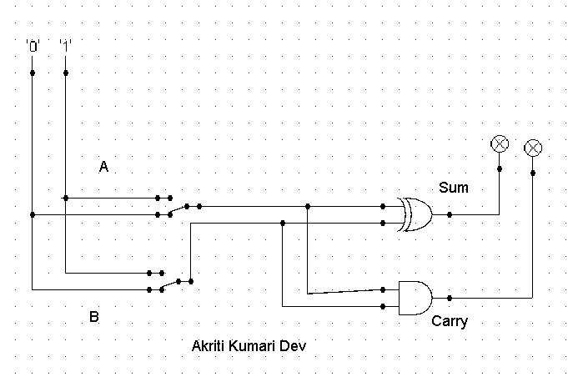

1. Draw a full adder using Logsim and construct a truth table.

| A | B | Carry in | Sum | Carry |
| --- | --- | --- | --- | --- |
| 0 | 0 | 0 | 0 | 0 |
| 0 | 0 | 1 | 1 | 0 |
| 0 | 1 | 0 | 1 | 0 |
| 0 | 1 | 1 | 0 | 1 |
| 1 | 0 | 0 | 1 | 0 |
| 1 | 0 | 1 | 0 | 1 |
| 1 | 1 | 0 | 0 | 1 |
| 1 | 1 | 1 | 1 | 1 |

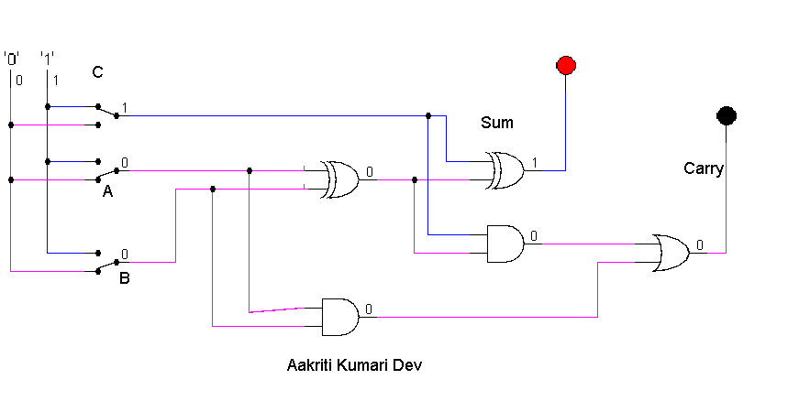

1. Draw the logic circuit for the following Boolean equations using logsim simulator.
   1. AB+C

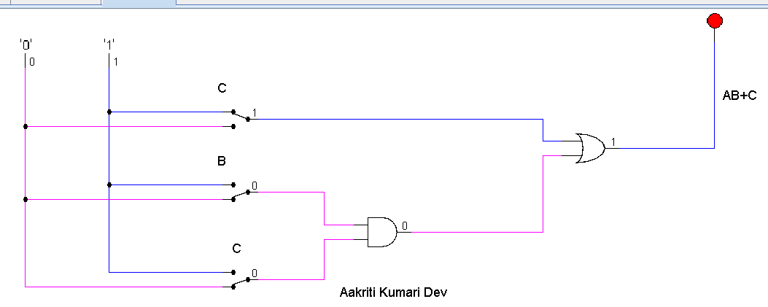

* 1. A(B+C)

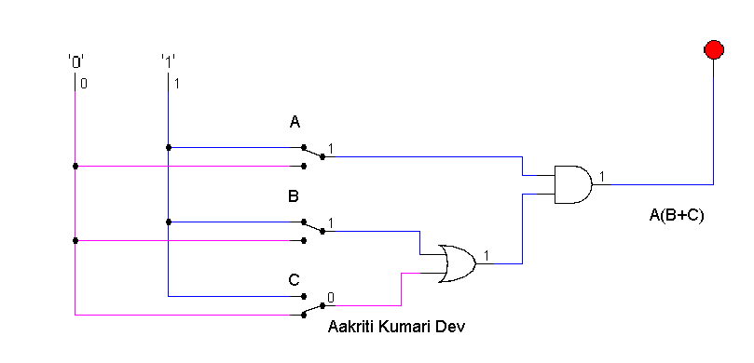

* 1. X’Y’Z’

