ALU

=An electronic circuit that performs both arithmetic and logic operations commonly is known as arithmetic logic unit (ALU). Mathematician John von Neumann came up with the plan of ALU in 1946. Probably he was the first human to obtain that all computers must perform key arithmetic at a lowest. He understood that it was feasible to have a circuit functioned those applications in particular.

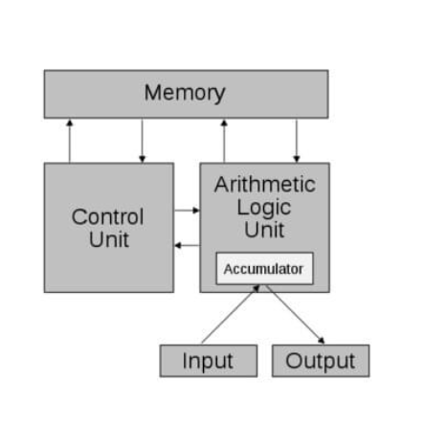

ALU represents the fundamental building block of the central processing unit (CPU) of a computer. Most of the operations of a CPU are performed by one or more ALUs, which load data from input registers. The Control Unit tells the ALU what operation to perform on that data and the ALU stores the result in output register. A register is a small amount of storage available as a part of a CPU. Basically, the ALU has direct input and output access to the processor controller, main memory (random access memory or RAM in a personal computer) and input/output devices. Inputs and outputs flow along an electronic path that is called a bus. The ALU performs simple addition, subtraction, multiplication, division, and logic operations, such as OR and AND. The memory stores the programs instructions and data.

Pros of ALU

It has a high range of accuracy and can perform on a very large set of instructions. There is no memory wastage with ALU and has no sensitivity issues. They minimize the logic gate requirements, are less expensive and their methods are very easy to master and implement other processors methods on the computer.

Cons of ALU

Memory space should be definite else bugs would occur in our computer. With the ALU, floating variables have more delays and the designed controller is not easy to understand.