Decoder

A decoder is a device that generates the original signal as output from the coded input signal and converts n lines of input into 2n lines of output. An And gate can be used as the basic a high output only when all inputs are high. A typical application of a line decoder circuit is used to select among multiple devices. In simple words, the **decoder** performs the reverse operation of the **encoder**. At a time, only one input line is activated for simplicity. The produced 2N-bit output code is equivalent to the binary information.

Decoder accepts coded binary data as its input. The decoder generates an active output signal in response to the coded data bits. The operation performed is complex. There are various types of decoders which are as follows.

2-to-4-line decoder: In the 2-to-4-line decoder, there is a total of three inputs, i.e., A0, and A1 and E and four outputs, i.e., Y0, Y1, Y2, and Y3. For each combination of inputs, when the enable 'E' is set to 1, one of these four outputs will be 1. The block diagram of the 2-to-4-line decoder is given below.

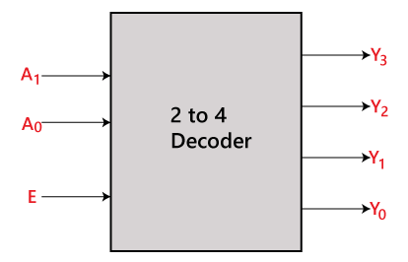

3-to-8-line decoder:

The 3-to-8-line decoder is also known as Binary to Octal Decoder. In a 3-to-8-line decoder, there is a total of eight outputs, i.e., Y0, Y1, Y2, Y3, Y4, Y5, Y6, and Y7 and three outputs, i.e., A0, A1, and A2. This circuit has an enable input 'E'. Just like 2-to-4-line decoder, when enable 'E' is set to 1, one of these four outputs will be 1. The block diagram of the 3-to-8-line encoder is given below.

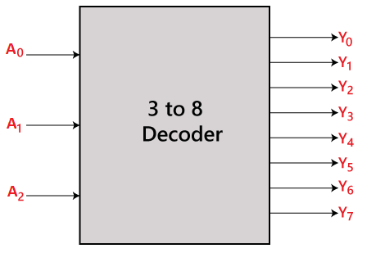

4-to-16-line decoder:

In the 4 to 16 line decoder, there is a total of 16 outputs, i.e., Y0, Y1, Y2,…, Y16 and four inputs, i.e., A0, A1, A2, and A3. The 3-to-16-line decoder can be constructed using either 2 to 4 decoder or 3 to 8 decoders. The block diagram of the 4-to-16-line decoder is given below.

