* 1. Define half adder.

=Half adder is a combinational logic circuit designed by combining one AND and one XOR function and also combines two one-bit binary numbers.

* 1. Draw a truth table for the sum and carry of half adder.

| A | B | Sum | Carry |
| --- | --- | --- | --- |
| 0 | 0 | 0 | 0 |
| 0 | 1 | 1 | 0 |
| 1 | 0 | 1 | 0 |
| 0 | 1 | 0 | 1 |

* 1. Write the sop expression from the truth table.

=Sum=A’B-AB’

=Carry=A.B

* 1. Draw the circuit using logsim.

*[Paste your gif image here]*

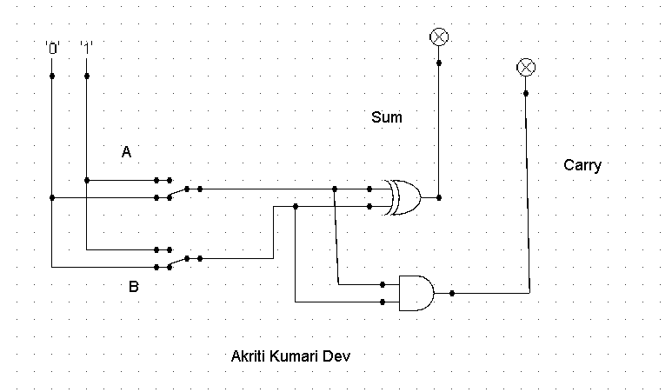

* 1. Draw the truth table for the outputs of the full adder.

| A | B | Carry in | Sum | Carry |
| --- | --- | --- | --- | --- |
| 0 | 0 | 0 | 0 | 0 |
| 0 | 0 | 1 | 1 | 0 |
| 0 | 1 | 0 | 1 | 0 |
| 0 | 1 | 1 | 0 | 1 |
| 1 | 0 | 0 | 1 | 0 |
| 1 | 0 | 1 | 0 | 1 |
| 1 | 1 | 0 | 0 | 1 |
| 1 | 1 | 1 | 1 | 1 |

* 1. Write the corresponding sop expression for sum and carry of full adder and simplify the expression

=Sum= AB’C’+A’BC’+A’B’C-ABC

=A(B’C’+BC)+A’(BC’+B’C)

=A(B⊕C)’+A’(B⊕C)

=A⊕(B⊕C)

=A⊕B⊕C

Carry Out=ABC’+AB’C+A’BC+ABC

=ABC’+ABC+AB’C+A’BC

=AB(C’+C)+C(AB’+A’B)

=AB+C(AB’+A’B)

=AB+C(A+B)

=AB+AC+BC

* 1. Draw full adder using two half adder and an OR gate.

*[Paste your gif image here]*

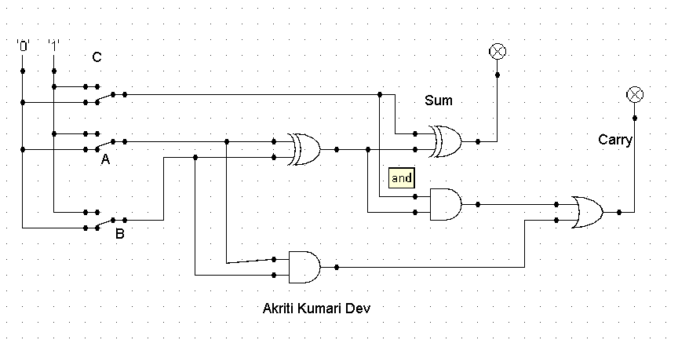

1. Using the three stages of design, construct the circuits for the following input /output values. Here A, B and C are the inputs whereas D, E, F, G, H and I are outputs. *Note: Draw circuit diagram using logsim corresponding to the simplified expression of outputs D, E, F, G, H and I.*

| A | B | C | D | E | F | G | H | I |
| --- | --- | --- | --- | --- | --- | --- | --- | --- |
| 0 | 0 | 0 | 1 | 0 | 1 | 0 | 1 | 1 |
| 0 | 0 | 1 | 1 | 0 | 1 | 1 | 0 | 1 |
| 0 | 1 | 0 | 1 | 0 | 1 | 1 | 1 | 1 |
| 1 | 0 | 0 | 1 | 0 | 0 | 1 | 0 | 1 |
| 1 | 1 | 1 | 1 | 1 | 1 | 1 | 1 | 1 |
| 1 | 1 | 0 | 1 | 1 | 0 | 1 | 0 | 1 |
| 1 | 0 | 1 | 1 | 1 | 1 | 1 | 1 | 0 |
| 0 | 1 | 1 | 0 | 0 | 0 | 1 | 1 | 1 |

*[Paste your gif images here]*

**D=A+B’+C’**

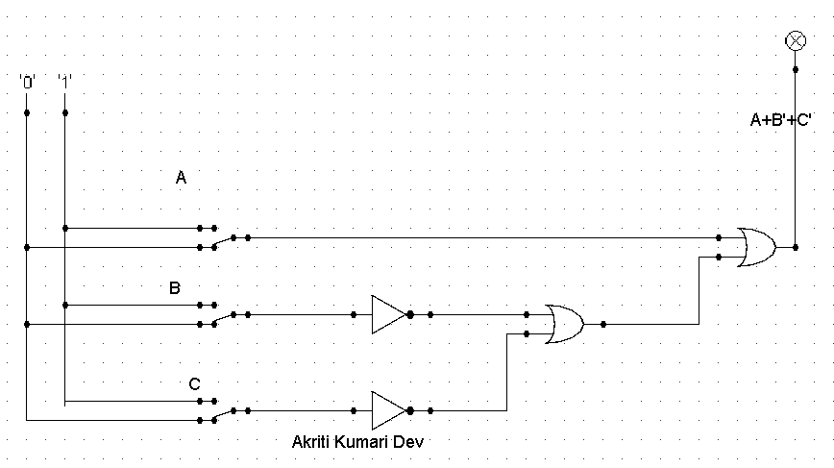

**E=ABC+ABC’+AB’C**

**=ABC+(B**⊕C)

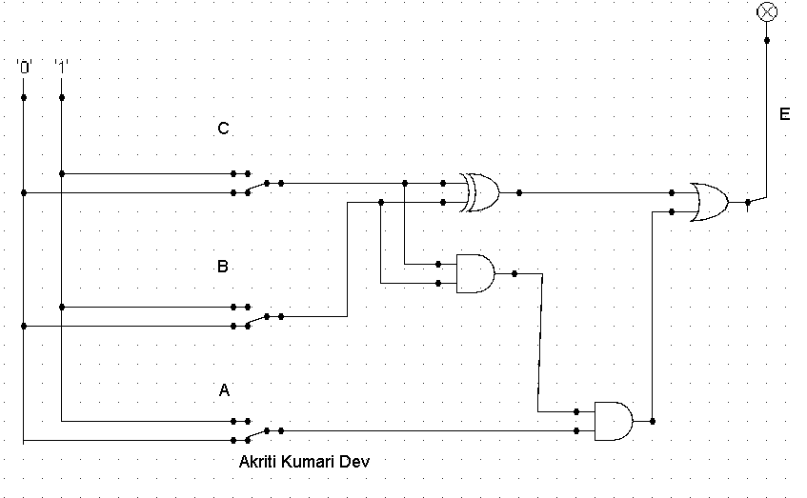

F=A’B’C’+A’B’C+A’BC’+ABC+AB’C

=A’B+AC

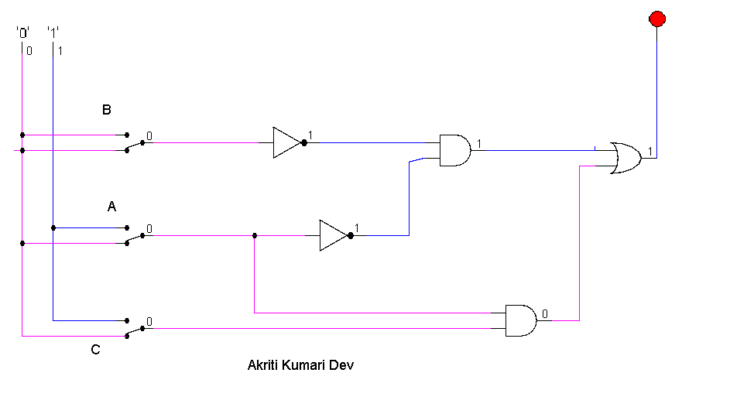

**G=A+B+C**

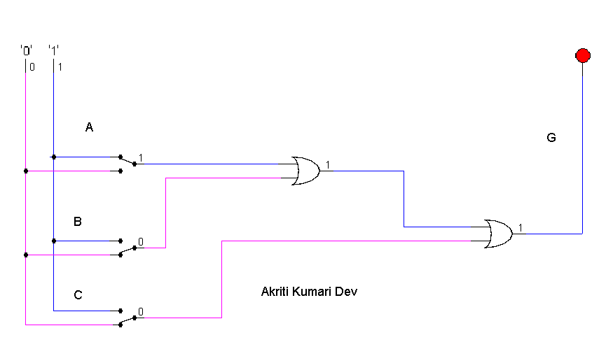

H=A’B’C’+A’BC’+ABC+AB’C+A’BC

=(A⊕C)’+A’BC

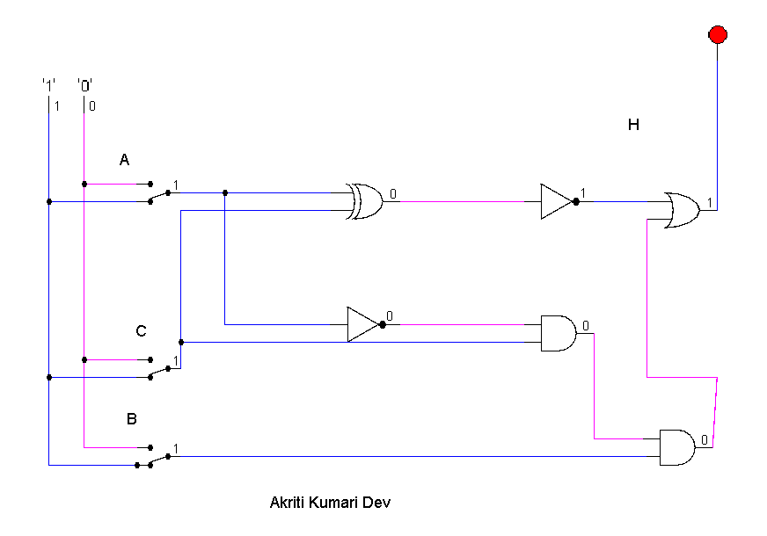I=A’+B+C’

