**4CS001**

**Python Workshop 11: Exception Handling**

**Part 1**

1. How many except statements can a try-except block have?  
   a) zero  
   b) one  
   c) one or more  
   d) none of the above
2. When will the else part of try-except-else be executed?  
   a) always  
   b) when an exception occurs  
   c) when no exception occurs  
   d) when an exception occurs in to except block
3. Is the following Python code valid?

**try**:

*# Do something*

**except**:

*# Do something*

**finally**:

*# Do something*

1. no, there is no such thing as finally
2. no, finally cannot be used with except
3. no, finally must come before except
4. yes
5. Is the following Python code valid?

**try**:

*# Do something*

**except**:

*# Do something*

**else**:

*# Do something*

a) no, there is no such thing as else  
b) no, else cannot be used with except  
c) no, else must come before except  
d) yes

1. When is the finally block executed?  
   a) when there is no exception  
   b) when there is an exception  
   c) only if some condition that has been specified is satisfied  
   d) always

**Part 2**

1. Using try…except, showcase the ZeroDivisionError.

1. Create a simple list containing five elements and try to printthe sixth element of the list. [use IndexError exception]

1. Try printing a variable without declaring it first. [use NameError exception]

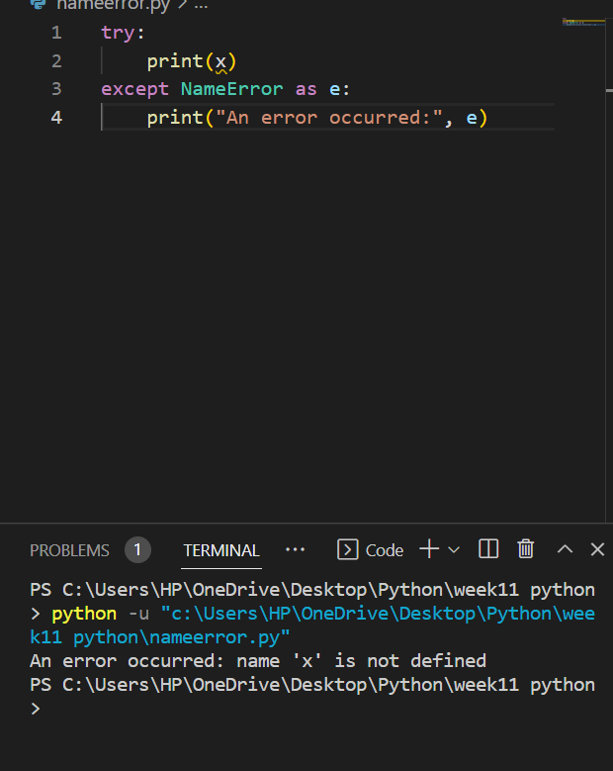

1. The ‘else’ in try…except…else statements is used to run the code on the else block if there are no exceptions in the ‘except’ block. Show an example.

1. In Python, we can choose to throw an exception if a condition occurs. To throw the exception, we use ‘raise’ keyword. Show an example.

**Part 3**

1. Ask the user for the numerator and denominator value; and perform division. If the user enters a number, the program will evaluate and produce the result.

If the user enters a non-numeric value then, the try block will throw a ValueError exception, and we can catch that using a first catch block ‘except ValueError’ by printing the message ‘Entered value is wrong’.

And suppose the user enters the denominator as zero. In that case, the try block will throw a ZeroDivisionError, and we can catch that using a second catch block by printing the message ‘Can’t divide by zero’.

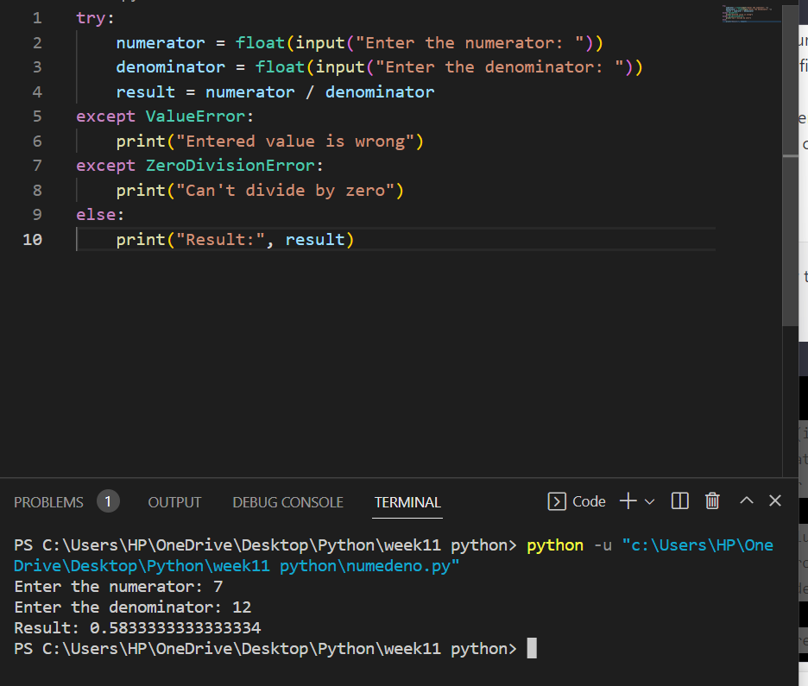

1. Ask the user to enter an amount of money. In the try block, run a condition to check if the input value is less than 10 thousand; in which case raise a ValueError and print your message inside it. In the except block, catch the ValueError we previously raised and print the message inside it.

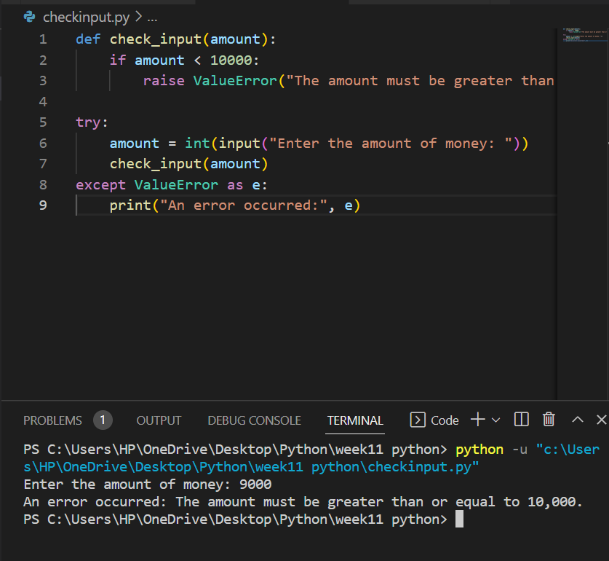

1. An EOFError is raised when built-in functions like input() hits an end-of-file condition (EOF) without reading any data. The file methods like readline() return an empty string when they hit EOF. Show an example.

