**4CS001**

**Python Workshop 11: File Handling**

**Part 1**

1. Create a program in Python that opens a file named 'datafile.txt' for reading and assigns identifier input_file to the file object created.

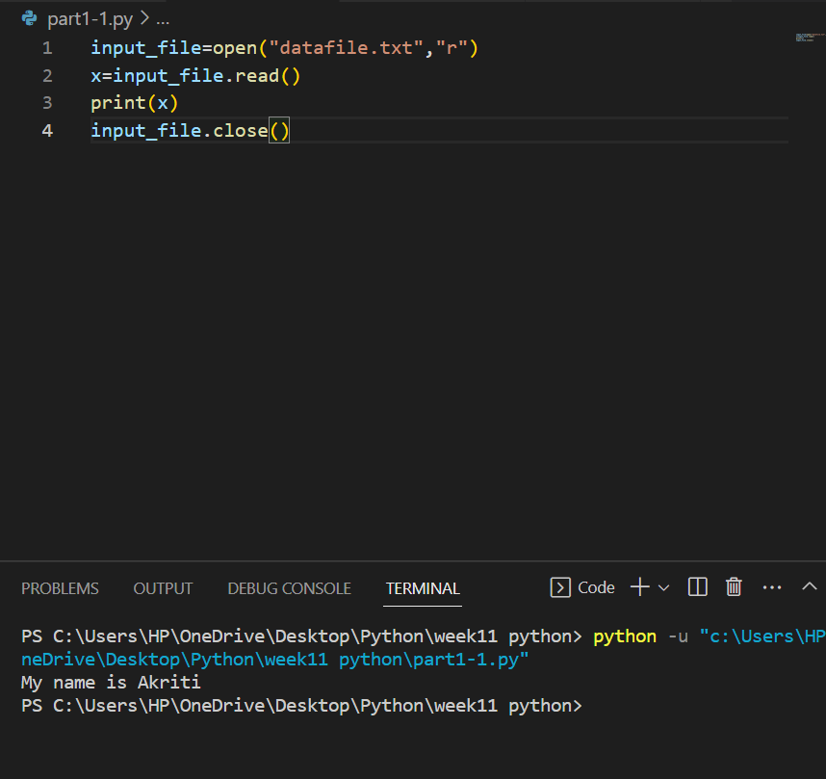

1. Create a program in Python that opens a file named 'datafile2.txt' for writing and assigns identifier output_file to the file object created.

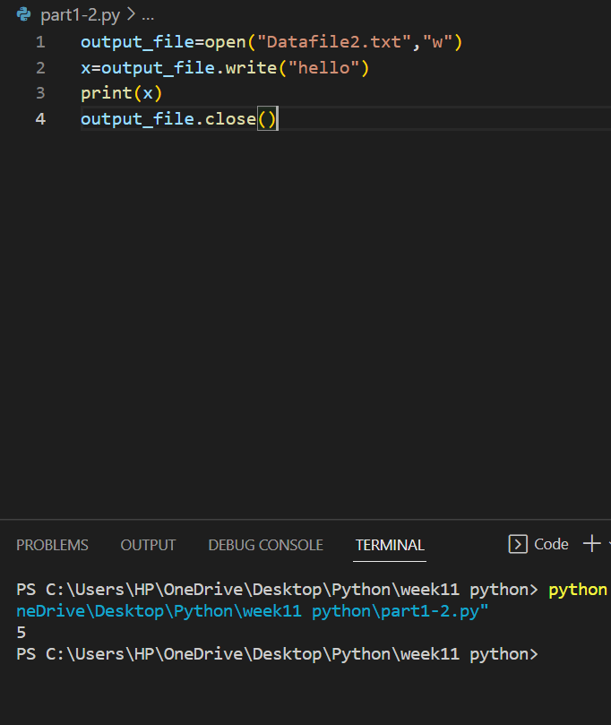

3. Assume that input_file is a file object for a text file open for reading, and output_file is a file object for a text file open for writing. Explain the contents of the output after the following code terminates:

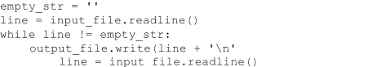

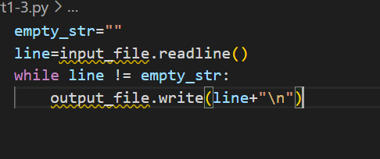

=Here, The loop runs as long as the line is not equal to empty string. Here, readline() reads the file line by line and this gets written to another file with object output_file as long as the condition is met.

4. Identify the error in the following code:

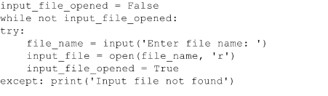

=The given code does not close the opened file so here is the code without errors.

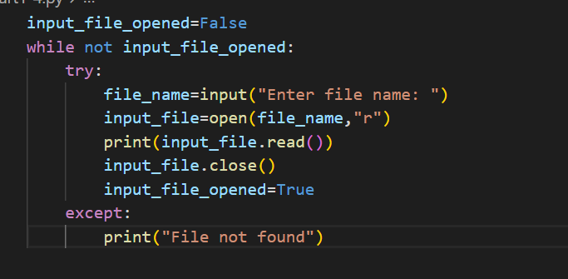

**Part 2**

1. Write a Python function called reduce_spaces that is given a line read from a text file and returns the line with all extra space characters removed:

‘This line has extra space characters’ → ’This line has extra space characters’

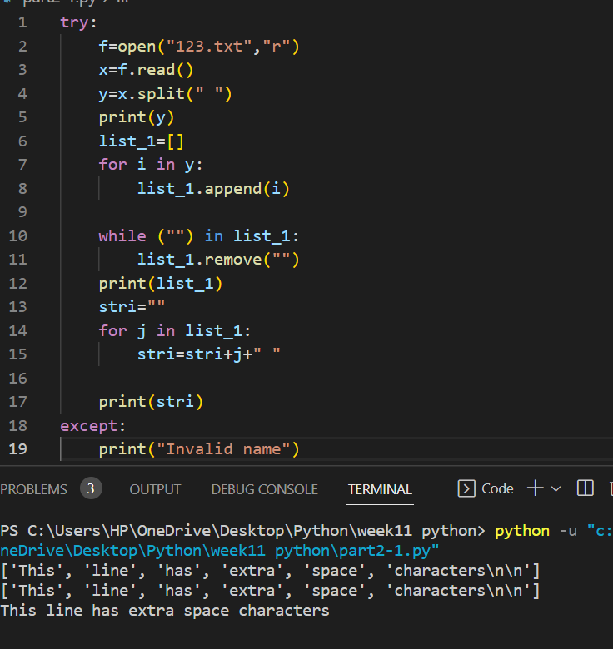

2. Write a Python function named extract_temp that is given a line read from a text file and displays the one number (integer) found in the string:

’The high today will be 75 degrees’ → 75.

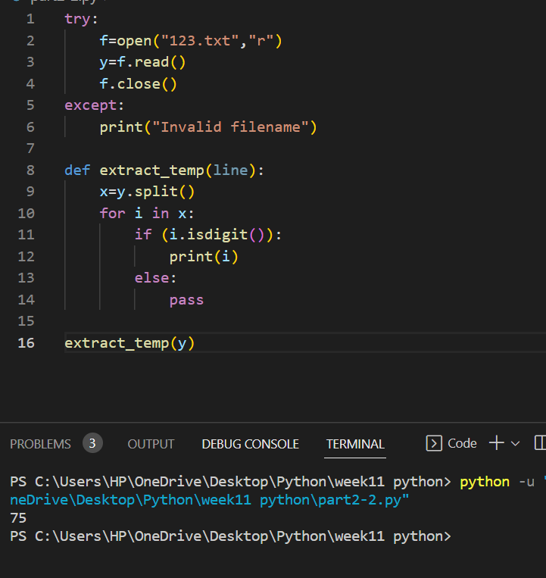

3. Write a Python function named check_quotes that is given a line read from a text file and returns True if each quote characters in the line has a matching quote (of the same type), otherwise returns False.

‘Today’s high temperature will be 75 degrees’ → False

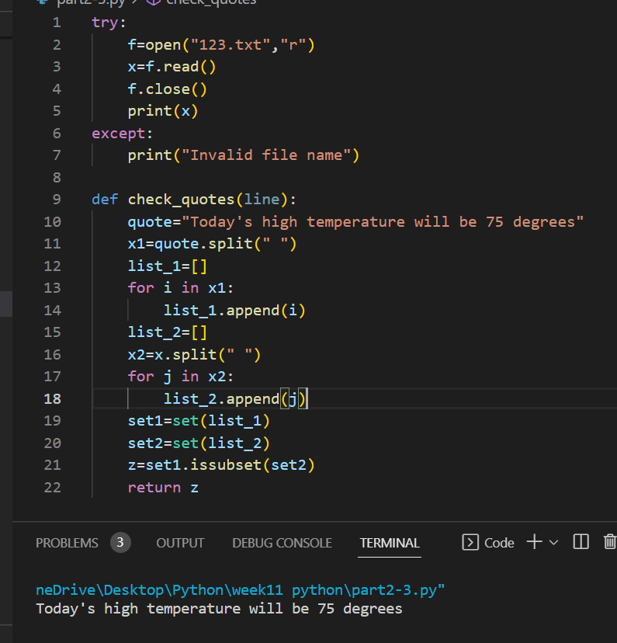

4. Write a Python function named count_letters that is given a line read from a text file and returns a list containing every letter in the line and the number of times that each letter appears (with upper/lower case letters counted together)

‘This is a line’ → [ (‘t’, 1), (‘h’, 1), (‘i’, 3), (‘s’, 2), (‘a’, 1), (‘l’, 1), (‘n’, 1), (‘e’, 1) ]

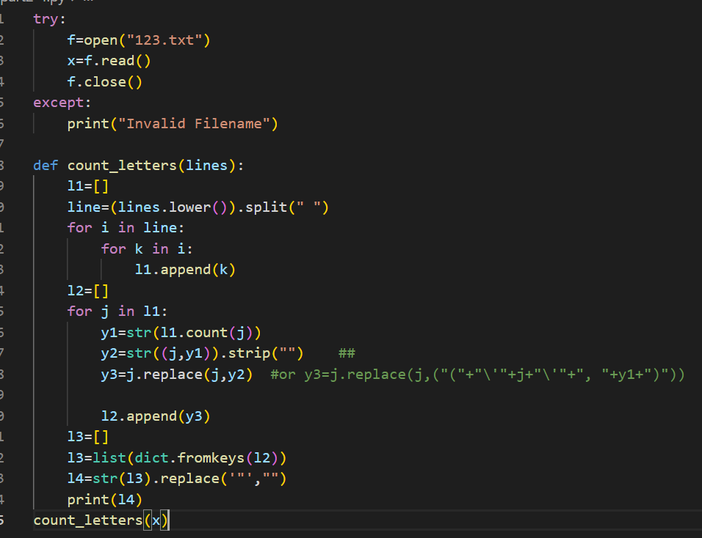

5. Write a Python function named interleave_chars that is given two lines read from a text, and returns a single string containing the characters of each string interleaved: ‘Hello’, ‘Goodbye’ → ‘HGeololdobye’

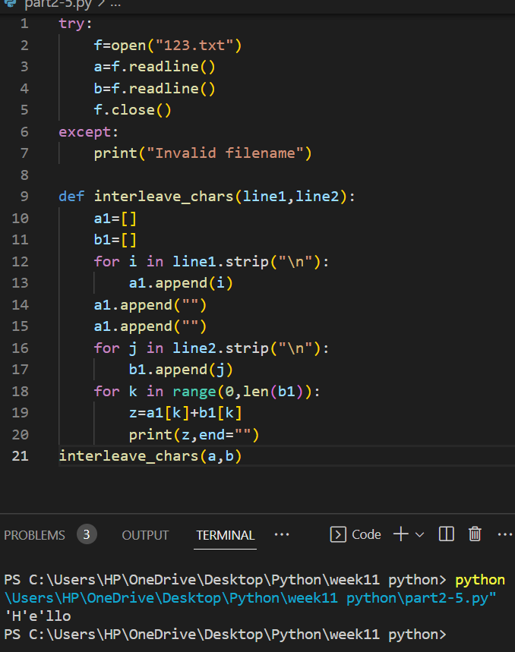

6. Give a for loop that counts all the characters in a string assigned to variable line, except blanks and the newline character.

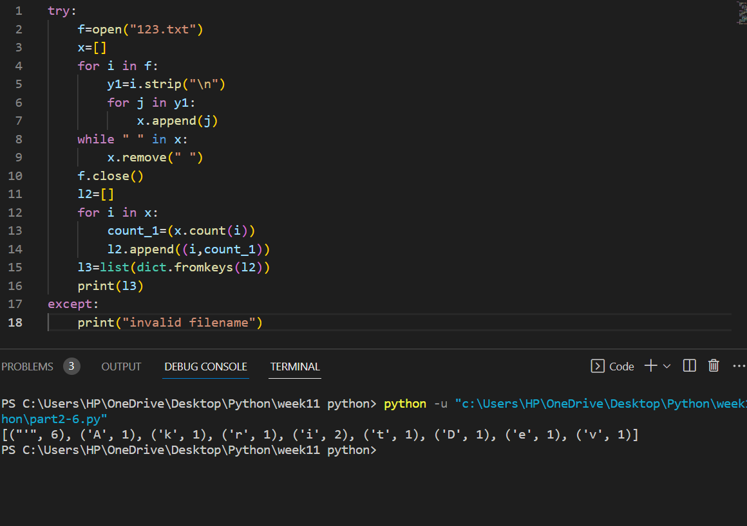

7. For variable month which contains the full name of any given month, give an expression to display just the first three letters of the month.

8. Give an expression that displays True if the letter ‘r’ appears in a given month name stored in variable month, otherwise displays False.

9. Give an expression for determining how many times the letter ‘r’ appears in a given month name stored in variable month.

10. For a person’s first name stored in variable first_name, and last name stored in variable last_name, give an expression that displays the person’s name formatted exactly as follows: Jones, William.

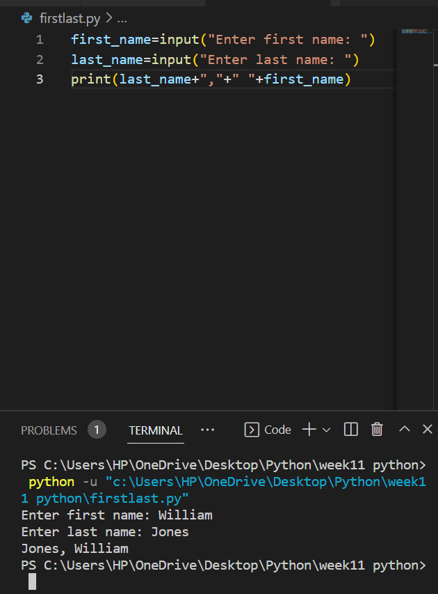

11. Give an instruction that determines if a given social security number represented as a string and stored in variable ss_num, contains any non- digits.

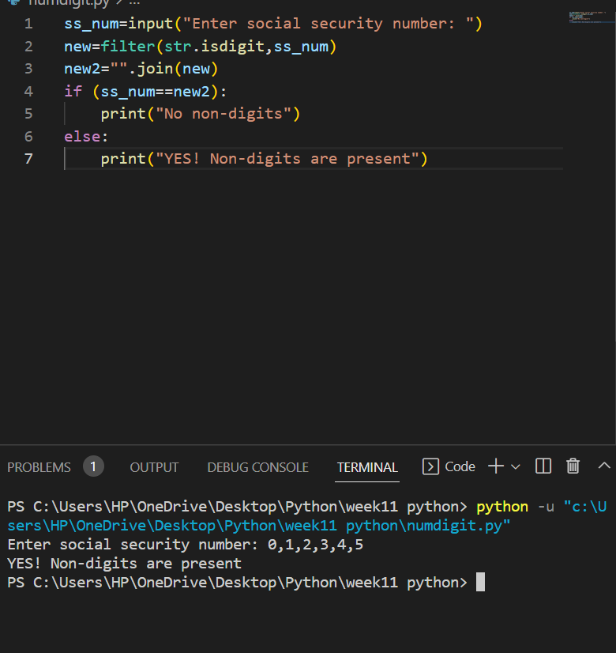

12. Give an instruction that determines the index of the ‘@’ character in an email address stored in variable email_addr.

13. For a variable named date containing a date in the form 12/14/2012, give an expression that replaces all slashes characters with dashes.

14. For a variable named err_mesg that contains error messages in the form ** error message **, give an expression that produces a string containing the error message without the leading and trailing asterisks and blank characters.

**Part 3**

1. Write a program that opens and reads a text file and displays how many lines of text are in the file.

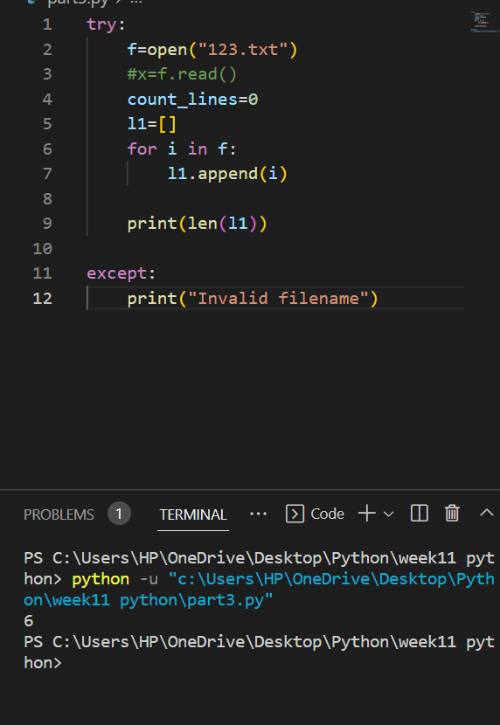

1. Write a program that reads a text file named original_text, and writes every other line, starting with the first line, to a new file named new_text.

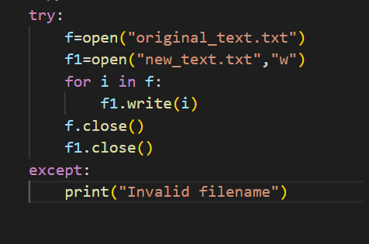

1. Write a program that reads a text file named original_text, and counts how many time the letter 'e' occurs (the most frequently occurring letter in English), and displays how many occurrences there are.

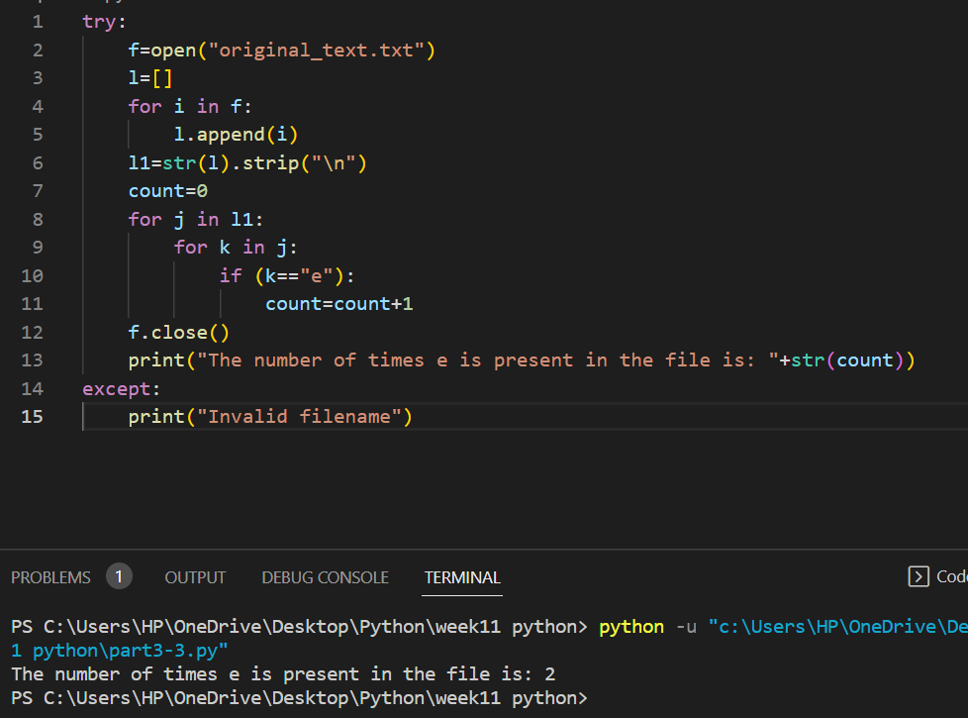

4. Write a program that reads a text file containing numerical expressions on

each line and print them out along with the results. For example, for the numerical expression 4 + 2 in your file, your program should output: 4 + 2 = 6.

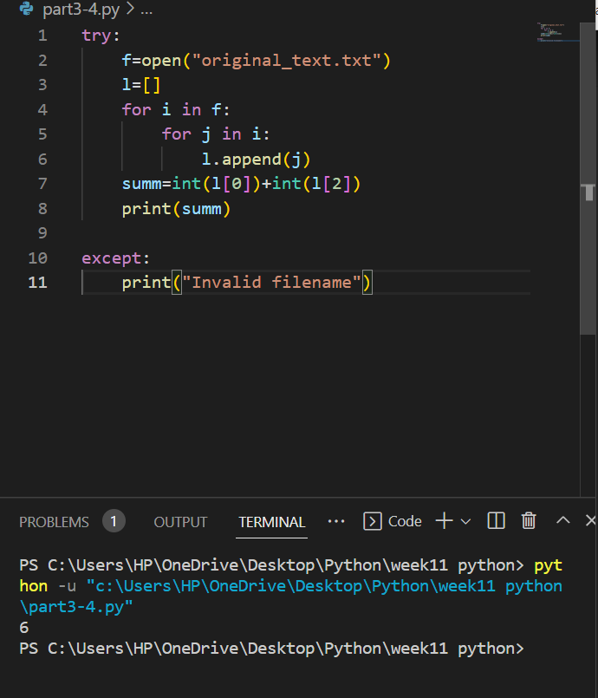

**Part 4 (Optional)**

Write a Python program that encrypts and decrypts text files using a substitution cipher. Your program should ask the user for the name of a text file and whether they would like to encrypt or decrypt. Once the process is complete, you should write the output to a new text file with a modified name:

This program will encrypt and decrypt text files

Enter (e) to encrypt a password, and (d) to decrypt: e

Enter the name of a text file to encrypt: hello.txt Output written to: encrypted_hello.txt

Your program should catch exceptions and print helpful error messages. You should use your solution to Coding Challenge 03 to help you.