DEVOPS_TUTEDUDE
ASSIGNMENT 7: Kubernetes
– By Akriti Dey
1. Deploy your your previous assignment flask frontend and express backend in kubernetes cluster locally with minikube.
a. getting started with Minikube
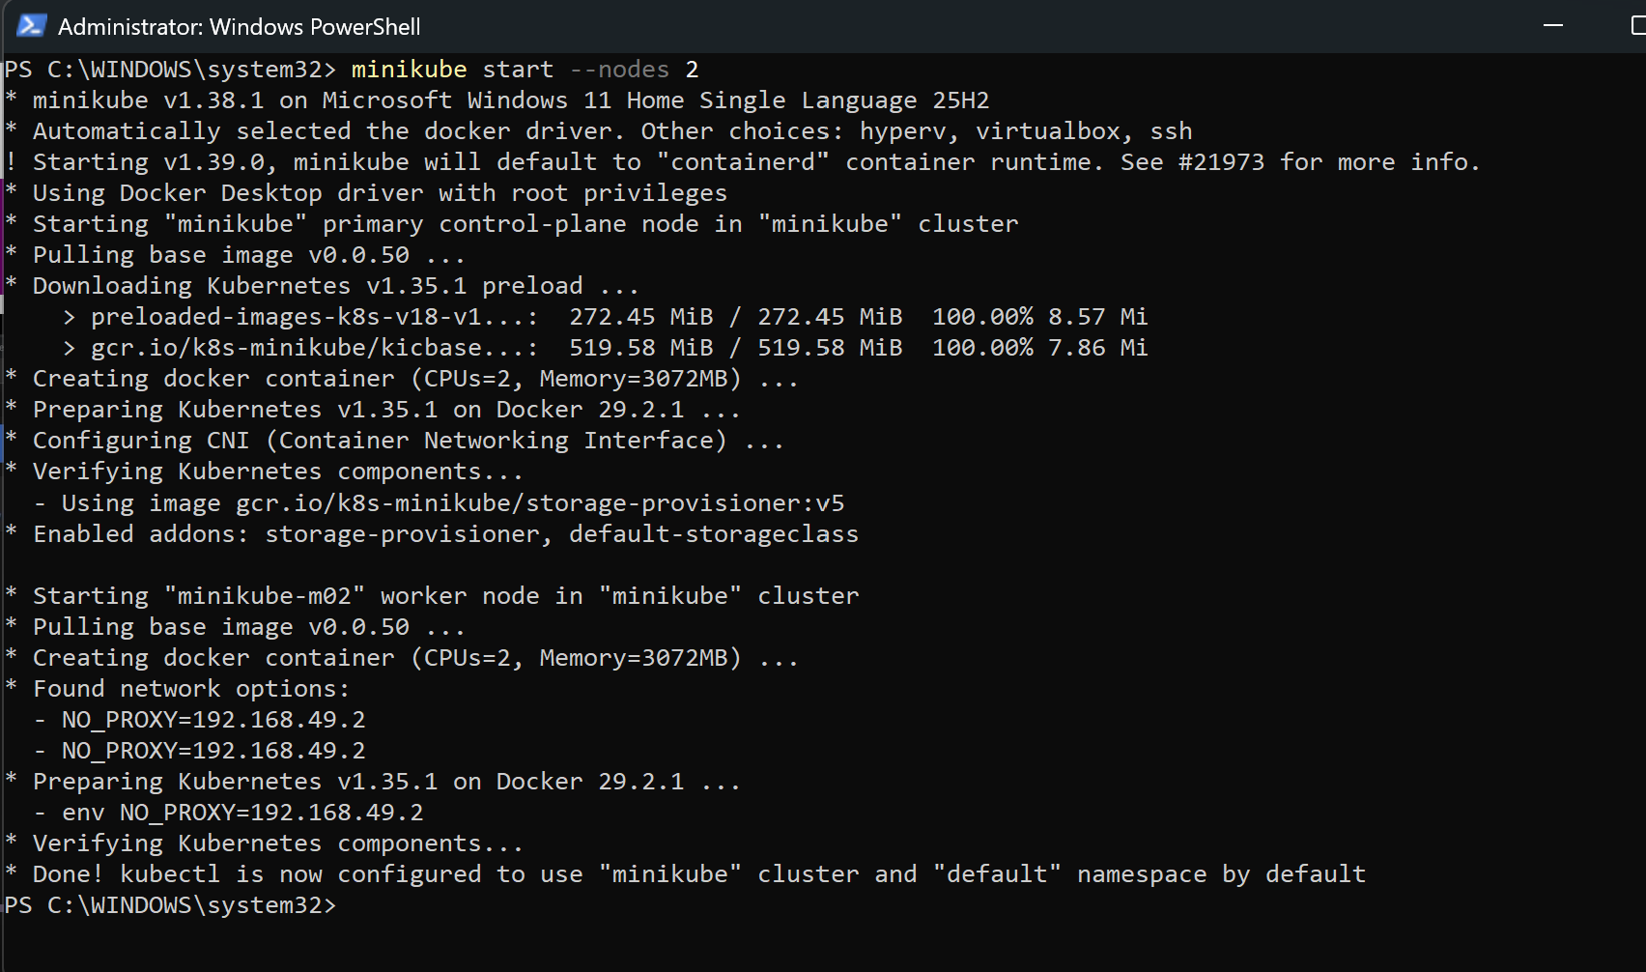
b. Master node and worker node running
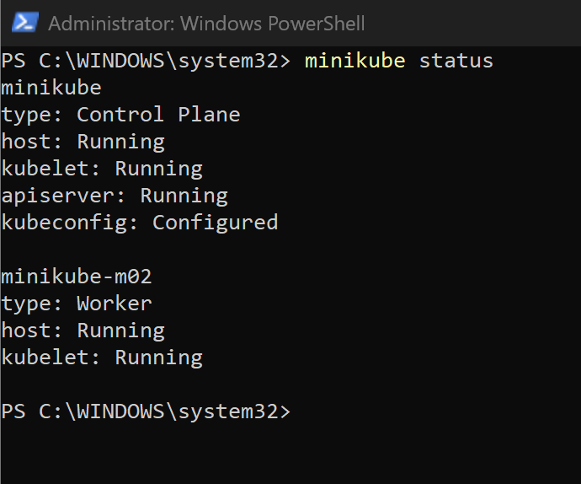
c. Deployment.yaml created
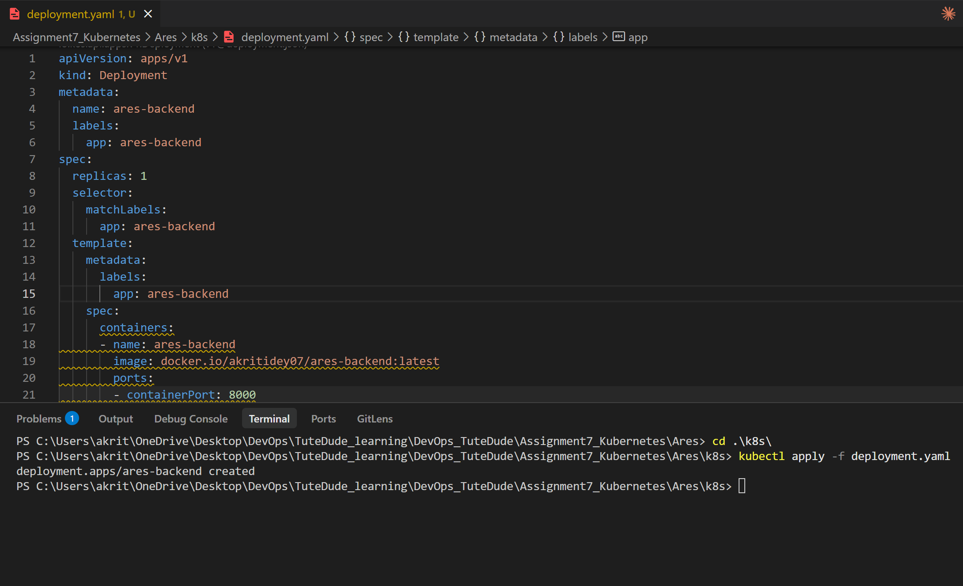
d. the dashboard shows my flask application:
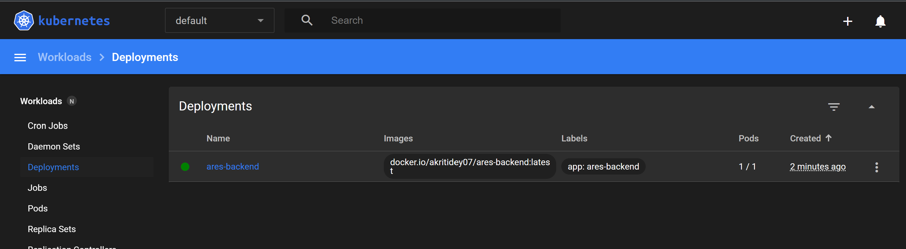
e. service.yaml created
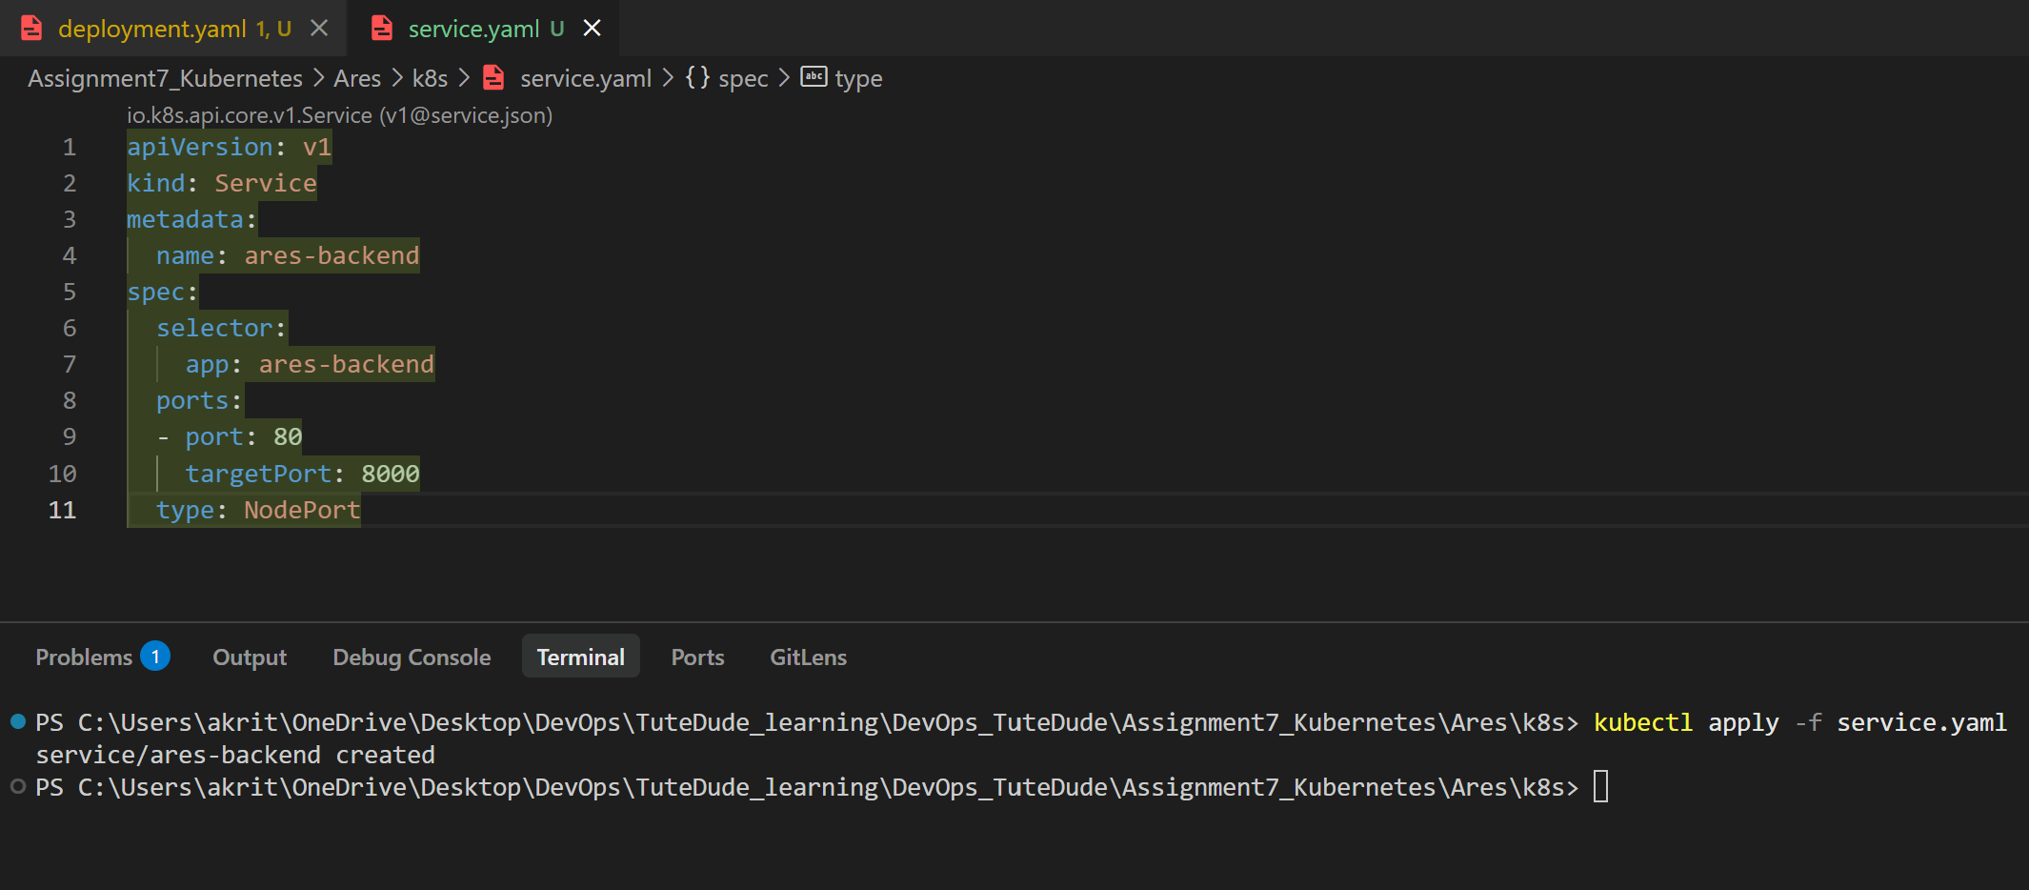
My code:
