DEVOPS_TUTEDUDE
ASSIGNMENT 5: DOCKER
– By Akriti Dey
- Create a frontend using Express and Node.js.
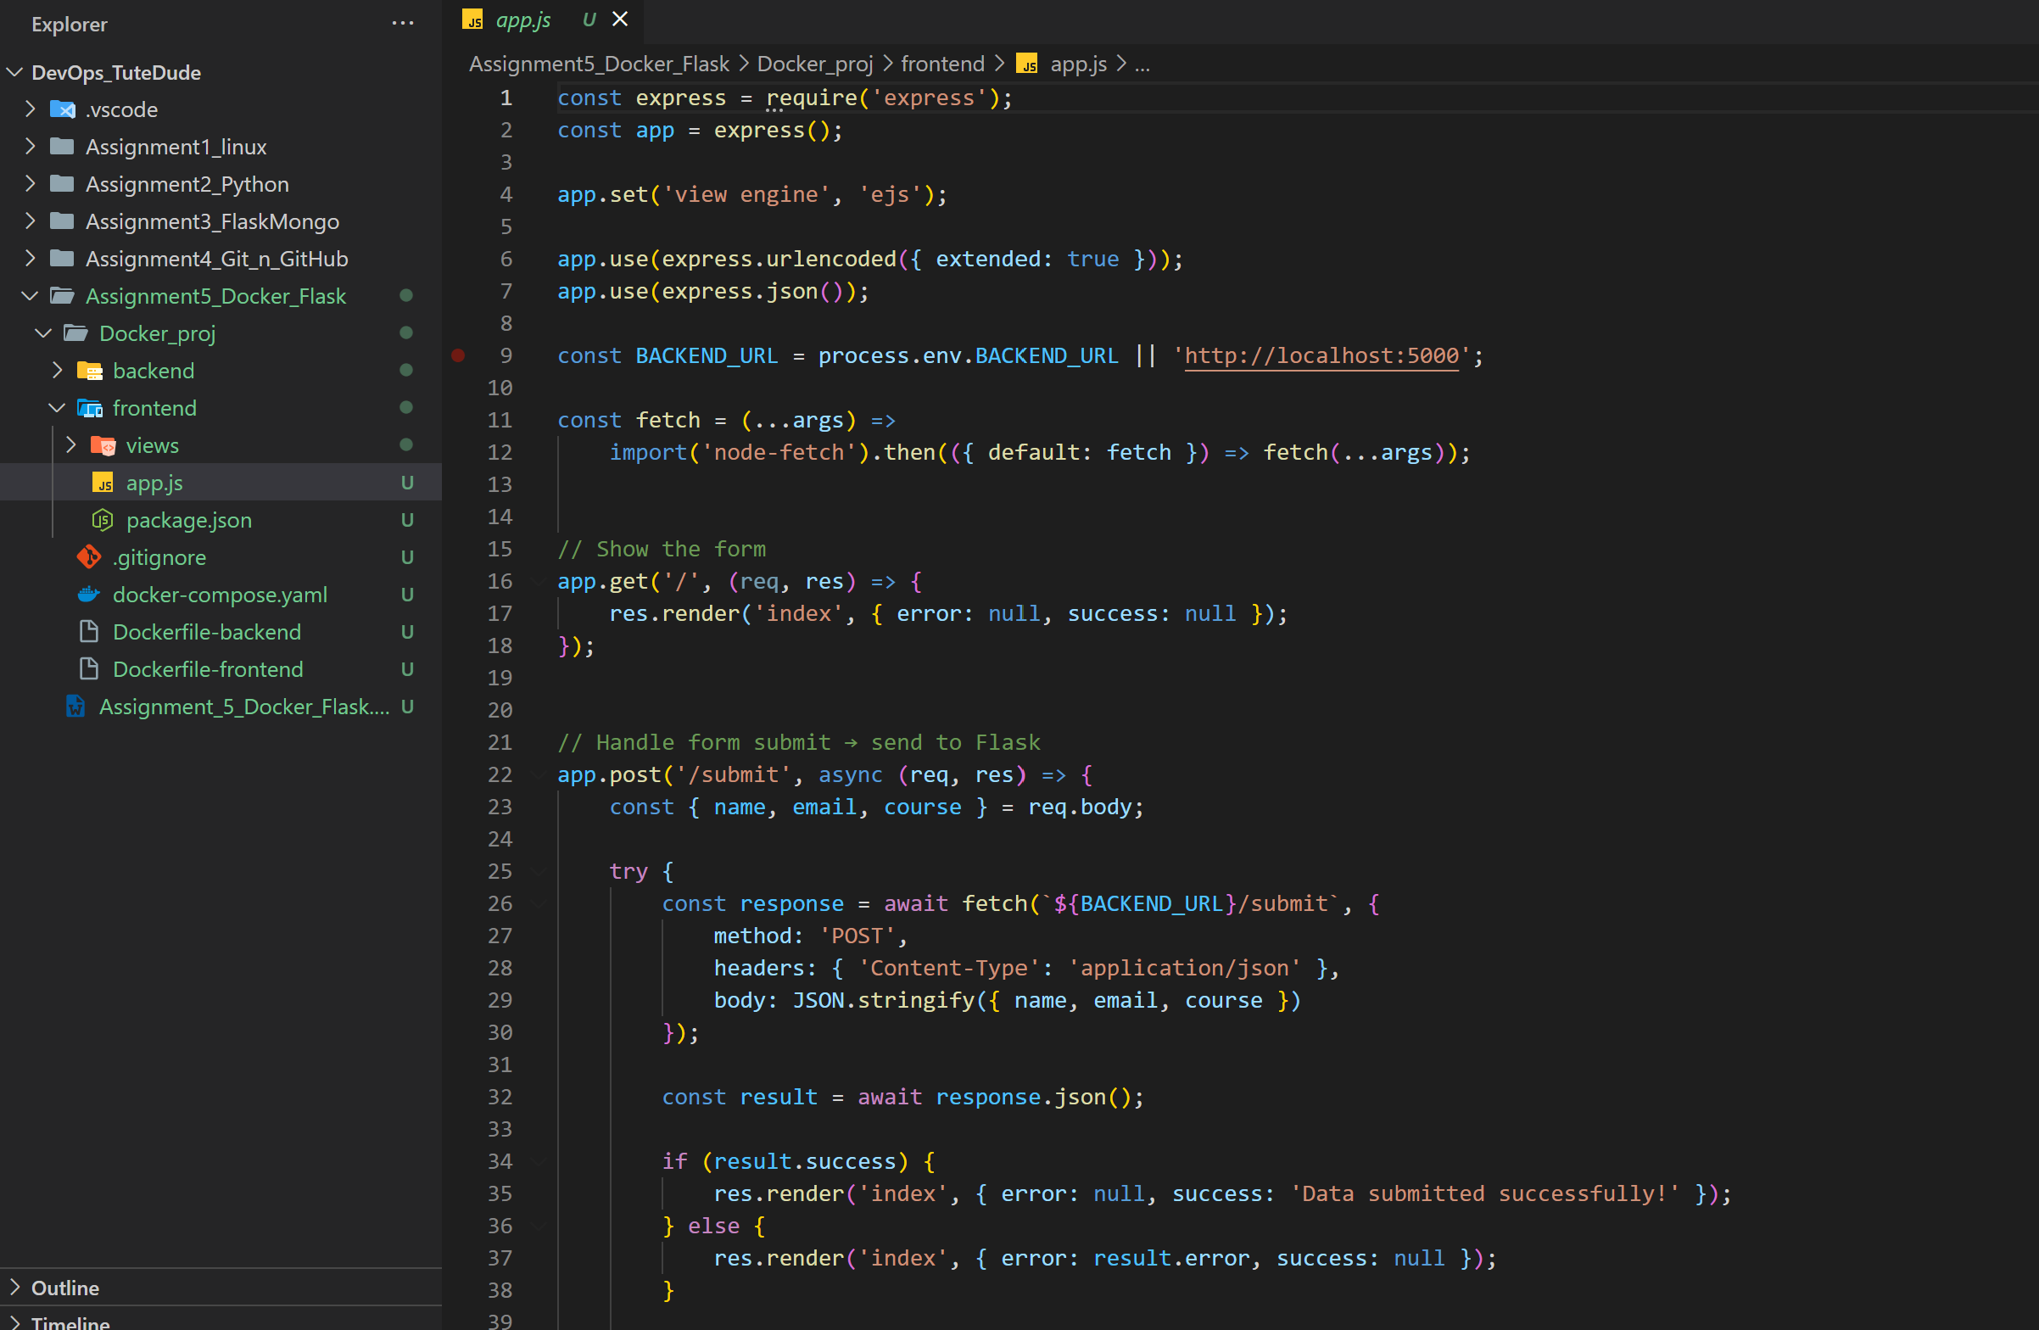
- Include a form similar to the one from the Flask Assignment 2.
- Configure the form to send a request to the Flask backend.
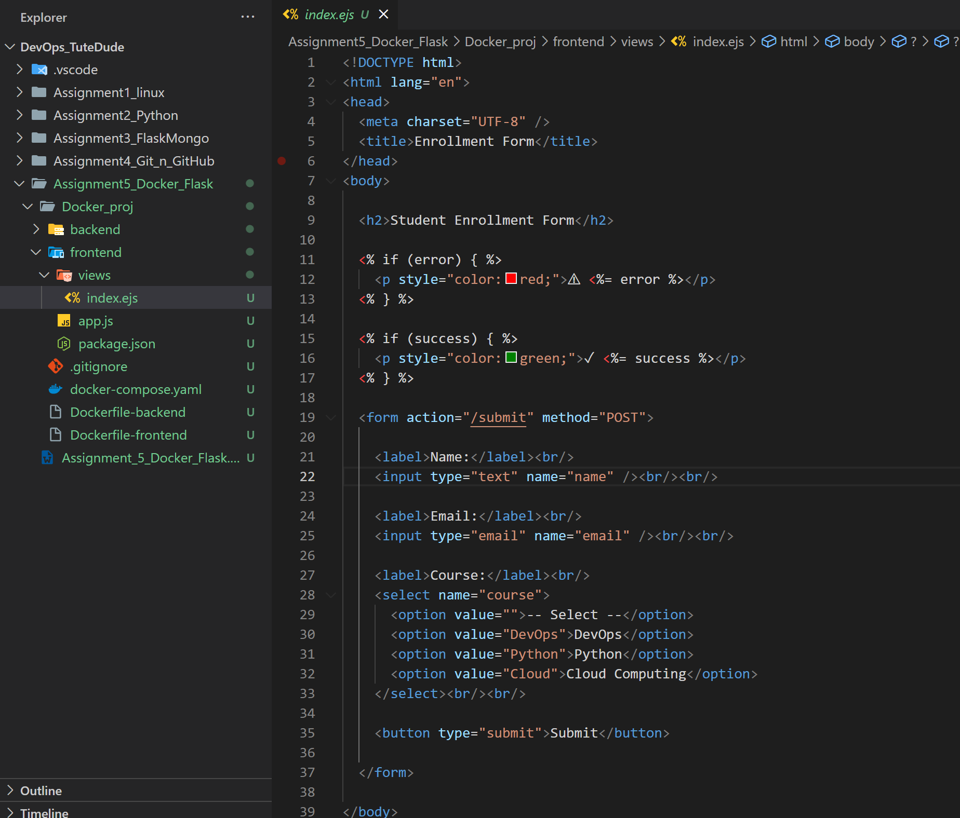
- Backend (Flask):
- Use the Flask backend to handle the form submission and process the data.
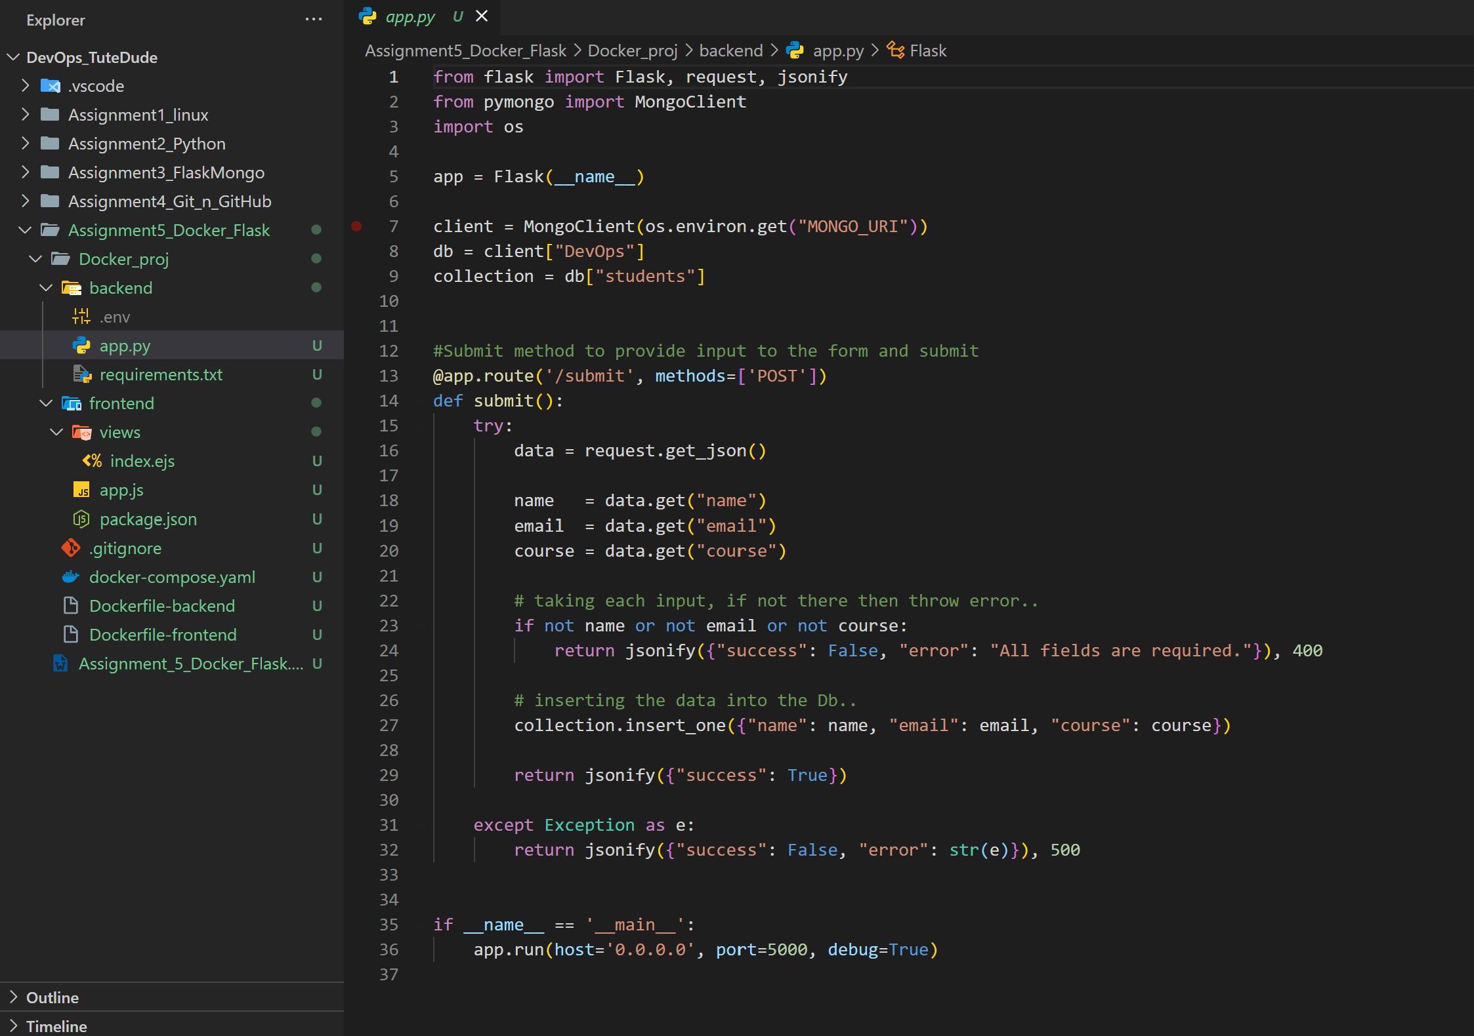
- Folder Structure:
- Organize the project with separate folders for the frontend and backend.
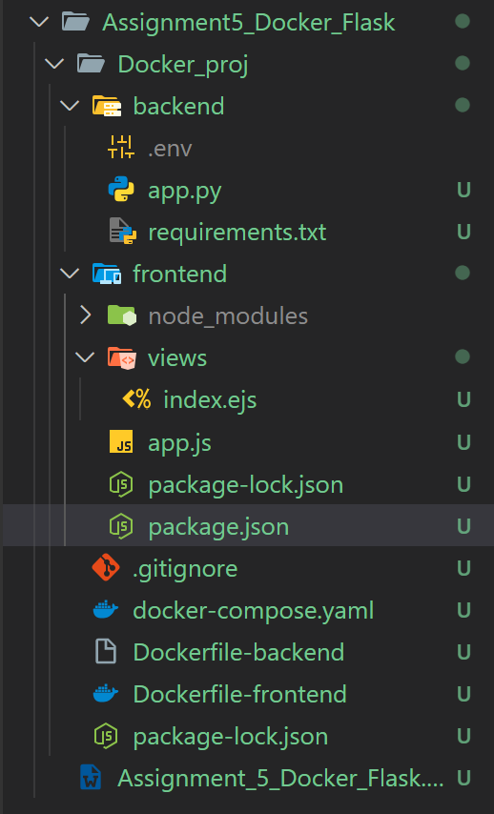

- Docker Configuration:
- Create a Dockerfile for both the frontend and backend.
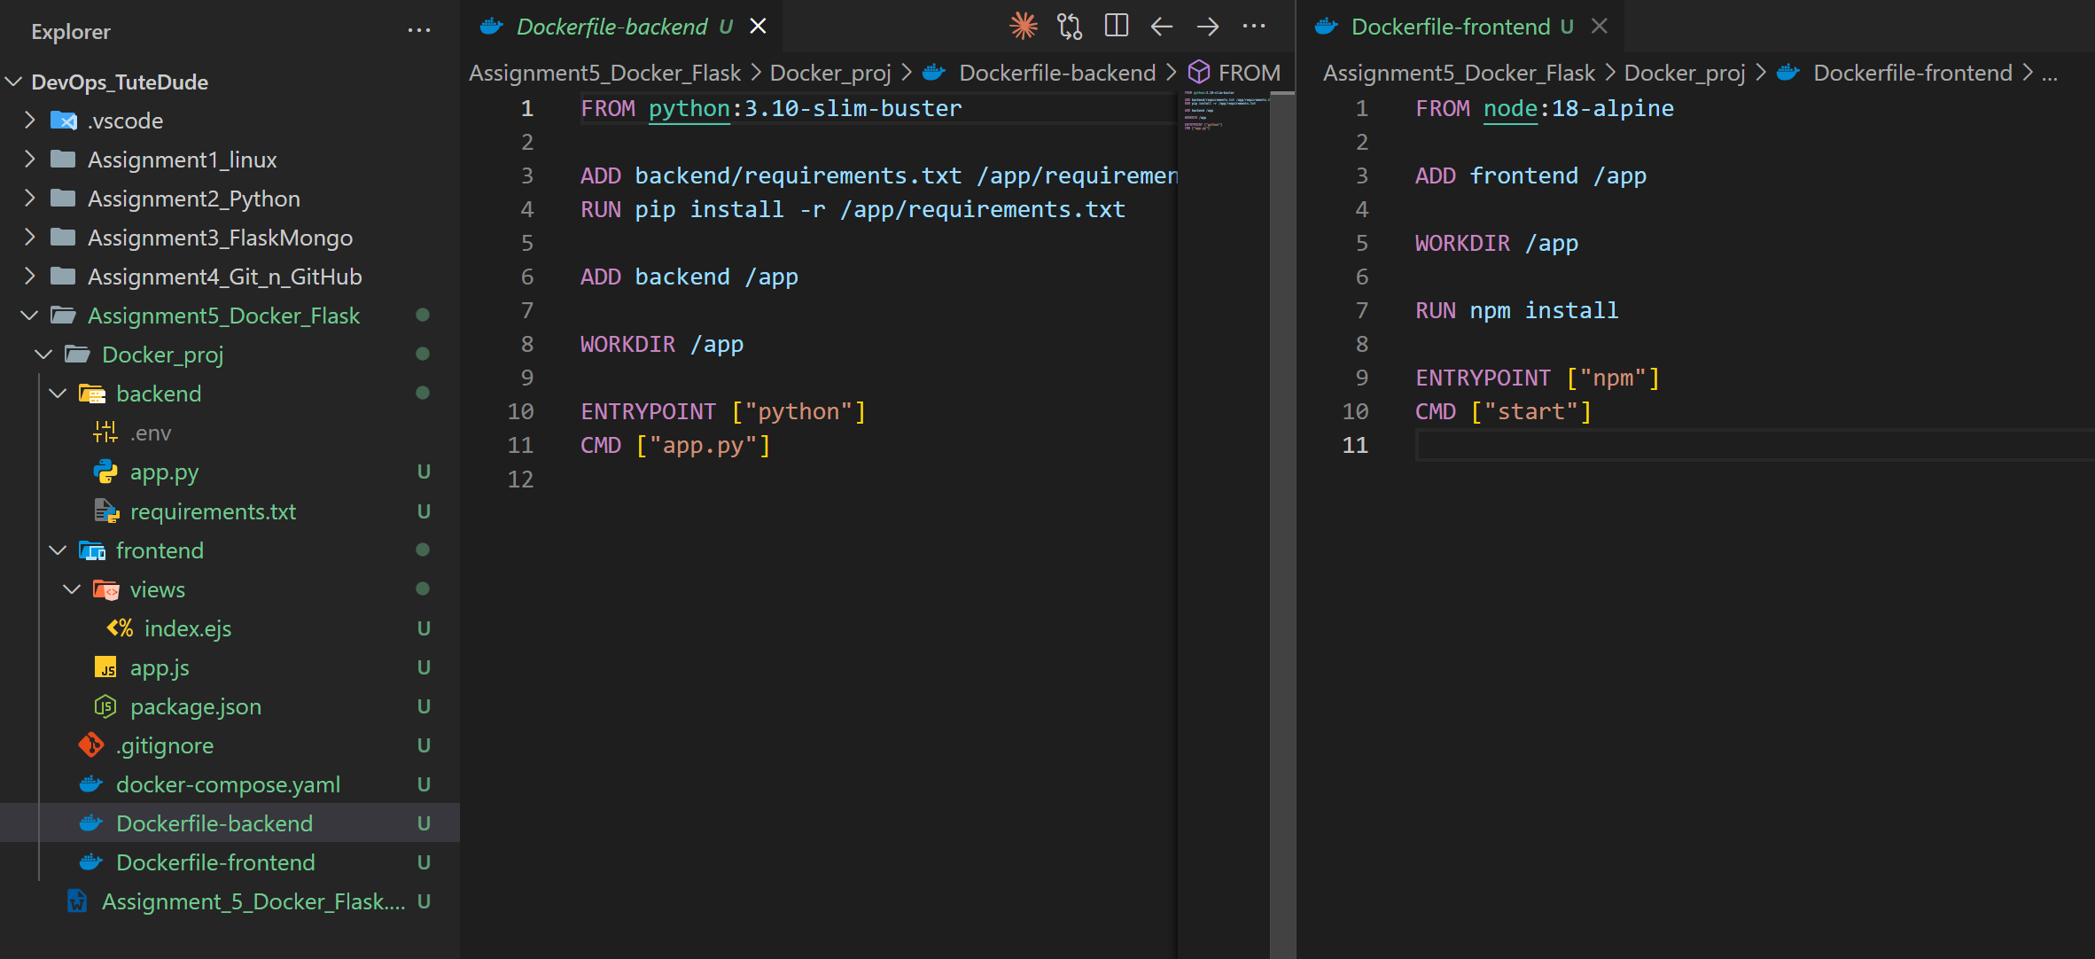

- Write a .yaml file (Docker Compose) to connect both services in the same network.
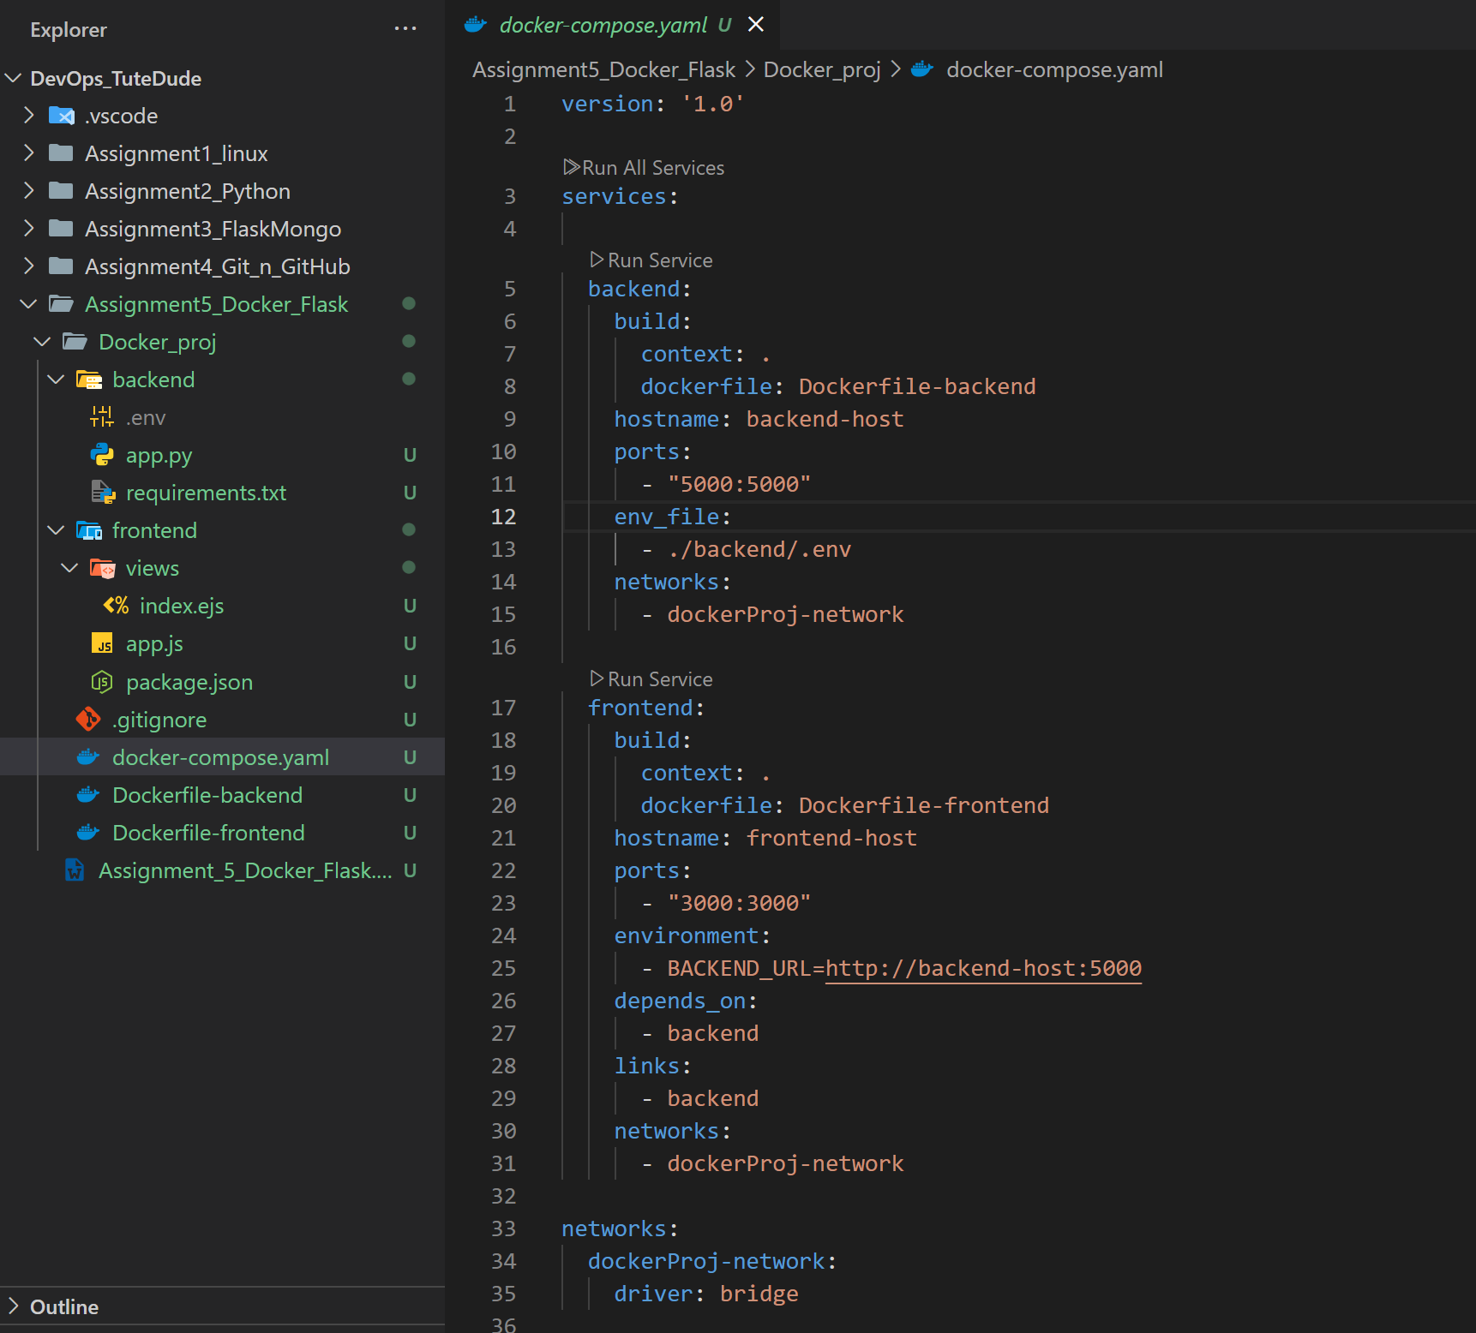

- Upload both images to docker hub and push your whole code to github and add the node_modules and other non required files(.vscode) in .gitignore

Created Docker-compose.yaml file and ran the command $docker compose up
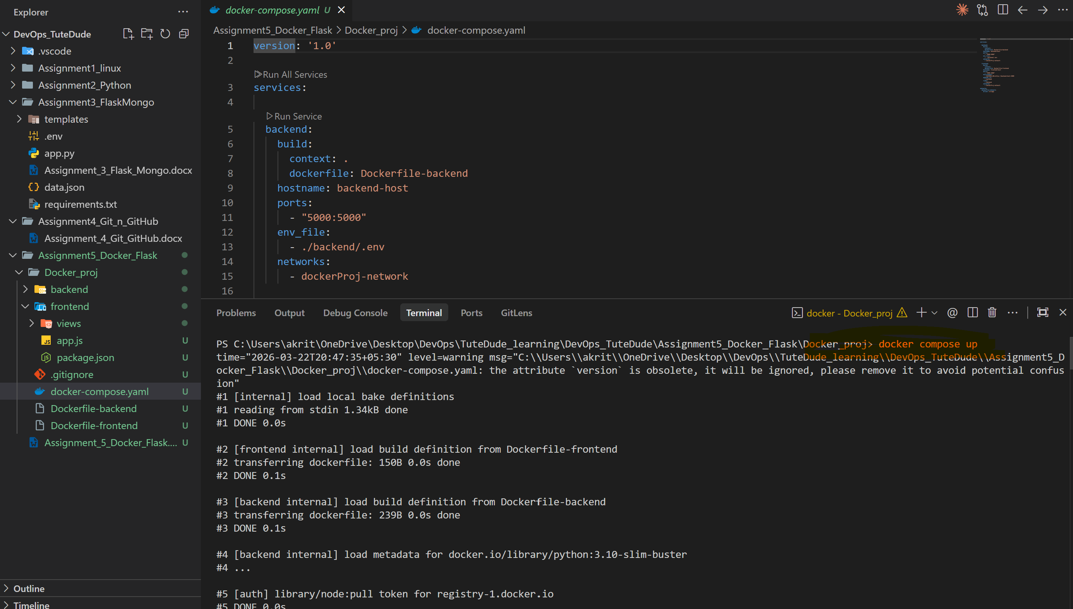

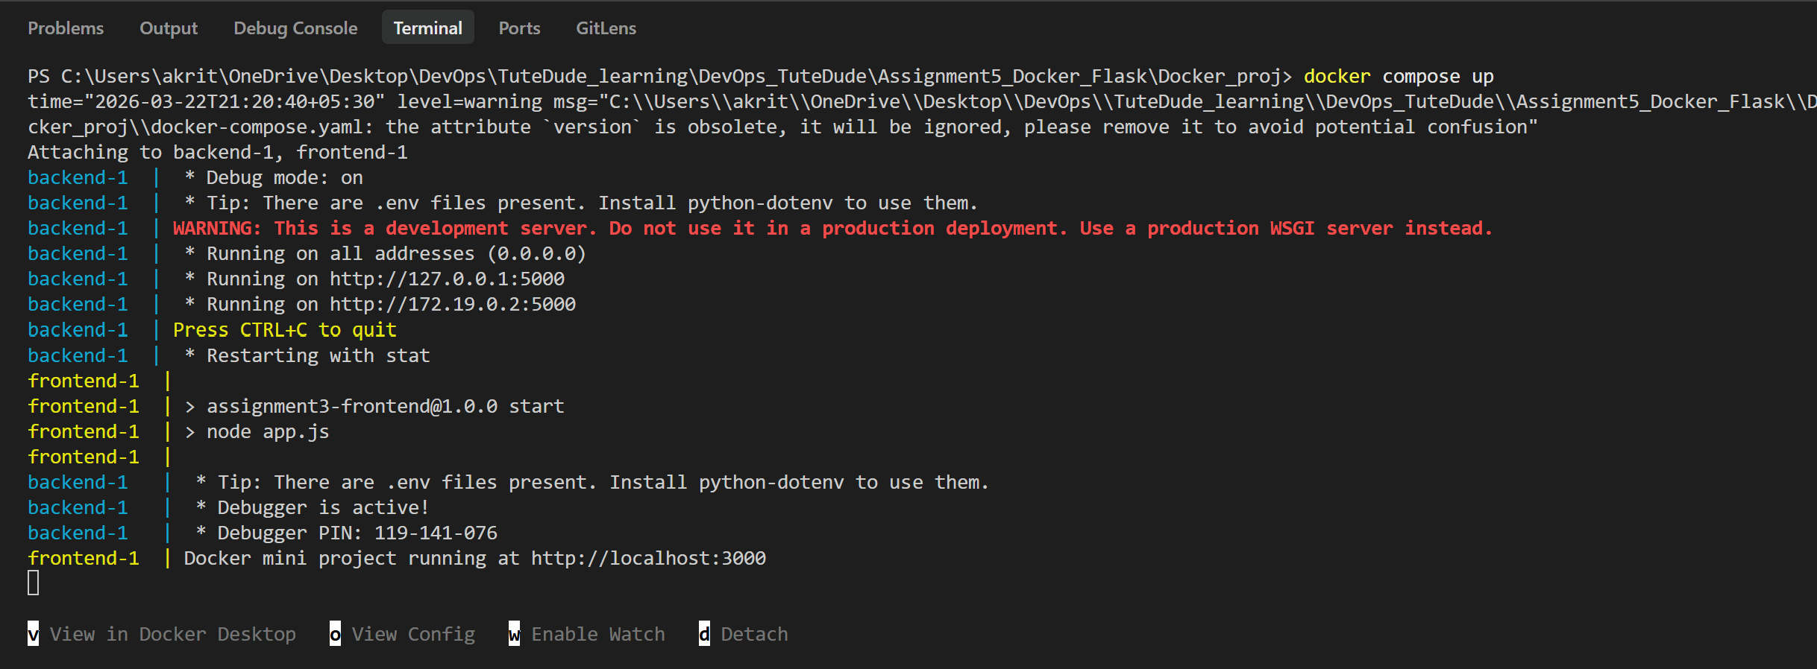

Ran command $docker images
docker_proj-backend:latest & docker_proj-frontend:latest are running
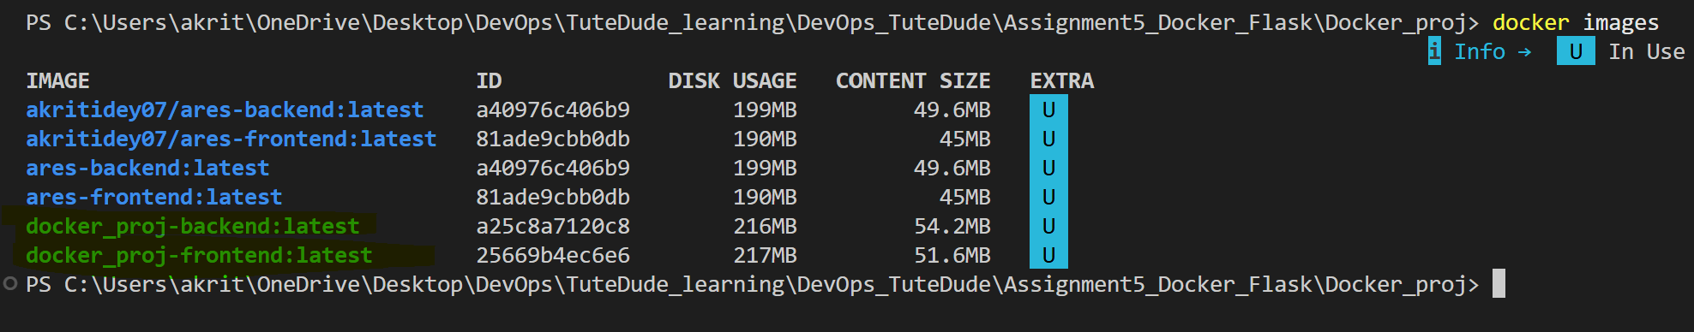

Ran the ‘$docker tag’ and ‘$docker push’ command for the backend and the frontend to register my images in hub.docker .com
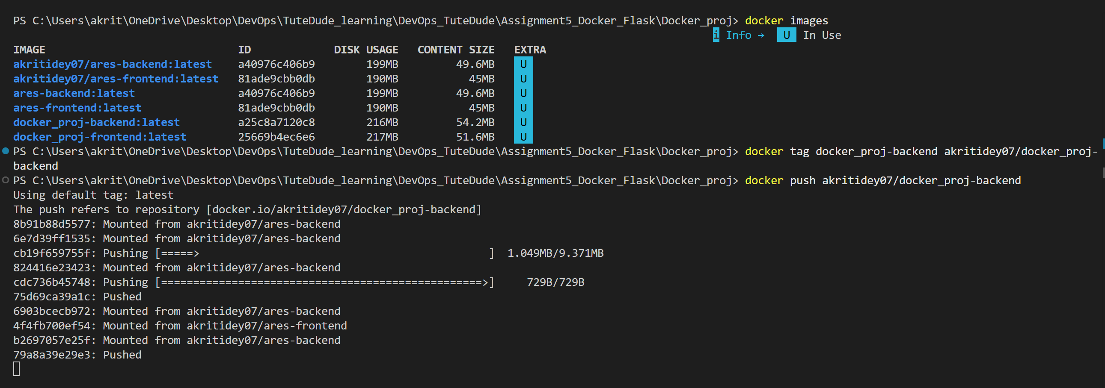
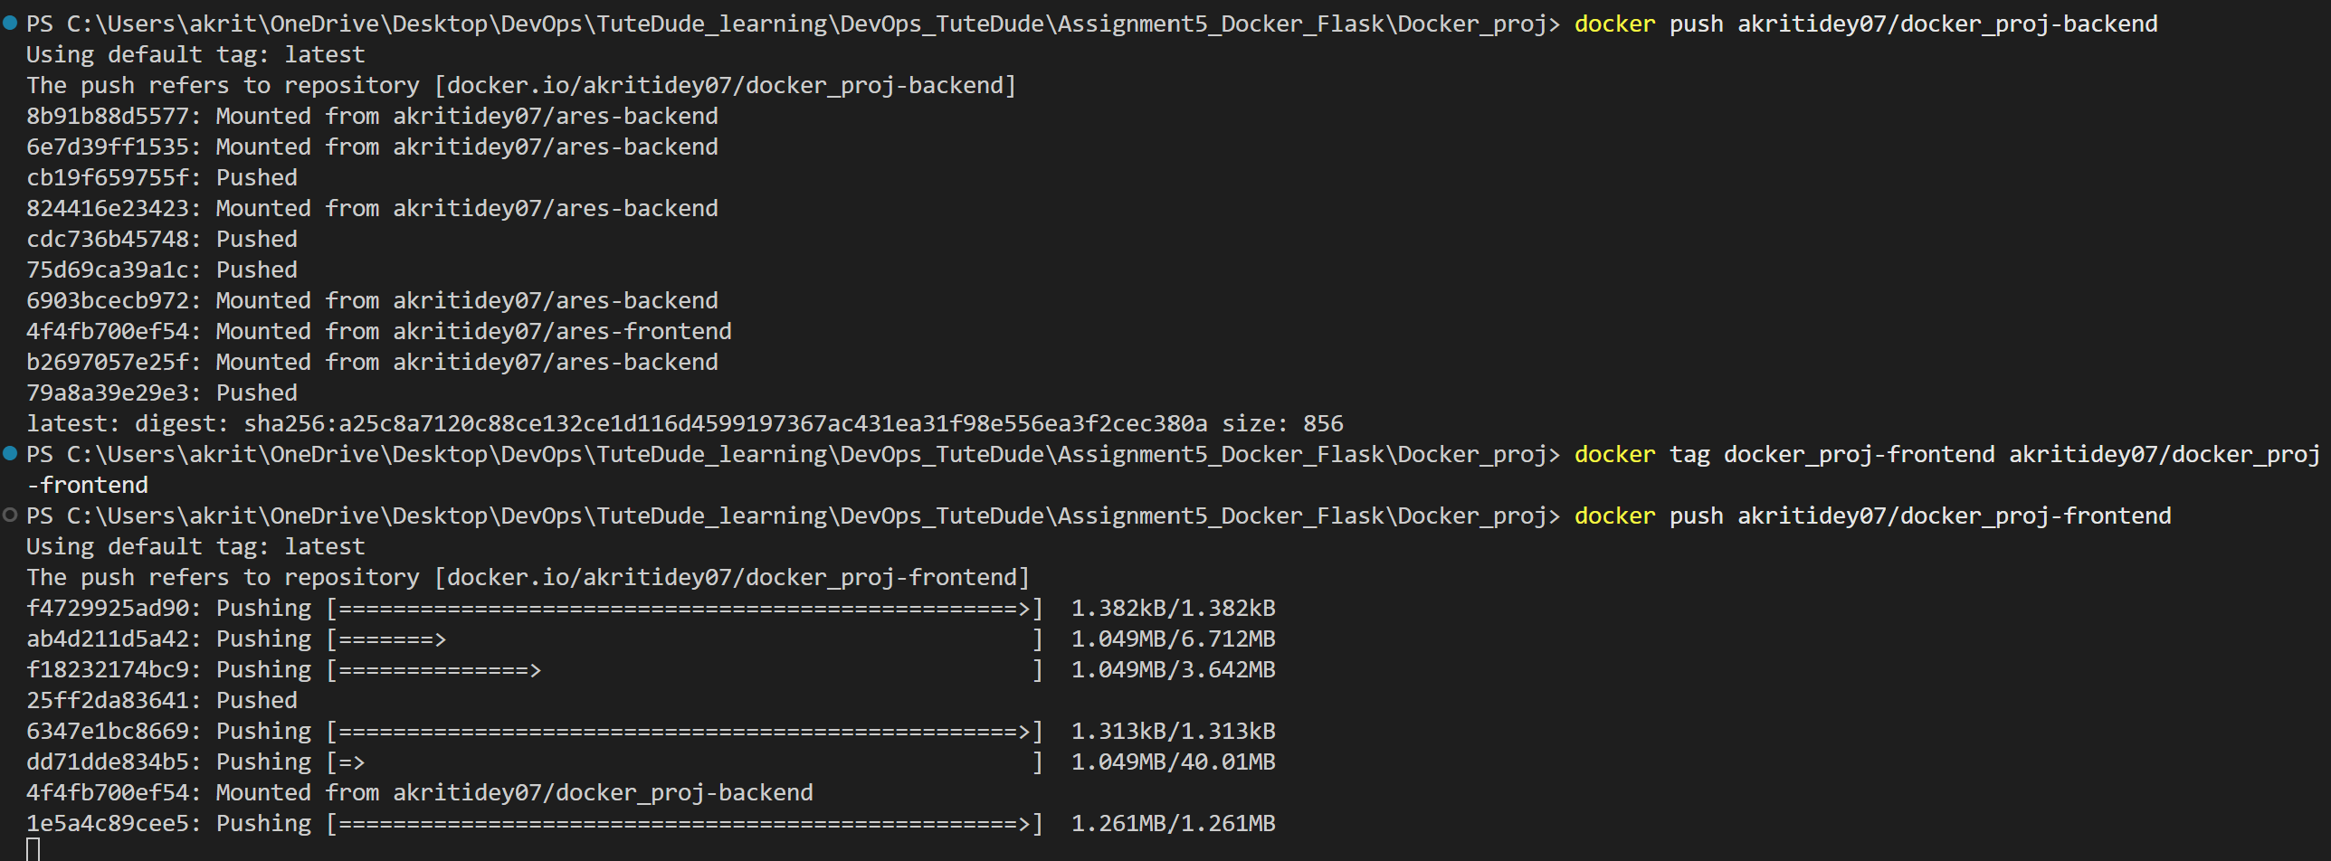

Repo created over hub.docker.com and highlighted below:
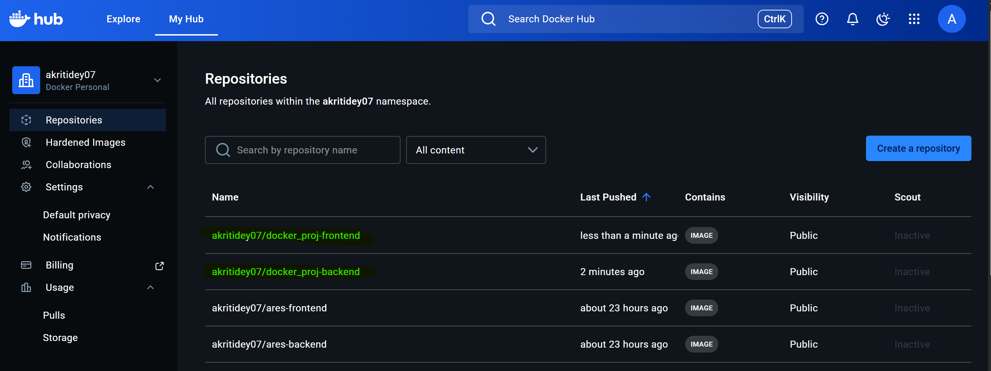

Uploading the code to github:
