DEVOPS_TUTEDUDE
ASSIGNMENT 4: Git and GitHub
– By Akriti Dey

1. Create a new GitHub repository, clone it via SSH, create a branch, add Flask files, commit and merge into main.

Step 1: Created a new GitHub repository on GitHub.com
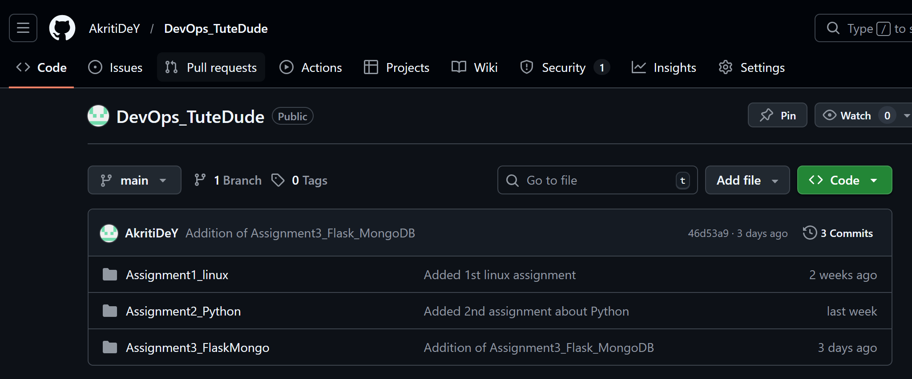

Step 2: Generated an SSH key and Added the public SSH key to your GitHub account
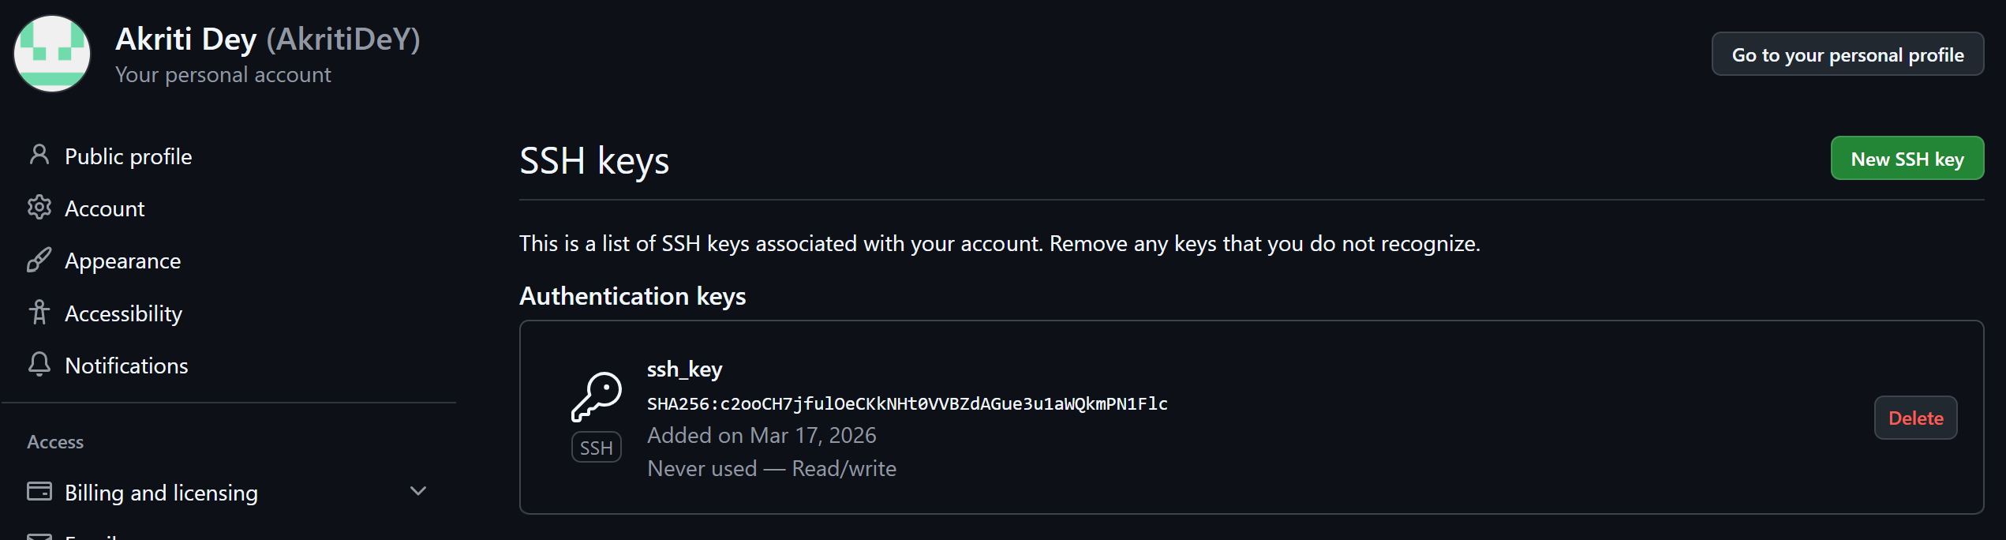
Step 3: Cloned the repository using SSH
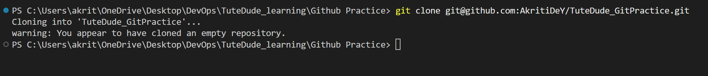
Step 4: Created a new branch named after my username
Step 5: Added my Flask project files to this branch
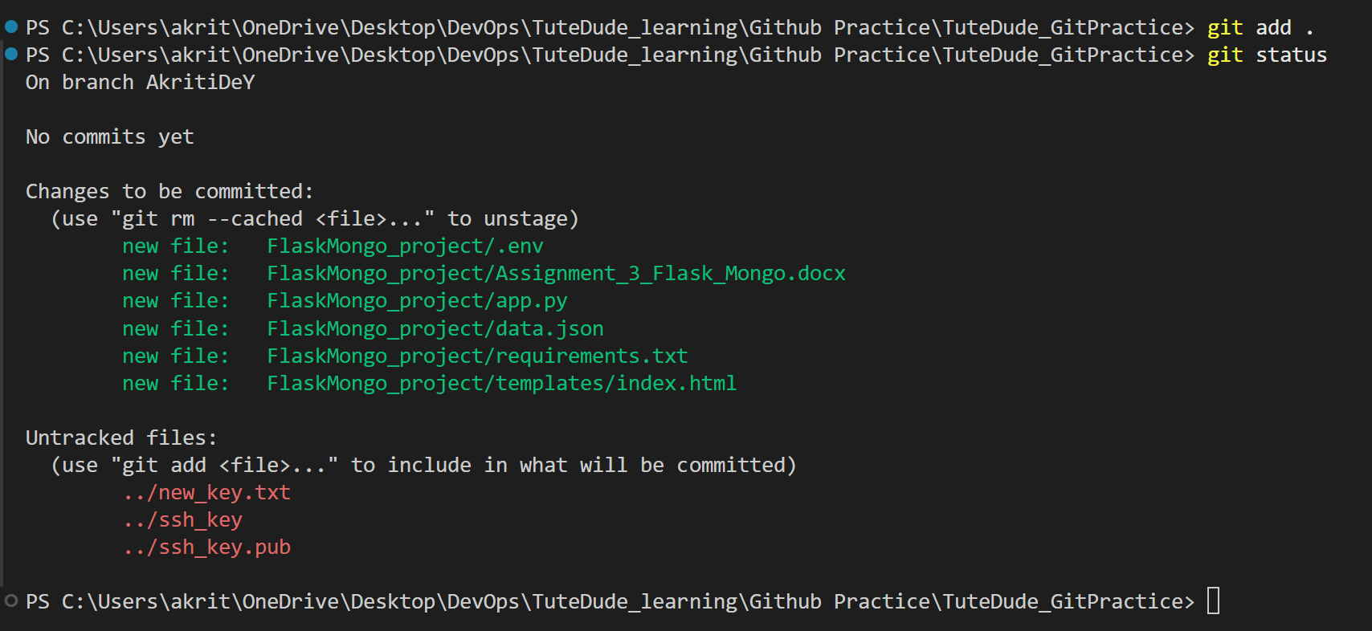
Step 7: Committed the changes
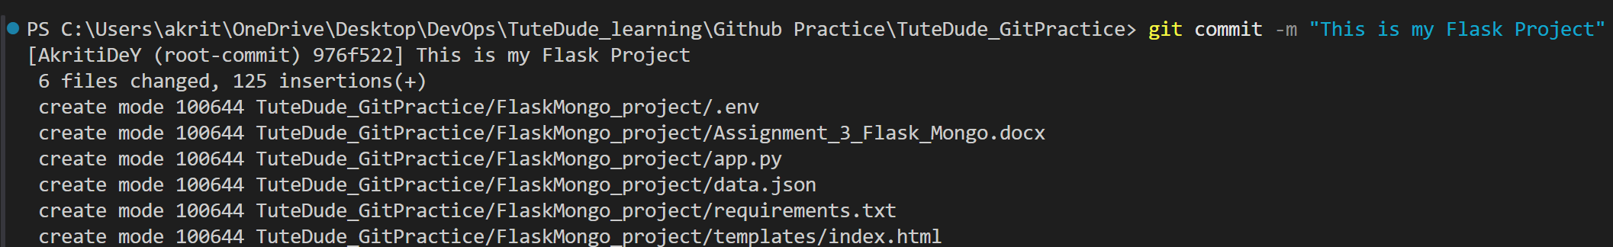

2. Create branch AkritiDeY_new, update data.json, merge into main and resolve any conflicts.

Step 1: Created a new branch named AkritiDeY_new
$ git checkout -b AkritiDeY_new
Step 2: Updated the content of data.json and commit the changes Merge AkritiDeY_new into main

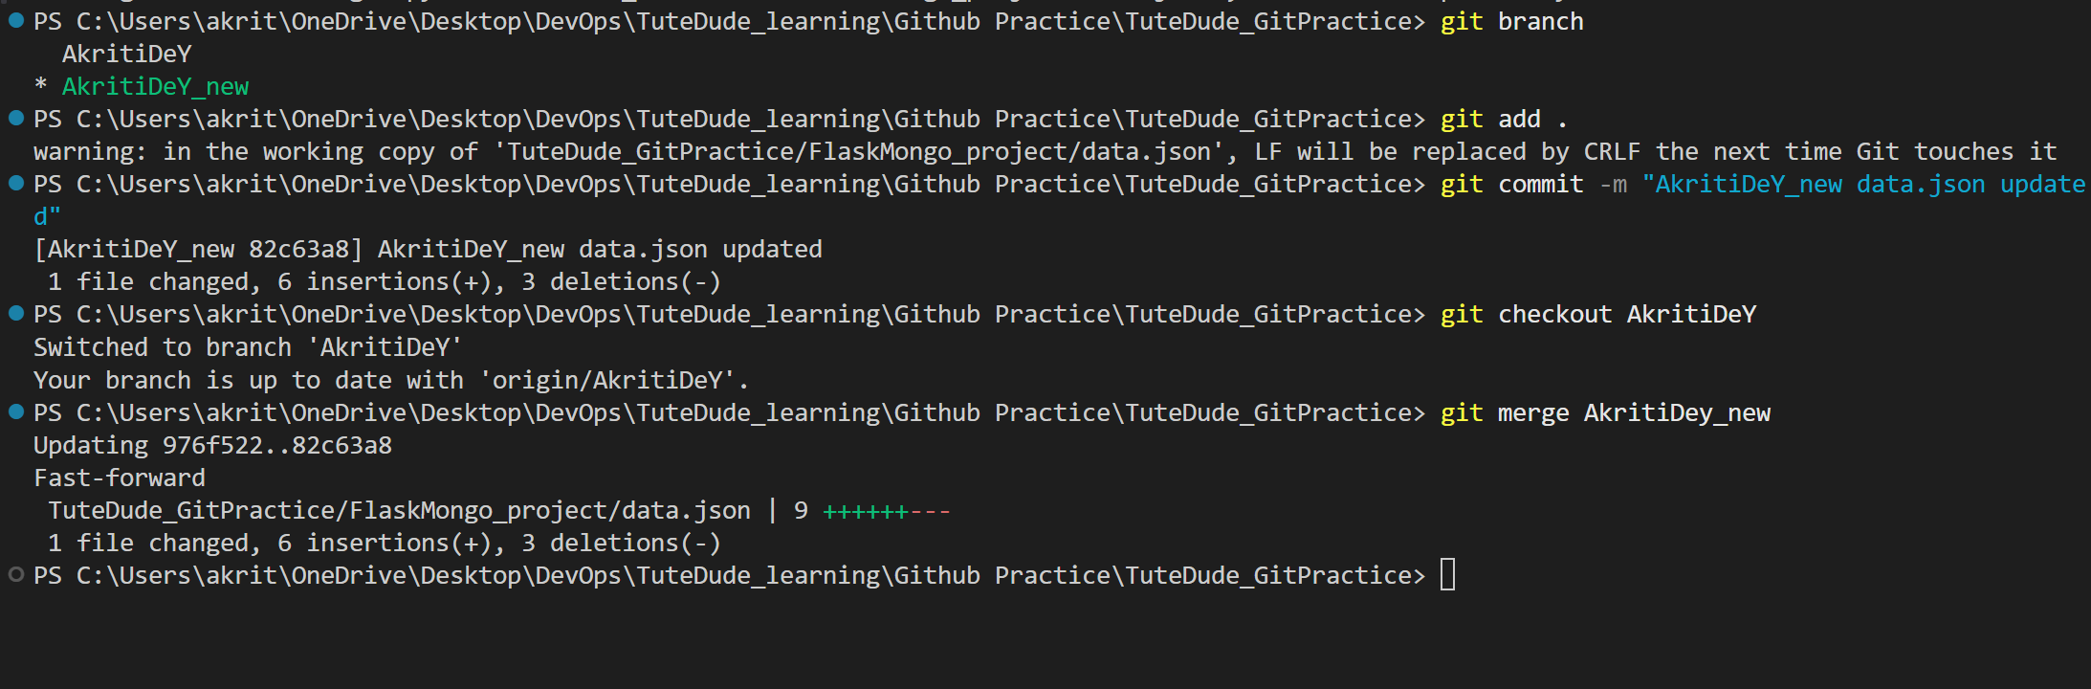
Step 5: If conflicts exist — resolve them by accepting changes from AkritiDeY_new
$ git push origin main(my main is AkritiDeY)
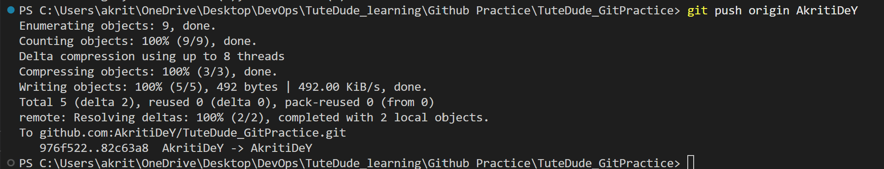
3. Create branches master_1 and master_2. Add To-Do frontend in master_1 and /submittodoitem backend route in master_2. Merge both into main.

Step 1: Created master_1 and master_2 branches from main
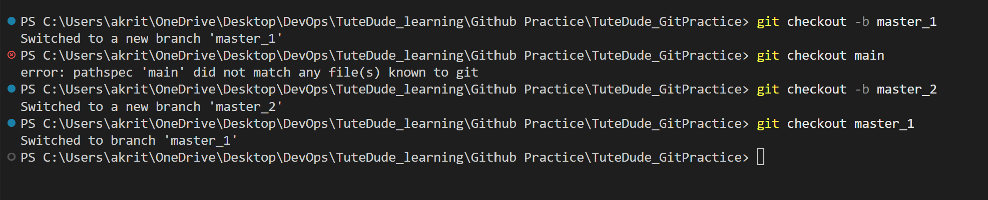
Step 2: In master_1 Created the To-Do frontend page (todo.html)
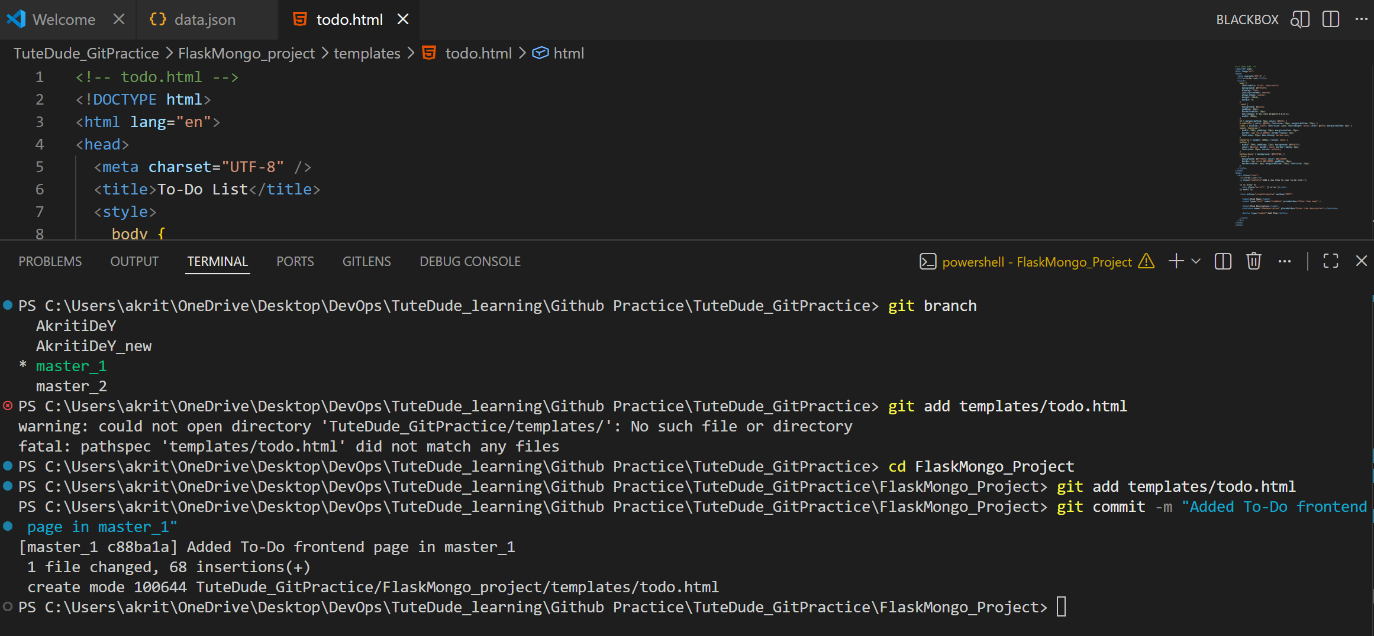
Step 3: In master_2 Created the /submittodoitem backend route in app.py
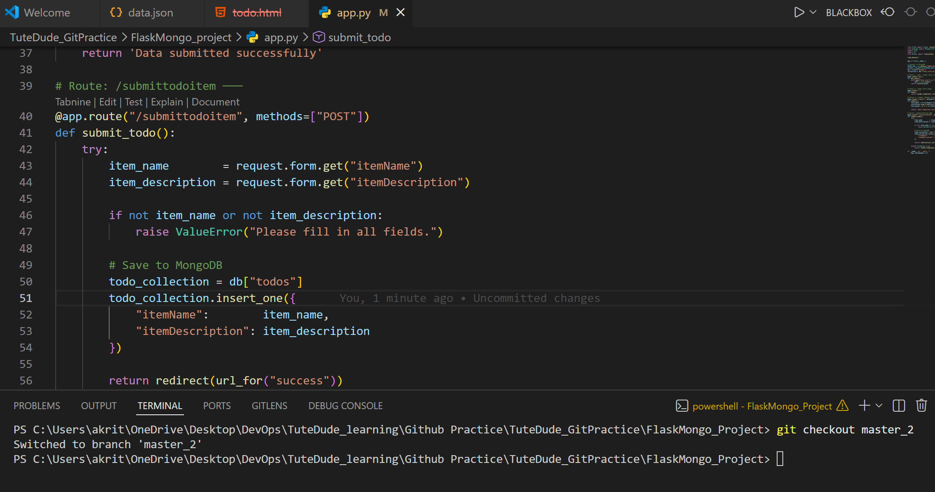
Step 4: Merged master_1 into main
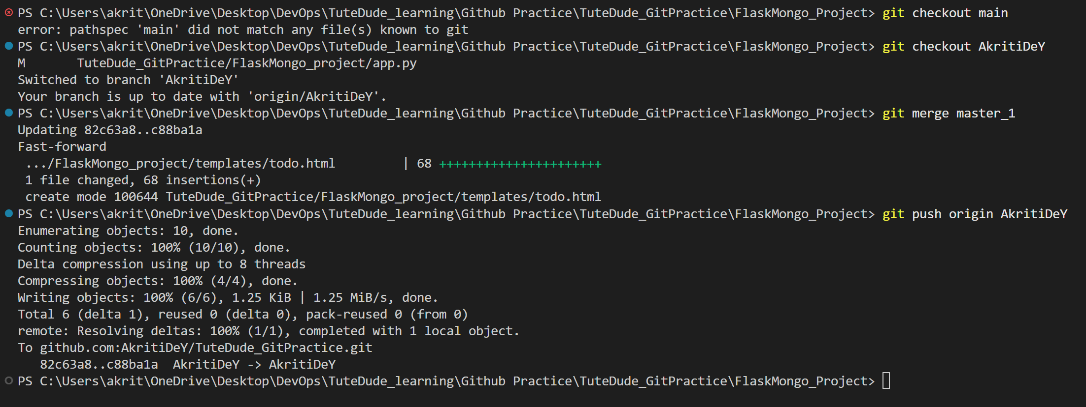

Step 5: Merged master_2 into main
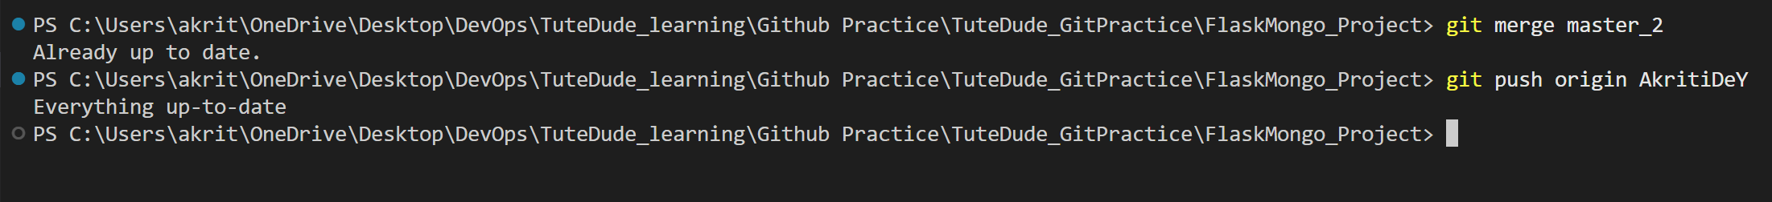

4. Enhance the To-Do form with 3 new fields (3 separate commits), merge to main, use git reset to roll back, rebase main into master_1.

Step 1: Switchd to master_1 branch

Step 2: First commit : Addede Item ID field to todo.html
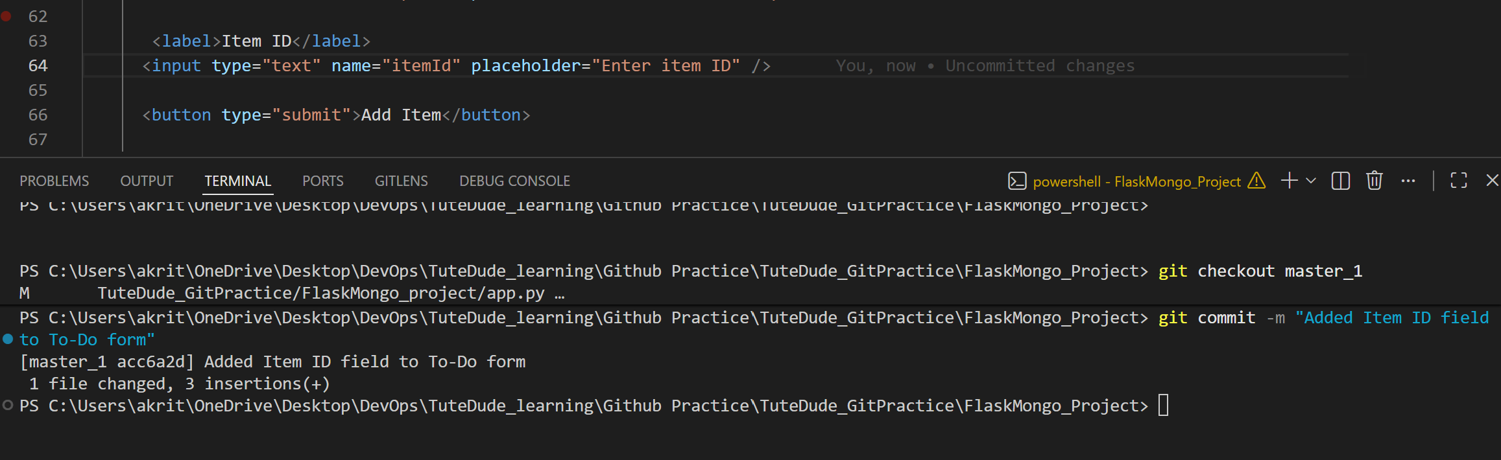
Step 3: Second commit : Added Item UUID field to todo.html
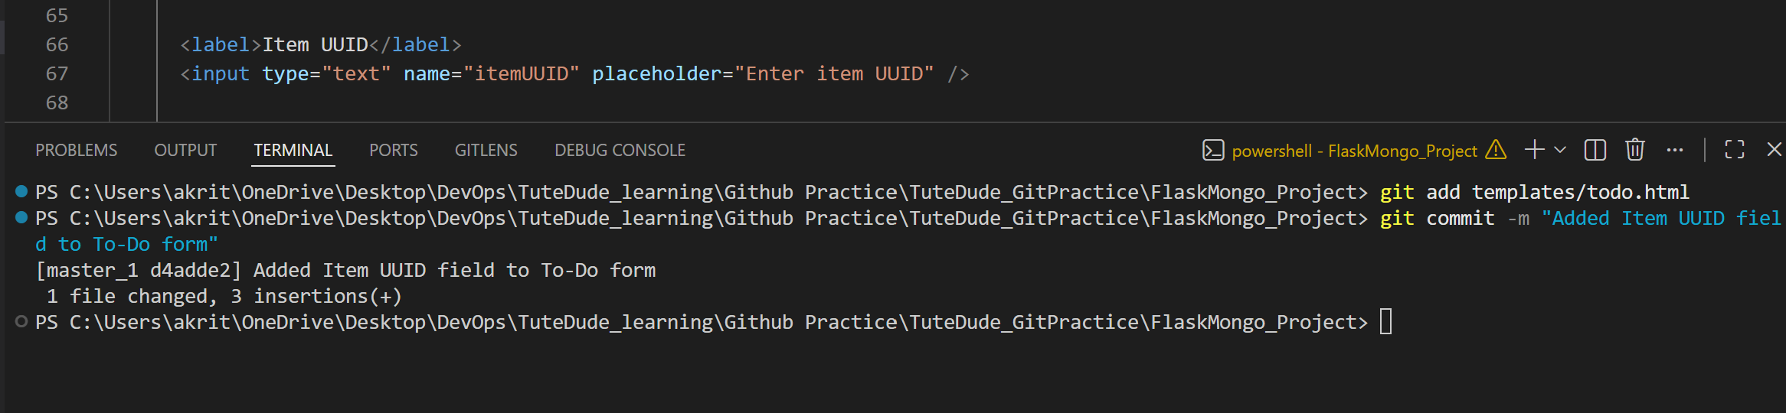

Step 4: Third commit :Added Item Hash field to todo.html
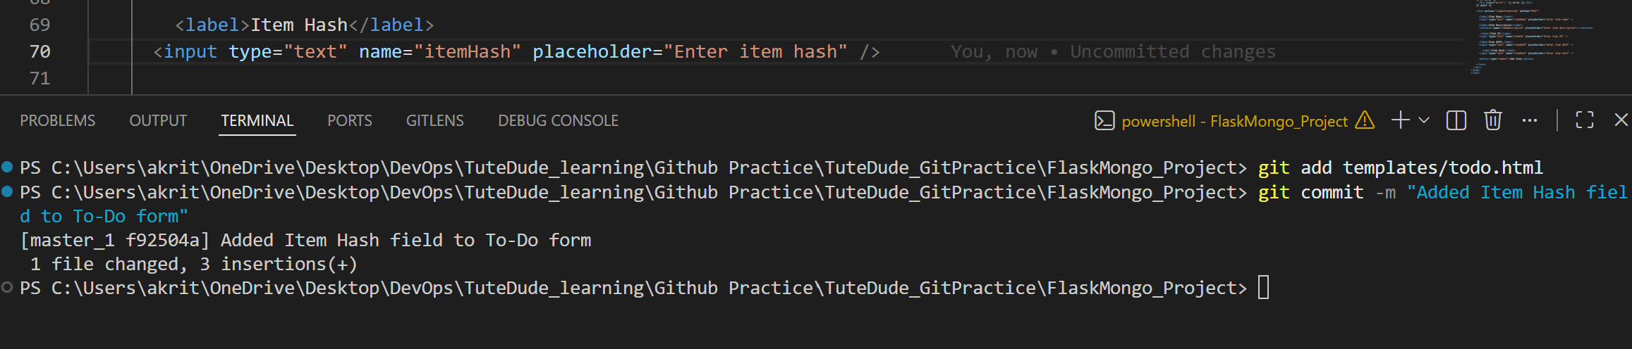
Step 5: Merged masterd_1 into main
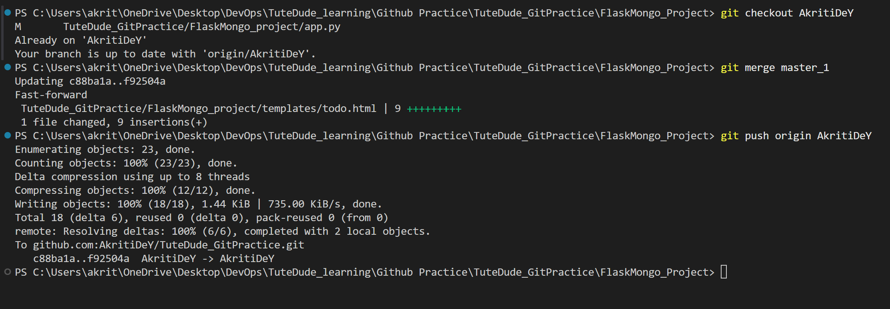
Step 6: checked commit log to find the commit hash for 'Item ID only' state and Used git reset --soft to roll back to the Item ID commit and Re-commit this state

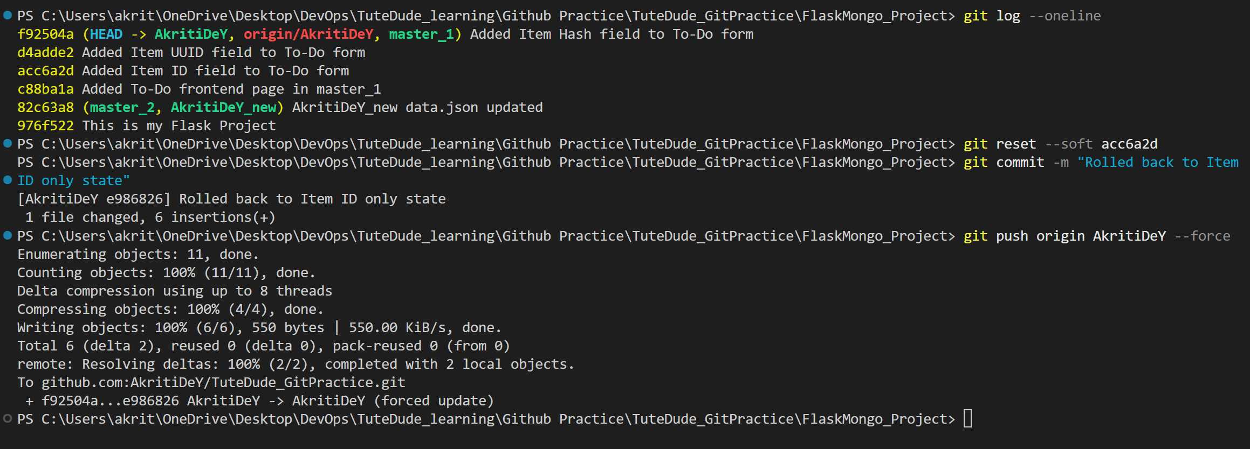

Step 9: Rebase main into master_1 (preserving individual commits)
