DEVOPS_TUTEDUDE
ASSIGNMENT 2: PYTHON
– By Akriti Dey
1. Grade_checker
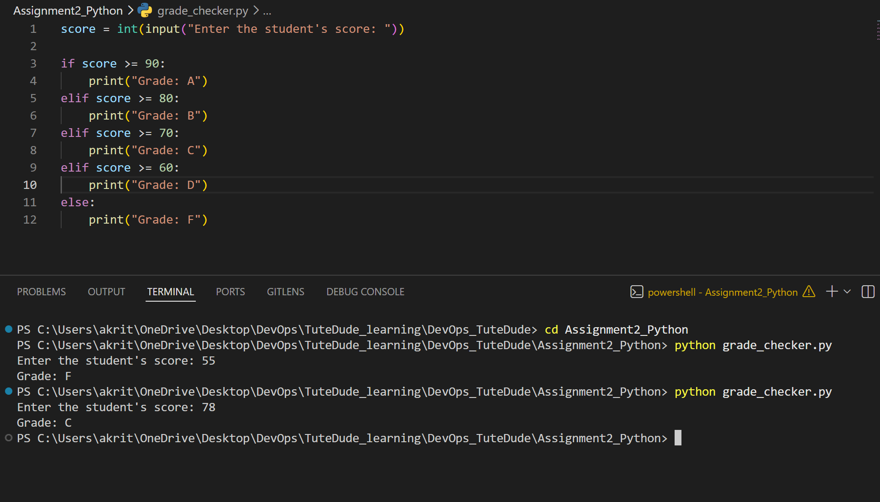
This is a simple grade checked if-else logic
2. Student_grade.
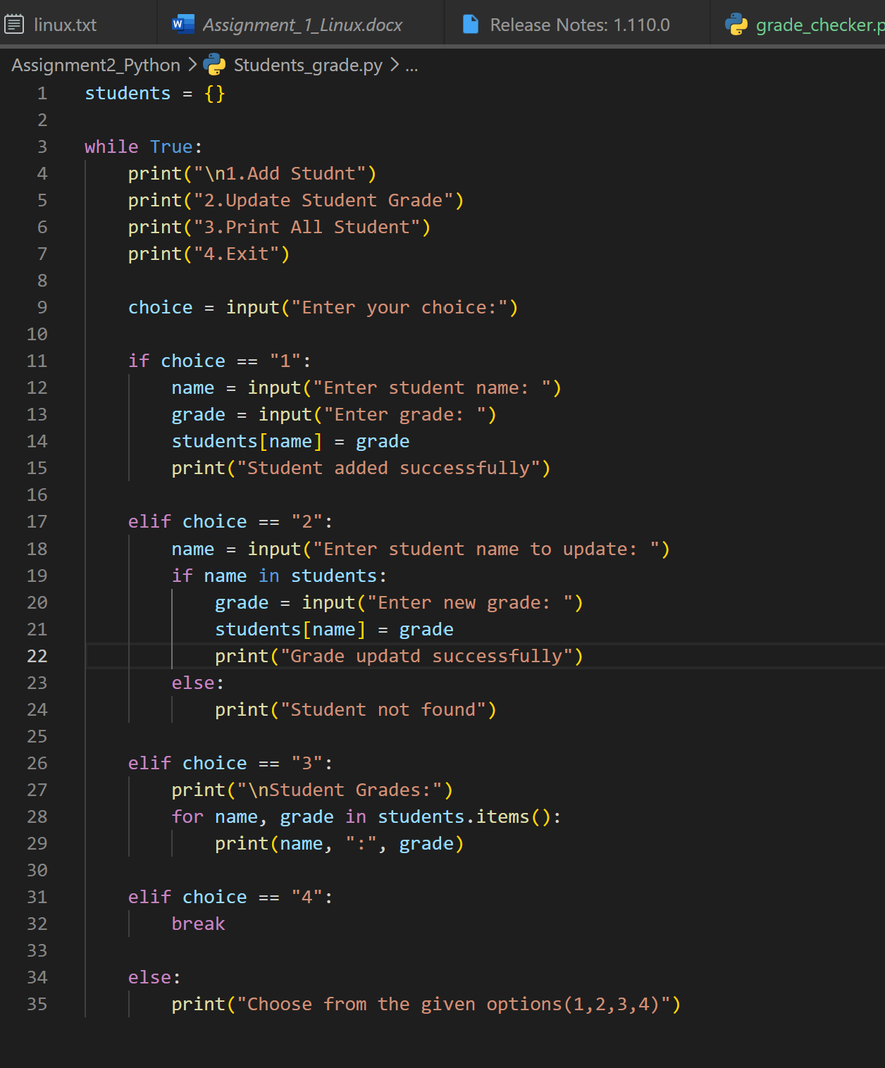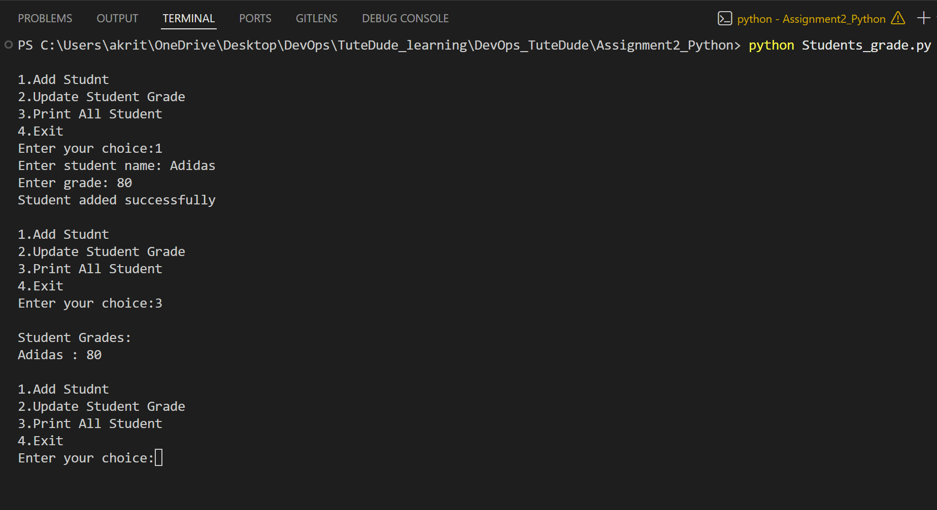
This code has been customized as per user to add as many students as they want

3.Write to a file in python
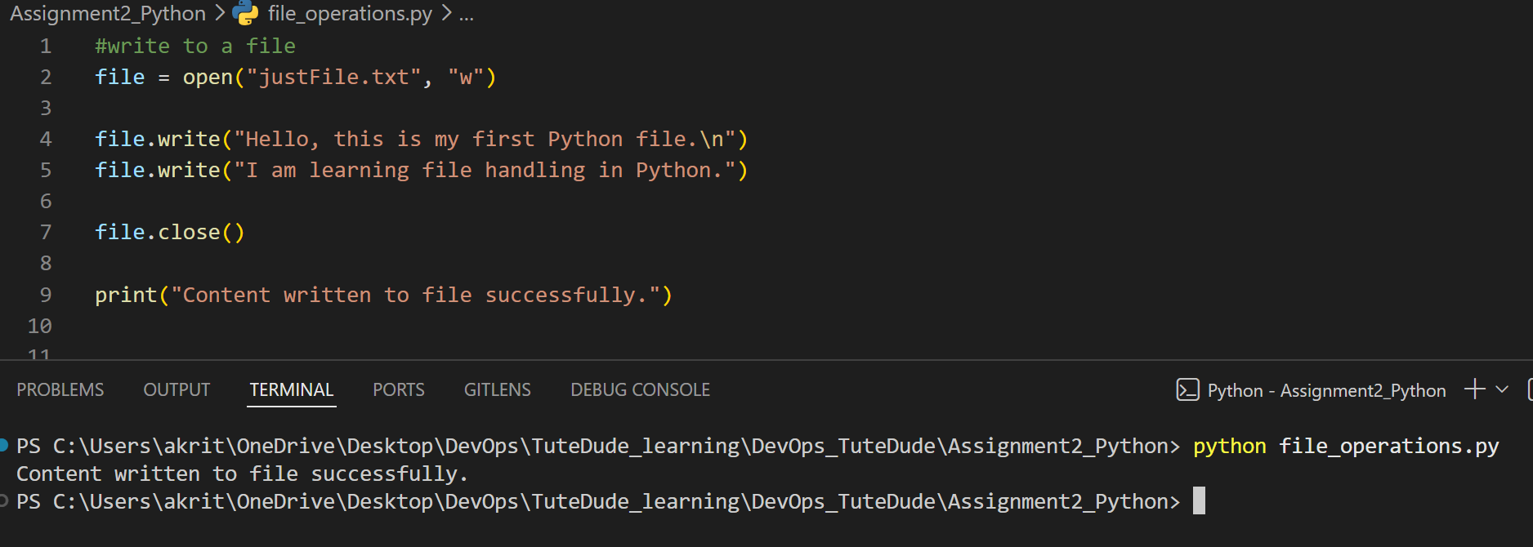
Writing in file is successful and is shown below
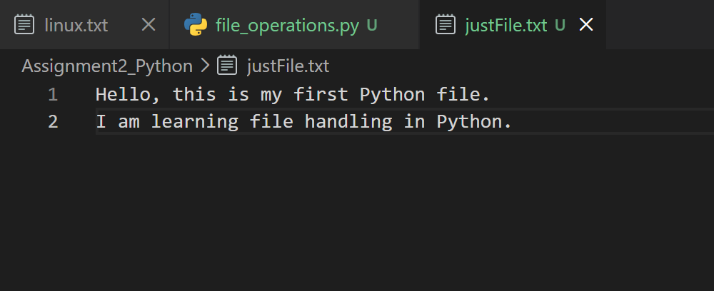

4. Read from a file in python
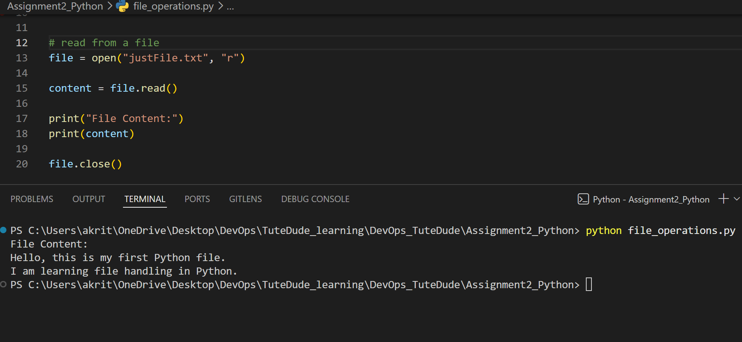
reading from the file is successful

