DEVOPS_TUTEDUDE
ASSIGNMENT 1 : Linux Commands
– By Akriti Dey

1. Creating and Renaming Files/Directories
Create a directory named test_dir using mkdir.
Inside test_dir, create an empty file called example.txt.
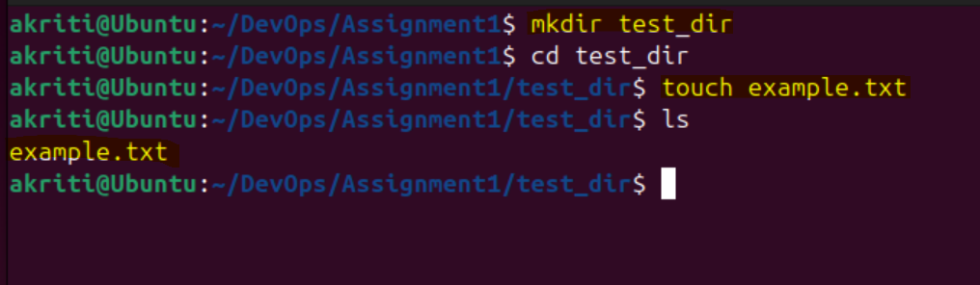
a. here a new directory named test_dir in the current location is created
b. and an empty file named example.txt inside test_dir is created.
Rename example.txt to renamed_example.txt using mv
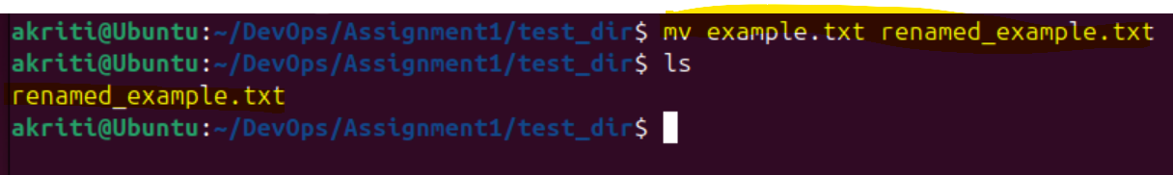
a. here mv is used to rename or move files.
2. Viewing File Contents
Use cat to display the contents of /etc/passwd.
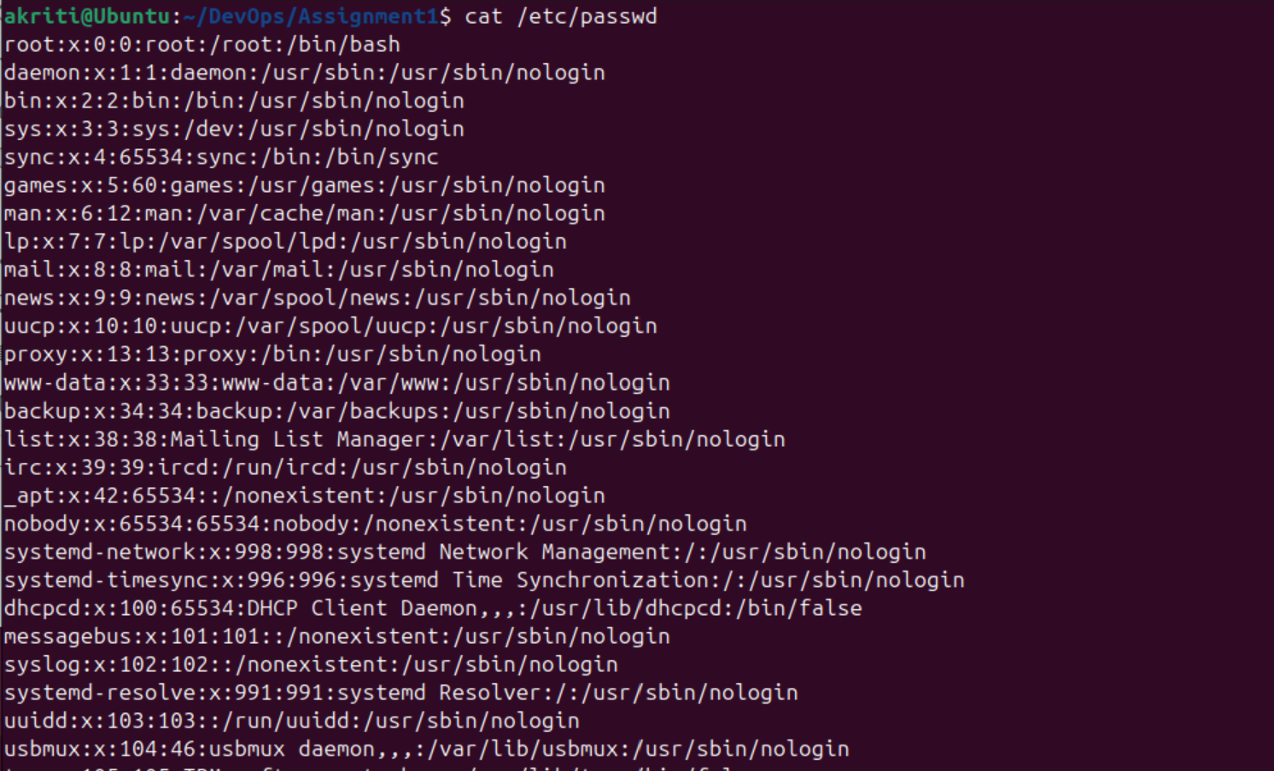
Tusing cat, I printed entire file to terminal

Display only the first 5 lines of /etc/passwd using head.
Display only the last 5 lines of /etc/passwd using tail.
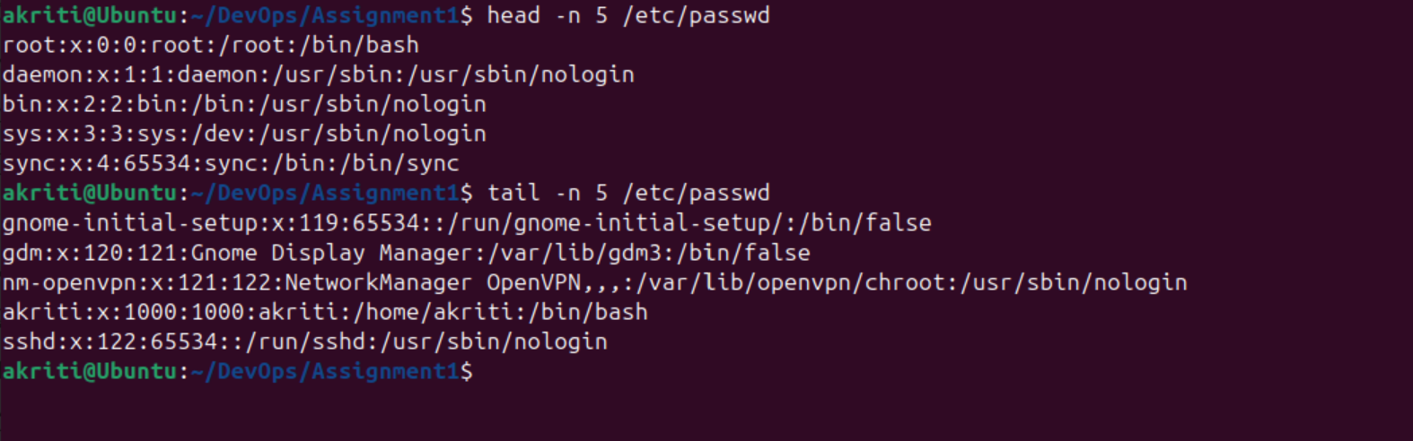
Using Head and tail I have printed first 5 and last 5 lines respectively from the /etc/passwd file

3.Searching for Patterns
Use grep to find all lines containing the word "root" in /etc/passwd.
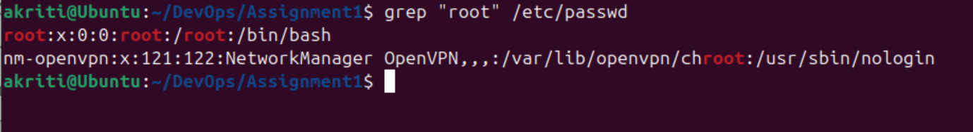
I have used grep that searched for a pattern inside a file and printed matching lines

4. Zipping and Unzipping
Compress the test_dir directory into a file named test_dir.zip using zip.
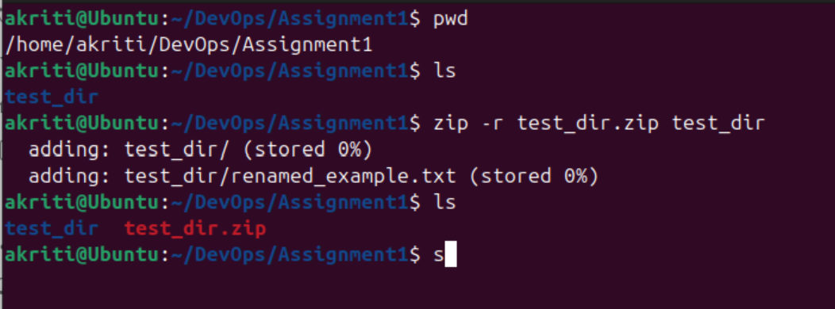
In the above image, I have first checked the files using ‘ls’ and zipped the test_dir using ‘zip -r’(compresses recursively)

Unzip test_dir.zip into a new directory named unzipped_dir.
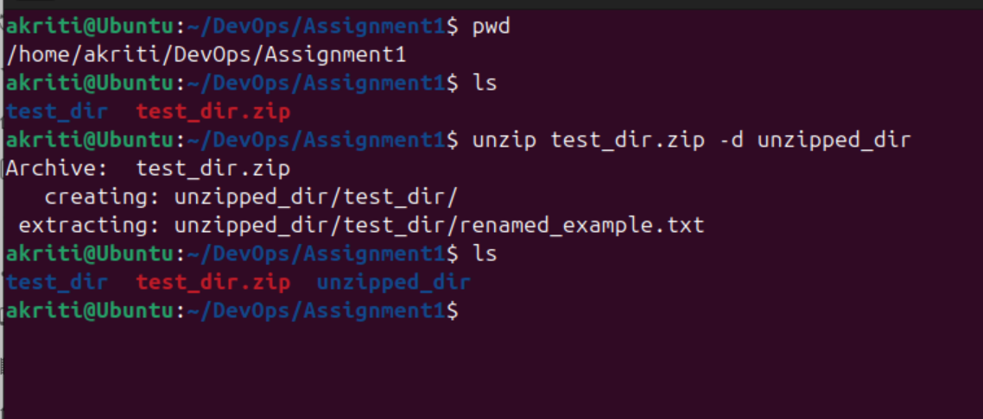
Again checked the existing zipped files using ‘ls’ command. And unzipped using ‘unzip -d’(extracts into the specified destination directory)
5. Downloading Files
Use wget to download a file from a URL (e.g., https://example.com/sample.txt).
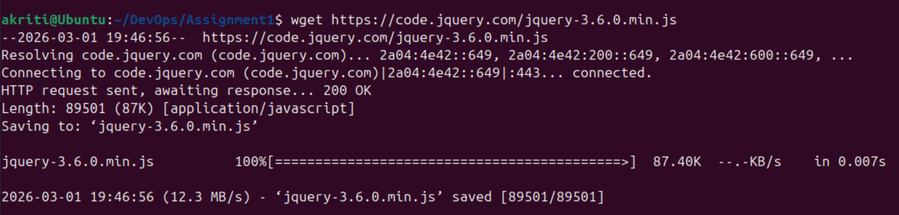
I have tried to download a simple jquery file using the ‘wget’ command here
6. Changing Permissions
Create a file named secure.txt and change its permissions to read-only for everyone using chmod.
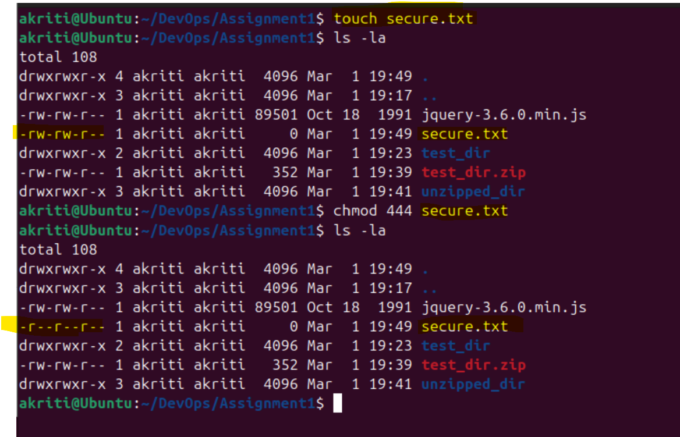
Changed permissions like read-only (r--r--r--) for owner, group, and others using the chmod.
And cross checked using the ‘ls -la’ command

7. Working with Environment Variables
Use export to set a new environment variable called MY_VAR with the value "Hello, Linux!".
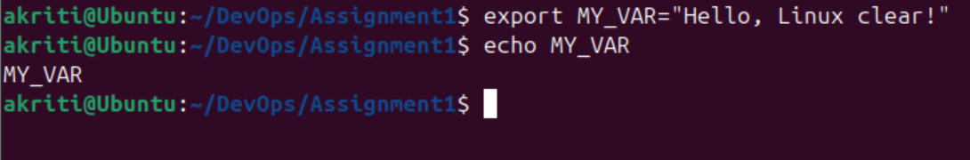
I hav created an env variable ‘MY_VAR’ and cross checked the value using ‘Echo ’ command.

