DEVOPS_TUTEDUDE
ASSIGNMENT 3: Flask and MongoDB
– By Akriti Dey
Below is my entire application with the folder structure:
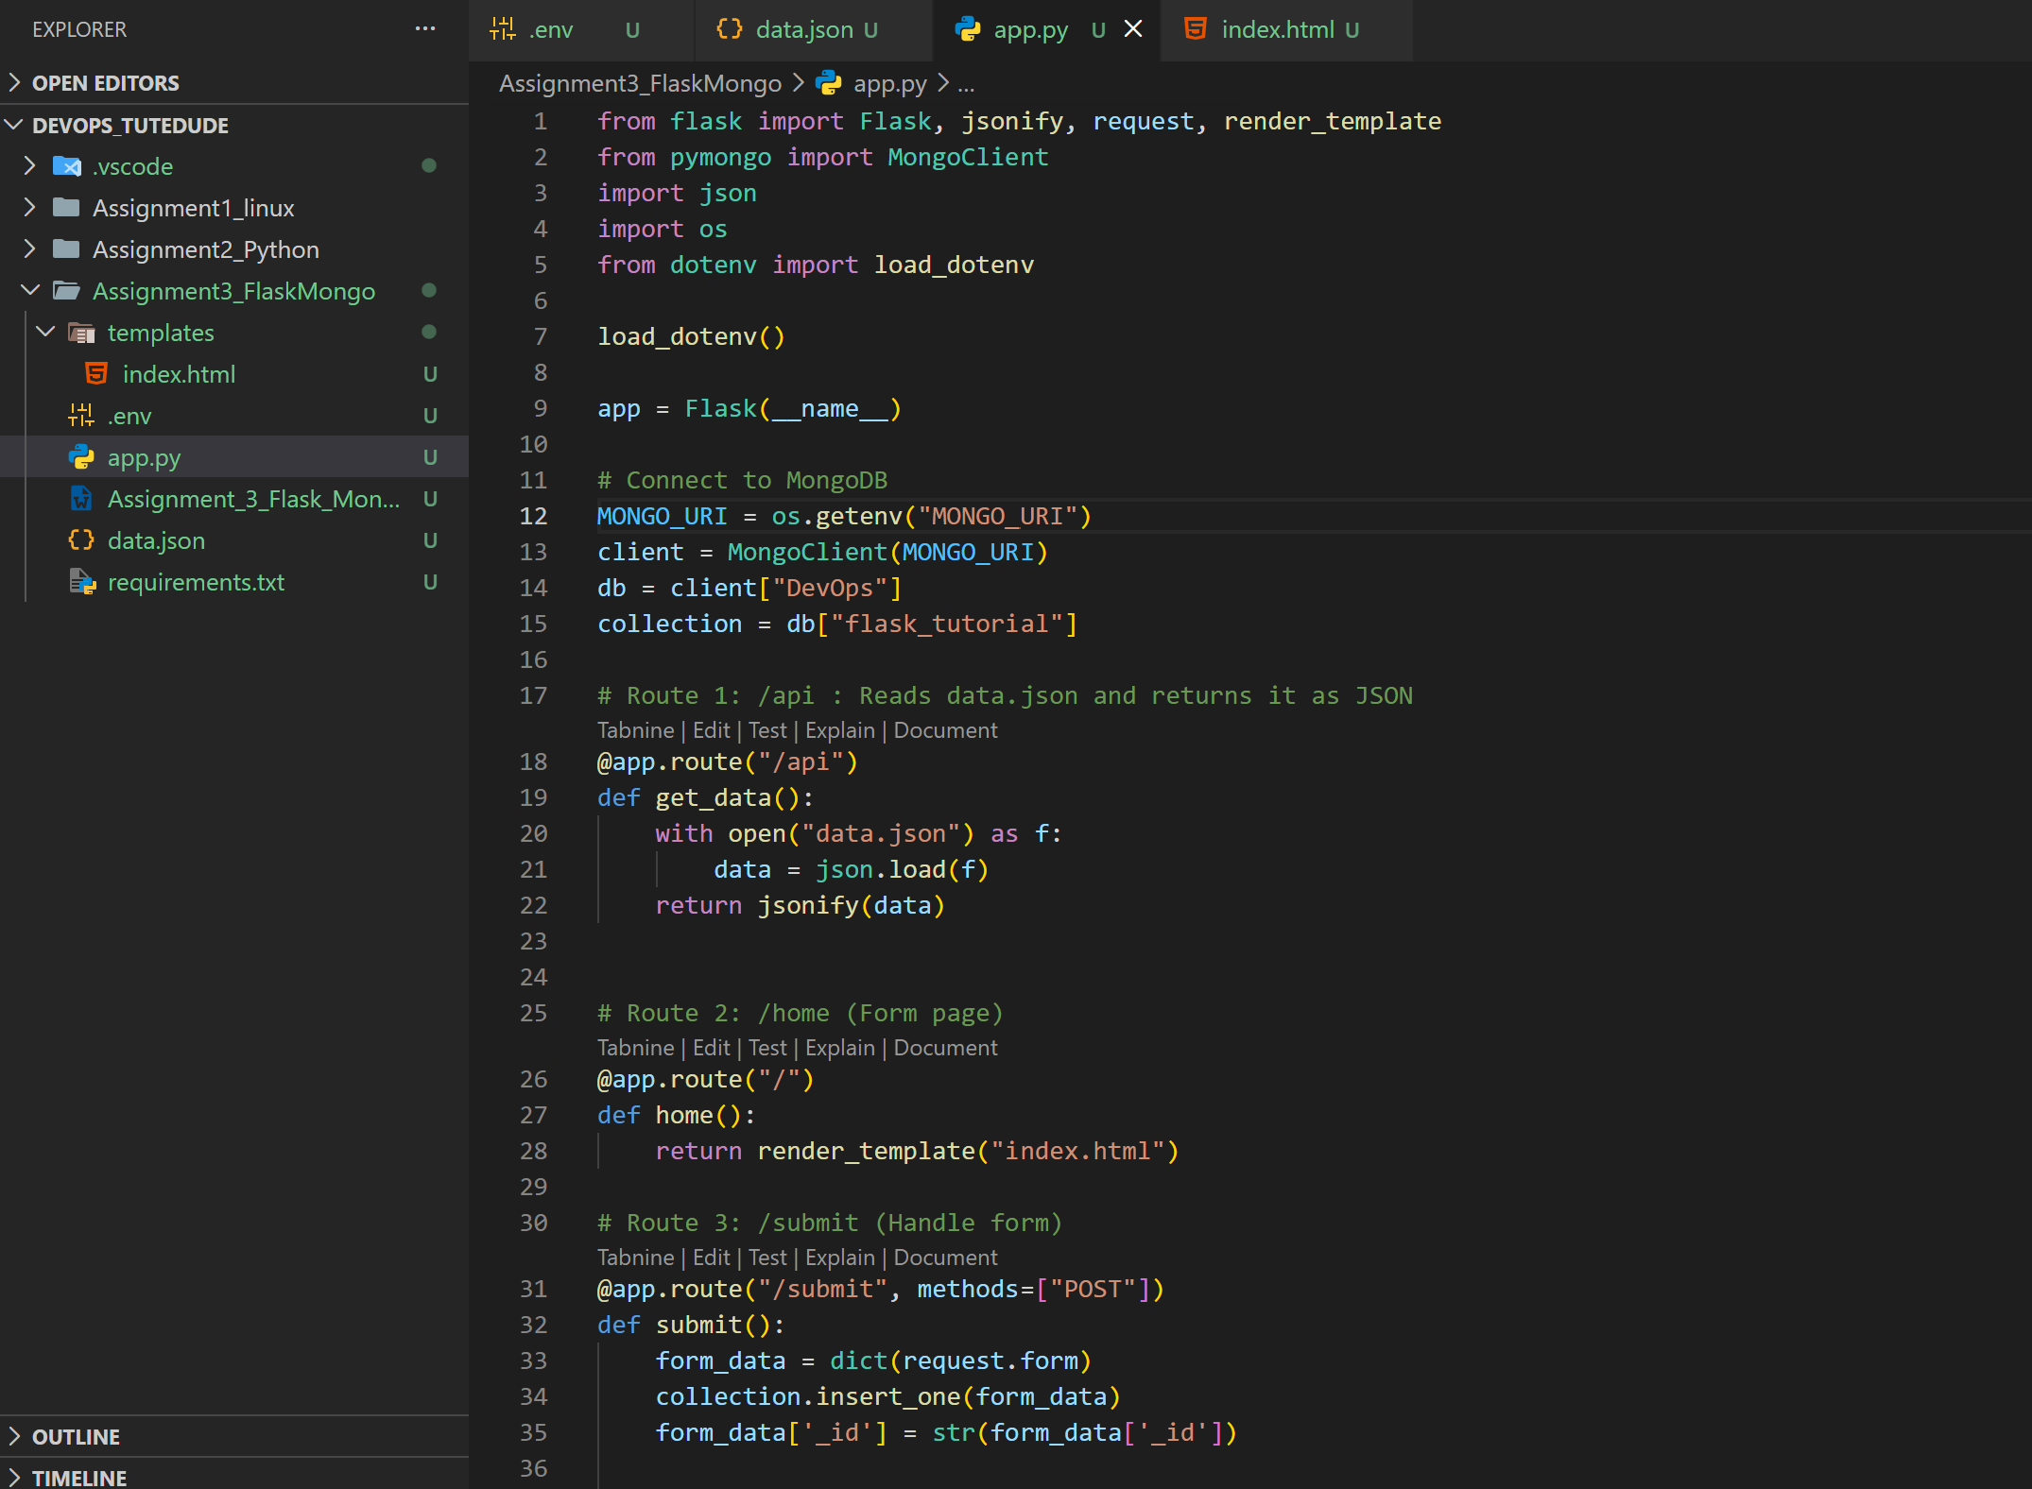

1. Create a Flask application with an /api route. When this route is accessed, it should return a JSON list. The data should be stored in a backend file, read from it, and sent as a response.
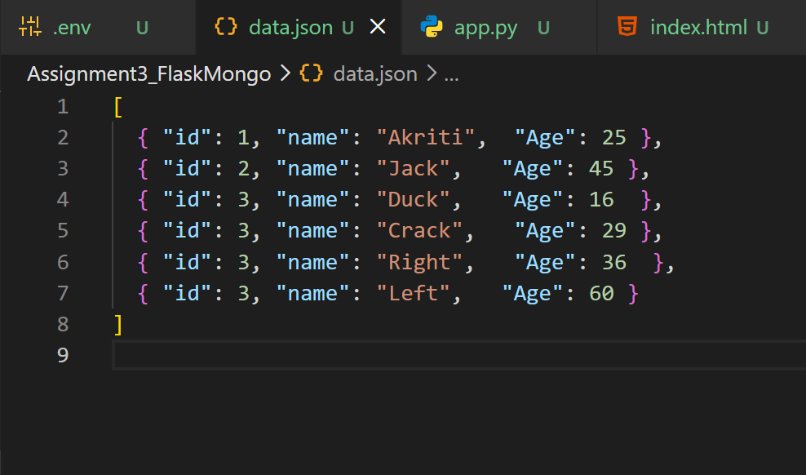
This is the json list that I will be returning for route /api
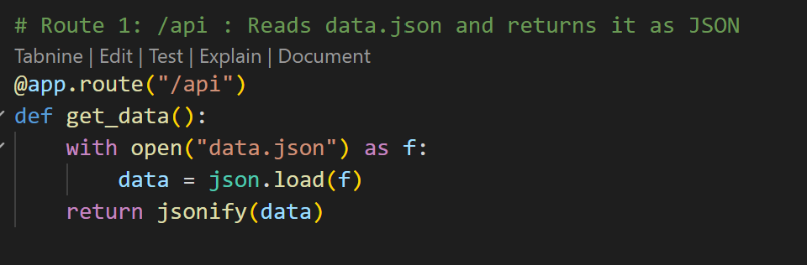
Here’s the code
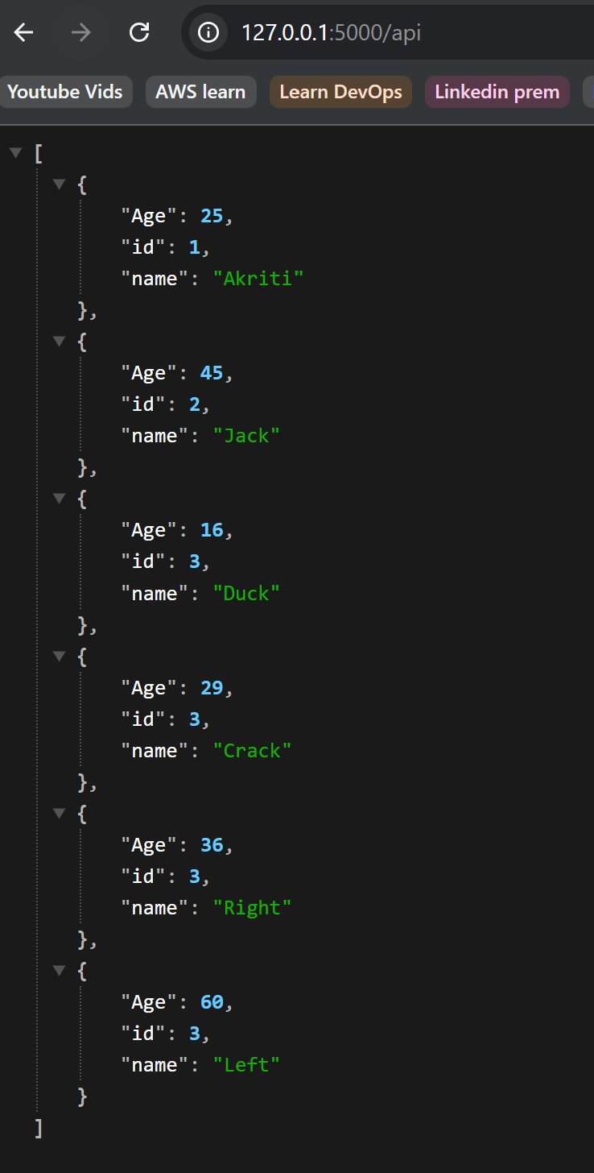
This is the result json showing up on web using the route /api
2. Create a form on the frontend that, when submitted, inserts data into MongoDB Atlas. Upon successful submission, the user should be redirected to another page displaying the message "Data submitted successfully". If there's an error during submission, display the error on the same page without redirection.
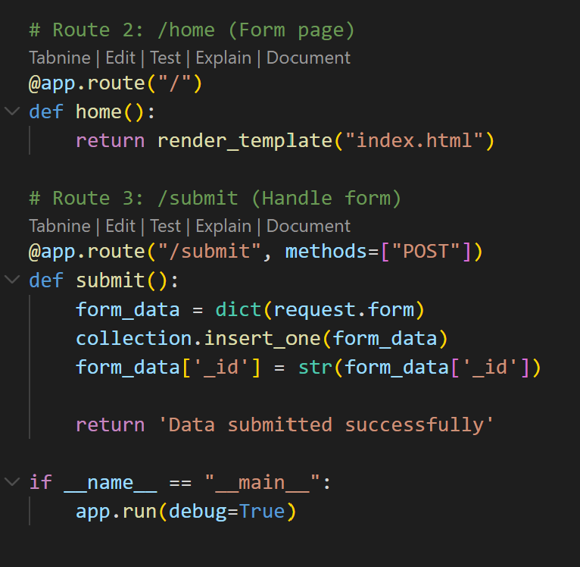
This is the piece of code used for handling a form and saving the data in MongoDB and returning ‘Data Submitted successfully’
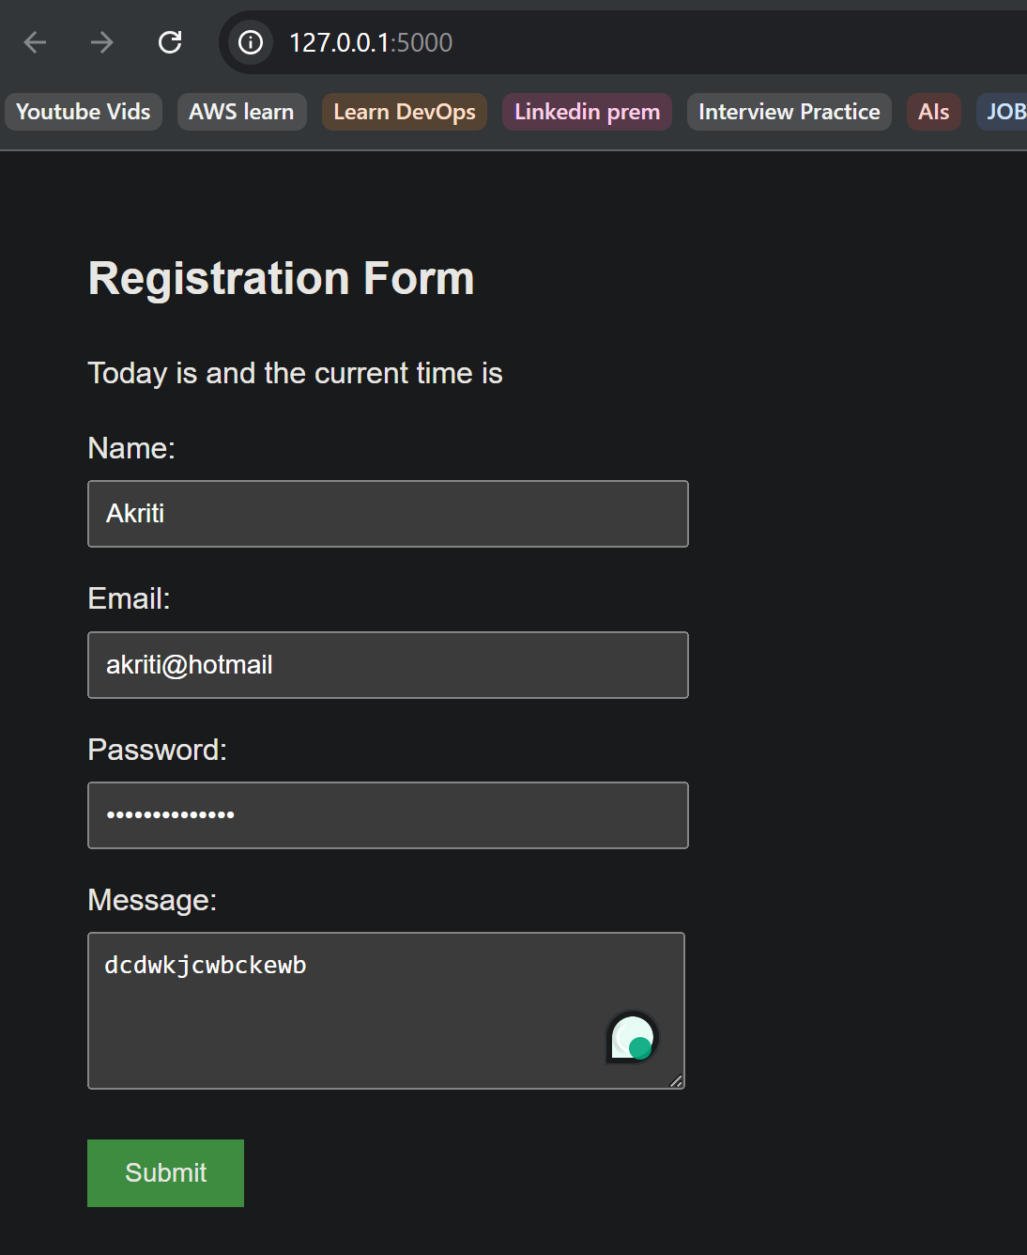
Home page shows a registration form, once submitted the below page will display:
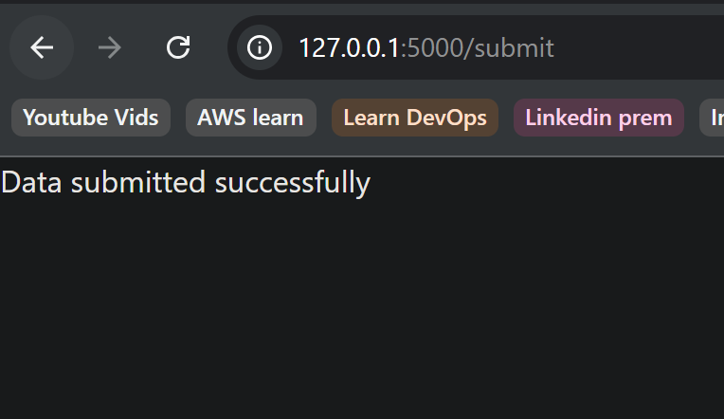
submitted record is now stored in MongoDb:
