**Files:**

1. **Intensity Measure (IM) fields**

In the intensity measure (IM fields) the spatially distributed IM values are stored for all the pre-computed events of the given hazard (e.g. seismic). The files that contain the IM fields are named as follows:

“fields” to indicate that IM values are stored on an event basis

hazard name (e.g. seismic/weather)

name of the demo site (Egnatia or Acciona)

index (more than one IM fields can be stored for the given demo site and hazard)

Egnatia_seismic_fields_01.h5

Figure 1: IM fields file naming.

An example of the IM fields that are computed for the seismic hazard for Egnatia Odos are stored in the “IMfields/Egnatia_seismic_fields_45.h5” file. All the IM fields are computed for a given IM type (such as peak ground acceleration, average spectral acceleration etc) that can be accessed via the following command:

im_type = numpy.array(scenarios.get('gmf_data').get('imts')).item()

where the scenarios variable is generated when reading the IM file. The IM fields for this IM type can be accessed by:

im_fields = numpy.array(scenarios.get('gmf_data').get('data'))

where the event ID of all seismic events as well as the ground motion values (gmv) for the locations indicated by the site IDs (sid) can be found.

An example of the IM fields is presented in Figure 2 in a csv format. Specifically, the “event_id” column contains the unique IDs of all the events that have been generated. For each event, the “gmv_AvgSA” column contains the ground motion values calculated for AvgSA at all locations of interest, that are indicated in the “site_id” column. It should be noted that the IM type is extremely important since it is used for mapping the IM fields with the pre-computed consequences per asset taxonomy. This means that for the given example, the asset consequences should be calculated in terms of AvgSA.

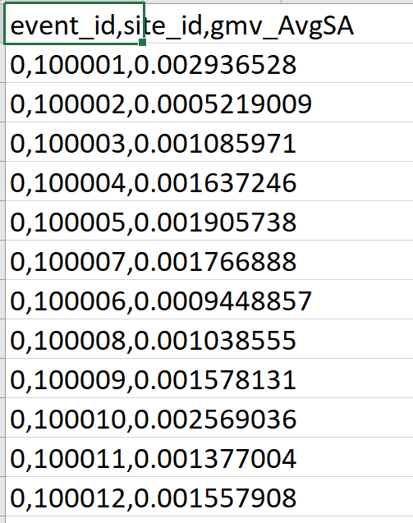

Figure 2: Example of ground motion field in a csv format.

1. **Exposure model**

The exposure model contains information on all the assets that are exposed to any kind of hazard for the given demo site. An example of the exposure model for Egnatia Odos in Greece is stored in the “Exposure/pp_exposure_model_Egnatia.json” file, that is presented in Figure 3. The exposure model should follow the format:

* ExposureModel: default tag that is needed to define the exposure model
  + id: id of the exposure model that is included in this file [mandatory]
  + description: description of the exposure model [mandatory]
  + exposure_categories: the exposure model might contain one or more categories such as transportation, sewage, water, power, telecommunication, buildings etc. For each category the following fields should be defined:
    - exposure_category: name of the exposure category
    - tagNames: names of tags that might need to be added for all assets. One tag category that might be useful for filtering the asset is “group”, since a short key-word for each asset category can be defined to allow e.g. grouping all bridges together.
    - description: a description of the assets that are contained in the given exposure category [mandatory]
    - dirs: metadata for the direction where each asset is located. For transportation assets it should contain the ID that indicates the travel direction where each asset is located as well as the corresponding description [optional – needed only for assets that are linked to a certain travel direction]
    - conversions: this probably not useful for our analysis
    - assets: all assets of interest that belong to the given exposure category are defined based on their name
    - asset name: name of the asset
    - number: how many assets are found in the specific location and which is the unit this number refers to [mandatory but not included yet in our analysis]
    - taxonomy: name of the class where the asset belongs [mandatory and very important]. This is used to map the asset with the fragility and vulnerability model of the given asset taxonomy to estimate the consequences. This is also done in the simple example we sent to Antonis in order to map each asset to the pre-computed consequences for the asset taxonomy.
    - asset type: three options of asset types are available for PANOPTIS, that are linear, point and area assets. Liner assets are distributed along a line, such as the pavement or the utility poles. The area assets cover a geographic area (e.g. slopes and plant covered areas), while point assets are located at a certain point (such as bridges, sign-post bridges, tolls etc) [mandatory]
    - location: site id(s) where the asset is located [mandatory]. The coordinates for each site ID can be found in the sites mtdata file. Depending on the type of the asset, its location can be defined following one of the available options:
      * point assets: for point assets either a single site ID or the IDs of the beginning and the end point of the asset can be defined. The former is used for assets that can be represented on a map by a single point, while the latter for those that need to be represented by a line which starts from the beginning point and ends at the end of the asset* (such as the bridges). For point assets that are located at a single point, the IM values for this point will be adopted for estimating the consequences. For the point assets whose location is defined by more than one site IDs, the first point is adopted for estimating the intensity measure values from the IM fields or the site ID that is defined in the “hzrd_ctrl_pnt” tag [optional].

The “orient” is useful only for assets that are vulnerable to weather-related hazard. It indicates the orientation of the asset in degrees.

*The beginning and the end point should belong to the same type and type_id category as defined in the site mtdata file for assets that are linked to one travel direction.

* + - * linear assets: for linear assets two or more site IDs should be defined in the “location” tag. They can refer to the beginning and the end points of the linearly distributed asset if the type is “start_end” or to the individual points where such assets can be found if the type is “individual”. Internally, the linear assets are translated into multiple point assets with the characteristics of the linear asset. This is not added in the simple example we have prepared for Antonis since we have not included linear assets that are vulnerable to the seismic hazard.
      * area assets: the “boundaries” of the asset are defined as well as the control point (hzrd_ctrl_pnt) that is used to determine the IM value for the given asset through the IM fields.

The geometry is added at each asset to help Antonis create the geojson file from the exposure model (for this reason we have the “pp_” at the beginning of the file’s name).

* + - dir: the travel direction the asset belongs to (one from the options defined in “dirs”) [mandatory for assets that belong to the transportation network]
    - tags: data for the tags defined in the tagNames entry
    - costs: costs for the cost types defined in the costType entry (probably not useful for our analysis)
    - figures: one or more names of the figures for the asset (optional) that are stored in the Figures folder (found in the same path as the exposure file)

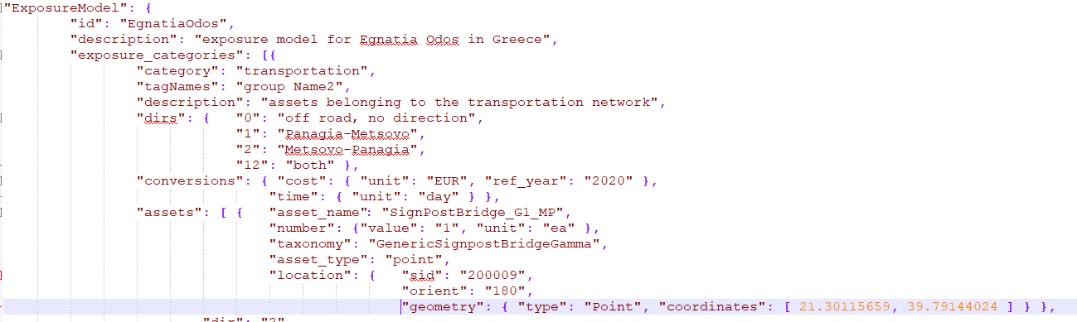

Figure 3: Example of the exposure model for the Greek demo site before adding the geometry tag (Egnatia Odos).

1. **Consequences per asset**
   1. **Tier I assets**

For assets that belong to the Tier I category, i.e. those that are treated via a component-based approach, N = 100 realizations of all potential consequences are generated for their critical components and stored in the consequences file. The file name should follow the format:

“consequences” to indicate that the consequences are stored in this file

name of the asset taxonomy

G7Bridge_ consequences.json

Figure 4: Consequence file naming.

An example is presented in Figure 5 for the G7 bridge of the Greek Demo Site, where the following fields are defined:

* mtdata: metadata of the values stored in this file, such as:
  + units: units of e.g. the speed limit/cost/time
  + Nrealizations: number of recovery realizations that have been produced for all asset taxonomies
* consequences_by_taxonomy: consequences for each asset taxonomy:
  + - asset_taxonomy: asset taxonomy for which the consequences have been computed [mandatory]
    - hazard_type: hazard for which the consequences are computed
    - im_type: intensity measure type for which the consequences have been computed. This is used for mapping the IM fields with the associated consequences [mandatory].
    - mtdata: metadata for the given asset taxonomy (e.g. maximum speed limit)
    - component_damage_state_description: name and description of the damage states for all the critical components of the asset and for global damage states that refer to the entire asset [mandatory]. A figure with the component naming should also be included in the exposure model as the one presented in Figure 6 for Tier I assets that are treated via a component-based approach [optional but useful].
    - iml_consequences: consequences for each IM level:
      * im_level: value of the IM level
      * consequences: the consequences for all components are stored
        + component: name of the component
        + cost/damage_state: cost and damage state realizations

for global component: consequences that refer to the entire asset

* + - * + cost realizations for the entire asset
        + recovery: for each realization the speed limit for all lanes of the RI are reported as well as the time needed to recover
        + damage state: damage state that describes the entire asset behavior. Only the number x of the damage state is defined and can be mapped to the damage state description through the corresponding field in the comp_ds_description/global/DSx.

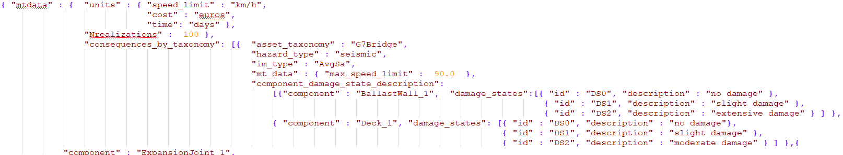

…

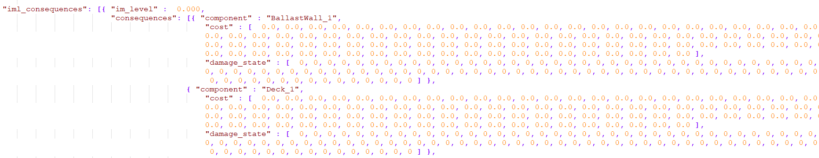

Figure 5: Example (G7 Bridge of Egnatia Odos) of consequence realizations for Tier I assets that are treated via a component-based approach.

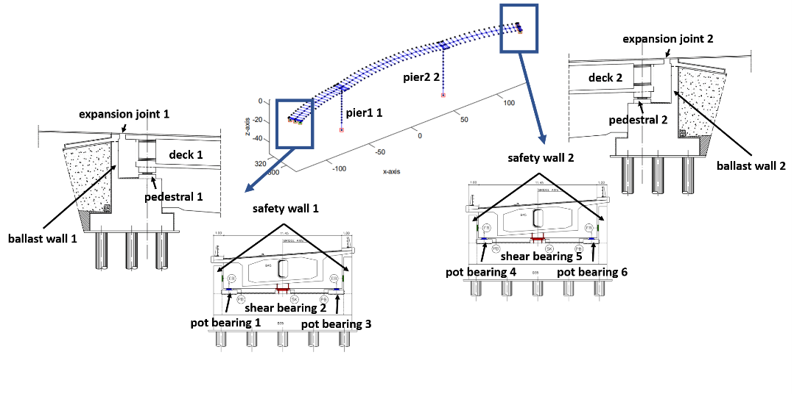

Figure 6: Critical components of the G7 bridge of Egnatia Odos for which the consequences have been calculated.

* 1. **Tier II assets**

The consequences for Tier II assets follow the same format as the ones for the Tier I assets but they refer to the entire system. An example is presented for an asset (dummy data).

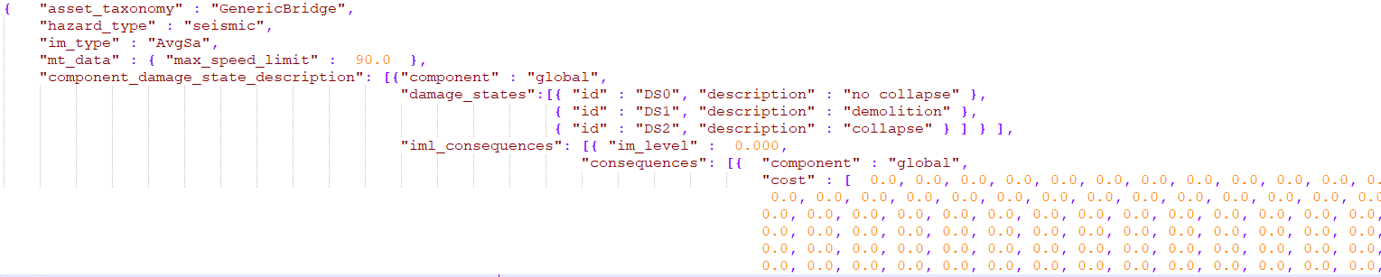

Figure 7: Example of consequence realizations for Tier II assets that are treated via a system-only approach.

1. **Simple example**

Our aim is to compute for each IM field the consequences of all highway assets. For this reason, we need to combine the ground motion fields with the consequences of all assets that are affected by the hazard of interest and produce e.g. N = 100 realizations of all potential consequences for the highway assets. A simple example can be found in the “SimpleExample.py” that uses the simple exposure model found in the same folder as input.

*Outputs*

The outputs are stored in json or geojson files in the folder: SimpleExample/Results. Specifically, the following outputs are produced:

1. Most frequent damage state per asset and event:

The name of the file follows the format:

MostFrequentDSperAsset_seismic_eid1996.json

event ID

hazard name (e.g. seismic/weather)

output type

Figure 8: Output: most frequent damage state per asset and event file naming.

The json outputs can be converted to figures as shown below:

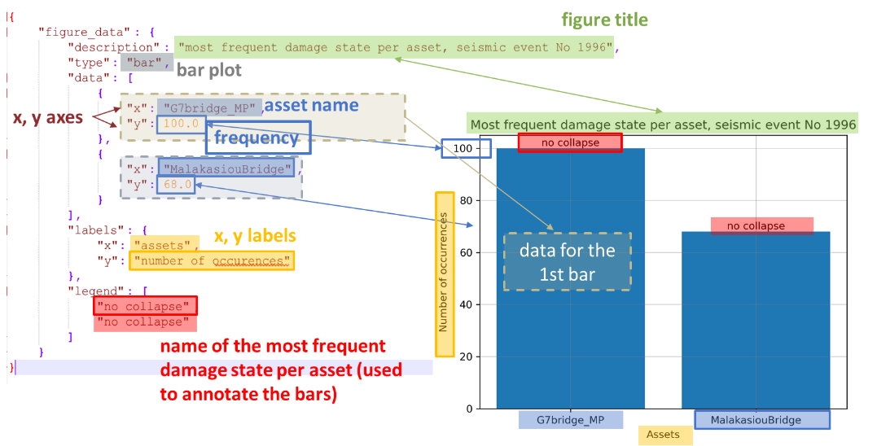

Figure 9: Output: most frequent damage state per asset and event – json to figure.

1. Collapse map

hazard name (e.g. seismic/weather)

The name of the file follows the format:

CollapseMap_seismic_eid1996.geojson

hazard name (e.g. seismic/weather)

output type

event ID

Figure 10: Output: recovery realization for a given asset and event file naming.

The geojson outputs can be directly loaded e.g. <https://geojson.io/>. See below for more details:

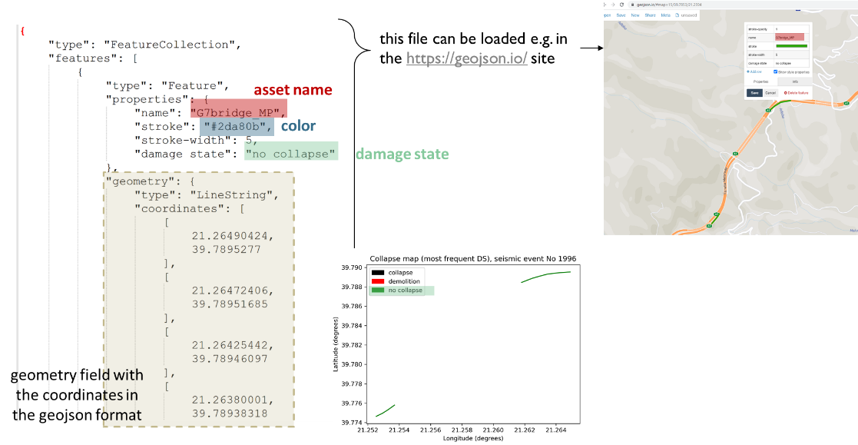

Figure 11: Output: collapse map for a given event – geojson format.

1. Recovery realization for a given asset and event plot

The name of the file follows the format:

seismic_eid1996_MalakasiouBridge_recovery_rlz_1.json

hazard name (e.g. seismic/weather)

realization number

asset name

event ID

Figure 12: Output: recovery realization for a given asset and event file naming.

The json outputs can be converted to figures as shown below:

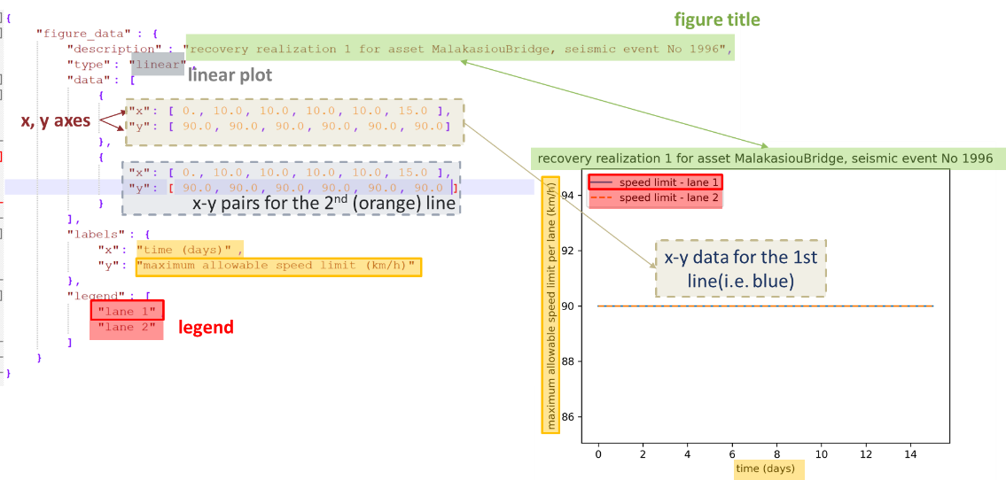

Figure 13: Output: recovery realization per asset and event – json to figure.