Source Data Mapping Approach to CDMV5.3.1

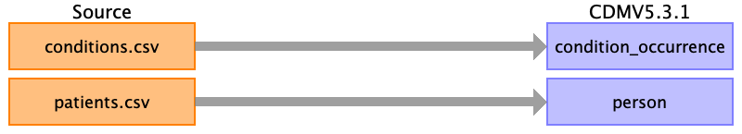

Table name: condition_occurrence

Reading from conditions.csv

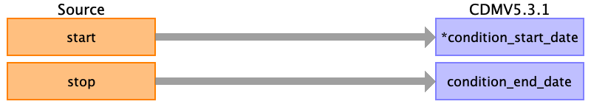

|  |  |  |  |
| --- | --- | --- | --- |
| Destination Field | Source Field | Logic | Comment |
| condition_occurrence_id |  |  |  |
| person_id |  |  |  |
| condition_concept_id |  |  |  |
| condition_start_date | start |  |  |
| condition_start_datetime |  |  |  |
| condition_end_date | stop |  |  |
| condition_end_datetime |  |  |  |
| condition_type_concept_id |  |  |  |
| stop_reason |  |  |  |
| provider_id |  |  |  |
| visit_occurrence_id |  |  |  |
| visit_detail_id |  |  |  |
| condition_source_value |  |  |  |
| condition_source_concept_id |  |  |  |
| condition_status_source_value |  |  |  |
| condition_status_concept_id |  |  |  |

Table name: death

Table name: device_exposure

Table name: drug_exposure

Table name: fact_relationship

Table name: measurement

Table name: note

Table name: note_nlp

Table name: observation

Table name: observation_period

Table name: person

Reading from patients.csv

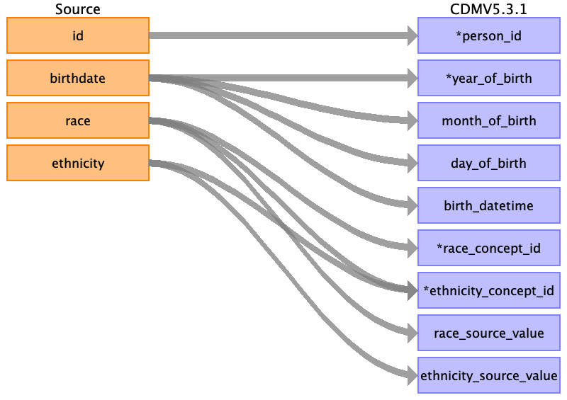

|  |  |  |  |
| --- | --- | --- | --- |
| Destination Field | Source Field | Logic | Comment |
| person_id | id |  |  |
| gender_concept_id |  |  |  |
| year_of_birth | birthdate | Take Year from birthdate |  |
| month_of_birth | birthdate | Take month from birthdate |  |
| day_of_birth | birthdate | Take day from birthdate |  |
| birth_datetime | birthdate | With midnight as time 00:00:00 |  |
| race_concept_id | race | case upper(race)  when 'WHITE' then 8527  when 'BLACK' then 8516  when 'ASIAN' then 8515  else 0  end |  |
| ethnicity_concept_id | race  ethnicity |  |  |
| location_id |  |  |  |
| provider_id |  |  |  |
| care_site_id |  |  |  |
| person_source_value |  |  |  |
| gender_source_value |  |  |  |
| gender_source_concept_id |  |  |  |
| race_source_value | race |  |  |
| race_source_concept_id |  |  |  |
| ethnicity_source_value | ethnicity |  |  |
| ethnicity_source_concept_id |  |  |  |

Table name: procedure_occurrence

Table name: specimen

Table name: visit_detail

Table name: visit_occurrence

Table name: cohort

Table name: cohort_attribute

Table name: condition_era

Table name: dose_era

Table name: drug_era

Table name: cost

Table name: payer_plan_period

Table name: care_site

Table name: location

Table name: provider

Table name: cdm_source

Table name: metadata

Table name: attribute_definition

Table name: cohort_definition

Appendix: source tables

Table: allergies.csv

|  |  |  |  |
| --- | --- | --- | --- |
| Field | Type | Most freq. value | Comment |
| start | date | 2008-03-24 |  |
| stop | date |  |  |
| patient | varchar | 99a94a01-bb91-4ad7-9a69-b9bd0f114d47 |  |
| encounter | varchar | c430e49d-9612-4ba0-92ec-70ab4afdcb5f |  |
| code | int | 419474003 |  |
| description | varchar | Allergy to mould |  |

Table: careplans.csv

|  |  |  |  |
| --- | --- | --- | --- |
| Field | Type | Most freq. value | Comment |
| id | varchar | 906fceed-443f-4f59-acab-562f80c5cb44 |  |
| start | date | 2016-11-09 |  |
| stop | date |  |  |
| patient | varchar | b6750e05-91df-471b-97bb-a19ab9fe79c5 |  |
| encounter | varchar | 17781139-da60-46dc-ba6e-13637cb13c61 |  |
| code | int | 53950000 |  |
| description | varchar | Respiratory therapy |  |
| reasoncode | int | 10509002 |  |
| reasondescription | varchar | Acute bronchitis (disorder) |  |

Table: conditions.csv

|  |  |  |  |
| --- | --- | --- | --- |
| Field | Type | Most freq. value | Comment |
| start | date | 2017-12-26 |  |
| stop | date |  |  |
| patient | varchar | ffab9299-0b3d-474f-96a4-bb279c244c7c |  |
| encounter | varchar | 50bbccc5-bb6b-4073-8244-045f10a28469 |  |
| code | int | 444814009 |  |
| description | varchar | Viral sinusitis (disorder) |  |

Table: encounters.csv

|  |  |  |  |
| --- | --- | --- | --- |
| Field | Type | Most freq. value | Comment |
| id | varchar | 8ead2604-2f95-4ecb-a898-8c29f74709fb |  |
| start | varchar | 1983-04-24T05:36:43Z |  |
| stop | varchar | 2001-10-05T03:47:01Z |  |
| patient | varchar | 24121ee3-3413-4e42-8e17-0410204adf10 |  |
| encounterclass | varchar | ambulatory |  |
| code | int | 185349003 |  |
| description | varchar | Encounter for check up (procedure) |  |
| cost | real | 129.16 |  |
| reasoncode | int |  |  |
| reasondescription | varchar |  |  |

Table: imaging_studies.csv

|  |  |  |  |
| --- | --- | --- | --- |
| Field | Type | Most freq. value | Comment |
| id | varchar | 26cd0a95-10a6-4a30-8af1-ebc602d39b72 |  |
| date | date | 2015-10-26 |  |
| patient | varchar | 5dacca68-eb32-45ea-bf9d-f224f96e4299 |  |
| encounter | varchar | fcd7e8af-0242-4efb-a392-642ed4cb01d1 |  |
| bodysite_code | int | 51185008 |  |
| bodysite_description | varchar | Thoracic structure (body structure) |  |
| modality_code | varchar | CT |  |
| modality_description | varchar | Computed Tomography |  |
| sop_code | varchar | 1.2.840.10008.5.1.4.1.1.2 |  |
| sop_description | varchar | CT Image Storage |  |

Table: immunizations.csv

|  |  |  |  |
| --- | --- | --- | --- |
| Field | Type | Most freq. value | Comment |
| date | date | 2016-06-16 |  |
| patient | varchar | 8734f7b8-4525-4db3-b8b7-60da22f729b5 |  |
| encounter | varchar | c9557a0c-7f03-48ba-9975-667d28f2dc39 |  |
| code | int | 140 |  |
| description | varchar | Influenza seasonal injectable preservative free |  |
| cost | real | 140.52 |  |

Table: medications.csv

|  |  |  |  |
| --- | --- | --- | --- |
| Field | Type | Most freq. value | Comment |
| start | date | 2016-04-03 |  |
| stop | date |  |  |
| patient | varchar | 5dacca68-eb32-45ea-bf9d-f224f96e4299 |  |
| encounter | varchar | 93917d59-daf9-4206-b59c-c73262c4ca9f |  |
| code | int | 316672 |  |
| description | varchar | Simvistatin 10 MG |  |
| cost | real | 263.49 |  |
| dispenses | int | 1 |  |
| totalcost | real | 3161.88 |  |
| reasoncode | int |  |  |
| reasondescription | varchar |  |  |

Table: observations.csv

|  |  |  |  |
| --- | --- | --- | --- |
| Field | Type | Most freq. value | Comment |
| date | date | 1986-06-20 |  |
| patient | varchar | cfe0b091-a7b4-4fbb-a0a2-d0fd86a596e4 |  |
| encounter | varchar | e84bdba6-e316-4c1f-a778-99a05f0dde1f |  |
| code | varchar | 72514-3 |  |
| description | varchar | Pain severity - 0-10 verbal numeric rating [Score] - Reported |  |
| value | varchar | Never smoker |  |
| units | varchar | mg/dL |  |
| type | varchar | numeric |  |

Table: patients.csv

|  |  |  |  |
| --- | --- | --- | --- |
| Field | Type | Most freq. value | Comment |
| id | varchar | e31a194d-e8b1-4e81-a511-5da4ad99f8c8 |  |
| birthdate | date | 1926-02-23 |  |
| deathdate | date |  |  |
| ssn | varchar | 999-41-5589 |  |
| drivers | varchar |  |  |
| passport | varchar |  |  |
| prefix | varchar | Mr. |  |
| first | varchar | Benito209 |  |
| last | varchar | Marks830 |  |
| suffix | varchar |  |  |
| maiden | varchar |  |  |
| marital | varchar | M |  |
| race | varchar | white |  |
| ethnicity | varchar | irish |  |
| gender | varchar | M |  |
| birthplace | varchar | Boston |  |
| address | varchar | 192 MacGyver Dam |  |
| city | varchar | Boston |  |
| state | varchar | Massachusetts |  |
| zip | int | 02108 |  |

Table: procedures.csv

|  |  |  |  |
| --- | --- | --- | --- |
| Field | Type | Most freq. value | Comment |
| date | date | 2018-02-27 |  |
| patient | varchar | 24121ee3-3413-4e42-8e17-0410204adf10 |  |
| encounter | varchar | 7a9a4f7d-060c-4de9-b03d-0eee972ff7f1 |  |
| code | varchar | 428191000124101 |  |
| description | varchar | Documentation of current medications |  |
| cost | real | 516.65 |  |
| reasoncode | int | 72892002 |  |
| reasondescription | varchar | Normal pregnancy |  |