Source Data Mapping Approach to CDMV5.3.1

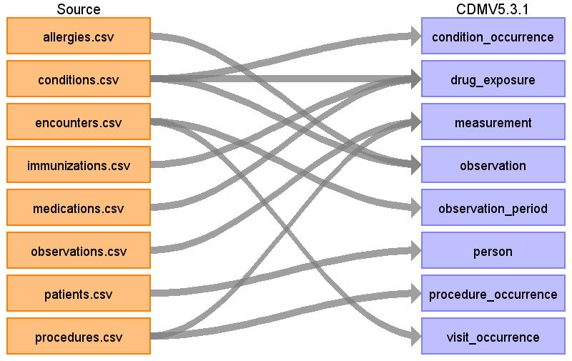

# Table name: condition_occurrence

Reading from conditions.csv

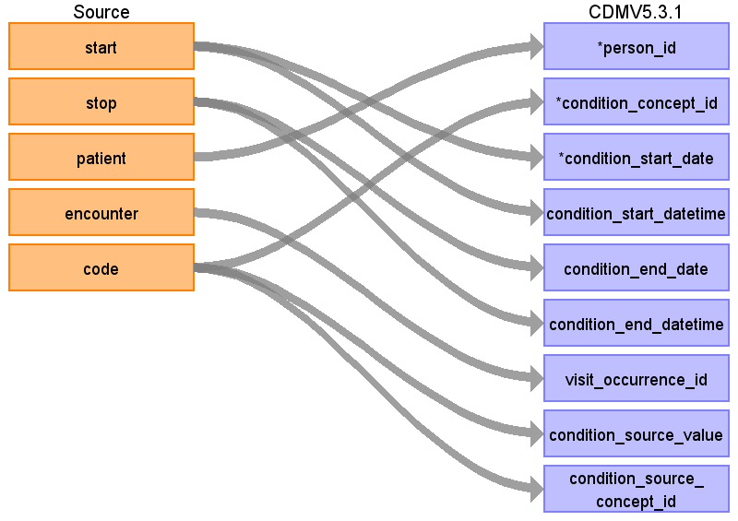

|  |  |  |  |
| --- | --- | --- | --- |
| Destination Field | Source Field | Logic | Comment |
| condition_occurrence_id |  |  | AUTOGENERATE |
| person_id | patient | Map by mapping person.person_source_value to patient.  Find person.person_id by mapping encouters.patient to person.person_source_value. |  |
| condition_concept_id | code | Use code to lookup target_concept_id in CTE_TARGET_VOCAB_MAP:  select ctvm.target_concept_id  from conditions c  join cte_target_vocab_map ctvm  on ctvm.source_code = c.code  and ctvm.target_domain_id = 'Condition'  and ctvm.target_vocabulary_id = 'SNOMED'  and ctvm.target_invalid_reason is NULL  and ctvm.target_standard_concept = ‘S’ |  |
| condition_start_date | start |  |  |
| condition_start_datetime | start |  |  |
| condition_end_date | stop |  |  |
| condition_end_datetime | stop |  |  |
| condition_type_concept_id |  |  | concept_id: 32020 |
| stop_reason |  |  | NULL |
| provider_id |  |  | NULL |
| visit_occurrence_id | encounter | Lookup visit_occurrence_id using encounter, joining to temp table defined in AllVisitTable.sql. |  |
| visit_detail_id |  |  | 0 |
| condition_source_value | code |  |  |
| condition_source_concept_id | code | Use code to lookup source_concept_id in CTE_SOURCE_VOCAB_MAP:  select csvm.source_concept_id  from cte_source_vocab_map csvm  join conditions c  on csvm.source_code = c.code  and csvm.source_vocabulary_id = 'SNOMED' |  |
| condition_status_source_value |  |  | NULL |
| condition_status_concept_id |  |  | 0 |

Table name: death

Table name: device_exposure

# Table name: drug_exposure

Reading from conditions.csv

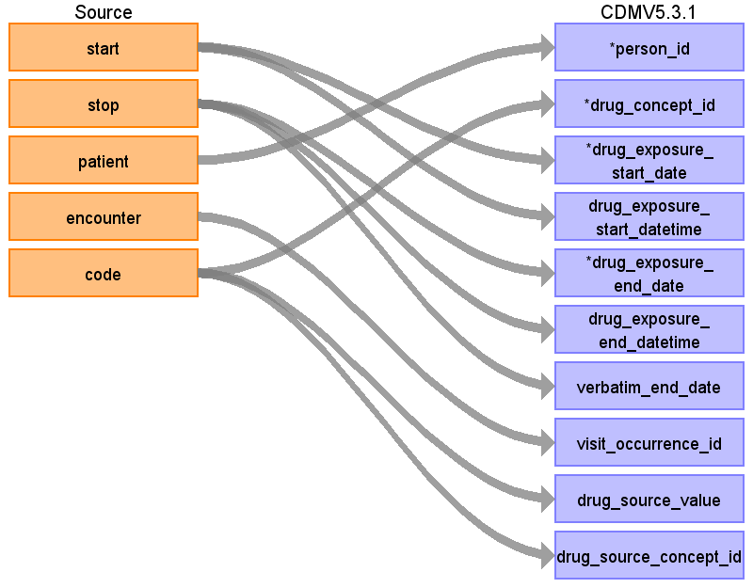

|  |  |  |  |
| --- | --- | --- | --- |
| Destination Field | Source Field | Logic | Comment |
| drug_exposure_id |  |  | Autogenerate |
| person_id | patient | Map by mapping person.person_source_value to patient.  Find person.person_id by mapping encouters.patient to person.person_source_value. |  |
| drug_concept_id | code | Use code to lookup target_concept_id in CTE_TARGET_VOCAB_MAP:  select ctvm.target_concept_id  from conditions c  join cte_target_vocab_map ctvm  on ctvm.source_code = c.code  and ctvm.target_domain_id = 'Drug'  and ctvm.target_vocabulary_id = 'RxNorm'  and ctvm.target_invalid_reason is NULL  and ctvm.target_standard_concept = ‘S’ |  |
| drug_exposure_start_date | start |  |  |
| drug_exposure_start_datetime | start |  |  |
| drug_exposure_end_date | stop |  |  |
| drug_exposure_end_datetime | stop |  |  |
| verbatim_end_date | stop |  | NULL |
| drug_type_concept_id |  |  | 581452 |
| stop_reason |  |  | NULL |
| refills |  |  | 0 |
| quantity |  |  | 0 |
| days_supply |  |  | 0 |
| sig |  |  | NULL |
| route_concept_id |  |  | 0 |
| lot_number |  |  | 0 |
| provider_id |  |  | 0 |
| visit_occurrence_id | encounter | Lookup visit_occurrence_id using encounter, joining to temp table defined in AllVisitTable.sql. |  |
| visit_detail_id |  |  | 0 |
| drug_source_value | code |  |  |
| drug_source_concept_id | code | Use code to lookup source_concept_id in CTE_SOURCE_VOCAB_MAP:  select csvm.source_concept_id  from cte_source_vocab_map csvm  join conditions c  on csvm.source_code = c.code  and csvm.source_vocabulary_id = 'SNOMED' |  |
| route_source_value |  |  | NULL |
| dose_unit_source_value |  |  | NULL |

Reading from medications.csv

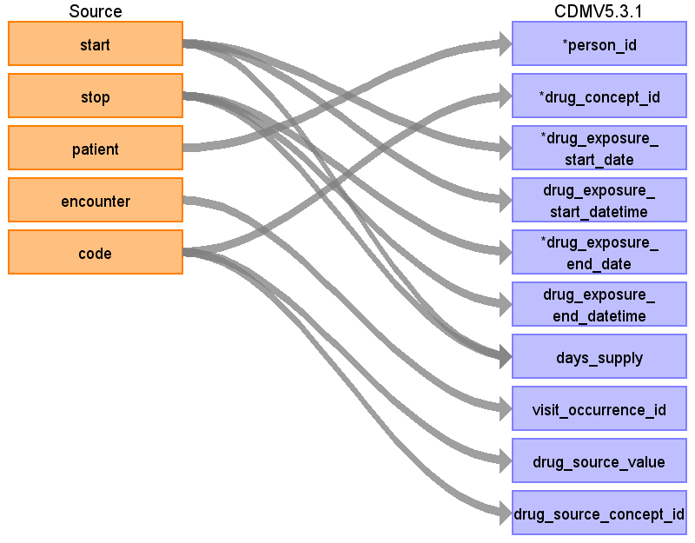

|  |  |  |  |
| --- | --- | --- | --- |
| Destination Field | Source Field | Logic | Comment |
| drug_exposure_id |  |  | Autogenerate |
| person_id | patient | Map by mapping person.person_source_value to patient.  Find person.person_id by mapping encouters.patient to person.person_source_value. |  |
| drug_concept_id | code | Use code to lookup target_concept_id in CTE_TARGET_VOCAB_MAP:  select ctvm.target_concept_id  from medications m  join cte_target_vocab_map ctvm  on ctvm.source_code = m.code  and ctvm.target_domain_id = 'Drug'  and ctvm.target_vocabulary_id = 'RxNorm'  and ctvm.target_invalid_reason is NULL  and ctvm.target_standard_concept = ‘S’ |  |
| drug_exposure_start_date | start |  |  |
| drug_exposure_start_datetime | start |  |  |
| drug_exposure_end_date | stop |  |  |
| drug_exposure_end_datetime | stop |  |  |
| verbatim_end_date |  |  | NULL |
| drug_type_concept_id |  |  | 38000177 |
| stop_reason |  |  | NULL |
| refills |  |  | 0 |
| quantity |  |  | 0 |
| days_supply | start  stop |  | 0 |
| sig |  |  | NULL |
| route_concept_id |  |  | 0 |
| lot_number |  |  | 0 |
| provider_id |  |  | 0 |
| visit_occurrence_id | encounter | Lookup visit_occurrence_id using encounter, joining to temp table defined in AllVisitTable.sql. |  |
| visit_detail_id |  |  | 0 |
| drug_source_value | code |  |  |
| drug_source_concept_id | code | Use code to lookup target_concept_id in CTE_SOURCE_VOCAB_MAP:  select csvm.source_concept_id  from medications m  join cte_source_vocab_map csvm  on cvm.source_code = m.code  and cvm.source_vocabulary_id = 'RxNorm' |  |
| route_source_value |  |  | NULL |
| dose_unit_source_value |  |  | NULL |

Reading from immunizations.csv

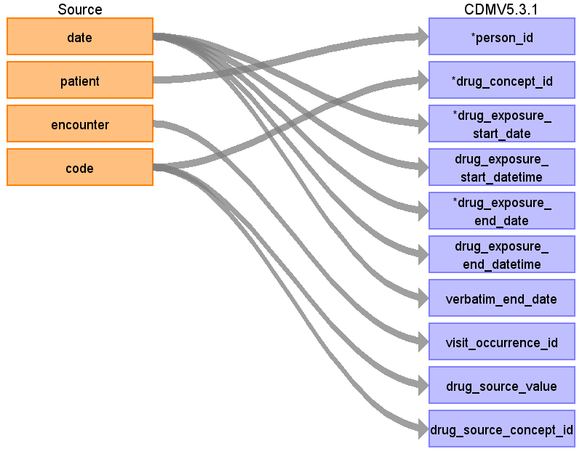

|  |  |  |  |
| --- | --- | --- | --- |
| Destination Field | Source Field | Logic | Comment |
| drug_exposure_id |  |  | Autogenerate |
| person_id | patient | Map by mapping person.person_source_value to patient.  Find person.person_id by mapping encouters.patient to person.person_source_value. |  |
| drug_concept_id | code | Use code to lookup target_concept_id in CTE_TARGET_VOCAB_MAP:  select ctvm.target_concept_id  from immunizations i  join cte_target_vocab_map ctvm  on ctvm.source_code = i.code  and ctvm.target_domain_id = 'Drug'  and ctvm.target_vocabulary_id = 'CVX'  and ctvm.target_invalid_reason is NULL  and ctvm.target_standard_concept = ‘S’ |  |
| drug_exposure_start_date | date |  |  |
| drug_exposure_start_datetime | date |  |  |
| drug_exposure_end_date | date |  |  |
| drug_exposure_end_datetime | date |  |  |
| verbatim_end_date | date |  | NULL |
| drug_type_concept_id |  |  | 581452 |
| stop_reason |  |  | NULL |
| refills |  |  | 0 |
| quantity |  |  | 0 |
| days_supply |  |  | 0 |
| sig |  |  | NULL |
| route_concept_id |  |  | 0 |
| lot_number |  |  | 0 |
| provider_id |  |  | 0 |
| visit_occurrence_id | encounter | Lookup visit_occurrence_id using encounter, joining to temp table defined in AllVisitTable.sql. |  |
| visit_detail_id |  |  | 0 |
| drug_source_value | code |  |  |
| drug_source_concept_id | code | Use code to lookup target_concept_id in CTE_SOURCE_VOCAB_MAP:  select csvm.source_concept_id  from immunizations i  join cte_source_vocab_map csvm  on csvm.source_code = i.code  and csvm.source_vocabulary_id = 'CVX' |  |
| route_source_value |  |  | NULL |
| dose_unit_source_value |  |  | NULL |

Table name: fact_relationship

# Table name: measurement

Reading from procedures.csv

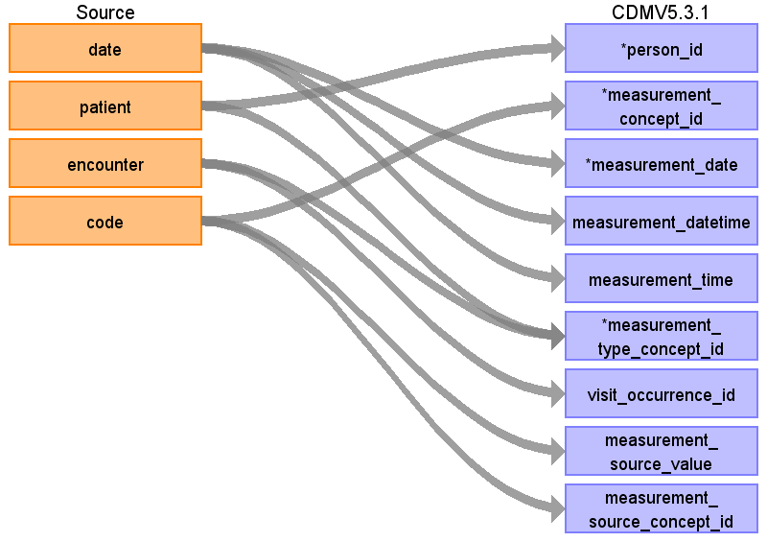

|  |  |  |  |
| --- | --- | --- | --- |
| Destination Field | Source Field | Logic | Comment |
| measurement_id |  |  | autogenerate |
| person_id | patient | Lookup in the person table: map by mapping person.person_source_value to patient. |  |
| measurement_concept_id | code | Use code to lookup target_concept_id in CTE_TARGET_VOCAB_MAP:  select ctvm.target_concept_id  from procedures pr  join cte_target_vocab_map ctvm  on ctvm.source_code = pr.code  and ctvm.target_domain_id = 'Measurement'  and ctvm.target_vocabulary_id = 'SNOMED'  and ctvm.target_invalid_reason is NULL  and ctvm.target_standard_concept = ‘S’ |  |
| measurement_date | date |  |  |
| measurement_datetime | date |  |  |
| measurement_time | date |  | NULL |
| measurement_type_concept_id | encounter  patient |  | concept_id: 5001 |
| operator_concept_id |  |  | 0 |
| value_as_number |  |  |  |
| value_as_concept_id |  |  | 0 |
| unit_concept_id |  |  | 0 |
| range_low |  |  | NULL |
| range_high |  |  | NULL |
| provider_id |  |  | 0 |
| visit_occurrence_id | encounter | Lookup visit_occurrence_id using encounter, joining to temp table defined in AllVisitTable.sql. |  |
| visit_detail_id |  |  | 0 |
| measurement_source_value | code |  |  |
| measurement_source_concept_id | code | Use code to lookup source_concept_id in CTE_SOURCE_VOCAB_MAP:  select csvm.source_concept_id  from cte_source_vocab_map csvm  join procedures pr  on csvm.source_code = pr.code  and csvm.source_vocabulary_id = 'SNOMED' |  |
| unit_source_value |  |  |  |
| value_source_value |  |  |  |

Reading from observations.csv

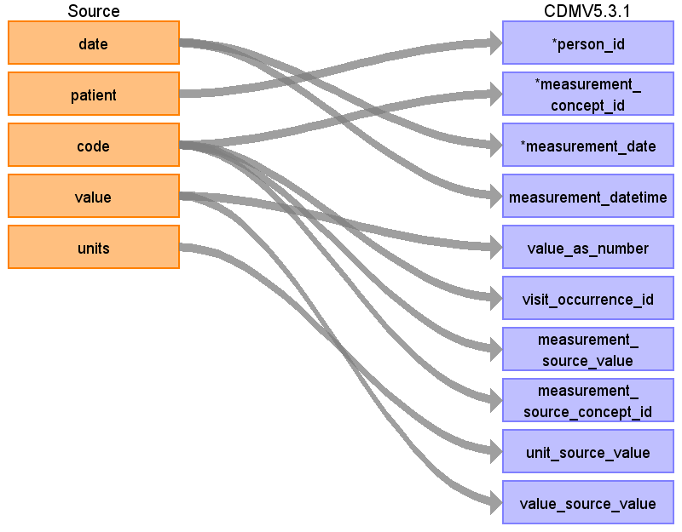

|  |  |  |  |
| --- | --- | --- | --- |
| Destination Field | Source Field | Logic | Comment |
| measurement_id |  |  | autogenerate |
| person_id | patient | Map by mapping person.person_source_value to patient.  Find person.person_id by mapping encouters.patient to person.person_source_value. |  |
| measurement_concept_id | code | Use code to lookup target_concept_id in CTE_TARGET_VOCAB_MAP:  select ctvm.target_concept_id  from observations o  join cte_target_vocab_map ctvm  on ctvm.source_code = o.code  and ctvm.target_domain_id = 'Measurement'  and ctvm.target_vocabulary_id = 'LOINC'  and ctvm.target_invalid_reason is NULL  and ctvm.target_standard_concept = ‘S’ |  |
| measurement_date | date |  |  |
| measurement_datetime | date |  |  |
| measurement_time |  |  | NULL |
| measurement_type_concept_id |  |  | concept_id: 5001 |
| operator_concept_id |  |  | 0 |
| value_as_number | value |  |  |
| value_as_concept_id |  |  | 0 |
| unit_concept_id |  |  | 0 |
| range_low |  |  | NULL |
| range_high |  |  | NULL |
| provider_id |  |  | 0 |
| visit_occurrence_id | code | Lookup visit_occurrence_id using encounter, joining to temp table defined in AllVisitTable.sql. |  |
| visit_detail_id |  |  | 0 |
| measurement_source_value | code |  |  |
| measurement_source_concept_id | code | Use code to lookup source_concept_id in CTE_SOURCE_VOCAB_MAP:  select csvm.source_concept_id  from cte_source_vocab_map csvm  join observations o  on csvm.source_code = o.code  and csvm.source_vocabulary_id = 'LOINC' |  |
| unit_source_value | units |  |  |
| value_source_value | value |  |  |

Table name: note

Table name: note_nlp

# Table name: observation

Reading from allergies.csv

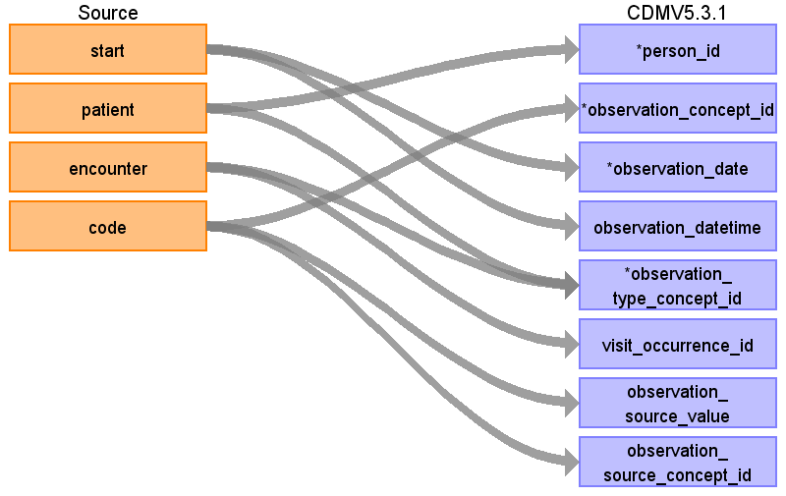

|  |  |  |  |
| --- | --- | --- | --- |
| Destination Field | Source Field | Logic | Comment |
| observation_id |  |  | AUTOGENERATE |
| person_id | patient | Map by mapping person.person_source_value to patient.  Find person.person_id by mapping encouters.patient to person.person_source_value. |  |
| observation_concept_id | code | Use code to lookup target_concept_id in CTE_TARGET_VOCAB_MAP:  select ctvm.target_concept_id  from allergies a  join cte_target_vocab_map ctvm  on ctvm.source_code = a.code  and ctvm.target_domain_id = 'Observation'  and ctvm.target_vocabulary_id = 'SNOMED'  and target_invalid_reason is NULL  and target_standard_concept = ‘S’ |  |
| observation_date | start |  |  |
| observation_datetime | start |  |  |
| observation_type_concept_id |  |  | 38000280 |
| value_as_number |  |  | NULL |
| value_as_string |  |  | NULL |
| value_as_concept_id |  |  | 0 |
| qualifier_concept_id |  |  | 0 |
| unit_concept_id |  |  | 0 |
| provider_id |  |  | 0 |
| visit_occurrence_id | encounter | Lookup visit_occurrence_id using encounter, joining to temp table defined in AllVisitTable.sql. |  |
| visit_detail_id |  |  | 0 |
| observation_source_value | code |  |  |
| observation_source_concept_id | code | Use code to lookup source_concept_id in CTE_SOURCE_VOCAB_MAP:  select csvm.source_concept_id  from cte_source_vocab_map csvm  join allergies a  on csvm.source_code = a.code  and csvm.source_vocabulary_id = 'SNOMED' |  |
| unit_source_value |  |  | NULL |
| qualifier_source_value |  |  | NULL |

Reading from conditions.csv



|  |  |  |  |
| --- | --- | --- | --- |
| Destination Field | Source Field | Logic | Comment |
| observation_id |  |  | AUTOGENERATE |
| person_id | patient | Map by mapping person.person_source_value to patient.  Find person.person_id by mapping encouters.patient to person.person_source_value. |  |
| observation_concept_id | code | Use code to lookup target_concept_id in CTE_TARGET_VOCAB_MAP:  select ctvm.target_concept_id  from conditions c  join cte_target_vocab_map ctvm  on ctvm.source_code = c.code  and ctvm.target_domain_id = 'Observation'  and ctvm.target_vocabulary_id = 'SNOMED'  and ctvm.target_invalid_reason is NULL  and ctvm.target_standard_concept = ‘S’ |  |
| observation_date | start |  |  |
| observation_datetime | start |  |  |
| observation_type_concept_id | encounter  patient |  | 38000276 |
| value_as_number |  |  | NULL |
| value_as_string |  |  | NULL |
| value_as_concept_id |  |  | 0 |
| qualifier_concept_id |  |  | 0 |
| unit_concept_id |  |  | 0 |
| provider_id |  |  | 0 |
| visit_occurrence_id | encounter | Lookup visit_occurrence_id using encounter, joining to temp table defined in AllVisitTable.sql. |  |
| visit_detail_id |  |  | 0 |
| observation_source_value | code |  |  |
| observation_source_concept_id | code | Use code to lookup source_concept_id in CTE_SOURCE_VOCAB_MAP:  select csvm.source_concept_id  from cte_source_vocab_map csvm  join conditions c  on csvm.source_code = c.code  and csvm.source_vocabulary_id = 'SNOMED' |  |
| unit_source_value |  |  | NULL |
| qualifier_source_value |  |  | NULL |

# Table name: observation_period

Reading from encounters.csv

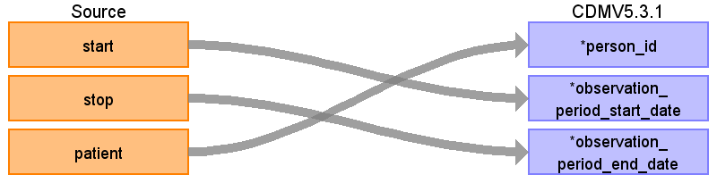

|  |  |  |  |
| --- | --- | --- | --- |
| Destination Field | Source Field | Logic | Comment |
| observation_period_id |  |  | Autogenerate |
| person_id | patient | Map by mapping person.person_source_value to patient.  Find person.person_id by mapping encouters.patient to person.person_source_value. |  |
| observation_period_start_date | start | min(start) group by patient  Take the earliest START per patient |  |
| observation_period_end_date | stop | max(stop) group by patient  Take the latest STOP per patient |  |
| period_type_concept_id |  |  | concept_id: 44814724 |

# Table name: person

Reading from patients.csv

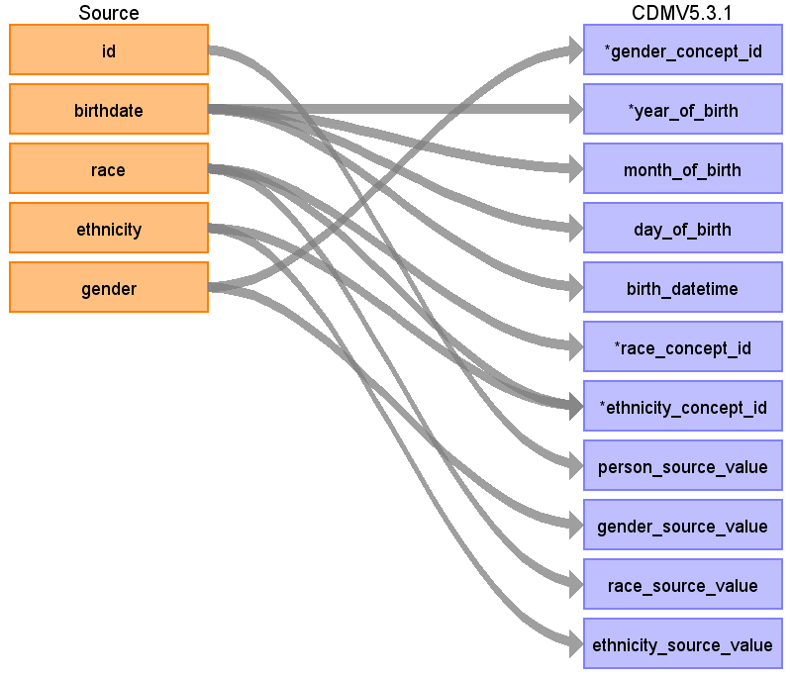

|  |  |  |  |
| --- | --- | --- | --- |
| Destination Field | Source Field | Logic | Comment |
| person_id |  |  | Autogenerate |
| gender_concept_id | gender | case upper(p.gender)  when 'M' then 8507  when 'F' then 8532  end | Please drop rows with missing/unknown gender. |
| year_of_birth | birthdate | Take Year from birthdate |  |
| month_of_birth | birthdate | Take month from birthdate |  |
| day_of_birth | birthdate | Take day from birthdate |  |
| birth_datetime | birthdate | With midnight as time 00:00:00 |  |
| race_concept_id | race | case upper(race)  when 'WHITE' then 8527  when 'BLACK' then 8516  when 'ASIAN' then 8515  else 0  end |  |
| ethnicity_concept_id | race  ethnicity | case when upper(race) in ('HISPANIC') then 38003563 else 0 end  case when upper(ethnicity) in (  'CENTRAL_AMERICAN',  'DOMINICAN',  'MEXICAN',  'PUERTO_RICAN',  'SOUTH_AMERICAN'  ) or upper(race) = 'HISPANIC'  then 38003563 else 0  end |  |
| location_id |  |  | NULL |
| provider_id |  |  | NULL |
| care_site_id |  |  | NULL |
| person_source_value | id |  |  |
| gender_source_value | gender |  |  |
| gender_source_concept_id |  |  | 0 |
| race_source_value | race |  |  |
| race_source_concept_id |  |  | 0 |
| ethnicity_source_value | ethnicity |  |  |
| ethnicity_source_concept_id |  |  | 0 |

# Table name: procedure_occurrence

Reading from procedures.csv

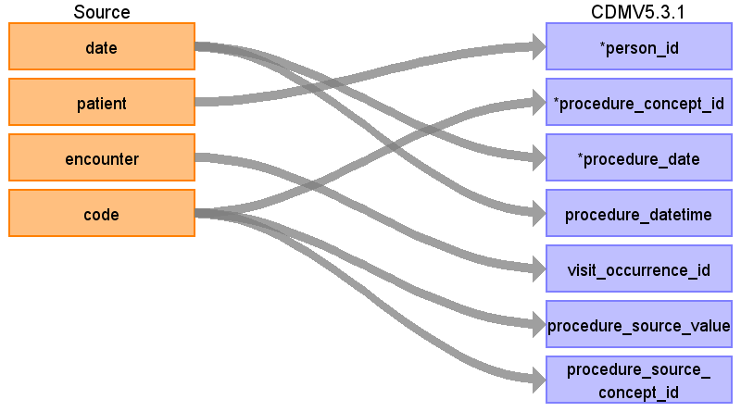

|  |  |  |  |
| --- | --- | --- | --- |
| Destination Field | Source Field | Logic | Comment |
| procedure_occurrence_id |  |  | AUTOGENERATE |
| person_id | patient | Map by mapping person.person_source_value to patient.  Find person.person_id by mapping encouters.patient to person.person_source_value. |  |
| procedure_concept_id | code | Use code to lookup target_concept_id in CTE_TARGET_VOCAB_MAP:  select ctvm.target_concept_id  from procedures pr  join cte_target_vocab_map ctvm  on ctvm.source_code = pr.code  and ctvm.target_domain_id = 'Procedure'  and ctvm.target_vocabulary_id = 'SNOMED' |  |
| procedure_date | date |  |  |
| procedure_datetime | date |  |  |
| procedure_type_concept_id |  |  | concept_id: 38000275 |
| modifier_concept_id |  |  | 0 |
| quantity |  |  | NULL |
| provider_id |  |  | NULL |
| visit_occurrence_id | encounter | Lookup visit_occurrence_id using encounter, joining to temp table defined in AllVisitTable.sql. |  |
| visit_detail_id |  |  | 0 |
| procedure_source_value | code |  |  |
| procedure_source_concept_id | code | Use code to lookup source_concept_id in CTE_SOURCE_VOCAB_MAP:  select csvm.source_concept_id  from cte_source_vocab_map csvm  join procedures pr  on csvm.source_code = pr.code  and csvm.source_vocabulary_id = 'SNOMED' |  |
| modifier_source_value |  |  | NULL |

Table name: specimen

Table name: visit_detail

# Table name: visit_occurrence

Reading from encounters.csv

Use logic found here:

https://github.com/OHDSI/ETL-Synthea/blob/master/ETL/SQL/AllVisitTable.sql

PART 1 - Generate visits by:

-For encounterclass = ‘Inpatient’ (IP):

---Sort data in ascending order by PERSON_ID, VISIT_START_DATE, VISIT_END_DATE.

---Then by PERSON_ID, collapse lines of claim as long as the time between the VISIT_END_DATE of one line and the VISIT_START_DATE of the next is <=1.

---Then each consolidated inpatient claim is considered as one inpatient visit, set

------MIN(VISIT_START_DATE) as VISIT_START_DATE

------MAX(VISIT_END_DATE) as VISIT_END_DATE

------‘IP’ as PLACE_OF_SERVICE_SOURCE_VALUE

---See if any ‘outpatient’ (OP), ‘ambulatory’ (OP), ‘wellness’ (OP), ‘emergency’ (ER) or 'urgentcare' (ER) records occur during an ‘inpatient’ visit. These should be consolidated into that ‘inpatient’ visit, unless it is an ‘emergency’ or 'urgentcare' visit that starts and ends on the first day of the ‘inpatient’ visit. Types of outpatient (OP) visits not collapsed: [1] if an OP starts before an IP but ends during an IP or [2] if an OP starts before and ends after an IP visit. If an OP is collapsed into an IP and its VISIT_END_DATE is greater than the IP's VISIT_END_DATE it does not change the IP VISIT_END_DATE.

-For claim type in ('emergency','urgentcare') (ER)

---Sort data in ascending order by PERSON_ID, VISIT_START_DATE, VISIT_END_DATE.

---Then by PERSON_ID, collapse all (ER) claims that start on the same day as one ER visit, then take VISIT_START_DATE as VISIT_START_DATE, MAX (VISIT_END_DATE) as VISIT_END_DATE, and ‘ER’ as PLACE_OF_SERVICE_SOURCE_VALUE.

-For claim type in ('ambulatory', 'wellness', 'outpatient') (OP)

---Sort data in ascending order by PERSON_ID, VISIT_START_DATE, VISIT_END_DATE.

---Then by PERSON_ID take VISIT_START_DATE as VISIT_START_DATE, MAX (VISIT_END_DATE) as VISIT_END_DATE, and ‘OP’ as PLACE_OF_SERVICE_SOURCE_VALUE.

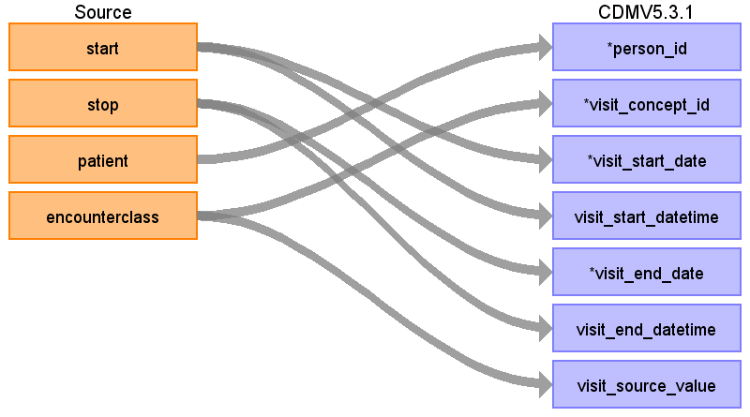

|  |  |  |  |
| --- | --- | --- | --- |
| Destination Field | Source Field | Logic | Comment |
| visit_occurrence_id |  |  | Autogenerate |
| person_id | patient | Map by mapping person.person_source_value to patient.  Find person.person_id by mapping encouters.patient to person.person_source_value. |  |
| visit_concept_id | encounterclass | case  when lower(encouterclass) = 'ambulatory' then 9202  when lower(encouterclass) = 'emergency' then 9203  when lower(encouterclass) = 'inpatient' then 9201  when lower(encouterclass) = 'wellness' then 9202  when lower(encouterclass) = 'urgentcare' then 9203  when lower(encouterclass) = 'outpatient' then 9202  else 0  end |  |
| visit_start_date | start |  |  |
| visit_start_datetime | start |  |  |
| visit_end_date | stop |  |  |
| visit_end_datetime | stop |  |  |
| visit_type_concept_id |  |  | 44818517 |
| provider_id |  |  | NULL |
| care_site_id |  |  | NULL |
| visit_source_value | encounterclass |  |  |
| visit_source_concept_id |  |  | 0 |
| admitting_source_concept_id |  |  | 0 |
| admitting_source_value |  |  | NULL |
| discharge_to_concept_id |  |  | 0 |
| discharge_to_source_value |  |  | NULL |
| preceding_visit_occurrence_id |  |  | For a given person, find the previous visit:  lag(visit_occurrence_id)  over(partition by person_id order by visit_start_date) |

Table name: cohort

Table name: cohort_attribute

# Table name: condition_era

# Table name: dose_era

Table name: drug_era

Table name: cost

Table name: payer_plan_period

Table name: care_site

Table name: location

Table name: provider

Table name: cdm_source

Table name: metadata

Table name: attribute_definition

Table name: cohort_definition

Appendix: source tables

Table: allergies.csv

|  |  |  |  |
| --- | --- | --- | --- |
| Field | Type | Most freq. value | Comment |
| start | date | 2008-03-24 |  |
| stop | date |  |  |
| patient | varchar | 99a94a01-bb91-4ad7-9a69-b9bd0f114d47 |  |
| encounter | varchar | c430e49d-9612-4ba0-92ec-70ab4afdcb5f |  |
| code | int | 419474003 |  |
| description | varchar | Allergy to mould |  |

Table: careplans.csv

|  |  |  |  |
| --- | --- | --- | --- |
| Field | Type | Most freq. value | Comment |
| id | varchar | 906fceed-443f-4f59-acab-562f80c5cb44 |  |
| start | date | 2016-11-09 |  |
| stop | date |  |  |
| patient | varchar | b6750e05-91df-471b-97bb-a19ab9fe79c5 |  |
| encounter | varchar | 17781139-da60-46dc-ba6e-13637cb13c61 |  |
| code | int | 53950000 |  |
| description | varchar | Respiratory therapy |  |
| reasoncode | int | 10509002 |  |
| reasondescription | varchar | Acute bronchitis (disorder) |  |

Table: conditions.csv

|  |  |  |  |
| --- | --- | --- | --- |
| Field | Type | Most freq. value | Comment |
| start | date | 2017-12-26 |  |
| stop | date |  |  |
| patient | varchar | ffab9299-0b3d-474f-96a4-bb279c244c7c |  |
| encounter | varchar | 50bbccc5-bb6b-4073-8244-045f10a28469 |  |
| code | int | 444814009 |  |
| description | varchar | Viral sinusitis (disorder) |  |

Table: encounters.csv

|  |  |  |  |
| --- | --- | --- | --- |
| Field | Type | Most freq. value | Comment |
| id | varchar | 8ead2604-2f95-4ecb-a898-8c29f74709fb |  |
| start | varchar | 1983-04-24T05:36:43Z |  |
| stop | varchar | 2001-10-05T03:47:01Z |  |
| patient | varchar | 24121ee3-3413-4e42-8e17-0410204adf10 |  |
| encounterclass | varchar | ambulatory | case  when lower(encouterclass) = 'ambulatory' then 9202  when lower(encouterclass) = 'emergency' then 9203  when lower(encouterclass) = 'inpatient' then 9201  when lower(encouterclass) = 'wellness' then 9202  when lower(encouterclass) = 'urgentcare' then 9203  when lower(encouterclass) = 'outpatient' then 9202  else 0  end |
| code | int | 185349003 |  |
| description | varchar | Encounter for check up (procedure) |  |
| cost | real | 129.16 |  |
| reasoncode | int |  |  |
| reasondescription | varchar |  |  |

Table: imaging_studies.csv

|  |  |  |  |
| --- | --- | --- | --- |
| Field | Type | Most freq. value | Comment |
| id | varchar | 26cd0a95-10a6-4a30-8af1-ebc602d39b72 |  |
| date | date | 2015-10-26 |  |
| patient | varchar | 5dacca68-eb32-45ea-bf9d-f224f96e4299 |  |
| encounter | varchar | fcd7e8af-0242-4efb-a392-642ed4cb01d1 |  |
| bodysite_code | int | 51185008 |  |
| bodysite_description | varchar | Thoracic structure (body structure) |  |
| modality_code | varchar | CT |  |
| modality_description | varchar | Computed Tomography |  |
| sop_code | varchar | 1.2.840.10008.5.1.4.1.1.2 |  |
| sop_description | varchar | CT Image Storage |  |

Table: immunizations.csv

|  |  |  |  |
| --- | --- | --- | --- |
| Field | Type | Most freq. value | Comment |
| date | date | 2016-06-16 |  |
| patient | varchar | 8734f7b8-4525-4db3-b8b7-60da22f729b5 |  |
| encounter | varchar | c9557a0c-7f03-48ba-9975-667d28f2dc39 |  |
| code | int | 140 |  |
| description | varchar | Influenza seasonal injectable preservative free |  |
| cost | real | 140.52 |  |

Table: medications.csv

|  |  |  |  |
| --- | --- | --- | --- |
| Field | Type | Most freq. value | Comment |
| start | date | 2016-04-03 |  |
| stop | date |  |  |
| patient | varchar | 5dacca68-eb32-45ea-bf9d-f224f96e4299 |  |
| encounter | varchar | 93917d59-daf9-4206-b59c-c73262c4ca9f |  |
| code | int | 316672 |  |
| description | varchar | Simvistatin 10 MG |  |
| cost | real | 263.49 |  |
| dispenses | int | 1 |  |
| totalcost | real | 3161.88 |  |
| reasoncode | int |  |  |
| reasondescription | varchar |  |  |

Table: observations.csv

|  |  |  |  |
| --- | --- | --- | --- |
| Field | Type | Most freq. value | Comment |
| date | date | 1986-06-20 |  |
| patient | varchar | cfe0b091-a7b4-4fbb-a0a2-d0fd86a596e4 |  |
| encounter | varchar | e84bdba6-e316-4c1f-a778-99a05f0dde1f |  |
| code | varchar | 72514-3 |  |
| description | varchar | Pain severity - 0-10 verbal numeric rating [Score] - Reported |  |
| value | varchar | Never smoker |  |
| units | varchar | mg/dL |  |
| type | varchar | numeric |  |

Table: patients.csv

|  |  |  |  |
| --- | --- | --- | --- |
| Field | Type | Most freq. value | Comment |
| id | varchar | e31a194d-e8b1-4e81-a511-5da4ad99f8c8 |  |
| birthdate | date | 1926-02-23 |  |
| deathdate | date |  |  |
| ssn | varchar | 999-41-5589 |  |
| drivers | varchar |  |  |
| passport | varchar |  |  |
| prefix | varchar | Mr. |  |
| first | varchar | Benito209 |  |
| last | varchar | Marks830 |  |
| suffix | varchar |  |  |
| maiden | varchar |  |  |
| marital | varchar | M |  |
| race | varchar | white |  |
| ethnicity | varchar | irish |  |
| gender | varchar | M |  |
| birthplace | varchar | Boston |  |
| address | varchar | 192 MacGyver Dam |  |
| city | varchar | Boston |  |
| state | varchar | Massachusetts |  |
| zip | int | 02108 |  |

Table: procedures.csv

|  |  |  |  |
| --- | --- | --- | --- |
| Field | Type | Most freq. value | Comment |
| date | date | 2018-02-27 |  |
| patient | varchar | 24121ee3-3413-4e42-8e17-0410204adf10 |  |
| encounter | varchar | 7a9a4f7d-060c-4de9-b03d-0eee972ff7f1 |  |
| code | varchar | 428191000124101 |  |
| description | varchar | Documentation of current medications |  |
| cost | real | 516.65 |  |
| reasoncode | int | 72892002 |  |
| reasondescription | varchar | Normal pregnancy |  |