Source Data Mapping Approach to CDMV6.0

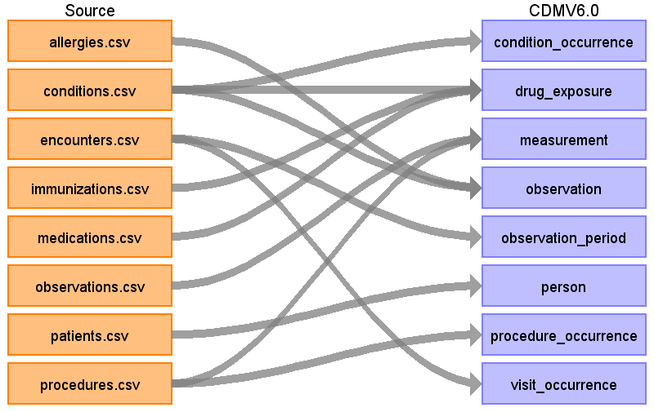

Table name: condition_occurrence

Reading from conditions.csv

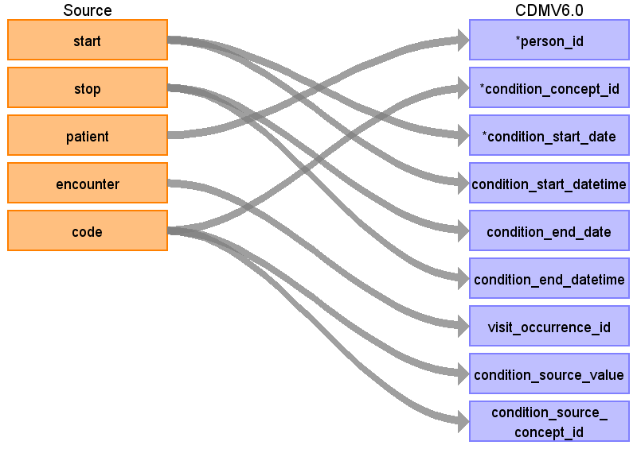

|  |  |  |  |
| --- | --- | --- | --- |
| Destination Field | Source Field | Logic | Comment |
| condition_occurrence_id |  |  | Autogenerate |
| person_id | patient | Map by mapping person.person_source_value to patient.  Find person.person_id by mapping encouters.patient to person.person_source_value. |  |
| condition_concept_id | code | Use the following SQL code to lookup target_concept_id in CTE_TARGET_VOCAB_MAP:  select ctvm.target_concept_id  from conditions c  join cte_target_vocab_map ctvm  on ctvm.source_code = c.code  and ctvm.target_domain_id = 'Condition'  and ctvm.target_vocabulary_id = 'SNOMED'  and ctvm.target_invalid_reason is NULL  and ctvm.target_standard_concept = 'S' |  |
| condition_start_date | start |  |  |
| condition_start_datetime | start |  |  |
| condition_end_date | stop |  |  |
| condition_end_datetime | stop |  |  |
| condition_type_concept_id |  |  | Set to 32020 (EHR Encounter Diagnosis) for all records |
| stop_reason |  |  |  |
| provider_id |  |  |  |
| visit_occurrence_id | encounter | Lookup visit_occurrence_id using encounter, joining to temp table defined in AllVisitTable.sql. |  |
| visit_detail_id |  |  |  |
| condition_source_value | code |  |  |
| condition_source_concept_id | code | Use the following SQL code to lookup the source_concept_id in CTE_SOURCE_VOCAB_MAP:  select csvm.source_concept_id  from cte_source_vocab_map csvm  join conditions c  on csvm.source_code = c.code  and csvm.source_vocabulary_id = 'SNOMED' |  |
| condition_status_source_value |  |  |  |
| condition_status_concept_id |  |  |  |

Table name: device_exposure

Table name: drug_exposure

Reading from conditions.csv

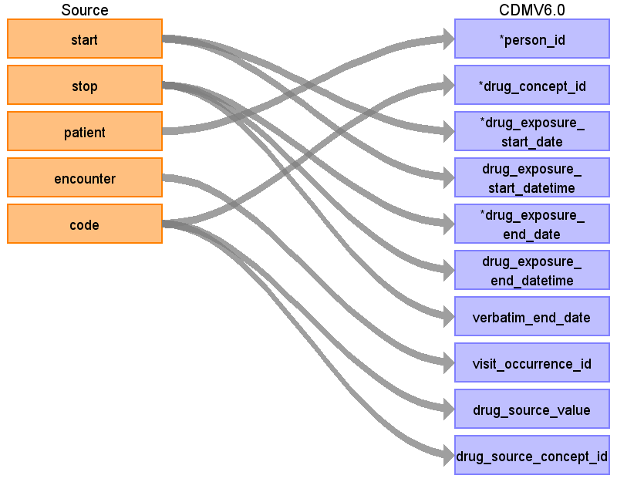

|  |  |  |  |
| --- | --- | --- | --- |
| Destination Field | Source Field | Logic | Comment |
| drug_exposure_id |  |  | Autogenerate |
| person_id | patient | Map by mapping person.person_source_value to patient.  Find person.person_id by mapping encouters.patient to person.person_source_value. |  |
| drug_concept_id | code | Use code to lookup target_concept_id in CTE_TARGET_VOCAB_MAP:  select ctvm.target_concept_id  from conditions c  join cte_target_vocab_map ctvm  on ctvm.source_code = c.code  and ctvm.target_domain_id = 'Drug'  and ctvm.target_vocabulary_id = 'RxNorm'  and ctvm.target_standard_concept = 'S'  and ctvm.target_invalid_reason is NULL |  |
| drug_exposure_start_date | start |  |  |
| drug_exposure_start_datetime | start |  |  |
| drug_exposure_end_date | stop |  | If there is no stop date, use the start date instead. |
| drug_exposure_end_datetime | stop |  | If there is no stop date, use the start date instead. |
| verbatim_end_date | stop |  |  |
| drug_type_concept_id |  |  | Use the concept_id 581452 for all records from the immunizations and conditions tables and concept_id 38000177 for all records from the medications table. |
| stop_reason |  |  |  |
| refills |  |  |  |
| quantity |  |  |  |
| days_supply |  |  | Subtract the start date from the stop date to find the days_supply. If there is no stop date this should be 0. |
| sig |  |  |  |
| route_concept_id |  |  |  |
| lot_number |  |  |  |
| provider_id |  |  |  |
| visit_occurrence_id | encounter | Lookup visit_occurrence_id using encounter, joining to temp table defined in AllVisitTable.sql. |  |
| visit_detail_id |  |  |  |
| drug_source_value | code |  |  |
| drug_source_concept_id | code | Use code to lookup source_concept_id in CTE_SOURCE_VOCAB_MAP:  select csvm.source_concept_id  from cte_source_vocab_map csvm  join conditions c  on csvm.source_code = c.code  and csvm.source_vocabulary_id = 'SNOMED' |  |
| route_source_value |  |  |  |
| dose_unit_source_value |  |  |  |

Reading from immunizations.csv

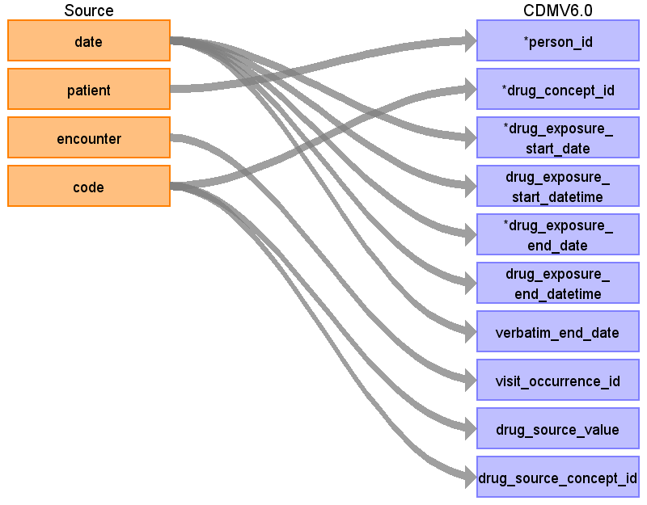

|  |  |  |  |
| --- | --- | --- | --- |
| Destination Field | Source Field | Logic | Comment |
| drug_exposure_id |  |  | Autogenerate |
| person_id | patient | Map by mapping person.person_source_value to patient.  Find person.person_id by mapping immunizations.patient to person.person_source_value. |  |
| drug_concept_id | code | Use code to lookup target_concept_id in CTE_TARGET_VOCAB_MAP:  select ctvm.target_concept_id  from immunizations i  join cte_target_vocab_map ctvm  on ctvm.source_code = i.code  and ctvm.target_domain_id = 'Drug'  and ctvm.target_vocabulary_id = 'CVX'  and ctvm.target_standard_concept = 'S'  and ctvm.target_invalid_reason is NULL |  |
| drug_exposure_start_date | date |  |  |
| drug_exposure_start_datetime | date | Use 00:00:00 as the time. |  |
| drug_exposure_end_date | date |  | If there is no stop date, use the start date instead. |
| drug_exposure_end_datetime | date | Use 00:00:00 as the time. | If there is no stop date, use the start date instead. |
| verbatim_end_date | date |  |  |
| drug_type_concept_id |  |  | Use the concept_id 581452 for all records from the immunizations and conditions tables and concept_id 38000177 for all records from the medications table. |
| stop_reason |  |  |  |
| refills |  |  |  |
| quantity |  |  |  |
| days_supply |  |  | Subtract the start date from the stop date to find the days_supply. If there is no stop date this should be 0. |
| sig |  |  |  |
| route_concept_id |  |  |  |
| lot_number |  |  |  |
| provider_id |  |  |  |
| visit_occurrence_id | encounter | Lookup visit_occurrence_id using encounter, joining to temp table defined in AllVisitTable.sql. |  |
| visit_detail_id |  |  |  |
| drug_source_value | code |  |  |
| drug_source_concept_id | code | Use code to lookup target_concept_id in CTE_SOURCE_VOCAB_MAP:  select csvm.source_concept_id  from immunizations i  join cte_source_vocab_map csvm  on csvm.source_code = i.code  and csvm.source_vocabulary_id = 'CVX' |  |
| route_source_value |  |  |  |
| dose_unit_source_value |  |  |  |

Reading from medications.csv

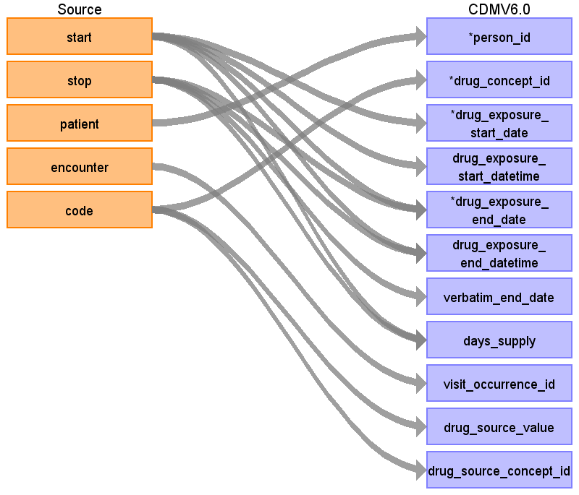

|  |  |  |  |
| --- | --- | --- | --- |
| Destination Field | Source Field | Logic | Comment |
| drug_exposure_id |  |  | Autogenerate |
| person_id | patient | Map by mapping person.person_source_value to patient.  Find person.person_id by mapping medications.patient to person.person_source_value. |  |
| drug_concept_id | code | Use code to lookup target_concept_id in CTE_TARGET_VOCAB_MAP:  select ctvm.target_concept_id  from medications m  join cte_target_vocab_map ctvm  on ctvm.source_code = m.code  and ctvm.target_domain_id = 'Drug'  and ctvm.target_vocabulary_id = 'RxNorm'  and ctvm.target_standard_concept = 'S'  and ctvm.target_invalid_reason is NULL |  |
| drug_exposure_start_date | start |  |  |
| drug_exposure_start_datetime | start | Use 00:00:00 as the time. |  |
| drug_exposure_end_date | stop  start |  | If there is no stop date, use the start date instead. |
| drug_exposure_end_datetime | stop  start | Use 00:00:00 as the time. | If there is no stop date, use the start date instead. |
| verbatim_end_date | stop |  |  |
| drug_type_concept_id |  |  | Use the concept_id 581452 for all records from the immunizations and conditions tables and concept_id 38000177 for all records from the medications table. |
| stop_reason |  |  |  |
| refills |  |  |  |
| quantity |  |  |  |
| days_supply | start  stop |  | Subtract the start date from the stop date to find the days_supply. If there is no stop date this should be 0. |
| sig |  |  |  |
| route_concept_id |  |  |  |
| lot_number |  |  |  |
| provider_id |  |  |  |
| visit_occurrence_id | encounter | Lookup visit_occurrence_id using encounter, joining to temp table defined in AllVisitTable.sql. |  |
| visit_detail_id |  |  |  |
| drug_source_value | code |  |  |
| drug_source_concept_id | code | Use code to lookup target_concept_id in CTE_SOURCE_VOCAB_MAP:  select csvm.source_concept_id  from medications m  join cte_source_vocab_map csvm  on cvm.source_code = m.code  and cvm.source_vocabulary_id = 'RxNorm' |  |
| route_source_value |  |  |  |
| dose_unit_source_value |  |  |  |

Table name: fact_relationship

Table name: measurement

Reading from observations.csv

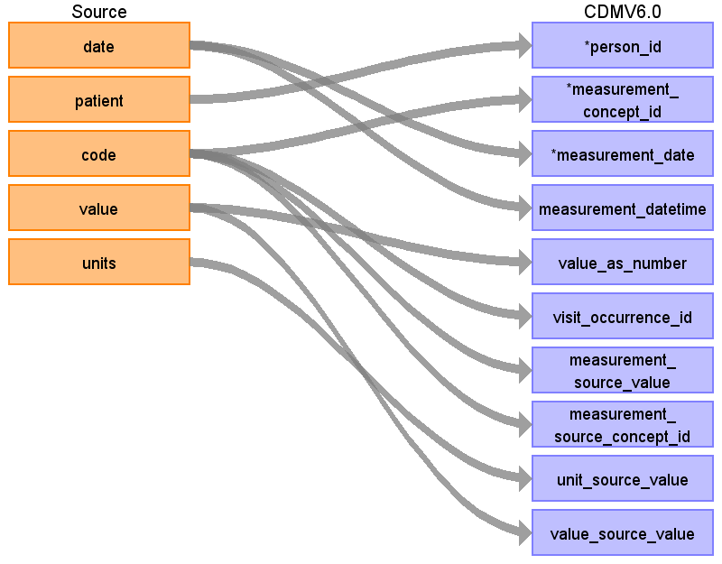

|  |  |  |  |
| --- | --- | --- | --- |
| Destination Field | Source Field | Logic | Comment |
| measurement_id |  |  | Autogenerate |
| person_id | patient | Map by mapping person.person_source_value to patient.  Find person.person_id by mapping encouters.patient to person.person_source_value. |  |
| measurement_concept_id | code | Use code to lookup target_concept_id in CTE_TARGET_VOCAB_MAP:  select ctvm.target_concept_id  from observations o  join cte_target_vocab_map ctvm  on ctvm.source_code = o.code  and ctvm.target_domain_id = 'Measurement'  and ctvm.target_standard_concept = 'S'  and ctvm.target_invalid_reason is NULL |  |
| measurement_date | date |  |  |
| measurement_datetime | date | Use 00:00:00 as time. |  |
| measurement_time |  |  |  |
| measurement_type_concept_id |  |  | Use concept_id 5001 for all records |
| operator_concept_id |  |  |  |
| value_as_number | value |  |  |
| value_as_concept_id |  |  |  |
| unit_concept_id |  |  |  |
| range_low |  |  |  |
| range_high |  |  |  |
| provider_id |  |  |  |
| visit_occurrence_id | code | Lookup visit_occurrence_id using encounter, joining to temp table defined in AllVisitTable.sql. |  |
| visit_detail_id |  |  |  |
| measurement_source_value | code |  |  |
| measurement_source_concept_id | code | Use code to lookup source_concept_id in CTE_SOURCE_VOCAB_MAP:  select csvm.source_concept_id  from cte_source_vocab_map csvm  join observations o  on csvm.source_code = o.code  and csvm.source_vocabulary_id = 'SNOMED' |  |
| unit_source_value | units |  |  |
| value_source_value | value |  |  |

Reading from procedures.csv

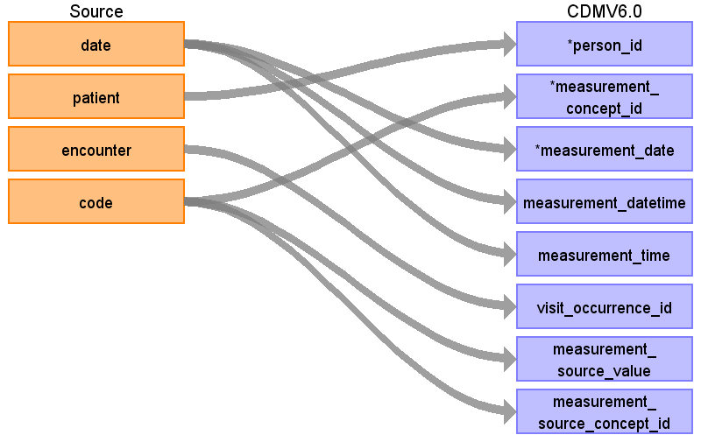

|  |  |  |  |
| --- | --- | --- | --- |
| Destination Field | Source Field | Logic | Comment |
| measurement_id |  |  | Autogenerate |
| person_id | patient | Lookup in the person table: map by mapping person.person_source_value to patient. |  |
| measurement_concept_id | code | Use code to lookup target_concept_id in CTE_TARGET_VOCAB_MAP:  select ctvm.target_concept_id  from procedures pr  join cte_target_vocab_map ctvm  on ctvm.source_code = pr.code  and ctvm.target_domain_id = 'Measurement'  and ctvm.target_vocabulary_id = 'SNOMED'  and ctvm.target_standard_concept = 'S'  and ctvm.target_invalid_reason is NULL |  |
| measurement_date | date |  |  |
| measurement_datetime | date | Use 00:00:00 as the time. |  |
| measurement_time | date |  |  |
| measurement_type_concept_id |  |  | Use concept_id 5001 for all records |
| operator_concept_id |  |  |  |
| value_as_number |  |  |  |
| value_as_concept_id |  |  |  |
| unit_concept_id |  |  |  |
| range_low |  |  |  |
| range_high |  |  |  |
| provider_id |  |  |  |
| visit_occurrence_id | encounter | Lookup visit_occurrence_id using encounter, joining to temp table defined in AllVisitTable.sql. |  |
| visit_detail_id |  |  |  |
| measurement_source_value | code |  |  |
| measurement_source_concept_id | code | Use code to lookup source_concept_id in CTE_SOURCE_VOCAB_MAP:  select csvm.source_concept_id  from cte_source_vocab_map csvm  join procedures pr  on csvm.source_code = pr.code  and csvm.source_vocabulary_id = 'SNOMED' |  |
| unit_source_value |  |  |  |
| value_source_value |  |  |  |

Table name: note

Table name: note_nlp

Table name: observation

Reading from allergies.csv

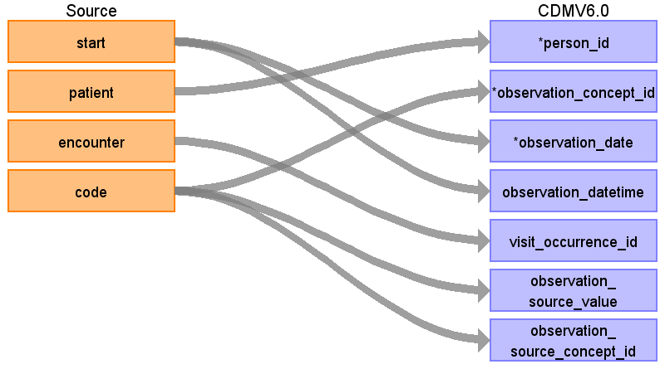

|  |  |  |  |
| --- | --- | --- | --- |
| Destination Field | Source Field | Logic | Comment |
| observation_id |  |  | Autogenerate |
| person_id | patient | Map by mapping person.person_source_value to patient.  Find person.person_id by mapping allergies.patient to person.person_source_value. |  |
| observation_concept_id | code | Use code to lookup target_concept_id in CTE_TARGET_VOCAB_MAP:  select ctvm.target_concept_id  from allergies a  join cte_target_vocab_map ctvm  on ctvm.source_code = a.code  and ctvm.target_domain_id = 'Observation'  and ctvm.target_vocabulary_id = 'SNOMED'  and ctvm.target_standard_concept = 'S'  and ctvm.target_invalid_reason is NULL |  |
| observation_date | start |  |  |
| observation_datetime | start | Use 00:00:00 as time. |  |
| observation_type_concept_id |  |  | Set as 38000280 for all records. |
| value_as_number |  |  |  |
| value_as_string |  |  |  |
| value_as_concept_id |  |  |  |
| qualifier_concept_id |  |  |  |
| unit_concept_id |  |  |  |
| provider_id |  |  |  |
| visit_occurrence_id | encounter | Lookup visit_occurrence_id using encounter, joining to temp table defined in AllVisitTable.sql. |  |
| visit_detail_id |  |  |  |
| observation_source_value | code |  |  |
| observation_source_concept_id | code | Use code to lookup source_concept_id in CTE_SOURCE_VOCAB_MAP:  select csvm.source_concept_id  from cte_source_vocab_map csvm  join allergies a  on csvm.source_code = a.code  and csvm.source_vocabulary_id = 'SNOMED' |  |
| unit_source_value |  |  |  |
| qualifier_source_value |  |  |  |
| observation_event_id |  |  |  |
| obs_event_field_concept_id |  |  |  |
| value_as_datetime |  |  |  |

Reading from conditions.csv



|  |  |  |  |
| --- | --- | --- | --- |
| Destination Field | Source Field | Logic | Comment |
| observation_id |  |  | Autogenerate |
| person_id | patient | Map by mapping person.person_source_value to patient.  Find person.person_id by mapping encouters.patient to person.person_source_value. |  |
| observation_concept_id | code | Use code to lookup target_concept_id in CTE_TARGET_VOCAB_MAP:  select ctvm.target_concept_id  from conditions c  join cte_target_vocab_map ctvm  on ctvm.source_code = c.code  and ctvm.target_domain_id = 'Observation'  and ctvm.target_vocabulary_id = 'SNOMED'  and ctvm.target_standard_concept = 'S'  and ctvm.target_invalid_reason is NULL |  |
| observation_date | start |  |  |
| observation_datetime | start |  |  |
| observation_type_concept_id |  |  | Set as 38000280 for all records. |
| value_as_number |  |  |  |
| value_as_string |  |  |  |
| value_as_concept_id |  |  |  |
| qualifier_concept_id |  |  |  |
| unit_concept_id |  |  |  |
| provider_id |  |  |  |
| visit_occurrence_id | encounter | Lookup visit_occurrence_id using encounter, joining to temp table defined in AllVisitTable.sql. |  |
| visit_detail_id |  |  |  |
| observation_source_value | code |  |  |
| observation_source_concept_id | code | Use code to lookup source_concept_id in CTE_SOURCE_VOCAB_MAP:  select csvm.source_concept_id  from cte_source_vocab_map csvm  join conditions c  on csvm.source_code = c.code  and csvm.source_vocabulary_id = 'SNOMED' |  |
| unit_source_value |  |  |  |
| qualifier_source_value |  |  |  |
| observation_event_id |  |  |  |
| obs_event_field_concept_id |  |  |  |
| value_as_datetime |  |  |  |

Table name: observation_period

Reading from encounters.csv

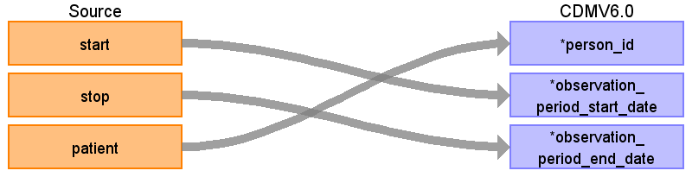

|  |  |  |  |
| --- | --- | --- | --- |
| Destination Field | Source Field | Logic | Comment |
| observation_period_id |  |  |  |
| person_id | patient | Map by mapping person.person_source_value to patient.  Find person.person_id by mapping encouters.patient to person.person_source_value. |  |
| observation_period_start_date | start | min(start) group by patient  Take the earliest START per patient |  |
| observation_period_end_date | stop | max(stop) group by patient  Take the latest STOP per patient |  |
| period_type_concept_id |  |  | Set as concept 44814724 for all records |

Table name: person

Reading from patients.csv

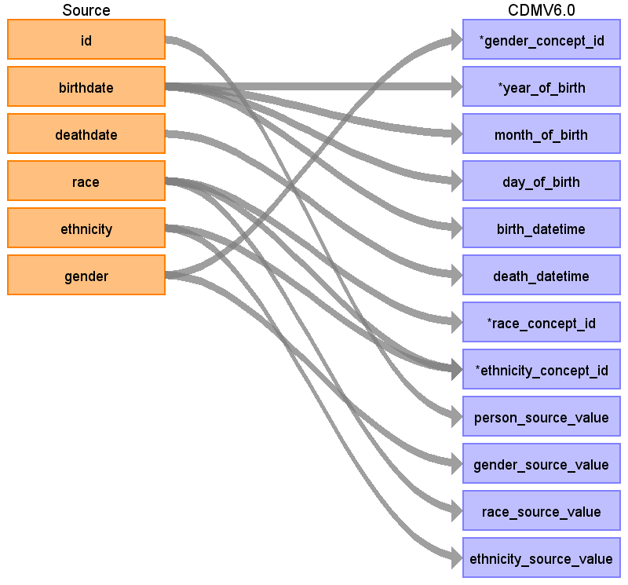

|  |  |  |  |
| --- | --- | --- | --- |
| Destination Field | Source Field | Logic | Comment |
| person_id |  |  | Autogenerate |
| gender_concept_id | gender | When gender = ‘M’ then set gender_concept_id to 8507, when gender = ‘F’ then set to 8532 | Drop any rows with missing/unknown gender. |
| year_of_birth | birthdate | Take year from birthdate |  |
| month_of_birth | birthdate | Take month from birthdate |  |
| day_of_birth | birthdate | Take day from birthdate |  |
| birth_datetime | birthdate | With midnight as time 00:00:00 |  |
| death_datetime | deathdate | With midnight as time 00:00:00 |  |
| race_concept_id | race | When race = ‘WHITE’ then set as 8527, when race = ‘BLACK’ then set as 8516, when race = ‘ASIAN’ then set as 8515, otherwise set as 0 |  |
| ethnicity_concept_id | race  ethnicity | When race = ‘HISPANIC’, or when ethnicity in (‘CENTRAL_AMERICAN’, ‘DOMINICAN’, ‘MEXICAN’, ‘PUERTO_RICAN’, ‘SOUTH_AMERICAN’ ) then set as 38003563, otherwise set as 0  When race = ‘HISPANIC’, or when ethnicity in (‘CENTRAL_AMERICAN’, ‘DOMINICAN’, ‘MEXICAN’, ‘PUERTO_RICAN’, ‘SOUTH_AMERICAN’ ) then set as 38003563, otherwise set as 0 |  |
| location_id |  |  |  |
| provider_id |  |  |  |
| care_site_id |  |  |  |
| person_source_value | id |  |  |
| gender_source_value | gender |  |  |
| gender_source_concept_id |  |  |  |
| race_source_value | race |  |  |
| race_source_concept_id |  |  |  |
| ethnicity_source_value | ethnicity |  |  |
| ethnicity_source_concept_id |  |  |  |

Table name: procedure_occurrence

Reading from procedures.csv

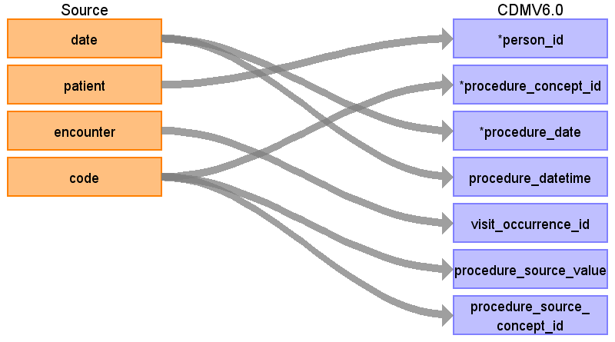

|  |  |  |  |
| --- | --- | --- | --- |
| Destination Field | Source Field | Logic | Comment |
| procedure_occurrence_id |  |  | Autogenerate |
| person_id | patient | Map by mapping person.person_source_value to patient.  Find person.person_id by mapping encouters.patient to person.person_source_value. |  |
| procedure_concept_id | code | Use code to lookup target_concept_id in CTE_TARGET_VOCAB_MAP:  select ctvm.target_concept_id  from procedures pr  join cte_target_vocab_map ctvm  on ctvm.source_code = pr.code  and ctvm.target_domain_id = 'Procedure'  and ctvm.target_vocabulary_id = 'SNOMED'  and ctvm.target_invalid_reason is NULL  and ctvm.target_standard_concept = 'S' |  |
| procedure_date | date |  |  |
| procedure_datetime | date | Use 00:00:00 as the time. |  |
| procedure_type_concept_id |  |  | Use concept_id 38000275 for all records. |
| modifier_concept_id |  |  |  |
| quantity |  |  |  |
| provider_id |  |  |  |
| visit_occurrence_id | encounter | Lookup visit_occurrence_id using encounter, joining to temp table defined in AllVisitTable.sql. |  |
| visit_detail_id |  |  |  |
| procedure_source_value | code |  |  |
| procedure_source_concept_id | code | Use code to lookup source_concept_id in CTE_SOURCE_VOCAB_MAP:  select csvm.source_concept_id  from cte_source_vocab_map csvm  join procedures pr  on csvm.source_code = pr.code  and csvm.source_vocabulary_id = 'SNOMED' |  |
| modifier_source_value |  |  |  |

Table name: specimen

Table name: visit_detail

Table name: visit_occurrence

Reading from encounters.csv

STEP 1

For encounterclass = ‘Inpatient’ (IP):

Sort data in ascending order by PATIENT, START, END.

Then by PERSON_ID, collapse lines of claim as long as the time between the END of one line and the START of the next is <=1 day.

Each consolidated inpatient claim is then considered as one inpatient visit, set

MIN(START) as VISIT_START_DATE

MAX(END) as VISIT_END_DATE

‘IP’ as PLACE_OF_SERVICE_SOURCE_VALUE

See if any records with encounterclass ‘outpatient’ (OP), ‘ambulatory’ (OP), ‘wellness’ (OP), ‘emergency’ (ER) or ‘urgentcare’ (ER) occur during an identified ‘inpatient’ visit. These should be consolidated into the ‘inpatient’ visit, unless it is an ‘emergency’ or ‘urgentcare’ visit that starts and ends on the first day of the ‘inpatient’ visit. Types of outpatient (OP) visits not collapsed:

If an OP starts before an IP but ends during an IP

If an OP starts before and ends after an IP visit. If an OP is collapsed into an IP and its VISIT_END_DATE is greater than the IP’s VISIT_END_DATE it does not change the IP VISIT_END_DATE.

For claim type in (‘emergency’,’urgentcare’) (ER)

Sort data in ascending order by PATIENT, START, END.

Then by PERSON_ID, collapse all (ER) claims that start on the same day as one ER visit, then take START as VISIT_START_DATE, MAX (END) as VISIT_END_DATE, and ‘ER’ as PLACE_OF_SERVICE_SOURCE_VALUE.

For claim type in (‘ambulatory’, ‘wellness’, ‘outpatient’) (OP)

Sort data in ascending order by PATIENT, START, END.

Then by PERSON_ID take START as VISIT_START_DATE, MAX(END) as VISIT_END_DATE, and ‘OP’ as PLACE_OF_SERVICE_SOURCE_VALUE.

Use logic found here: https://github.com/OHDSI/ETL-Synthea/blob/master/ETL/SQL/AllVisitTable.sql

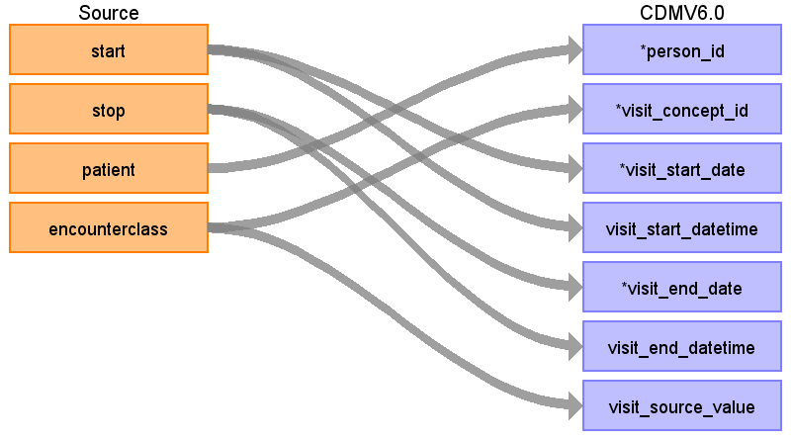

|  |  |  |  |
| --- | --- | --- | --- |
| Destination Field | Source Field | Logic | Comment |
| visit_occurrence_id |  |  | Autogenerate |
| person_id | patient | Map by mapping person.person_source_value to patient.  Find person.person_id by mapping encouters.patient to person.person_source_value. |  |
| visit_concept_id | encounterclass | When encounterclass is 'emergency' or 'urgentcare' then set to 9203. When encounterclass is 'ambulatory', 'wellness', or 'outpatient' then set to 9202. When encounterclass is 'inpatient' then set to 9201. Otherwise set to 0. |  |
| visit_start_date | start |  |  |
| visit_start_datetime | start |  |  |
| visit_end_date | stop |  |  |
| visit_end_datetime | stop |  |  |
| visit_type_concept_id |  |  | Set all records as concept_id 44818517. |
| provider_id |  |  |  |
| care_site_id |  |  |  |
| visit_source_value | encounterclass |  |  |
| visit_source_concept_id |  |  |  |
| admitted_from_concept_id |  |  |  |
| admitted_from_source_value |  |  |  |
| discharge_to_concept_id |  |  |  |
| discharge_to_source_value |  |  |  |
| preceding_visit_occurrence_id |  |  |  |

Table name: cohort

Table name: condition_era

Table name: dose_era

Table name: drug_era

Table name: cost

Table name: payer_plan_period

Table name: care_site

Table name: location

Table name: provider

Table name: cdm_source

Table name: metadata

Table name: cohort_definition

Table name: survey_conduct

Table name: location_history

Appendix: source tables

Table: allergies.csv

|  |  |  |  |
| --- | --- | --- | --- |
| Field | Type | Most freq. value | Comment |
| start | date | 2008-03-24 |  |
| stop | date |  |  |
| patient | varchar | 99a94a01-bb91-4ad7-9a69-b9bd0f114d47 |  |
| encounter | varchar | c430e49d-9612-4ba0-92ec-70ab4afdcb5f |  |
| code | int | 419474003 |  |
| description | varchar | Allergy to mould |  |

Table: careplans.csv

|  |  |  |  |
| --- | --- | --- | --- |
| Field | Type | Most freq. value | Comment |
| id | varchar | 906fceed-443f-4f59-acab-562f80c5cb44 |  |
| start | date | 2016-11-09 |  |
| stop | date |  |  |
| patient | varchar | b6750e05-91df-471b-97bb-a19ab9fe79c5 |  |
| encounter | varchar | 17781139-da60-46dc-ba6e-13637cb13c61 |  |
| code | int | 53950000 |  |
| description | varchar | Respiratory therapy |  |
| reasoncode | int | 10509002 |  |
| reasondescription | varchar | Acute bronchitis (disorder) |  |

Table: conditions.csv

|  |  |  |  |
| --- | --- | --- | --- |
| Field | Type | Most freq. value | Comment |
| start | date | 2017-12-26 |  |
| stop | date |  |  |
| patient | varchar | ffab9299-0b3d-474f-96a4-bb279c244c7c |  |
| encounter | varchar | 50bbccc5-bb6b-4073-8244-045f10a28469 |  |
| code | int | 444814009 |  |
| description | varchar | Viral sinusitis (disorder) |  |

Table: encounters.csv

|  |  |  |  |
| --- | --- | --- | --- |
| Field | Type | Most freq. value | Comment |
| id | varchar | 8ead2604-2f95-4ecb-a898-8c29f74709fb |  |
| start | varchar | 1983-04-24T05:36:43Z |  |
| stop | varchar | 2001-10-05T03:47:01Z |  |
| patient | varchar | 24121ee3-3413-4e42-8e17-0410204adf10 |  |
| encounterclass | varchar | ambulatory | case  when lower(encouterclass) = 'ambulatory' then 9202  when lower(encouterclass) = 'emergency' then 9203  when lower(encouterclass) = 'inpatient' then 9201  when lower(encouterclass) = 'wellness' then 9202  when lower(encouterclass) = 'urgentcare' then 9203  when lower(encouterclass) = 'outpatient' then 9202  else 0  end |
| code | int | 185349003 |  |
| description | varchar | Encounter for check up (procedure) |  |
| cost | real | 129.16 |  |
| reasoncode | int |  |  |
| reasondescription | varchar |  |  |

Table: imaging_studies.csv

|  |  |  |  |
| --- | --- | --- | --- |
| Field | Type | Most freq. value | Comment |
| id | varchar | 26cd0a95-10a6-4a30-8af1-ebc602d39b72 |  |
| date | date | 2015-10-26 |  |
| patient | varchar | 5dacca68-eb32-45ea-bf9d-f224f96e4299 |  |
| encounter | varchar | fcd7e8af-0242-4efb-a392-642ed4cb01d1 |  |
| bodysite_code | int | 51185008 |  |
| bodysite_description | varchar | Thoracic structure (body structure) |  |
| modality_code | varchar | CT |  |
| modality_description | varchar | Computed Tomography |  |
| sop_code | varchar | 1.2.840.10008.5.1.4.1.1.2 |  |
| sop_description | varchar | CT Image Storage |  |

Table: immunizations.csv

|  |  |  |  |
| --- | --- | --- | --- |
| Field | Type | Most freq. value | Comment |
| date | date | 2016-06-16 |  |
| patient | varchar | 8734f7b8-4525-4db3-b8b7-60da22f729b5 |  |
| encounter | varchar | c9557a0c-7f03-48ba-9975-667d28f2dc39 |  |
| code | int | 140 |  |
| description | varchar | Influenza seasonal injectable preservative free |  |
| cost | real | 140.52 |  |

Table: medications.csv

|  |  |  |  |
| --- | --- | --- | --- |
| Field | Type | Most freq. value | Comment |
| start | date | 2016-04-03 |  |
| stop | date |  |  |
| patient | varchar | 5dacca68-eb32-45ea-bf9d-f224f96e4299 |  |
| encounter | varchar | 93917d59-daf9-4206-b59c-c73262c4ca9f |  |
| code | int | 316672 |  |
| description | varchar | Simvistatin 10 MG |  |
| cost | real | 263.49 |  |
| dispenses | int | 1 |  |
| totalcost | real | 3161.88 |  |
| reasoncode | int |  |  |
| reasondescription | varchar |  |  |

Table: observations.csv

|  |  |  |  |
| --- | --- | --- | --- |
| Field | Type | Most freq. value | Comment |
| date | date | 1986-06-20 |  |
| patient | varchar | cfe0b091-a7b4-4fbb-a0a2-d0fd86a596e4 |  |
| encounter | varchar | e84bdba6-e316-4c1f-a778-99a05f0dde1f |  |
| code | varchar | 72514-3 |  |
| description | varchar | Pain severity - 0-10 verbal numeric rating [Score] - Reported |  |
| value | varchar | Never smoker |  |
| units | varchar | mg/dL |  |
| type | varchar | numeric |  |

Table: patients.csv

|  |  |  |  |
| --- | --- | --- | --- |
| Field | Type | Most freq. value | Comment |
| id | varchar | e31a194d-e8b1-4e81-a511-5da4ad99f8c8 |  |
| birthdate | date | 1926-02-23 |  |
| deathdate | date |  |  |
| ssn | varchar | 999-41-5589 |  |
| drivers | varchar |  |  |
| passport | varchar |  |  |
| prefix | varchar | Mr. |  |
| first | varchar | Benito209 |  |
| last | varchar | Marks830 |  |
| suffix | varchar |  |  |
| maiden | varchar |  |  |
| marital | varchar | M |  |
| race | varchar | white |  |
| ethnicity | varchar | irish |  |
| gender | varchar | M |  |
| birthplace | varchar | Boston |  |
| address | varchar | 192 MacGyver Dam |  |
| city | varchar | Boston |  |
| state | varchar | Massachusetts |  |
| zip | int | 02108 |  |

Table: procedures.csv

|  |  |  |  |
| --- | --- | --- | --- |
| Field | Type | Most freq. value | Comment |
| date | date | 2018-02-27 |  |
| patient | varchar | 24121ee3-3413-4e42-8e17-0410204adf10 |  |
| encounter | varchar | 7a9a4f7d-060c-4de9-b03d-0eee972ff7f1 |  |
| code | varchar | 428191000124101 |  |
| description | varchar | Documentation of current medications |  |
| cost | real | 516.65 |  |
| reasoncode | int | 72892002 |  |
| reasondescription | varchar | Normal pregnancy |  |