Task 0 :

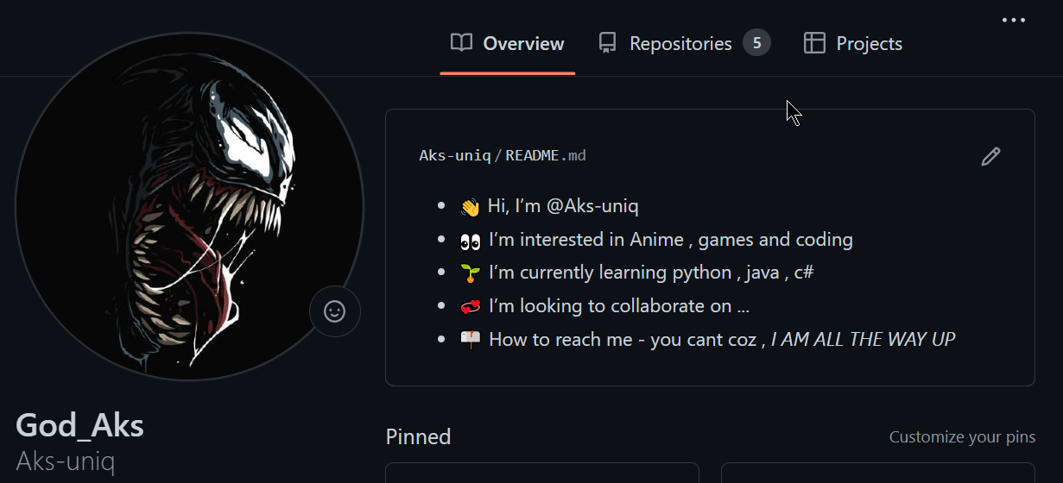

Task 1:

Visual studio Code IDE:

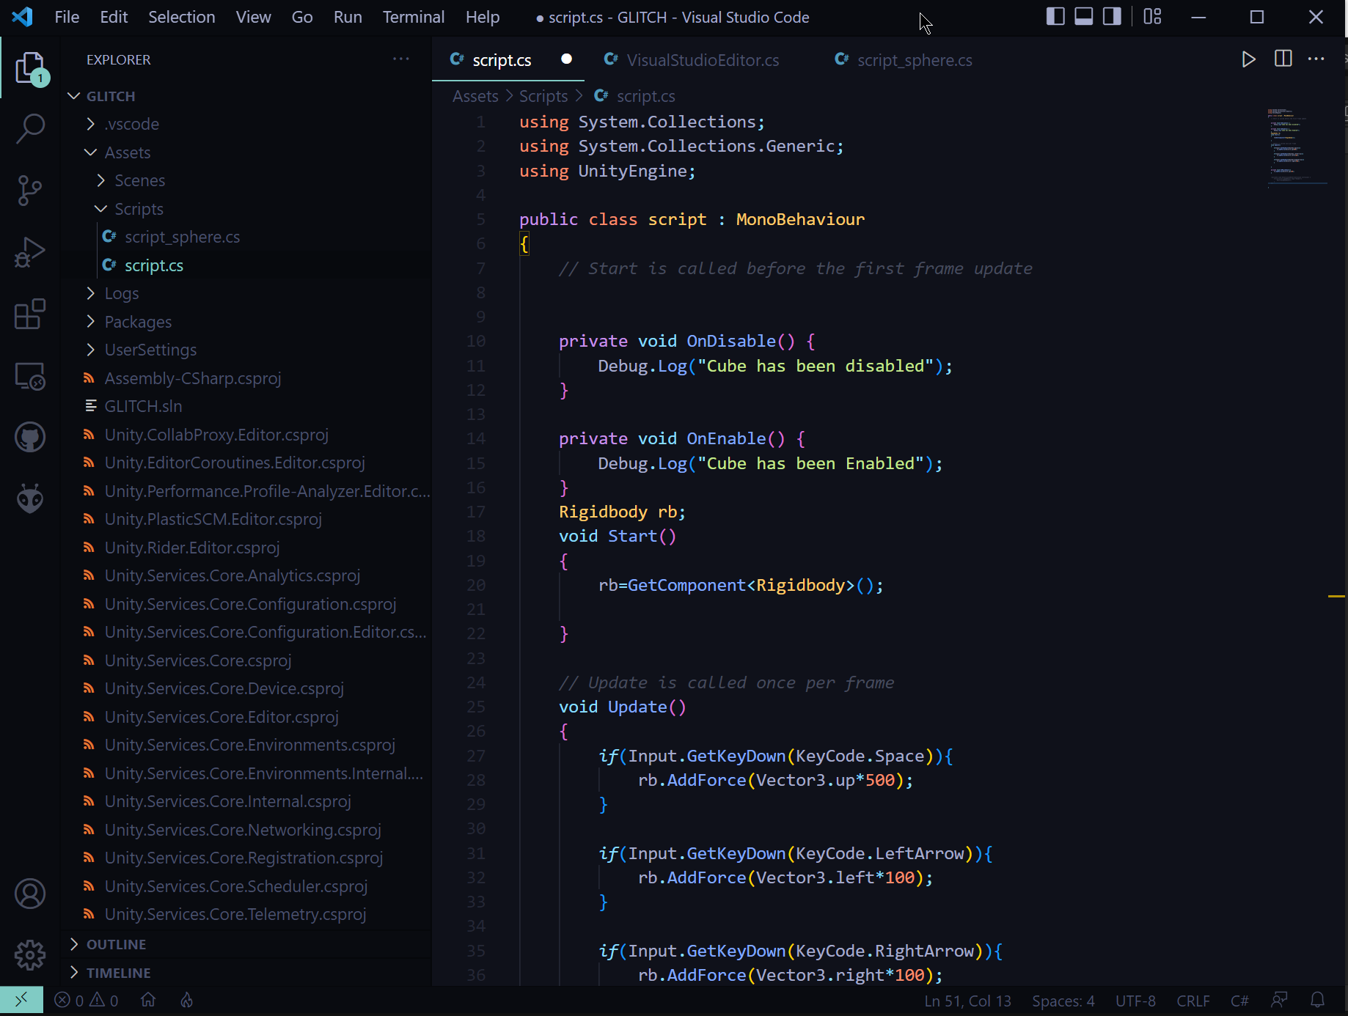

Task 2:

Unity installation:

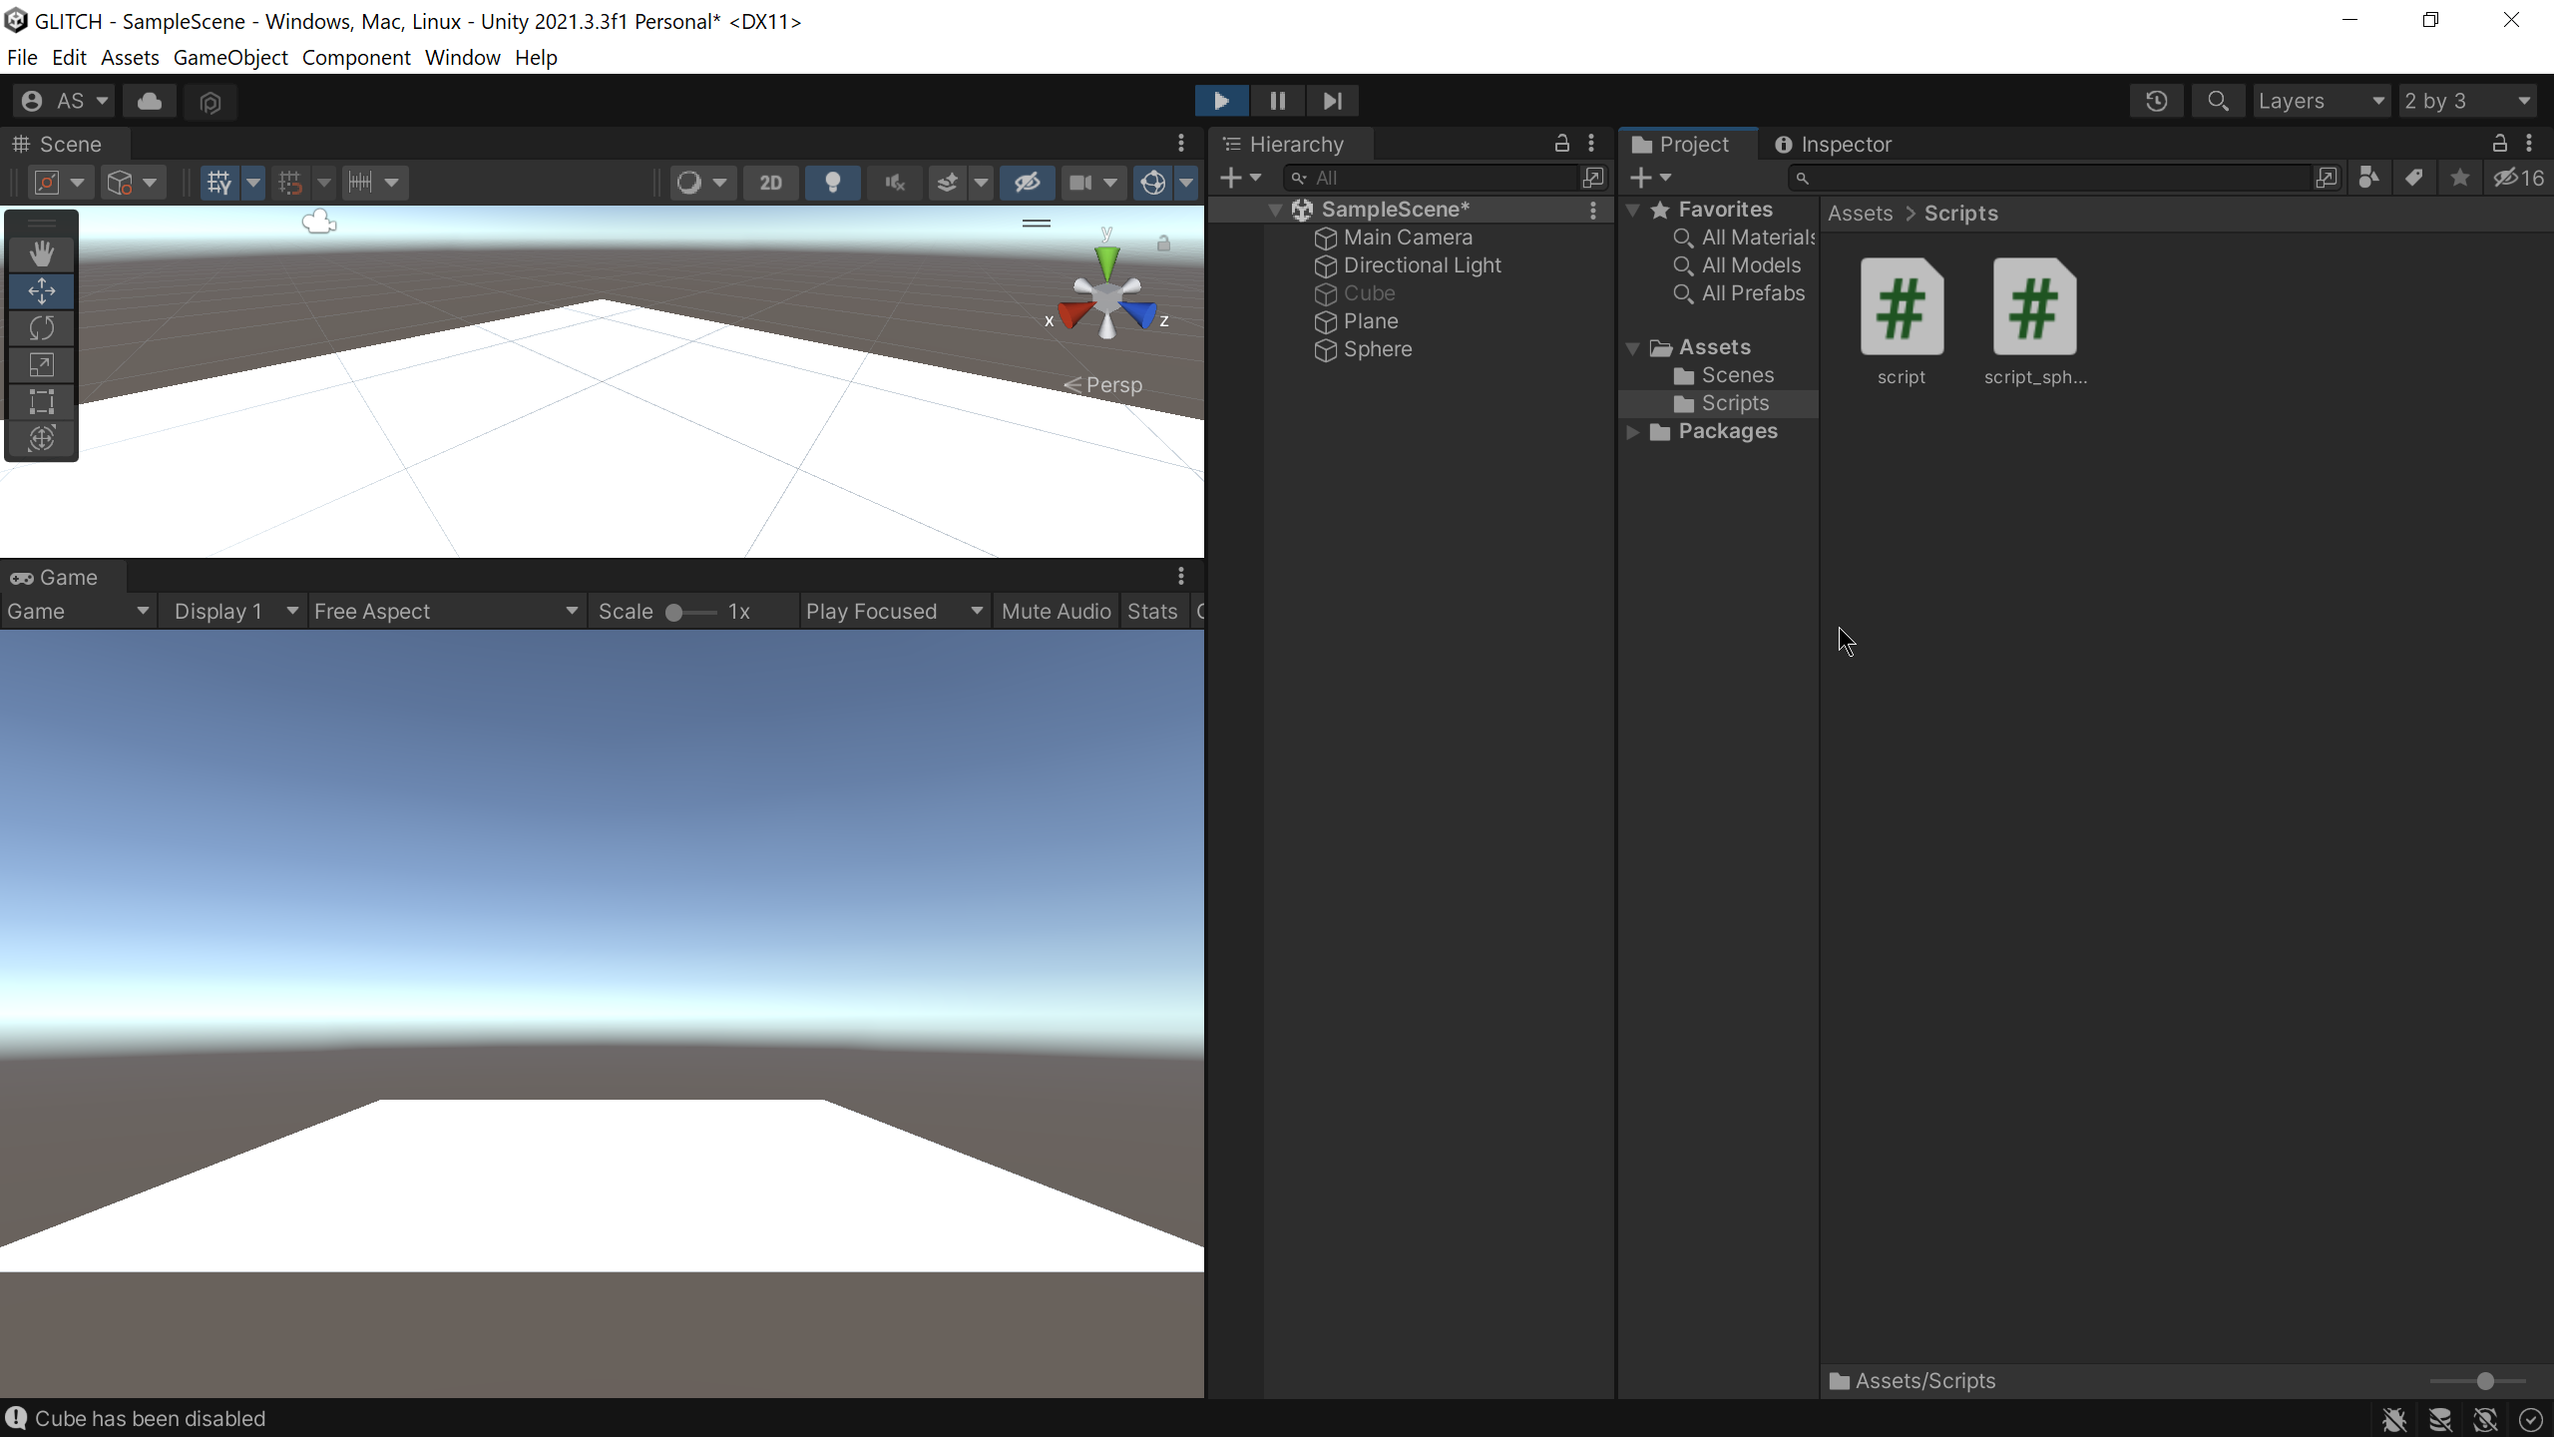

Integration with Vscode :

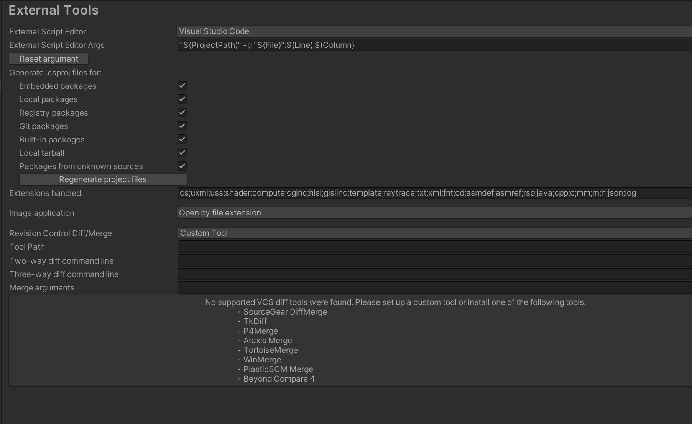

Task 3:

Task 4:

Integrating physics to 3D objects : Adding force

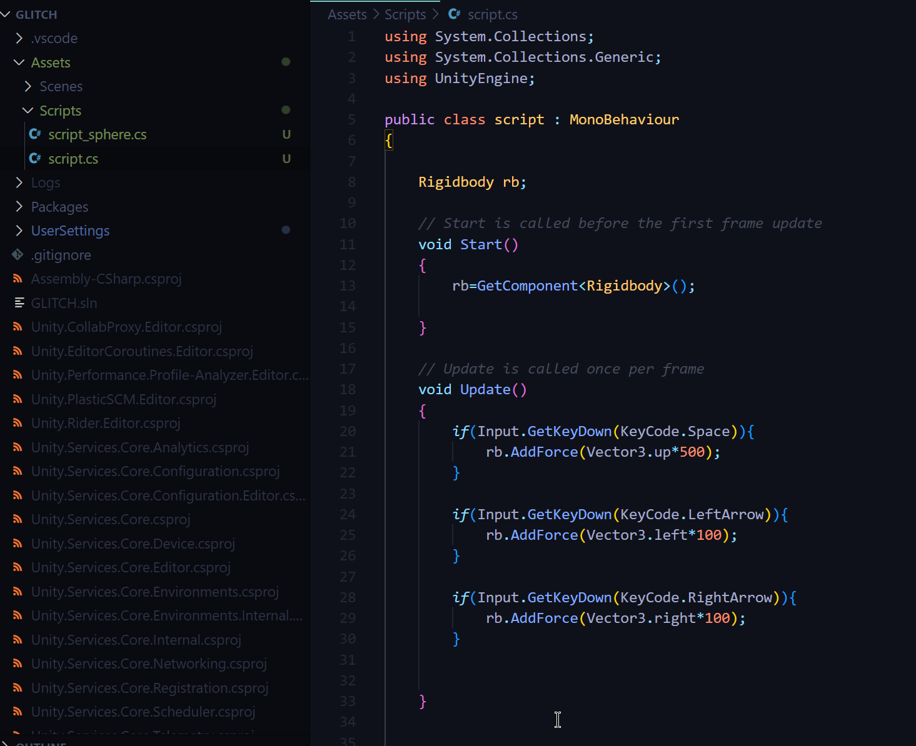

Using Mouse clicks to destroy current gameObject

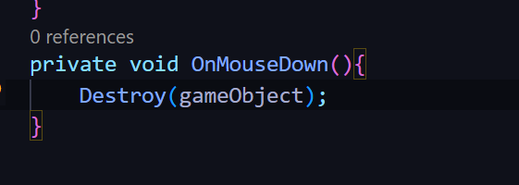

Reading Inputs from keyboard

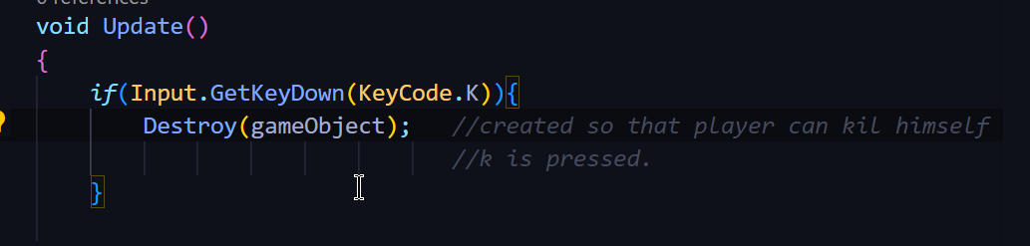

Detecting collisions and manipulating gameObject

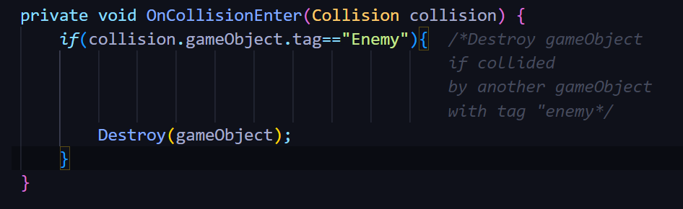

Moving gameObject using velocity

