Design and Deployment of a Cloud-Native Serverless & Scalable Student Portal on AWS
A Summer Training Project Report
Submitted in Partial Fulfillment of the Requirements for Summer Training
by
Abhishek Singh
Roll No: 1230438004
Under the Guidance of
Prashant Gautam Singh, Consultant-Subject Matter Expert
School Of Engineering (B.Tech in Computer Science & Engineering)
Babu Banarsi Das University
2026

Design and Deployment of a Cloud-Native Serverless & Scalable Student Portal on AWS
Summer Training Project Report
Submitted by
Abhishek Singh
Roll No: 1230438004
At
GRAS Education & Training Services Pvt. Ltd. (GRAStech)
Under the Guidance of
Prashant Gautam Singh, Consultant-Subject Matter Expert
School Of Engineering (B.Tech in Computer Science & Engineering)
Babu Banarsi Das University
Training Period: 22 June 2026 – 27 July 2026
2026
Copyright © 2026 Abhishek Singh
All Rights Reserved.

Candidate's Declaration
I hereby declare that the project work entitled "Design and Deployment of a Cloud-Native Serverless & Scalable Student Portal on AWS" is an authentic record of my own work carried out during the summer training at GRAS Education & Training Services Pvt. Ltd. (GRAStech) under the guidance of Prashant Gautam Singh, Consultant-Subject Matter Expert. I have not submitted the matter embodied in this project report for any other purpose.
Abhishek Singh
Roll Number: 1230438004
Date: July 27, 2026
Certified by:
____________________________
Signature of Supervisor
Prashant Gautam Singh, Consultant-Subject Matter Expert
Date: ______________

Acknowledgements
I would like to express my sincere gratitude to my project guide, Prashant Gautam Singh, Consultant-Subject Matter Expert, and the entire team at GRAS Education & Training Services Pvt. Ltd. (GRAStech) for their invaluable guidance, mentorship, and support throughout the 90-hour AWS Cloud Computing Training Program. Their insights into cloud architecture and best practices were instrumental in the successful completion of this project.
I am also thankful to the faculty members of the School Of Engineering (B.Tech in Computer Science & Engineering) at Babu Banarsi Das University for providing the necessary facilities, permissions, and encouragement to pursue this summer training.
Finally, I extend my heartfelt thanks to my family and friends for their constant encouragement and support throughout this endeavour.
Abhishek Singh

Abstract
This report presents the design, development, and deployment of a Cloud-Native Serverless & Scalable Student Portal built entirely on Amazon Web Services (AWS) as part of a 90-hour AWS Cloud Computing Training Program conducted by GRAS Education & Training Services Pvt. Ltd. (GRAStech). The objective of the training was to gain hands-on experience with core AWS services spanning networking, compute, serverless execution, storage, and security, and to apply this knowledge in building a functioning, production-representative web application.
The project implements a hybrid architecture that combines a traditional Auto-Scaled EC2 backend, fronted by an Application Load Balancer, with a fully serverless data-processing path composed of Amazon API Gateway, AWS Lambda, and Amazon DynamoDB. The frontend is a static HTML, CSS, Bootstrap 5, and JavaScript interface hosted on Amazon S3, which communicates asynchronously with the backend to perform Create, Read, and Delete operations on student records.
Key AWS services and concepts covered include Amazon VPC design with public subnets across two Availability Zones, Internet Gateway routing, Security Group configuration, Application Load Balancing, Auto Scaling Groups, Lambda-based CRUD logic written in Python 3.12, DynamoDB in On-Demand capacity mode, IAM role-based access control, and Amazon CloudWatch for monitoring and observability.
The outcome of the training was a fully functional, horizontally scalable, and cost-efficient student data management portal that demonstrates the practical integration of Infrastructure-as-a-Service and serverless computing paradigms. The project reinforces the significance of well-architected, secure, and observable cloud systems and lays the foundation for further enhancements such as authentication, CI/CD automation, and infrastructure-as-code deployment.

Contents
1 Introduction 1
1.1 General Introduction
1.2 Background of the Study / Company Profile
1.3 Problem Statement / Objective of Training
1.4 Scope of the Work
1.5 Significance of the Training
1.6 Organization of the Report
2 Literature Review / Technologies Studied 3
3 Design, Setup and Methodology 5
4 Results and Discussion 8
5 Conclusions and Scope for Future Work 10
Brief Bio-data of the Candidate 11
6 References 12
Appendix A: Source Code 13

List of Figures
Figure 3.1: Student Portal — AWS System Architecture 5
Figure 3.2: Student Portal — Request/Response Data Flow 7

List of Tables
Table 3.1: VPC Subnet Allocation 5
Table 3.2: Security Group Rules 6
Table 3.3: IAM Roles and Permissions 7
Table 4.1: Functional Test Summary 9

List of Abbreviations
- AWS – Amazon Web Services
- VPC – Virtual Private Cloud
- ALB – Application Load Balancer
- ASG – Auto Scaling Group
- EC2 – Elastic Compute Cloud
- S3 – Simple Storage Service
- IAM – Identity and Access Management
- REST – Representational State Transfer
- API – Application Programming Interface
- CRUD – Create, Read, Update, Delete
- JSON – JavaScript Object Notation
- CORS – Cross-Origin Resource Sharing
- CIDR – Classless Inter-Domain Routing
- IGW – Internet Gateway
- AZ – Availability Zone

Chapter 1: Introduction

1.1 General Introduction
Cloud computing has fundamentally changed the way modern web applications are designed, deployed, and scaled. Rather than provisioning and managing physical servers, organizations can now compose applications from managed, on-demand cloud services that scale automatically with demand and are billed on a pay-as-you-go basis. This project was undertaken as part of a 90-hour AWS Cloud Computing Training Program to gain practical, hands-on exposure to Amazon Web Services (AWS) by designing and deploying a real-world cloud-native application: a Student Portal for managing student records.
The Student Portal integrates both traditional server-based compute (Amazon EC2 behind an Application Load Balancer and Auto Scaling Group) and modern serverless components (Amazon API Gateway, AWS Lambda, and Amazon DynamoDB), giving a comprehensive view of two complementary approaches to building scalable systems on AWS.

1.2 Background of the Study / Company Profile
GRAS Education & Training Services Pvt. Ltd. (GRAStech) conducts structured, industry-oriented training programs in cloud computing, with a focus on Amazon Web Services. The 90-hour AWS Cloud Computing Training Program is designed to take learners from foundational cloud concepts through to the design and deployment of a complete, functioning cloud-native application, covering networking, compute, storage, serverless execution, security (IAM), and observability (CloudWatch).
As part of the School Of Engineering (B.Tech in Computer Science & Engineering) curriculum at Babu Banarsi Das University, this training was undertaken to complement classroom learning in computer science with practical, industry-relevant cloud engineering skills.

1.3 Problem Statement / Objective of Training
Educational institutions require simple, reliable systems to record and retrieve student information such as student ID, name, course, and email. Traditional monolithic deployments on a single server are difficult to scale and represent a single point of failure. The objective of this training and project was to design, build, and deploy a Student Portal that:
- Is horizontally scalable and resilient to instance failure through Auto Scaling and multi-AZ deployment.
- Exposes a serverless, pay-per-use API layer for CRUD (Create, Read, Delete) operations on student records.
- Is secured through least-privilege IAM roles and tightly scoped Security Groups.
- Is observable through centralized CloudWatch metrics, dashboards, and alarms.

1.4 Scope of the Work
The scope of this project covers the end-to-end design and implementation of the following: a custom Amazon VPC with public subnets across two Availability Zones; an Application Load Balancer and Auto Scaling Group fronting Apache-based EC2 instances; a serverless REST API built with Amazon API Gateway and AWS Lambda (Python 3.12); a NoSQL data store using Amazon DynamoDB in On-Demand mode; a static frontend hosted on Amazon S3 using HTML, CSS, Bootstrap 5, and JavaScript; and supporting IAM roles and CloudWatch monitoring. Authentication/authorization of end users, CI/CD pipelines, and infrastructure-as-code automation were identified as extensions but were outside the scope of the current training period.

1.5 Significance of the Training
This training provided practical exposure to designing well-architected cloud systems that balance scalability, security, and cost-efficiency. Working across both EC2-based and serverless compute models offered a comparative understanding of when to use managed infrastructure versus fully serverless services, a decision that is central to real-world cloud architecture. The project also reinforced core software engineering practices such as RESTful API design, asynchronous frontend-backend communication, and structured error handling.

1.6 Organization of the Report
Chapter 2 reviews the AWS technologies and services studied and used in this project. Chapter 3 describes the design, setup, and methodology followed to build the Student Portal, including network topology, compute configuration, serverless architecture, and data flow. Chapter 4 discusses the results obtained and observations from testing the deployed system. Chapter 5 concludes the report and outlines scope for future enhancement. Appendix A contains the complete Lambda function source code.

Chapter 2: Literature Review / Technologies Studied
This chapter summarizes the core AWS services and concepts studied and applied during the training program.

2.1 Amazon Virtual Private Cloud (VPC)
Amazon VPC allows the provisioning of a logically isolated network within AWS, where the user has complete control over IP addressing, subnetting, routing, and network gateways. Subnets can be designated public or private depending on whether they route outbound traffic through an Internet Gateway, and resources can be distributed across multiple Availability Zones (AZs) for fault tolerance.
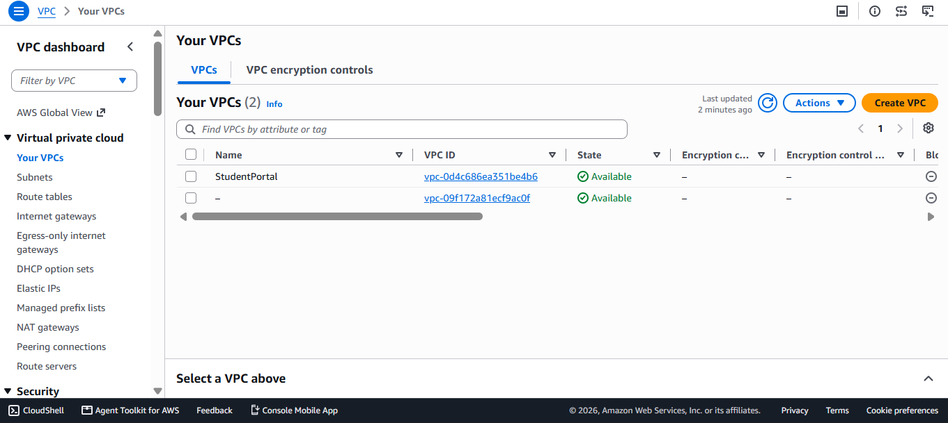

2.2 Elastic Load Balancing and Auto Scaling
The Application Load Balancer (ALB) operates at Layer 7 and distributes incoming HTTP/HTTPS traffic across healthy targets in multiple Availability Zones. Auto Scaling Groups (ASG) work alongside the ALB to automatically launch or terminate EC2 instances based on defined minimum, desired, and maximum capacity, ensuring the application can handle varying load while controlling cost.
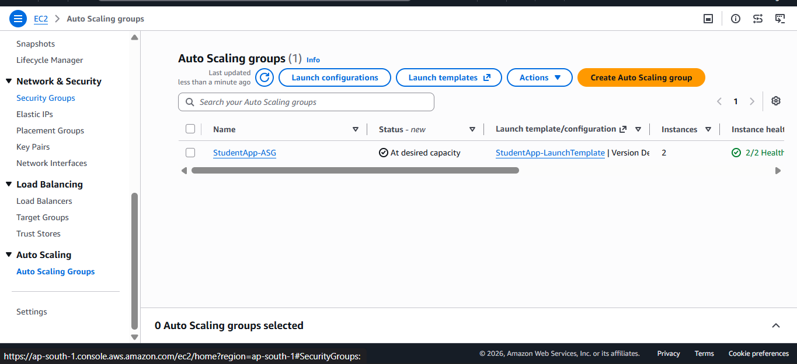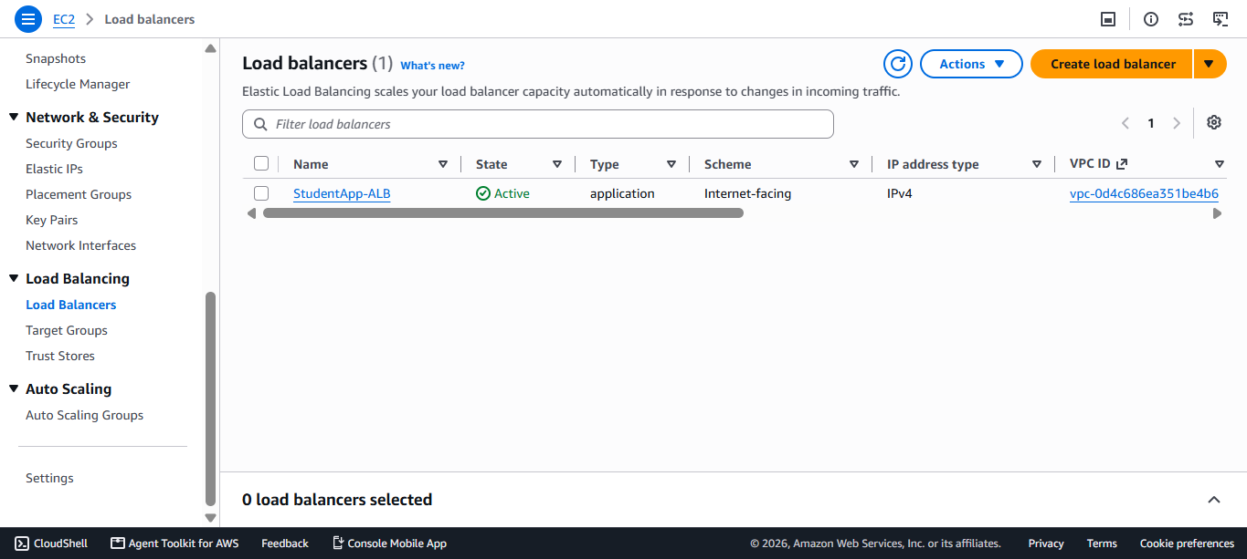

2.3 Amazon EC2 and Launch Templates
Amazon Elastic Compute Cloud (EC2) provides resizable virtual compute capacity. Launch Templates standardize instance configuration (AMI, instance type, security groups, and user data scripts), enabling the Auto Scaling Group to launch identically configured instances on demand.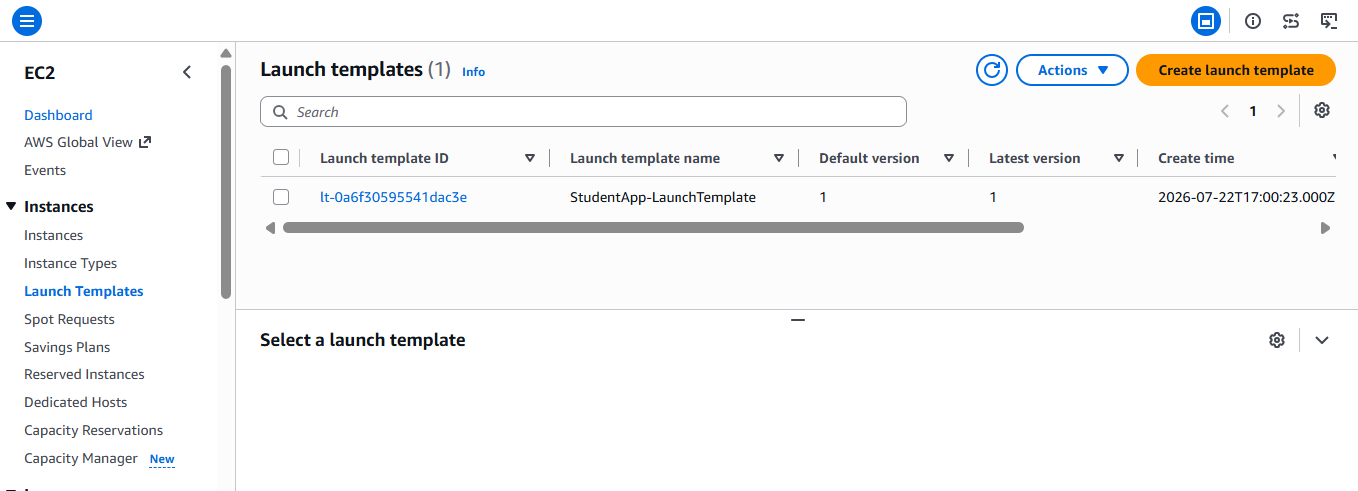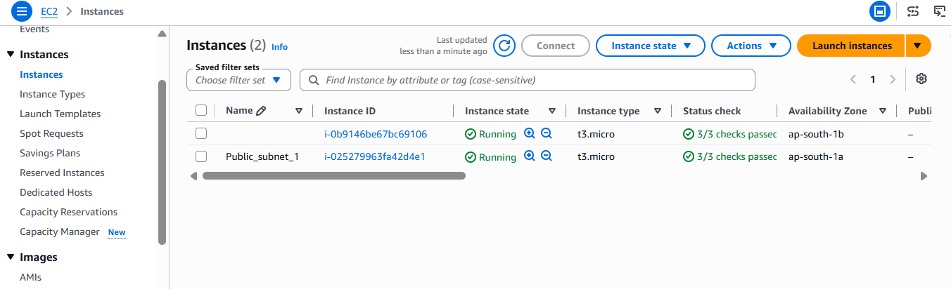

2.4 Amazon API Gateway
Amazon API Gateway is a fully managed service for creating, publishing, and securing REST and HTTP APIs at scale. It handles request routing, throttling, and Cross-Origin Resource Sharing (CORS), and integrates natively with AWS Lambda as a backend.
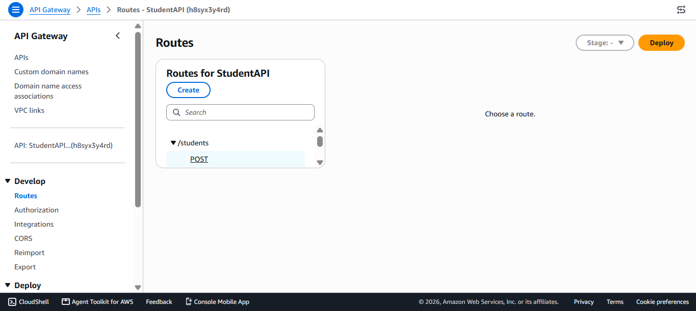

2.5 AWS Lambda
AWS Lambda is a serverless, event-driven compute service that runs code in response to triggers without requiring server provisioning or management. Billing is based on the number of invocations and execution duration, making it well suited to unpredictable or intermittent workloads such as CRUD operations on a student database.
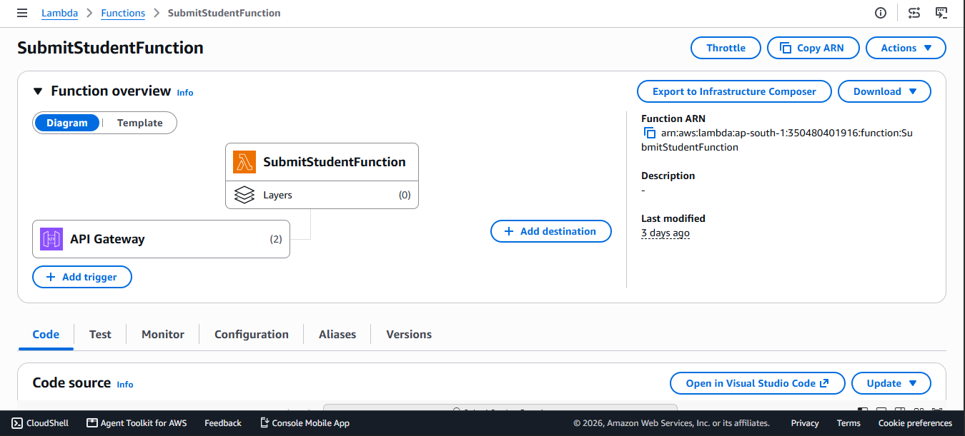

2.6 Amazon DynamoDB
Amazon DynamoDB is a fully managed, serverless NoSQL key-value and document database that delivers single-digit millisecond performance at any scale. On-Demand capacity mode automatically scales read/write throughput in line with actual traffic, removing the need for manual capacity planning.
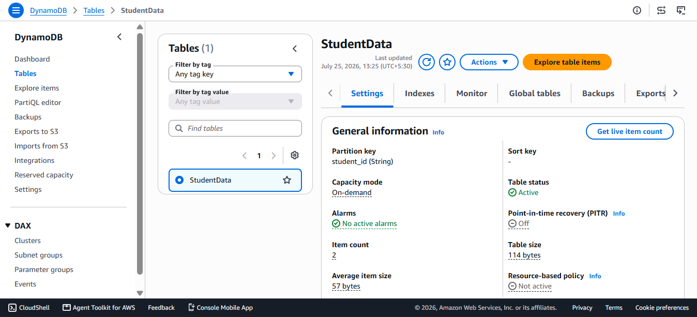

2.7 Amazon S3 Static Website Hosting
Amazon Simple Storage Service (S3) can serve static website content directly, making it a cost-effective and highly available hosting option for client-side applications built with HTML, CSS, and JavaScript frameworks such as Bootstrap.
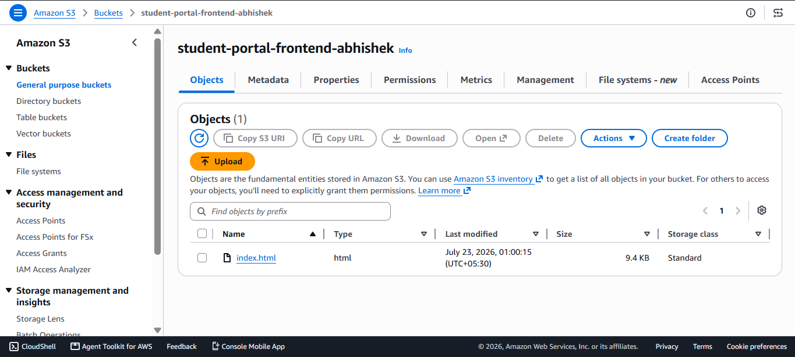

2.8 AWS IAM
AWS Identity and Access Management (IAM) enables fine-grained control over who (or what service) can access which AWS resources, following the principle of least privilege through roles and policies attached to services such as EC2 and Lambda.
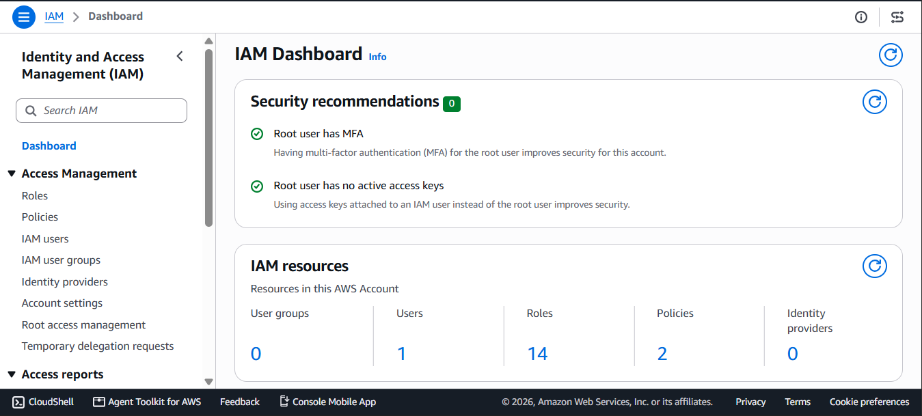

2.9 Amazon CloudWatch
Amazon CloudWatch collects metrics, logs, and events from AWS resources, enabling dashboards and alarms that provide observability into system health, such as EC2 CPU utilization, Lambda invocation counts, and API Gateway latency and error rates.
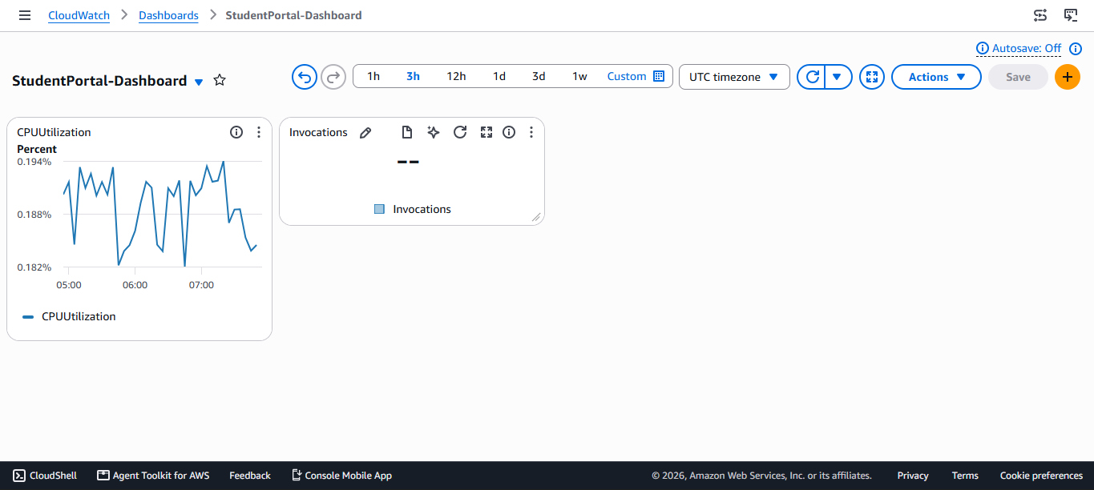

Chapter 3: Design, Setup and Methodology

3.1 System Architecture Overview
The Student Portal follows a hybrid architecture combining an Auto-Scaled EC2 web tier with a serverless data-processing path. The frontend, hosted on Amazon S3, communicates with the backend through two independent paths: static page delivery from S3, and dynamic data operations through API Gateway, Lambda, and DynamoDB. A separate EC2-based tier, fronted by an Application Load Balancer and Auto Scaling Group, was configured to demonstrate horizontally scalable compute for the Apache-based web layer.
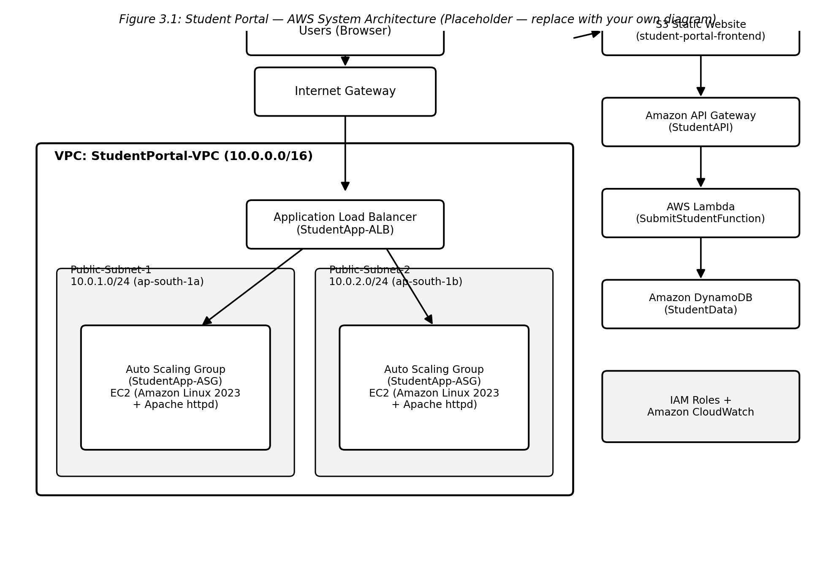
Figure 3.1: Student Portal — AWS System Architecture (placeholder — replace with your own diagram)

3.2 Network & Infrastructure Layer (Amazon VPC)
A custom VPC named StudentPortal-VPC was provisioned with an IPv4 CIDR block of 10.0.0.0/16, providing a private address space of over 65,000 IP addresses for future expansion.
- Public-Subnet-1: 10.0.1.0/24 in Availability Zone ap-south-1a
- Public-Subnet-2: 10.0.2.0/24 in Availability Zone ap-south-1b
Spreading the public subnets across two Availability Zones ensures that the Application Load Balancer and Auto Scaling Group can continue operating even if one AZ becomes unavailable. An Internet Gateway (IGW) was attached to the VPC and associated with the Public Route Tables, with a default route (0.0.0.0/0) directed to the IGW to allow inbound and outbound internet connectivity.
Subnet | CIDR Block | Availability Zone | Type
Public-Subnet-1 | 10.0.1.0/24 | ap-south-1a | Public
Public-Subnet-2 | 10.0.2.0/24 | ap-south-1b | Public
Table 3.1: VPC Subnet Allocation

3.3 Security Groups
Two Security Groups were configured to enforce least-privilege network access:
- ALB-SG: Allows inbound HTTP traffic on port 80 from 0.0.0.0/0, exposing the load balancer to the public internet.
- EC2-SG: Allows inbound HTTP traffic on port 80 only from ALB-SG (not directly from the internet), and restricts SSH access on port 22 to the administrator's IP address only.
This layered configuration ensures EC2 instances are never directly reachable from the public internet — all web traffic must pass through the Application Load Balancer.
Security Group | Inbound Rule | Source | Purpose
ALB-SG | HTTP (80) | 0.0.0.0/0 | Public access to the load balancer
EC2-SG | HTTP (80) | ALB-SG | Web traffic only from the ALB
EC2-SG | SSH (22) | Admin IP only | Restricted administrative access
Table 3.2: Security Group Rules

3.4 Backend Compute & Load Balancing
An Application Load Balancer named StudentApp-ALB was deployed across both public subnets to distribute inbound web traffic across multiple Availability Zones. An Auto Scaling Group, StudentApp-ASG, was configured with a minimum of 1, desired capacity of 2, and maximum of 3 EC2 instances. Instances run Amazon Linux 2023 with the Apache HTTP Server (httpd), initialized through a Launch Template and User Data scripts that install and start the web server automatically at boot.

3.5 Serverless Execution & API Tier
An HTTP REST API named StudentAPI was created in Amazon API Gateway to serve as the public entry point for data operations, with CORS fully enabled across GET, POST, DELETE, and OPTIONS methods. The API routes requests to a single AWS Lambda function, SubmitStudentFunction, written in Python 3.12, which performs the corresponding CRUD operation against DynamoDB. The function inspects the HTTP method (from either the REST or HTTP API event structure) and dispatches to the appropriate handler, returning JSON responses with CORS headers on every path, including a dedicated OPTIONS handler for preflight requests.

3.6 Data Storage & Frontend
Student records are persisted in a DynamoDB table named StudentData, operating in On-Demand capacity mode with student_id (String) as the partition key. The frontend is a static site hosted in an S3 bucket, student-portal-frontend-abhishek, built with HTML, CSS, Bootstrap 5, and JavaScript, which issues asynchronous fetch requests to the API Gateway endpoint to read, add, and delete student records without a page reload.

3.7 Security & Observability (IAM and CloudWatch)
Two IAM roles were defined to enforce least-privilege access:
- EC2-S3-Role: Grants EC2 instances read/write permissions to S3 and CloudWatch logging capability.
- Lambda-DynamoDB-Role: Grants the Lambda function execution rights along with AmazonDynamoDBFullAccess to perform CRUD operations on the StudentData table.
Amazon CloudWatch dashboards and alarms were configured to track EC2 CPU utilization, Lambda invocation counts, and API Gateway latency and error rates, providing visibility into the health and performance of both the compute and serverless tiers.
IAM Role | Attached To | Key Permissions
EC2-S3-Role | EC2 instances (via Instance Profile) | S3 read/write; CloudWatch Logs write
Lambda-DynamoDB-Role | SubmitStudentFunction (Lambda) | Lambda execution; AmazonDynamoDBFullAccess
Table 3.3: IAM Roles and Permissions

3.8 Data Flow & Execution Workflows
The end-to-end data flow of the Student Portal is as follows:
- User Request (Frontend): The user opens the static web page served from the S3 bucket.
- Read Operation (GET): The client page issues an asynchronous GET request to the API Gateway URL, which triggers the Lambda function to scan the DynamoDB table and return the resulting JSON record array for display in the UI.
- Write Operation (POST): A form submission sends a JSON payload (student_id, name, email, course) via POST to API Gateway, which triggers the Lambda function to execute a put_item() call into DynamoDB.
- Delete Operation (DELETE): The UI triggers a DELETE request containing the student_id, which API Gateway routes to Lambda; the function then executes delete_item() against DynamoDB.
Backend Load Distribution: Independent EC2-based compute workloads scale horizontally through the ALB and ASG across the ap-south-1a and ap-south-1b Availability Zones. 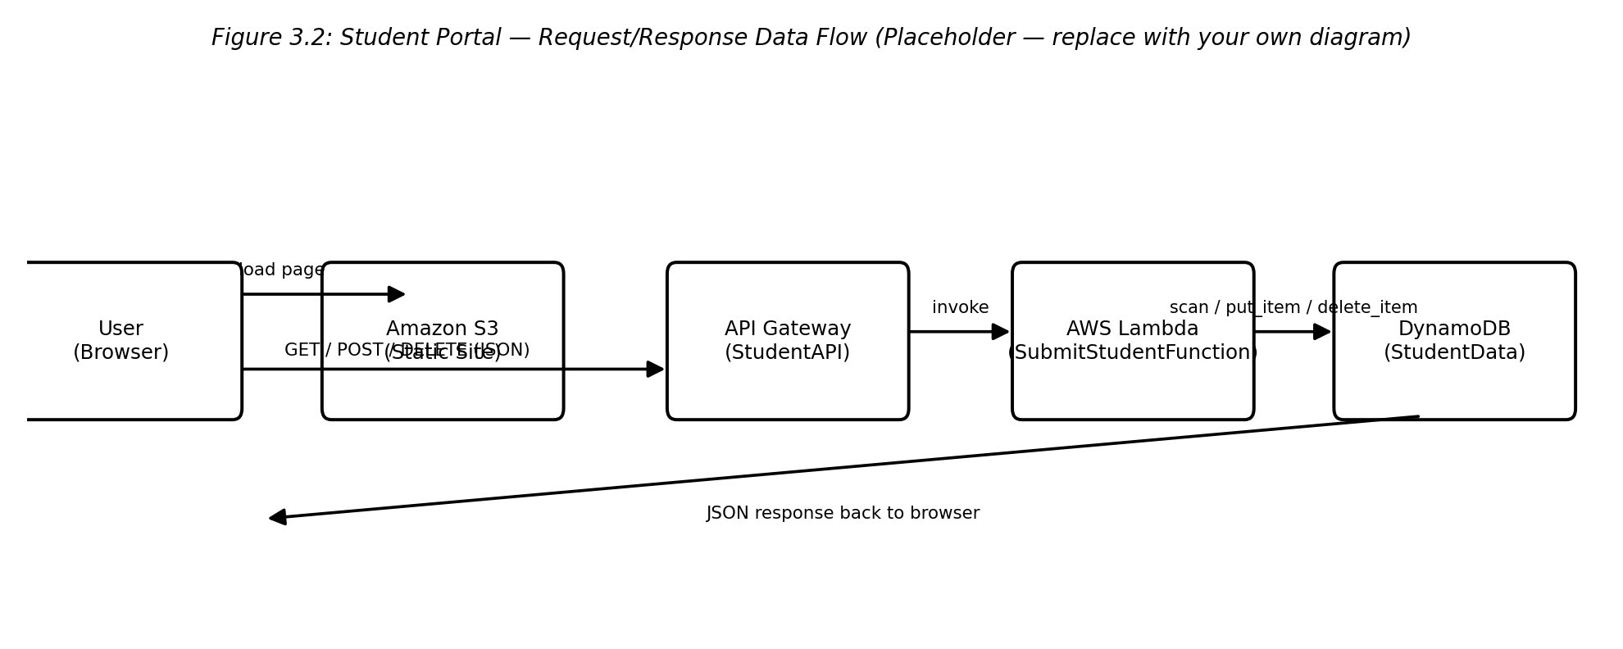
Figure 3.2: Student Portal — Request/Response Data Flow (placeholder — replace with your own diagram)

3.9 Lambda Function Implementation
The core business logic of the serverless tier resides in the SubmitStudentFunction Lambda, implemented in Python 3.12 using the boto3 SDK. The handler normalizes the incoming HTTP method across both REST and HTTP API event formats, applies a consistent set of CORS response headers to every response path, validates required fields (student_id and name) on write operations, and wraps all DynamoDB interactions in a try/except block that returns a structured JSON error response on failure. The complete source code is provided in Appendix A.

Chapter 4: Results and Discussion

4.1 Functional Verification
The deployed Student Portal was tested end-to-end across all supported operations. Submitting the frontend form successfully created new records in the DynamoDB StudentData table via the POST route, with the Lambda function correctly validating that student_id and name were present before writing the item and returning a 400 error response when required fields were missing.
The GET route correctly retrieved and rendered the full list of student records from DynamoDB on page load and after each write, confirming that the API Gateway–Lambda–DynamoDB integration functioned as designed. The DELETE route correctly removed the targeted record by student_id, and the UI reflected the updated record list without requiring a manual page refresh, demonstrating effective asynchronous frontend-backend communication.
Operation | HTTP Method | Expected Result | Observed Result
Create student record | POST | 200 OK, item written to DynamoDB | Pass
List student records | GET | 200 OK, JSON array of items | Pass
Delete student record | DELETE | 200 OK, item removed from DynamoDB | Pass
Missing required field | POST | 400 Bad Request with error message | Pass
CORS preflight | OPTIONS | 200 OK with CORS headers | Pass
Table 4.1: Functional Test Summary

4.2 CORS and Cross-Origin Behaviour
Because the frontend (hosted on S3) and the API (hosted on API Gateway) reside on different origins, CORS preflight OPTIONS requests were verified to return HTTP 200 with the appropriate Access-Control-Allow-Origin, Access-Control-Allow-Headers, and Access-Control-Allow-Methods headers, allowing the browser to proceed with the actual GET, POST, and DELETE requests without cross-origin errors.

4.3 Scalability and Load Distribution
With the Auto Scaling Group configured for a minimum of 1, desired of 2, and maximum of 3 instances, the Application Load Balancer was observed to distribute traffic evenly across the two running EC2 instances in ap-south-1a and ap-south-1b. This configuration confirmed that the web tier could absorb increased load by scaling out to a third instance while a single-AZ failure would not take the application offline, since the second Availability Zone would continue to serve traffic.

4.4 Observability
CloudWatch dashboards provided visibility into EC2 CPU utilization, Lambda invocation counts, and API Gateway latency and error metrics throughout testing. This confirmed that the serverless components responded within expected latency bounds under light test load and that no unexpected error spikes occurred during CRUD operation testing.

4.5 Discussion
The results confirm that a hybrid architecture combining EC2-based compute with a serverless data path is a viable and cost-effective pattern for applications with a predictable web-serving component and a variable, request-driven data layer. The serverless CRUD path in particular benefits from DynamoDB's On-Demand capacity mode and Lambda's pay-per-invocation model, avoiding the cost of idle compute for infrequent student data updates, while the ALB/ASG-backed EC2 tier demonstrates how compute-heavier or stateful components can still be scaled horizontally within the same VPC.

Chapter 5: Conclusions and Scope for Future Work

5.1 Conclusions
This project successfully demonstrated the design and deployment of a Cloud-Native Serverless & Scalable Student Portal on AWS, integrating networking (VPC, subnets, IGW, Security Groups), compute (EC2, ALB, ASG), serverless execution (API Gateway, Lambda), storage (S3, DynamoDB), security (IAM), and observability (CloudWatch) into a single, cohesive system. The training provided practical, hands-on experience in architecting systems that are secure by design, horizontally scalable, and cost-efficient, directly applying the concepts studied during the 90-hour AWS Cloud Computing Training Program.

5.2 Scope for Future Work
Several enhancements were identified as natural extensions of this project:
- User Authentication and Authorization: Integrating Amazon Cognito to authenticate students and administrators and restrict access to sensitive operations.
- Infrastructure as Code: Migrating the manually configured VPC, ALB, ASG, Lambda, and DynamoDB resources to AWS CloudFormation or Terraform for repeatable, version-controlled deployments.
- CI/CD Automation: Introducing a CI/CD pipeline (e.g., AWS CodePipeline) to automate testing and deployment of both the Lambda function and the S3-hosted frontend.
- HTTPS and Custom Domain: Adding an ACM certificate and Amazon CloudFront distribution to serve the frontend and API over HTTPS with a custom domain name.
- Enhanced Validation and Pagination: Extending the Lambda function to support server-side pagination of large student record sets and stricter input validation/sanitization.

Brief Bio-data of the Candidate
Abhishek Singh
B.Tech Student — Computer Science & Engineering
ps5878276@gmail.com | 8400492860 | Lucknow, Uttar Pradesh, India
GitHub: github.com/Aks12204 | LinkedIn: linkedin.com/in/abhishek-singh-30749129a | LeetCode: leetcode.com/u/Aks10432

EDUCATION
Babu Banarsi Das University, School of Engineering — B.Tech, Computer Science & Engineering Expected 2027
CGPA: 8.5 / 10
Intermediate (Class XII) / High School (Class X) 80% / 81%
TECHNICAL SKILLS
Languages: Python, Java, C, C++, SQL
Web Development: HTML, CSS, Django
Cloud (AWS): VPC, EC2, Application Load Balancer, Auto Scaling, API Gateway, Lambda, DynamoDB, S3, IAM, CloudWatch
Tools & Platforms: Linux, Git, Streamlit, boto3, Gemini API
PROJECTS
Cloud-Native Serverless & Scalable Student Portal AWS Training Project
• Designed and deployed a hybrid AWS architecture: an Auto Scaled EC2 web tier behind an Application Load Balancer, plus a serverless data layer (API Gateway, Lambda, DynamoDB).
• Built a Python 3.12 Lambda function for CRUD operations on student records, with CORS-enabled REST endpoints, least-privilege IAM roles, and a static S3-hosted frontend.
Mental Health Support Chatbot Python, NLP
• Built a conversational chatbot using a pretrained NLP model fine-tuned on medical/mental-health data to provide empathetic, context-aware support.
Resume Critifier Python, Streamlit, uv, Gemini API
• Developed a Streamlit app that analyzes resumes, computes an ATS compatibility score, and generates improvement recommendations using the Gemini API.
Query / Ticket Management System Java
• Built a system to raise, track, and manage user complaints and queries efficiently.
Student Management Dashboard Django, SQL
• Built during the Learnovate training program; a dashboard displaying and organizing student data to support administrative decision-making.
TRAINING & CERTIFICATIONS
90-Hour AWS Cloud Computing Training Program GRAStech
• Hands-on training covering AWS networking, compute, serverless architecture, storage, IAM, and CloudWatch monitoring; applied through the Student Portal project above.
Learnovate Training Program
• Data Structures & Algorithms with Java, plus a Student Management Dashboard built with Django and SQL.

Chapter 6: References
[1] Amazon Web Services, "Amazon VPC User Guide," AWS Documentation, 2026.
[2] Amazon Web Services, "Elastic Load Balancing – Application Load Balancers," AWS Documentation, 2026.
[3] Amazon Web Services, "Amazon EC2 Auto Scaling User Guide," AWS Documentation, 2026.
[4] Amazon Web Services, "Amazon API Gateway Developer Guide," AWS Documentation, 2026.
[5] Amazon Web Services, "AWS Lambda Developer Guide," AWS Documentation, 2026.
[6] Amazon Web Services, "Amazon DynamoDB Developer Guide," AWS Documentation, 2026.
[7] Amazon Web Services, "Amazon S3 User Guide – Hosting a Static Website," AWS Documentation, 2026.
[8] Amazon Web Services, "AWS Identity and Access Management User Guide," AWS Documentation, 2026.
[9] Amazon Web Services, "Amazon CloudWatch User Guide," AWS Documentation, 2026.
[10] GRAS Education & Training Services Pvt. Ltd. (GRAStech), "90-Hour AWS Cloud Computing Training Program – Course Material," Internal Training Documentation, 2026.

Appendix A: Source Code

A.1 Lambda Function — SubmitStudentFunction (Python 3.12)
The following is the complete source code of the AWS Lambda function used to handle GET, POST, DELETE, and OPTIONS requests routed from Amazon API Gateway to Amazon DynamoDB.
import json
import boto3

dynamodb = boto3.resource('dynamodb')
table = dynamodb.Table('StudentData')

def lambda_handler(event, context):
headers = {
'Content-Type': 'application/json',
'Access-Control-Allow-Origin': '*',
'Access-Control-Allow-Headers': 'Content-Type,Authorization,X-Amz-Date,X-Api-Key,X-Amz-Security-Token',
'Access-Control-Allow-Methods': 'OPTIONS,POST,GET,DELETE'
}

try:
http_method = event.get('httpMethod')
if not http_method and 'requestContext' in event:
http_method = event['requestContext'].get('http', {}).get('method')

if http_method == 'OPTIONS':
return {'statusCode': 200, 'headers': headers, 'body': json.dumps({'message': 'CORS OK'})}

elif http_method == 'GET':
response = table.scan()
items = response.get('Items', [])
return {'statusCode': 200, 'headers': headers, 'body': json.dumps(items)}

elif http_method == 'POST':
body = event.get('body', {})
if isinstance(body, str):
body = json.loads(body) if body else {}

student_id = body.get('student_id')
name = body.get('name')
course = body.get('course')
email = body.get('email', 'N/A')

if not student_id or not name:
return {'statusCode': 400, 'headers': headers, 'body': json.dumps({'error': 'Missing student_id or name'})}

table.put_item(
Item={
'student_id': str(student_id),
'name': str(name),
'course': str(course),
'email': str(email)
}
)
return {'statusCode': 200, 'headers': headers, 'body': json.dumps({'message': 'Student added successfully!'})}

elif http_method == 'DELETE':
body = event.get('body', {})
if isinstance(body, str):
body = json.loads(body) if body else {}

student_id = body.get('student_id')
if not student_id:
return {'statusCode': 400, 'headers': headers, 'body': json.dumps({'error': 'Missing student_id'})}

table.delete_item(Key={'student_id': str(student_id)})
return {'statusCode': 200, 'headers': headers, 'body': json.dumps({'message': 'Student deleted successfully!'})}

return {'statusCode': 400, 'headers': headers, 'body': json.dumps({'error': f'Unsupported method: {http_method}'})}

except Exception as e:
return {'statusCode': 500, 'headers': headers, 'body': json.dumps({'error': str(e)})}

A.2 EC2 User Data Setup Script

#!/bin/bash
yum update -y
yum install httpd -y
systemctl start httpd
systemctl enable httpd
EC2_HOST=$(hostname -f)
echo "<html><body style='font-family:sans-serif; text-align:center; padding-top:50px;'>" > /var/www/html/index.html
echo "<h1>Welcome to Smart Student Portal Backend</h1>" >> /var/www/html/index.html
echo "<p>Handled by EC2 Instance: <strong>$EC2_HOST</strong></p>" >> /var/www/html/index.html
echo "</body></html>" >> /var/www/html/index.html

A.3 Screenshot
