# Department of Computing

**CS-213: Advanced Programming**

**Class: BSCS 7AB**

# Lab 5: Node.js MySQL

**Date: 3rd October, 2019**

**Time: 10:00-01:00pm & 02:00-05:00pm**

**AKSA**

**BSCS 7B**

**228491**

# Instructor: Dr. Sidra Sultana

**Lab Engineer: Ms. Ayesha Asif**

# 

# Lab 5: Node.js MySQL

**Introduction**

Node.js can be used in database applications. One of the most popular databases is MySQL.client.

**Lab Tasks**

**Task 1:** Start by creating a connection to the database. Use the username and password from your MySQL database.

var mysql = require('mysql');

var con = mysql.createConnection({

host: "localhost",

user: "root",

password: ""

});

con.connect(function (err) {

if (err) throw err;

console.log("Connected!");

});

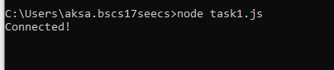

**Task 2:** Use SQL statements to read from (or write to) a MySQL database. The query method takes an sql statements as a parameter and returns the result.

code above in a file called "demo_db_select.js" and run the file

var mysql = require('mysql');

var con = mysql.createConnection({

host: "localhost",

user: "root",

password: "",

database:"mydb"

});

con.connect(function (err) {

if (err) throw err;

console.log("Connected!");

var sql = "SELECT * FROM customers";

con.query(sql, function (err, result) {

if (err) throw err;

console.log(result);

});

});

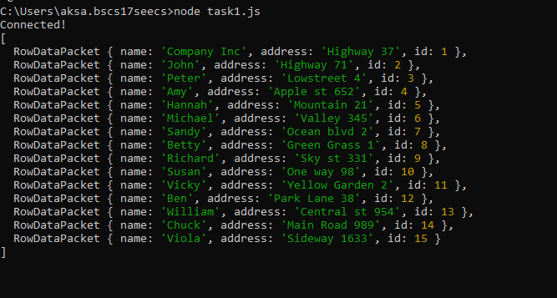

**Task 3:** Create a database named "mydb". Save the code in a file called "demo_create_db.js" and run the file.

var mysql = require('mysql');

var con = mysql.createConnection({

host: "localhost",

user: "root",

password: ""

});

con.connect(function (err) {

if (err) throw err;

console.log("Connected!");

con.query("CREATE DATABASE mydb", function (err, result) {

if (err) throw err;

console.log("Database created");

});

});

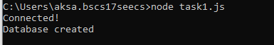

**Task 4:** Create a table named "customers". Save the code above in a file called "demo_create_table.js" and run the file

ar mysql = require('mysql');

var con = mysql.createConnection({

host: "localhost",

user: "root",

password: "",

database:"mydb"

});

con.connect(function (err) {

if (err) throw err;

console.log("Connected!");

var sql = "CREATE TABLE customers (name VARCHAR(255), address VARCHAR(255))";

con.query(sql, function (err, result) {

if (err) throw err;

console.log("Table created");

});

});

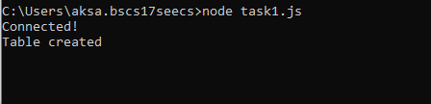

**Task 5:** Create primary key when creating the table. If the table already exists, use the ALTER TABLE keyword.

var mysql = require('mysql');

var con = mysql.createConnection({

host: "localhost",

user: "root",

password: "",

database:"mydb"

});

con.connect(function (err) {

if (err) throw err;

console.log("Connected!");

var sql = "ALTER TABLE customers ADD COLUMN id INT AUTO_INCREMENT PRIMARY KEY";

con.query(sql, function (err, result) {

if (err) throw err;

console.log("Table altered, primary key added");

});

});

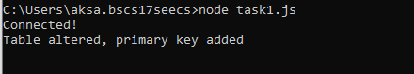

**Task 6:** Insert a record in the "customers" table. Save the code above in a file called "demo_db_insert.js", and run the file.

var mysql = require('mysql');

var con = mysql.createConnection({

host: "localhost",

user: "root",

password: "",

database:"mydb"

});

con.connect(function (err) {

if (err) throw err;

console.log("Connected!");

var sql = "INSERT INTO customers (name, address) VALUES ('Company Inc', 'Highway 37')";

con.query(sql, function (err, result) {

if (err) throw err;

console.log("1 record inserted into the customers table");

});

});

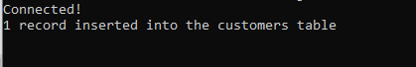

**Task 7:** Fill the "customers" table with multiple data. Save the code above in a file called "demo_db_insert_multple.js", and run the file. Return the number of affected rows

var mysql = require('mysql');

var con = mysql.createConnection({

host: "localhost",

user: "root",

password: "",

database:"mydb"

});

con.connect(function (err) {

if (err) throw err;

console.log("Connected!");

var sql = "INSERT INTO customers (name, address) VALUES ?";

var values = [

['John', 'Highway 71'],

['Peter', 'Lowstreet 4'],

['Amy', 'Apple st 652'],

['Hannah', 'Mountain 21'],

['Michael', 'Valley 345'],

['Sandy', 'Ocean blvd 2'],

['Betty', 'Green Grass 1'],

['Richard', 'Sky st 331'],

['Susan', 'One way 98'],

['Vicky', 'Yellow Garden 2'],

['Ben', 'Park Lane 38'],

['William', 'Central st 954'],

['Chuck', 'Main Road 989'],

['Viola', 'Sideway 1633']

];

con.query(sql, [values], function (err, result) {

if (err) throw err;

console.log("Number of records inserted: " + result.affectedRows);

});

});

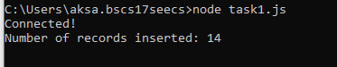

**Task 8:** Select all records from the "customers" table, and display the result object. Save the code above in a file called "demo_db_select.js" and run the file

var mysql = require('mysql');

var con = mysql.createConnection({

host: "localhost",

user: "root",

password: "",

database:"mydb"

});

con.connect(function (err) {

if (err) throw err;

console.log("Connected!");

var sql = "SELECT * FROM customers";

con.query(sql, function (err, result) {

if (err) throw err;

console.log(result);

});

});



**Task 9:** Select name and address from the "customers" table, and display the return object. Save the code above in a file called "demo_db_select2.js" and run the file

var mysql = require('mysql');

var con = mysql.createConnection({

host: "localhost",

user: "root",

password: "",

database:"mydb"

});

con.connect(function (err) {

if (err) throw err;

console.log("Connected!");

var sql = "SELECT name, address FROM customers";

con.query(sql, function (err, result) {

if (err) throw err;

console.log(result);

});

});

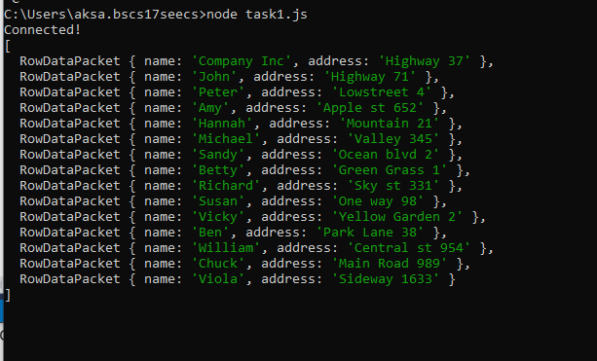

**Task 10:** Select all records from the "customers" table, and display the fields object. Save the code above in a file called "demo_db_select_fields.js" and run the file

var mysql = require('mysql');

var con = mysql.createConnection({

host: "localhost",

user: "root",

password: "",

database:"mydb"

});

con.connect(function (err) {

if (err) throw err;

console.log("Connected!");

var sql = "SELECT * FROM customers";

con.query(sql, function (err, result, fields) {

if (err) throw err;

console.log(fields);

});

});

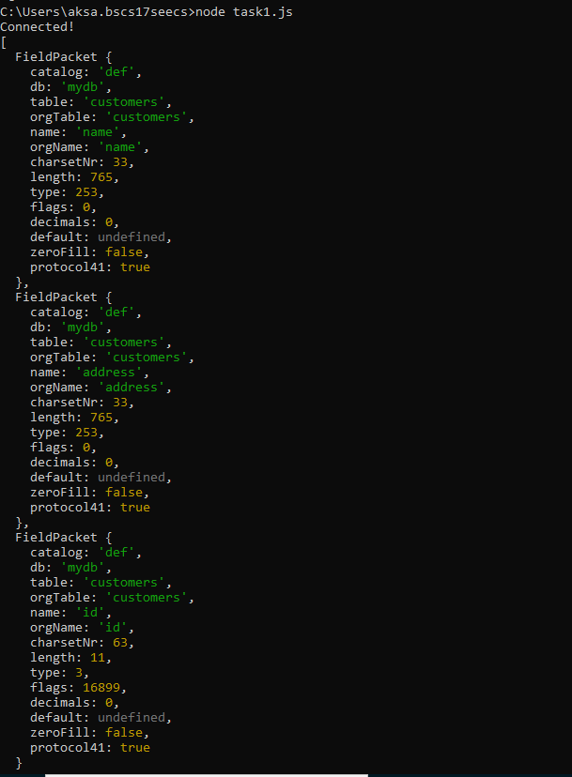

**Task11:** Select record(s) with the address "Park Lane 38". Save the code above in a file called "demo_db_where.js" and run the file

var mysql = require('mysql');

var con = mysql.createConnection({

host: "localhost",

user: "root",

password: "",

database:"mydb"

});

con.connect(function (err) {

if (err) throw err;

console.log("Connected!");

var sql = "SELECT * FROM customers WHERE address ='Park Lane 38'";

con.query(sql, function (err, result, fields) {

if (err) throw err;

console.log(result);

});

});

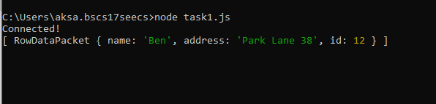

**Task 12:** Select records where the address starts with the letter 'S'. Save the code above in a file called "demo_db_where_s.js" and run the file.

var mysql = require('mysql');

var con = mysql.createConnection({

host: "localhost",

user: "root",

password: "",

database:"mydb"

});

con.connect(function (err) {

if (err) throw err;

console.log("Connected!");

var sql = "SELECT * FROM customers WHERE address LIKE 'S%'";

con.query(sql, function (err, result, fields) {

if (err) throw err;

console.log(result);

});

});

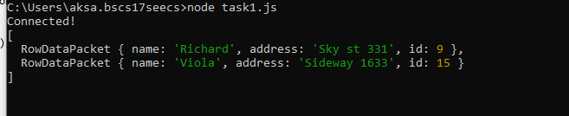

**Task 13:** Sort the result alphabetically by name. Save the code above in a file called "demo_db_orderby.js" and run the file

var mysql = require('mysql');

var con = mysql.createConnection({

host: "localhost",

user: "root",

password: "",

database:"mydb"

});

con.connect(function (err) {

if (err) throw err;

console.log("Connected!");

var sql = "SELECT * FROM customers ORDER BY name";

con.query(sql, function (err, result, fields) {

if (err) throw err;

console.log(result);

});

});

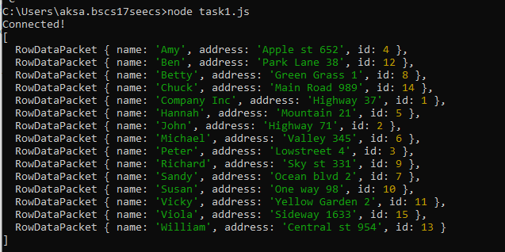

**Task 14:** Delete any record with the address "Mountain 21". Save the code above in a file called "demo_db_delete.js" and run the file.

var mysql = require('mysql');

var con = mysql.createConnection({

host: "localhost",

user: "root",

password: "",

database:"mydb"

});

con.connect(function (err) {

if (err) throw err;

console.log("Connected!");

var sql = "DELETE FROM customers WHERE address = 'Mountain 21'";

con.query(sql, function (err, result, fields) {

if (err) throw err;

console.log(result);

});

});

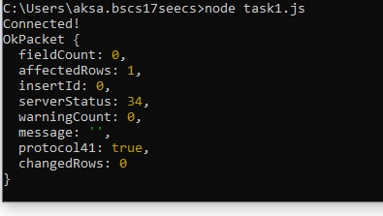

**Task 15:** Delete the table "customers". Save the code above in a file called "demo_db_drop_table_if.js" and run the file.

var con = mysql.createConnection({

host: "localhost",

user: "root",

password: "",

database:"mydb"

});

con.connect(function (err) {

if (err) throw err;

console.log("Connected!");

var sql = "DROP TABLE customers";

con.query(sql, function (err, result) {

if (err) throw err;

console.log("Table deleted");

});

});

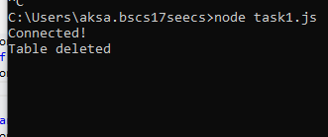

**Task 16:** Overwrite the address column from "Valley 345" to "Canyon 123". Save the code above in a file called "demo_db_update.js" and run the file

var mysql = require('mysql');

var con = mysql.createConnection({

host: "localhost",

user: "root",

password: "",

database:"mydb"

});

con.connect(function (err) {

if (err) throw err;

console.log("Connected!");

var sql = "UPDATE customers SET address = 'Canyon 123' WHERE address = 'Valley 345'";

con.query(sql, function (err, result, fields) {

if (err) throw err;

console.log(result);

});

});

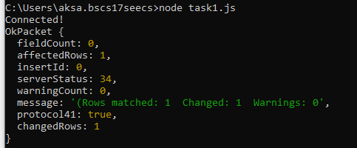

**Task 17:** Select the 5 first records in the "customers" table. Save the code above in a file called "demo_db_limit.js" and run the file. Now Start from position 3, and return the next 5 records.

var mysql = require('mysql');

var con = mysql.createConnection({

host: "localhost",

user: "root",

password: "",

database:"mydb"

});

con.connect(function (err) {

if (err) throw err;

console.log("Connected!");

var sql = "SELECT * FROM customers LIMIT 5";

con.query(sql, function (err, result, fields) {

if (err) throw err;

console.log(result);

});

});

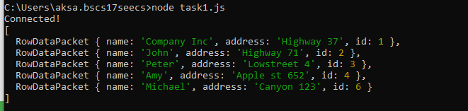

var mysql = require('mysql');

var con = mysql.createConnection({

host: "localhost",

user: "root",

password: "",

database:"mydb"

});

con.connect(function (err) {

if (err) throw err;

console.log("Connected!");

var sql = "SELECT * FROM customers LIMIT 5 OFFSET 2";

con.query(sql, function (err, result, fields) {

if (err) throw err;

console.log(result);

});

});

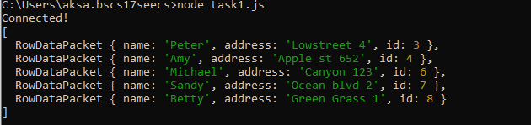

**Task 18:** Practice the Join operations on different tables.

var mysql = require('mysql');

var con = mysql.createConnection({

host: "localhost",

user: "root",

password: "",

database:"mydb"

});

con.connect(function (err) {

if (err) throw err;

console.log("Connected!");

var sql = "CREATE TABLE product (pid INT AUTO_INCREMENT PRIMARY KEY, pname VARCHAR(255), cust_id INT)";

con.query(sql, function (err, result) {

if (err) throw err;

console.log("Table created");

});

var sql = "INSERT INTO product (pname, cust_id) VALUES ?";

var values = [

['apple', 2],

['banana', 3],

['orange', 2],

['orange', 4],

['guava', 3],

];

con.query(sql, [values], function (err, result) {

if (err) throw err;

console.log("Number of records inserted: " + result.affectedRows);

});

var sql = "SELECT customers.name, product.pname FROM customers JOIN product ON customers.id = product.cust_id";

con.query(sql, function (err, result, fields) {

if (err) throw err;

console.log(result);

});

});

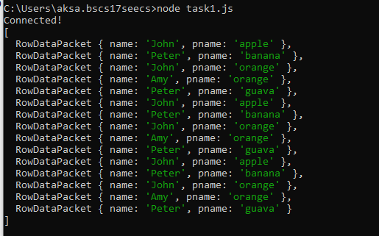

var con = mysql.createConnection({

host: "localhost",

user: "root",

password: "",

database:"mydb"

});

con.connect(function (err) {

if (err) throw err;

console.log("Connected!");

var sql = "SELECT customers.name, product.pname FROM customers LEFT JOIN product ON customers.id = product.cust_id";

con.query(sql, function (err, result, fields) {

if (err) throw err;

console.log(result);

});

});

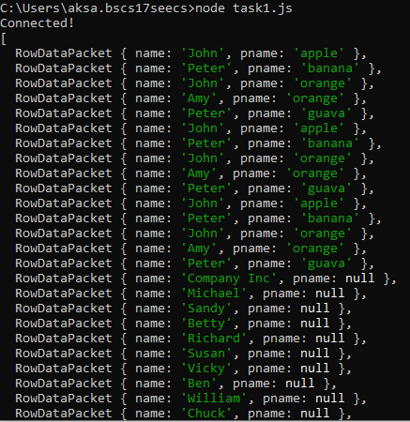

### Deliverables

Compile a single word document by filling in the solution part and submit this Word file on LMS. This lab grading policy is as follows: The lab is graded between 0 to 10 marks. The submitted solution can get a maximum of 5 marks. At the end of each lab or in the next lab, there will be a viva related to the tasks. The viva has a weightage of 5 marks. Insert the solution/answer in this document. You must show the implementation of the tasks in the designing tool, along with your complete Word document to get your work graded. You must also submit this Word document on the LMS. In case of any problems with submissions on LMS, submit your Lab assignments by emailing it to Ms. Ayesha Asif: [ayesha.asif@seecs.edu.pk](mailto:ayesha.asif@seecs.edu.pk).