# Department of Computing

**CS-213: Advanced Programming**

**Class: BSCS 7AB**

# Lab 07: Express JS

**Date: 17 October, 2019**

**Time: 10:00-01:00pm & 02:00-05:00pm**

**AKSA**

**228491**

**BSCS 7B**

# Instructor: Dr. Sidra Sultana

**Lab Engineer: Ms. Ayesha Asif**

# 

**Lab Tasks**

**Task 1:** Create Index.html file in the root folder of your application and write the HTML FORM POST method code in it. Modify server.js to handle home page requests as well as the input sent by the HTML form.

**Hint:** To handle HTTP POST request in Express.js version 4 and above, you need to install middleware module called body-parser. The middleware was a part of Express.js earlier but now you have to install it separately. This body-parser module parses the JSON, buffer, string and url encoded data submitted using HTTP POST request. Install body-parser using NPM as shown below.

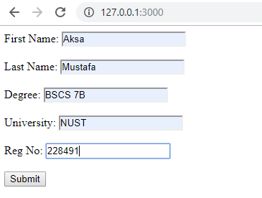

<!DOCTYPE html>

<html lang="en" xmlns="http://www.w3.org/1999/xhtml">

<head>

<meta charset="utf-8" />

<title>Form</title>

</head>

<body>

<form action="/" method="POST" enctype="multipart/form-data">

First Name: <input type="text" name="fname" value="first name" /><br /><br />

Last Name: <input type="text" name="lname" value="Last name" /><br /><br />

Degree: <input type="text" name="degree" value="degree" /><br /><br />

University: <input type="text" name="uni" value="university" /><br /><br />

Reg No: <input type="text" name="regno" value="Registration Number" /><br /><br />

<input type="submit" />

</form>

</body>

</html>

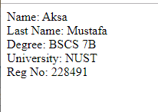

// JavaScript source code

var express = require("express")

var bodyParser = require("body-parser")

var path = require("path")

var multer = require("multer")

var upload = multer()

var app = express()

app.get("/", function(req, res)

{

res.sendFile(path.join(__dirname + '/index.html'))

})

app.use(bodyParser.json())

app.use(bodyParser.urlencoded({ extended: true }))

app.use(upload.array())

app.post('/', function(req, res)

{

console.log(req.body)

res.send("Name: " + req.body.fname + " <br>Last Name: " + req.body.lname + " <br>Degree: " + req.body.degree + " <br>University: " + req.body.uni + "<br>Reg No: " + req.body.regno)

})

app.listen(3000)

**Task 2:** Create a file uploader form in an html file. This form has method attribute set to POST and enctype attribute is set to multipart/form-data. Modify server.js to handle home page requests as well as file upload.

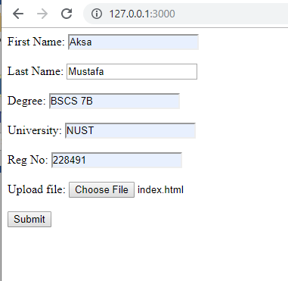

<!DOCTYPE html>

<html lang="en" xmlns="http://www.w3.org/1999/xhtml">

<head>

<meta charset="utf-8" />

<title>Form</title>

</head>

<body>

<form action="/" method="POST" enctype="multipart/form-data">

First Name: <input type="text" name="fname" value="first name" /><br /><br />

Last Name: <input type="text" name="lname" value="Last name" /><br /><br />

Degree: <input type="text" name="degree" value="degree" /><br /><br />

University: <input type="text" name="uni" value="university" /><br /><br />

Reg No: <input type="text" name="regno" value="Registration Number" /><br /><br />

Upload file: <input type="file" name="file" /><br /><br />

<input type="submit" />

</form>

</body>

</html>

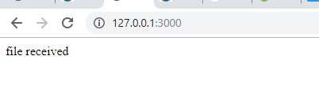

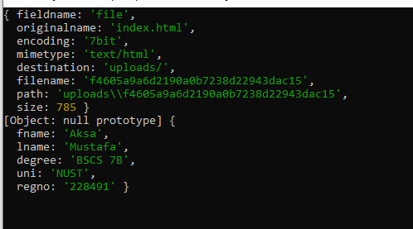

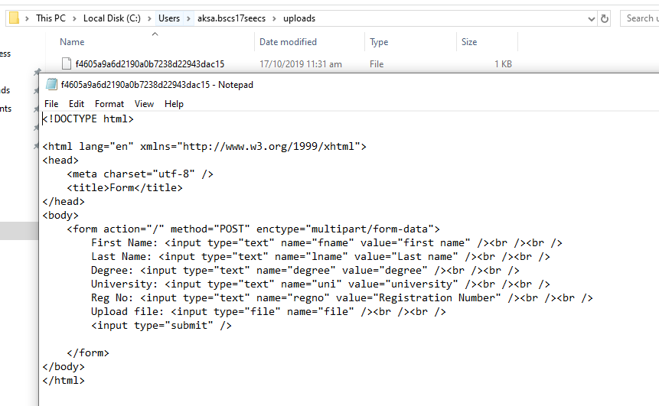

// JavaScript source code

var express = require("express")

var bodyParser = require("body-parser")

var path = require("path")

var multer = require("multer")

var upload = multer()

var app = express()

var upload = multer({ dest: 'uploads/' })

app.get("/", function(req, res)

{

res.sendFile(path.join(__dirname + '/index.html'))

})

app.post('/', upload.single('file'), function (req, res) {

console.log(req.file)

console.log(req.body)

res.send("file received")

})

app.listen(3000)

**Task 3:** By using the Pug templating engine create an HTML registration form.

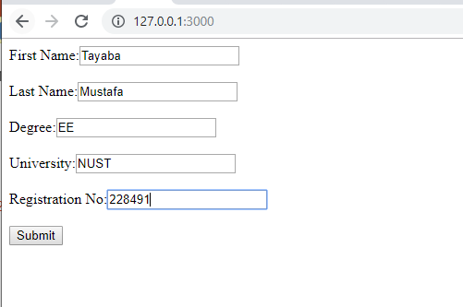

html

head

title "Form"

body

form(action="/", method="POST", enctype="multipart/form-data")

div

label First Name:

input(name="fname", type="text", value="First name")

br

div

label Last Name:

input(name="lname", type="text", value="Last name")

br

div

label Degree:

input(name="degree", type="text", value="Degree")

br

div

label University:

input(name="uni", type="text", value="University")

br

div

label Registration No:

input(name="regno", type="text", value="Registration No")

br

input(type="submit")

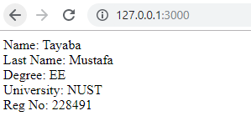

// JavaScript source code

// JavaScript source code

var express = require("express")

var bodyParser = require("body-parser")

var multer = require("multer")

var upload = multer()

var app = express()

app.get("/", function (req, res) {

res.render("form")

})

app.use(bodyParser.json())

app.use(bodyParser.urlencoded({ extended: true }))

app.use(upload.array())

app.set("view engine", "pug")

app.set("views", "./views")

app.post('/', function (req, res) {

console.log(req.body)

res.send("Name: " + req.body.fname + " <br>Last Name: " + req.body.lname + " <br>Degree: " + req.body.degree + " <br>University: " + req.body.uni + "<br>Reg No: " + req.body.regno)

})

app.listen(3000)