# Department of Computing

**CS-213: Advanced Programming**

**Class: BSCS 7AB**

# Lab 06: Node.js MongoDB

**Date: 3rd October, 2019**

**Time: 10:00-01:00pm & 02:00-05:00pm**

**AKSA**

**228491**

**BSCS 7B**

# Instructor: Dr. Sidra Sultana

**Lab Engineer: Ms. Ayesha Asif**

# 

# Lab 06: Node.js MongoDB

**Introduction**

Node.js can be used in database applications. One of the most popular NoSQL database is MongoDB.

**Lab Tasks**

**Task 1:** Create a database named "mydb". Save the code in a file called "demo_create_mongo_db.js" and run the file.

MongoClient = require('mongodb').MongoClient;

var url = "mongodb://127.0.0.1:27017/mydb1";

MongoClient.connect(url, {useNewUrlParser: true, useUnifiedTopology: true}, function(err, db)

{

if (err) throw err;

console.log("Database Created");

db.close();

})

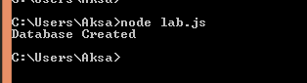

**Task 2:** Create a collection called "customers". Save the code in a file called "demo_mongodb_createcollection.js" and run the file.

MongoClient = require('mongodb').MongoClient;

var url = "mongodb://127.0.0.1:27017/";

MongoClient.connect(url, {useNewUrlParser: true, useUnifiedTopology: true}, function(err, db)

{

if (err) throw err;

console.log("connected");

var dbo = db.db("mydb1");

dbo.createCollection("customers", function(err, res)

{

if (err) throw err;

console.log("Collection created");

db.close();

})

})

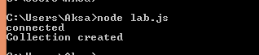

**Task 3:** Insert a document in the "customers" collection. Save the code in a file called "demo_mongodb_insert.js" and run the file.

MongoClient = require('mongodb').MongoClient;

var url = "mongodb://127.0.0.1:27017/";

MongoClient.connect(url, {useNewUrlParser: true, useUnifiedTopology: true}, function(err, db)

{

if (err) throw err;

console.log("connected");

var dbo = db.db("mydb1");

var myobj = {name:"aksa", address:"karachi"};

dbo.collection("customers").insertOne(myobj, function(err, res)

{

if (err) throw err;

console.log("1 document inserted");

db.close();

})

})



**Task 4:** Insert multiple documents in the "customers" collection. Save the code in a file called "demo_mongodb_insert_multiple.js" and run the file.

MongoClient = require('mongodb').MongoClient;

var url = "mongodb://127.0.0.1:27017/";

MongoClient.connect(url, {useNewUrlParser: true, useUnifiedTopology: true}, function(err, db)

{ if (err) throw err;

console.log("connected");

var dbo = db.db("mydb1");

var myobj = [

{name:"aksa", address:"karachi"},

{name:"ali", address:"islamabad"},

{name:"hassan", address:"lahore"},

{name:"hussain", address:"karachi"}

];

dbo.collection("customers").insertMany(myobj, function(err, res)

{

if (err) throw err;

console.log("documents inserted: " +res.insertedCount);

db.close();

})

})

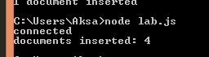

**Task 5:** Insert three records in a "products" table, with specified _id fields. Save the code in a file called "demo_mongodb_insert_id.js" and run the file.

MongoClient = require('mongodb').MongoClient;

var url = "mongodb://127.0.0.1:27017/";

MongoClient.connect(url, {useNewUrlParser: true, useUnifiedTopology: true}, function(err, db)

{

if (err) throw err;

console.log("connected");

var dbo = db.db("mydb1");

dbo.createCollection("products", function(err, res)

{

if (err) throw err;

console.log("products colection created");

db.close();

})

var dbo = db.db("mydb1");

var myobj = [

{_id: 4, name:"orange", cust_id:"5d9606b34198c21c700240e4" },

{_id:5, name:"guava", cust_id:"5d9615b9826daf1a60556b1"},

{_id:6, name:"mango", cust_id:"5d9615b9826daf1a60556b0"}

];

dbo.collection("products").insertMany(myobj, function(err, res)

{

if (err) throw err;

console.log(res);

db.close();

})

})

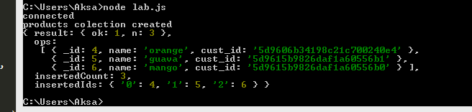

**Task 6:** Find the first document in the customer’s collection. Save the code in a file called "demo_mongodb_findone.js" and run the file.

MongoClient = require('mongodb').MongoClient;

var url = "mongodb://127.0.0.1:27017/";

MongoClient.connect(url, {useNewUrlParser: true, useUnifiedTopology: true}, function(err, db)

{

if (err) throw err;

console.log("connected");

var dbo = db.db("mydb1");

dbo.collection("customers").findOne({}, function(err, res)

{

if (err) throw err;

console.log(res);

db.close();

})

})

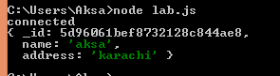

**Task 7:** Return the fields "name" and "address" of all documents in the customers collection

MongoClient = require('mongodb').MongoClient;

var url = "mongodb://127.0.0.1:27017/";

MongoClient.connect(url, {useNewUrlParser: true, useUnifiedTopology: true}, function(err, db)

{

if (err) throw err;

console.log("connected");

var dbo = db.db("mydb1");

dbo.collection("customers").find({}, {projection:{_id:0}}).toArray(function(err, res)

{

if (err) throw err;

console.log(res);

db.close();

})

})

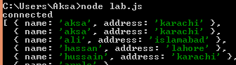

**Task 8:** Find documents with the address "Park Lane 38". Save the code in a file called "demo_mongodb_query.js" and run the file.

MongoClient = require('mongodb').MongoClient;

var url = "mongodb://127.0.0.1:27017/";

MongoClient.connect(url, {useNewUrlParser: true, useUnifiedTopology: true}, function(err, db)

{

if (err) throw err;

console.log("connected");

var dbo = db.db("mydb1");

var query= {address:"karachi"};

dbo.collection("customers").find(query).toArray(function(err, res)

{

if (err) throw err;

console.log(res);

db.close();

})

})

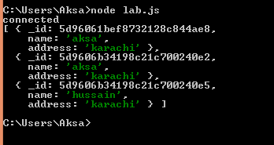

**Task 9:** Sort the result alphabetically by name. Save the code in a file called "demo_sort.js" and run the file.

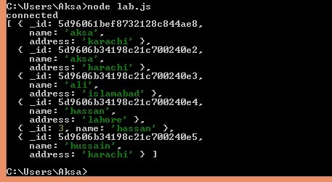

MongoClient = require('mongodb').MongoClient;

var url = "mongodb://127.0.0.1:27017/";

MongoClient.connect(url, {useNewUrlParser: true, useUnifiedTopology: true}, function(err, db)

{

if (err) throw err;

console.log("connected");

var dbo = db.db("mydb1");

var query= {name:1};

dbo.collection("customers").find().sort(query).toArray(function(err, res)

{

if (err) throw err;

console.log(res);

db.close();

})

})

**Task 10:** Delete the document with the address "Mountain 21". Save the code in a file called "demo_delete.js" and run the file.

MongoClient = require('mongodb').MongoClient;

var url = "mongodb://127.0.0.1:27017/";

MongoClient.connect(url, {useNewUrlParser: true, useUnifiedTopology: true}, function(err, db)

{ if (err) throw err;

console.log("connected");

var dbo = db.db("mydb1");

var query= {address:"islamabad"};

dbo.collection("customers").deleteMany(query, function(err, res)

{

if (err) throw err;

console.log("Number of documents deleted"+res.result.n);

db.close();

})

})



**Task 11:** Delete all documents were the address starts with the letter "O". Save the code in a file called "demo_delete_many.js" and run the file

MongoClient = require('mongodb').MongoClient;

var url = "mongodb://127.0.0.1:27017/";

MongoClient.connect(url, {useNewUrlParser: true, useUnifiedTopology: true}, function(err, db)

{

if (err) throw err;

console.log("connected");

var dbo = db.db("mydb1");

var query= {address:/^k/};

dbo.collection("customers").deleteMany(query, function(err, res)

{

if (err) throw err;

console.log("Number of documents deleted"+res.result.n);

db.close();

})

})

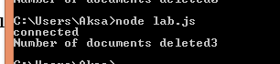

**Task 12:** Delete the "customers" table. Save the code in a file called "demo_drop.js" and run the file.

MongoClient = require('mongodb').MongoClient;

var url = "mongodb://127.0.0.1:27017/";

MongoClient.connect(url, {useNewUrlParser: true, useUnifiedTopology: true}, function(err, db)

{

if (err) throw err;

console.log("connected");

var dbo = db.db("mydb1");

dbo.collection("customers").drop(function(err, delOK) {

if (err) throw err;

if (delOK) console.log("Collection deleted");

db.close();

});

})



**Task 13:** Update the document with the address "Valley 345" to name="Mickey" and address="Canyon 123". Save the code in a file called "demo_update_one.js" and run the file

MongoClient = require('mongodb').MongoClient;

var url = "mongodb://127.0.0.1:27017/";

MongoClient.connect(url, {useNewUrlParser: true, useUnifiedTopology: true}, function(err, db)

{

if (err) throw err;

console.log("connected");

var dbo = db.db("mydb1");

var query= {address:"lahore"};

var newquery = {$set: {name:"areeba", address:"quetta"}};

dbo.collection("customers").updateMany(query, newquery, function(err, res)

{

if (err) throw err;

console.log("Number of documents updated: "+res.result.nModified);

db.close();

})

})



**Task 14:** Consider you have a "customers" collection. Limit the result to only return 5 documents. Save the code above in a file called "demo_mongodb_limit.js" and run the file.

MongoClient = require('mongodb').MongoClient;

var url = "mongodb://127.0.0.1:27017/";

MongoClient.connect(url, {useNewUrlParser: true, useUnifiedTopology: true}, function(err, db)

{ if (err) throw err;

console.log("connected");

var dbo = db.db("mydb1");

dbo.collection("customers").find().limit(5).toArray(function(err, res)

{

if (err) throw err;

console.log(res);

db.close();

})

})

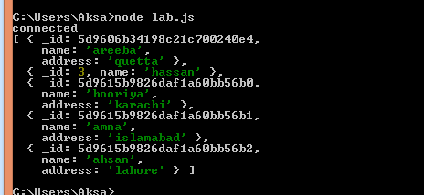

**Task 15:** Practice the Join operations on different tables.

MongoClient = require('mongodb').MongoClient;

var url = "mongodb://127.0.0.1:27017/";

MongoClient.connect(url, {useNewUrlParser: true, useUnifiedTopology: true}, function(err, db)

{

if (err) throw err;

console.log("connected");

var dbo = db.db("mydb1");

dbo.collection("products").aggregate([

{

$lookup:

{

from :'customers',

localField:'cust_id',

foreignField:"_id",

as: 'favouriteproducts'

}

}]).toArray(function(err, res)

{

if (err) throw err;

console.log(JSON.stringify(res));

db.close();

})

})

