PYTHON MINI PROJECT REPORT
Pomodoro Study Session Timer

Course: Programming in Python
Project Title: Pomodoro Study Session Timer
Student Name: Aksa Kunjumon
Roll Number: 19
Class: S6 CS A
College: Amal Jyothi College of Engineering

Abstract
The Pomodoro Study Session Timer is a simple productivity application developed using Python and the Tkinter GUI library. The purpose of the application is to help students manage their study time effectively by setting a fixed duration for focused study sessions. The timer displays a countdown along with a progress bar that visually represents the completion of the session. The user can start, pause, resume, and reset the timer using simple controls. Once the timer reaches zero, the system notifies the user with a message indicating that the session is complete. This project demonstrates the practical use of Python GUI programming and time-based event handling.

Problem Description
Students often struggle to maintain concentration during long study sessions. Without proper time management, productivity decreases and distractions increase. The Pomodoro technique is a popular time management method that divides work into focused time intervals followed by short breaks.
This project aims to develop a simple study timer that allows users to set a study duration and track their progress visually. The application provides an easy-to-use graphical interface where users can control the timer using different buttons. The system displays the remaining time and updates the progress bar during the session.
The main goal of this project is to demonstrate how Python can be used to build a simple graphical application that improves study productivity.

Libraries & Tools Used
Python – Main programming language used for implementing the application.
Tkinter – Python’s standard GUI library used to create the graphical interface.
ttk Module – Used to implement the progress bar widget.
Messagebox – Used to display alert messages and notifications to the user.

System Design / Workflow
1. The user enters the study time in minutes in the input field.
2. When the Start button is clicked, the program converts the time into seconds.
3. The countdown timer begins and updates every second.
4. The progress bar increases gradually as the time progresses.
5. The user can pause, resume, or reset the timer using control buttons.
6. When the timer reaches zero, the system displays a completion message and alert sound.
Input → Study time entered by the user
Processing → Countdown calculation and progress bar updates
Output → Timer display and completion notification

Implementation Details
The program is implemented using Python and Tkinter. The interface includes an input field to enter the study time, a large timer display, a progress bar, and control buttons. The timer works by converting minutes into seconds and updating the display every second using Tkinter's after() method.
Main Functions:
Start Timer – Initializes the timer and begins the countdown.
Update Timer – Updates the timer display and progress bar every second.
Pause Timer – Temporarily stops the countdown.
Resume Timer – Continues the timer from the paused state.
Reset Timer – Resets the timer and progress bar to the initial state.

Results & Output
The Pomodoro Study Timer successfully runs as a graphical desktop application. The interface allows the user to enter study time, start the timer, and track progress using the progress bar. Once the timer reaches zero, a notification message is displayed informing the user that the session is complete.
Screenshots to include in the report:
- Application start screen
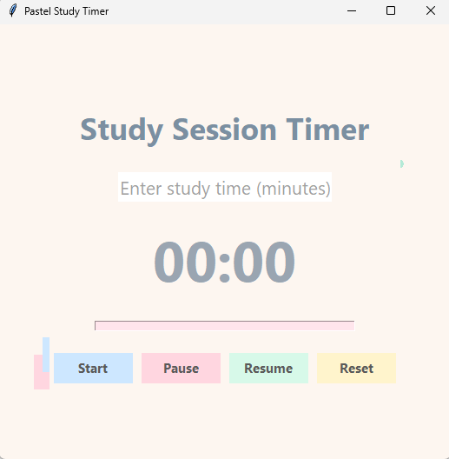
- Timer running with progress bar
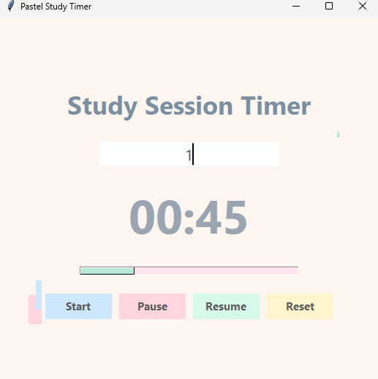
- Final completion message
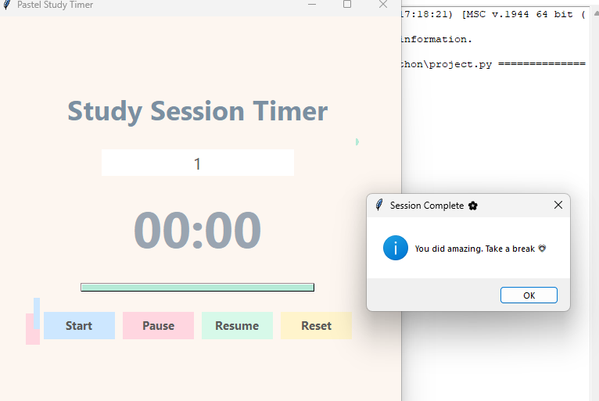

Conclusion
The Pomodoro Study Session Timer demonstrates how Python can be used to build simple and useful productivity tools. The project highlights the use of GUI programming with Tkinter and event-driven programming concepts. This application helps students manage their study sessions effectively.

Scope for Future Improvement
• Automatic break timers
• Study session history tracking
• Sound notifications and themes
• Mobile or web-based version

References
Python Official Documentation – https://docs.python.org
Tkinter Documentation – https://docs.python.org/3/library/tkinter.html

