**ONLINE-PARKING-SYSTEM**

**Course code: INT404**

**Section: K18GE**



|  |  |  |
| --- | --- | --- |
| ***Registration No.*** | ***Name of Students*** | ***Roll No.*** |
| 11811345 | **AMIT KUMAR** | RK18GEA03 |
| 11811391 | **DEVANSHU SHARMA** | RK18GEA07 |
| 11811343 | **PRASHANT MANRAL** | RK18GEA32 |
| 11903327 | **ARYAAN KHALID** | RK18GEA47 |

**Submitted to:-**

**Name of the faculty: Ms. Shabnam Mam**

**REPOSITORY LINK:** https://github.com/Aksamitkumar323/Online_parking_system

**Department of Intelligent Systems**

**School of Computer Science Engineering**

**Lovely Professional University, Jalandhar**

APRIL-2020

**Student Declaration**

This is to declare that this report has been written by us. No part of the report is copied from other sources. All information included from other sources has been duly acknowledged. We aver that if any part of the report is found to be copied, we are shall take full responsibility for it.

AMIT KUMAR

11811345

RK18GEA03

DEVANSHU SHARMA

11811391

RK18GEA07

PRASHANT MANRAL

11811343

RK18GEA32

ARYAAN KHALID

11903327

RK18GEA47

Place : LOVELY PROFESSIONAL UNIVERSITY,PHAGWARA,PUNJAB

Date : 12-04-2020

**INTRODUCTION**

The Online Vehicle Parking Reservation System (OVPRS) is a system that enables customers/drivers to reserve a parking space. It also allows the customers/drivers to view the parking status at a specific people’s parking.

The parking place is very important all over the worldespecially in the cities of the countries. Every thousands of car drivers spend a lot of the time to find where to park. The result of this situation is theft in urban areas, increasing traffic congestion and frustration of drivers. In order to solve this problem, the implementation of Online Vehicle Park Reservation System in this city for managing parking places is mandatory. It will allow the drivers to Reserve a parking place on the Platform of People’s Park Kyebando (PPK) anytime, anywhere.

This chapter gives an overview of the background of the study, statement of the problems,

Objectives of the study, research questions, scope of the study and significance of the study.

**Objective of the study**

1. **Main Objective**

To enable drivers to locate and reserve a parking place online through accessing it on web platform.

1. **Specific Objective**

To establish possible solutions to improve on the current Vehicle Parking Reservation system

To design and implement Online Vehicle Parking Reservation system

To make a good research about People’s Park and gather all necessary information that helped in designing the new parking reservation system.

**Scope of the Study**

1. **Time Scope**

The study was conducted for duration of four month from May-August 2016 from the stage of analysis, data collection and system development, for the purpose of collecting righteous information to enable me develop the system**.**

1. **Significance of Study**

The research has helped to minimize paperwork, errors madefrom the reservation office like miss spelling the number plate, vehicle model, time wastage, delays and congestion at the reservation office.

**User Requirements**

1. The system allows drivers/clients to create accounts on it
2. The system allows the system administrator to: book the parking place, printing their receipt , managing the client and parking lot information(such as deleting, updating, adding viewing the client information and viewing different type of parking lot status).
3. The system allows drivers to locate and reserve a parking place online through accessing it on web platform
4. The system allows the client and the system administrator to view the parking status (either available or already reserved)
5. The system allows authentication of registered users.
6. The system is easy to use and learn.
7. The system allows the clients to view their account info (booking status) and also to print receipt.

**Functional Requirements**

1. The web application displays the availability of parking lot
2. The web application enables employees to set the reaching date and time for the car also the departure date and time.
3. The web application enables employees to cancel a parking place.
4. The web application enables drivers to book parking place

**DISTRIBUTION OF MODULE**

**AMIT KUMAR**

* FLOW CHART
* DESIGN MADE

**PRASHANT MANRAL**

* CODING IMPLEMENTATION
* CODE MODULE

**ARYAAN KHALID**

* PROJECT REPORT
* IDEAS TO MAKE PROGRAM

**DEVANSHU SHARMA**

* INITIALISE THE PROJECT
* MADE SMALL MODULE

**FLOW CHART**

Users of the web application include; Clients and system administrator. When a client comes to the system (Web application), he/she is able to book a parking lot, parking place available and reserved, to read the FAQ, about us a without registration or signing in and he/she can create an

account on the system by registering through providing his/her full name, email, password, if he/she is an existing user he can just sign in using his/her email address and password. What system administrator are able to do on the system he/she is able to manage all users in the web application such as add a new user, update, delete a user, to view the detail information of client, managing parking lot information such as booking, updating, viewing different type of parking (car park, trailer park, lorry park), cancel the booking and also managing the system administrator setting. The logged in user can update his/her password by providing the current password and can log off the system.

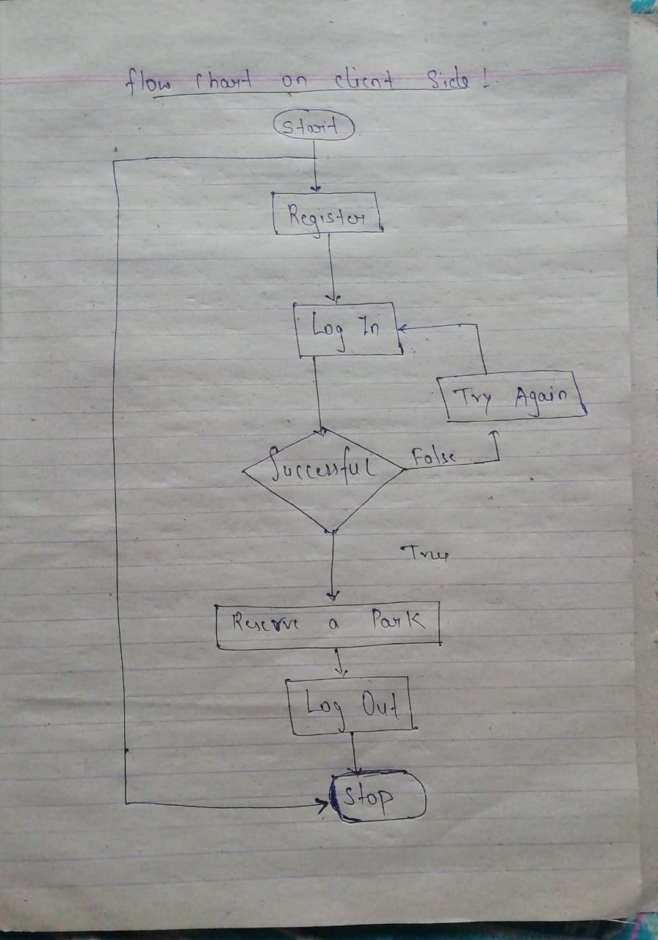

**Flow chart on client side....**

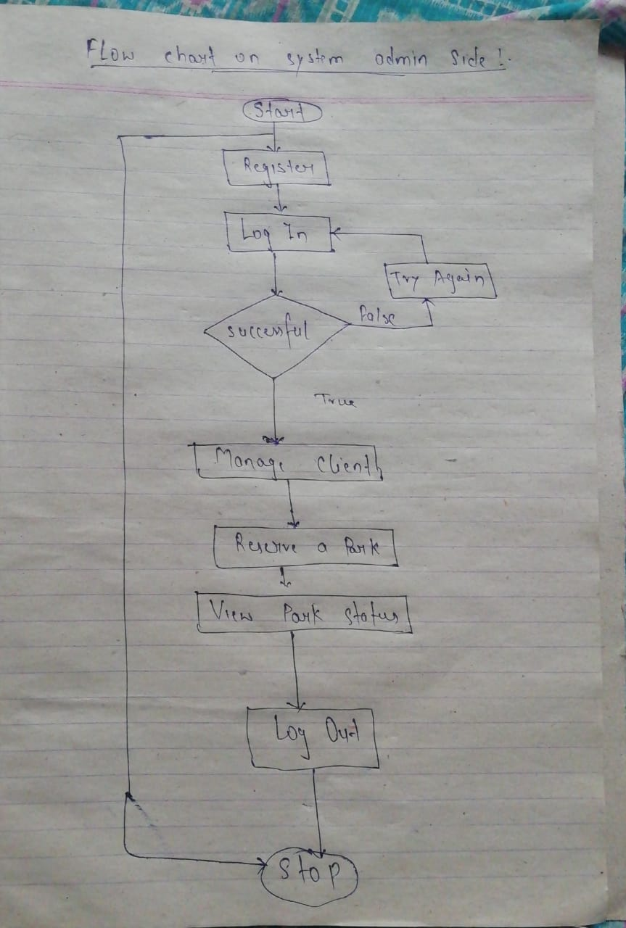

**Flow chart on system admin side.......**

**ARCHITECTURAL DESIGN OF THE SYSTEM**

The topmost level of the web application is the presentation layer which displays information such as browsing parking lot, client, system user login, booking, etc. It communicates with other layers by which it puts out the results to the browser/client tier and all other tiers in the network.

The Business Access Layer Project is responsible for all the business logic of the application by performing detailed processing, it interfaces the Data Access Layer and the presentation Layer. The Data Access Layer subsystem is responsible for accessing the database for data retrieval and insertion.

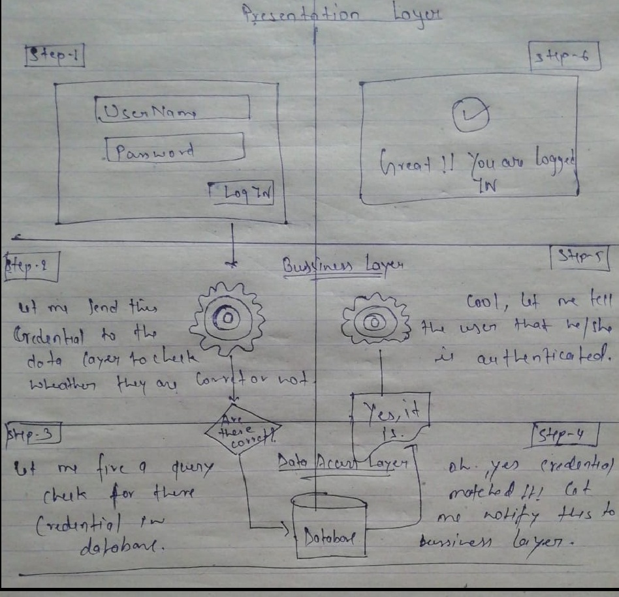

**The layer how the project is going to work..**

22

**ACHIEVEMENTS OF THE PROJECT**

1. Clients can create accounts on the system through registration.
2. System Administrator can manage the Employees by creating for them the account.
3. Employees are able to book the parking for the client
4. Clients can view the parking available and reserve parking lot online.
5. System Administrators can manage the parking lot, transaction and also he can manage the clients.
6. System Administrators can efficiently and effectively manage all the users on the application and roles.
7. The chances of vehicle getting damaged due to improper parking are considerably reduced.

**LIMITATION OF THE PROJECT**

1. Web application is not fully responsive (scaling down nicely according to different devices).
2. Since this project is for the final project the credit card is not working properly.

**SUMMARY**

This project was aimed to Improve on the current Vehicle Parking Reservation systems by creating online vehicle reservation system which enables the client/driver to book parking space online.

The existing vehicle parking reservation system was file based where customer pays cash at the receptionist then a receipt is given to the customer .this process was tiresome at people’s park. OVPRS enables drivers to locate and reserve a parking place online through accessing it on web platform where client login then she/he starts process of booking a parking.

**CONCLUSION**

Online vehicle parking reservation system improves the existing system since we are in computerized world. With this new system is mandatory, it enables the user of the system (client, employee, System administrator) to reserve a parking lot online and this reduces the wasting of

Time of the clients looking for where to park, increase the safety of the property since the parking lot is numbering.

Our AI checks if any possible move can allow itself to win. Otherwise, it checks if it must block the player’s move. Then the AI simply chooses any available corner space, then the center space, then the side spaces. This is a simple algorithm for the computer to follow.

The key to implementing our AI is by making copies of the board data and simulating moves on the copy. That way, the AI code can see if a move results in a win or loss. Then the AI can make that move on the real board. This type of simulation is effective at predicting that is it a good move or not.