**“JSON Converter” Task**

You are given a simple JSON file example:

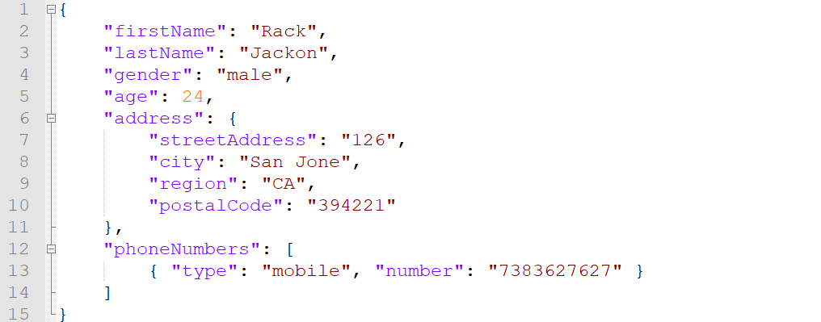

Replace the values provided with the data that is true about you and “convert” .json file into .xml.

