**Engineering Mathematics Homework 3 - Solution**

Ans:



1. Ans:



1. Sol:



4.

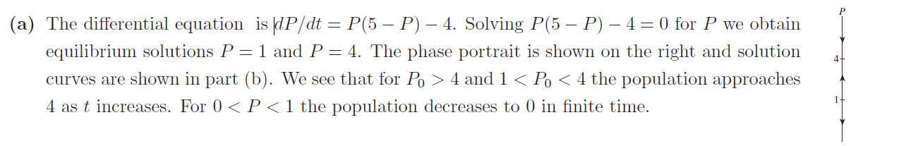

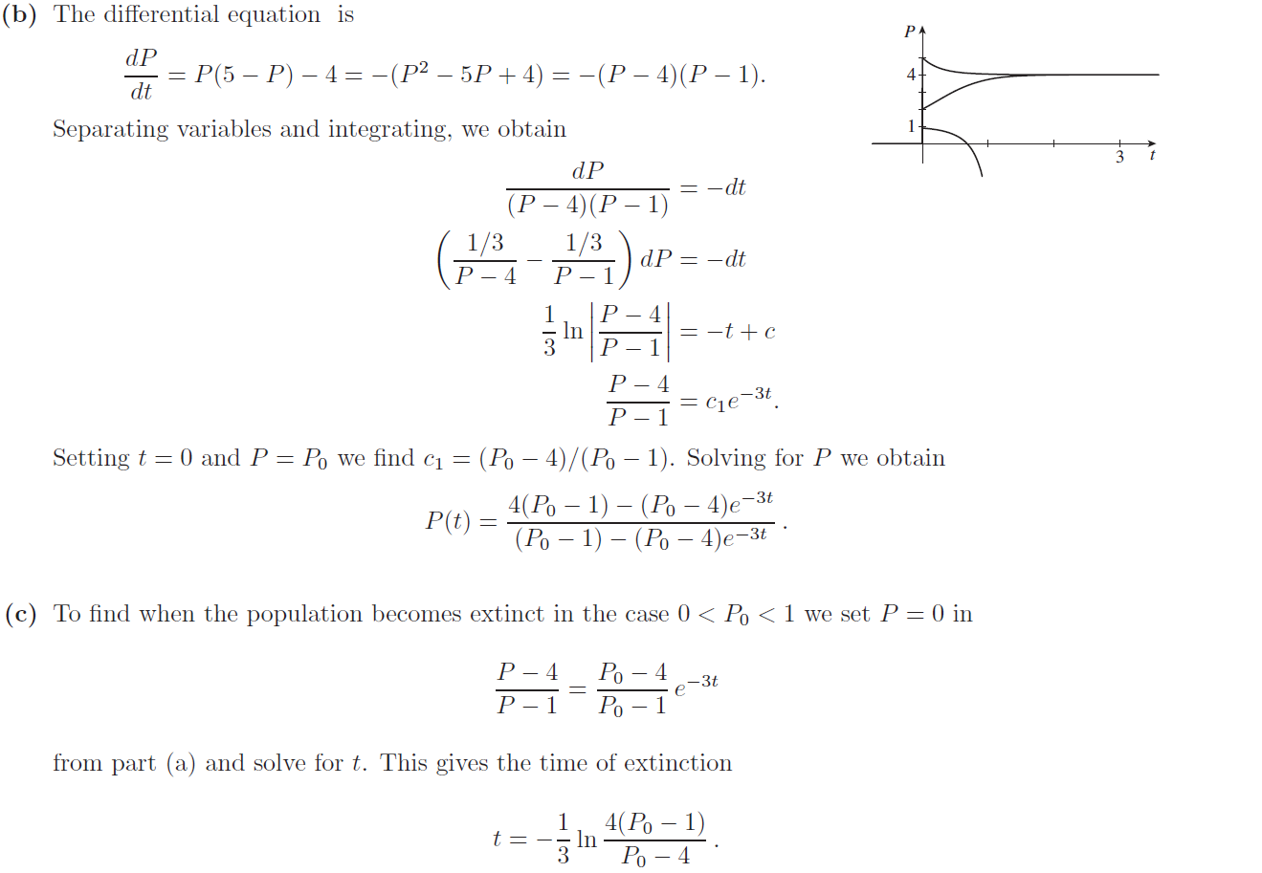

5.

