**Engineering Mathematics Homework 5**

4.2.26



4.3.36

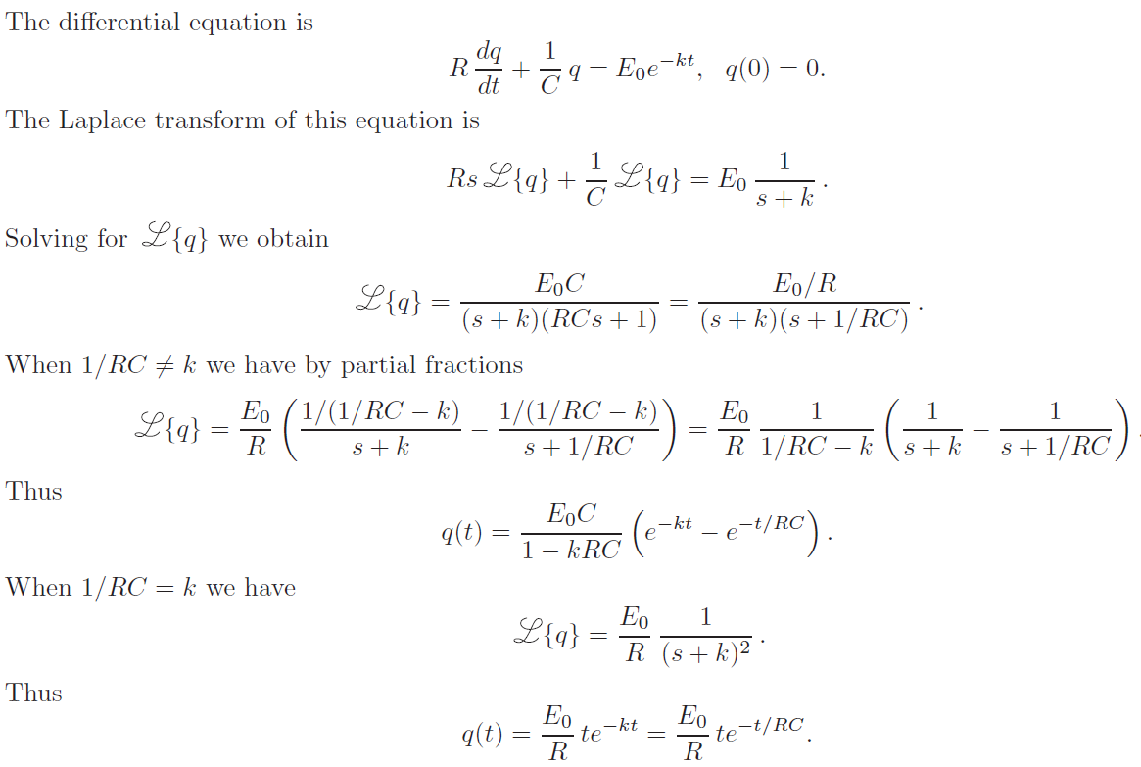

5.1.17

