F74031035 鞠之浩

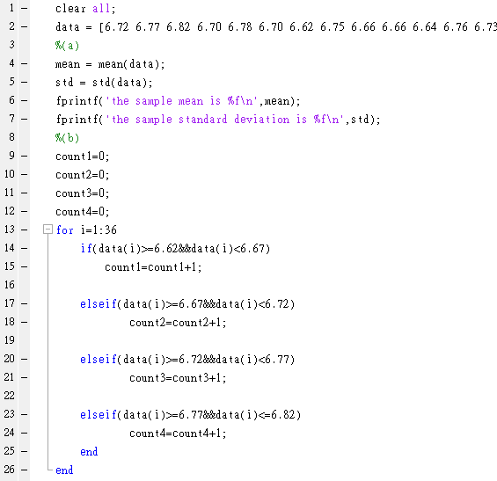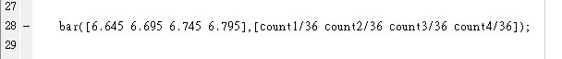

Result:



