HW1 F74031051 林允文

執行結果:

(a)

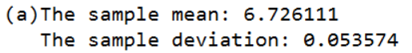

(b)

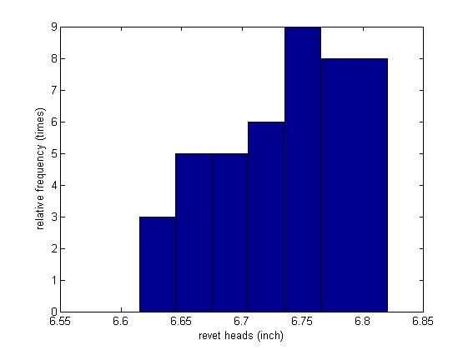

程式碼:

sample = [6.72 6.77 6.82 6.70 6.78 6.70 6.62 6.75 6.66 6.66 6.64 6.76 6.73 6.80 6.72 6.76 6.76 6.68 6.66 6.62 6.72 6.76 6.70 6.78 6.76 6.67 6.70 6.72 6.74 6.81 6.79 6.78 6.66 6.76 6.76 6.72 ];

temp=0;

for i=1:36

temp=temp+sample(i);

end

mean=temp/36;

temp=0;

for i=1:36

temp=temp+(sample(i)-mean)^2;

end

deviation=sqrt(temp/35);

fprintf('(a)The sample mean: %f\n The sample deviation: %f\n',mean,deviation);

xbins=6.60:0.03:6.80;

hist(sample,xbins);

xlabel ('revet heads (inch)');

ylabel ('relative frequency (times)');