HW2 資訊系 林允文 F74031051

**執行結果:**

5-41

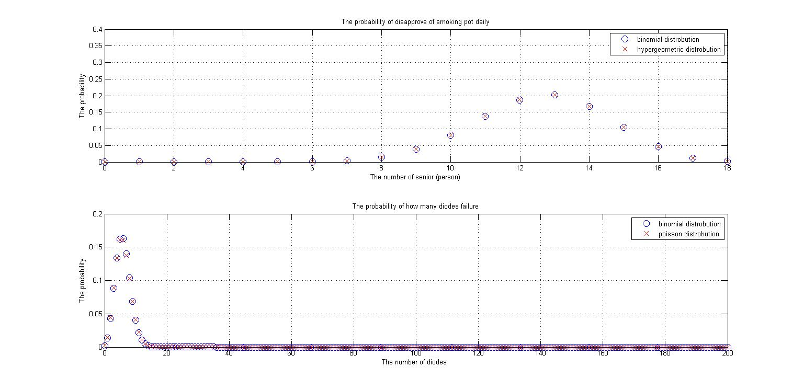

這是計算取x次時，每次都放回去的機率，9 ≦ x ≦ 14的狀況，而p=0.7，所以binomial distribution 為 ∫B(14,18,0.7) -∫B(9,18.0.7)，另外若用hypergeometric distribution計算是選取後不放回，x=14,N=17000，因為機率為70%，所以有11900人是有disapprove of smoking daily，n=11900,k=18，∫h(14,17000,11900,18)-∫h(9,17000,11900,18)，而且因為17000和18相差許多，所以每次就算選取一個人，所改變的機率直很小，此時binomial和hypergeometric會很接近，亦可由圖上所看到。



5-87(c)



這題是計算二極體壞掉的機率，而因為要200個二極體全部都是好的，元件才可以使用，所以x=0，binomial distribution為B(0,200,0.03)，而也因為n = 200，相對於x = 0，大很多，而且p = 0.03非常靠近0，故對此分布可用poisson distribution來近似，lambda為np，故為p(0,6)。

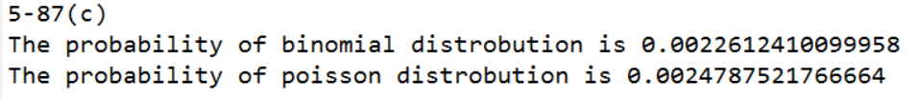

**程式碼:**

%5-41

binomialA1 = binopdf(14,18,0.7);

binomialA2 = binopdf(9,18,0.7);

hyperA1 = hygepdf(14,17000,11900,18);

hyperA2 = hygepdf(9,17000,11900,18);

binomialchart = 0:18;

hyperchart = 0:18;

for i = 0:1:18

binomialchart(i+1) = binopdf(i,18,0.7);

hyperchart(i+1) = hygepdf(i,17000,11900,18);

end

%plot the chart

i = [0 1 2 3 4 5 6 7 8 9 10 11 12 13 14 15 16 17 18];

subplot(211);

chart1 = plot(i,binomialchart,'bO',i,hyperchart,'rX');

set(chart1,'markerSize',10);

axis([0,18,0,0.4]);

grid on;

legend('binomial distrobution','hypergeometric distrobution');

xlabel('The number of senior (person)');

ylabel('The probability');

title('The probability of disapprove of smoking pot daily');

fprintf('5-41\n');

fprintf('The probability of binomial distrobution between 9 and 14 is %f \n',binomialA1-binomialA2);

fprintf('The probability of hypergeometric distrobution between 9 and 14 is %f \n\n',hyperA1-hyperA2);

%5-87 (c)

binomialC = binopdf(0,200,0.03);

poissonC = poisspdf(0,6);

poissonchart(1) = 0;

for i = 0:1:200

binomialchart(i+1) = binopdf(i,200,0.03);

poissonchart(i+1) = poisspdf(i,6);

end

%plot the chart

i = 0:200;

subplot(212);

chart3 = plot(i,binomialchart,'bO',i,poissonchart,'rX');

set(chart3,'markerSize',10);

axis([0,200,0,0.2]);

grid on;

legend('binomial distrobution','poisson distrobution');

xlabel('The number of diodes ');

ylabel('The probability');

title('The probability of how many diodes failure');

fprintf('5-87(c)\n');

fprintf('The probability of binomial distrobution is %.16f \n',binomialC);

fprintf('The probability of poisson distrobution is %.16f \n\n',poissonC);

**說明:**

主要是呼叫binomial、hypergeometric、poisson的function進行計算，然後題目並無要求化成histogram，故用plot指令畫出各個圖形。