HW4 F74031051 林允文

執行結果:

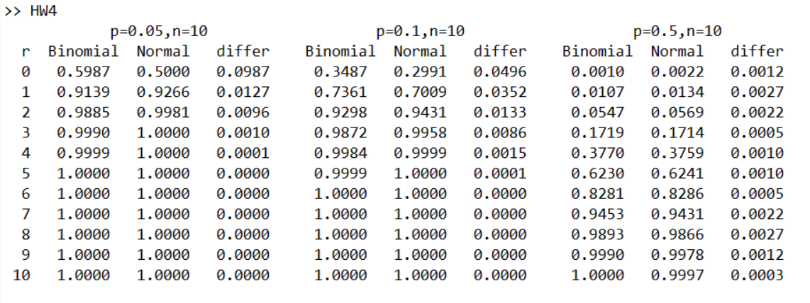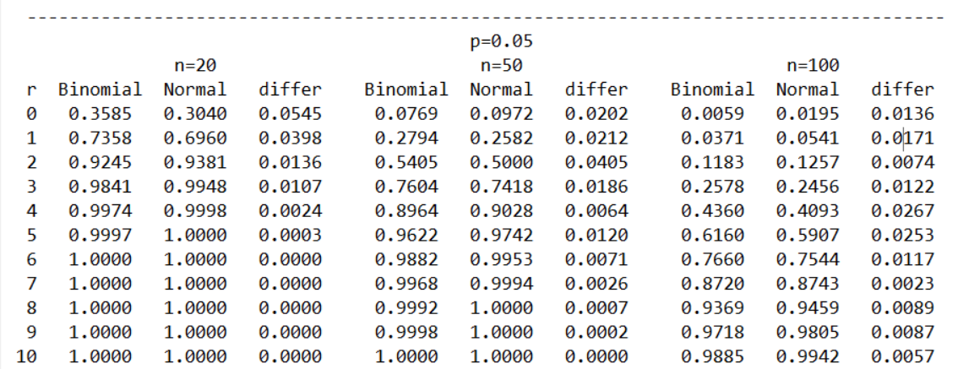

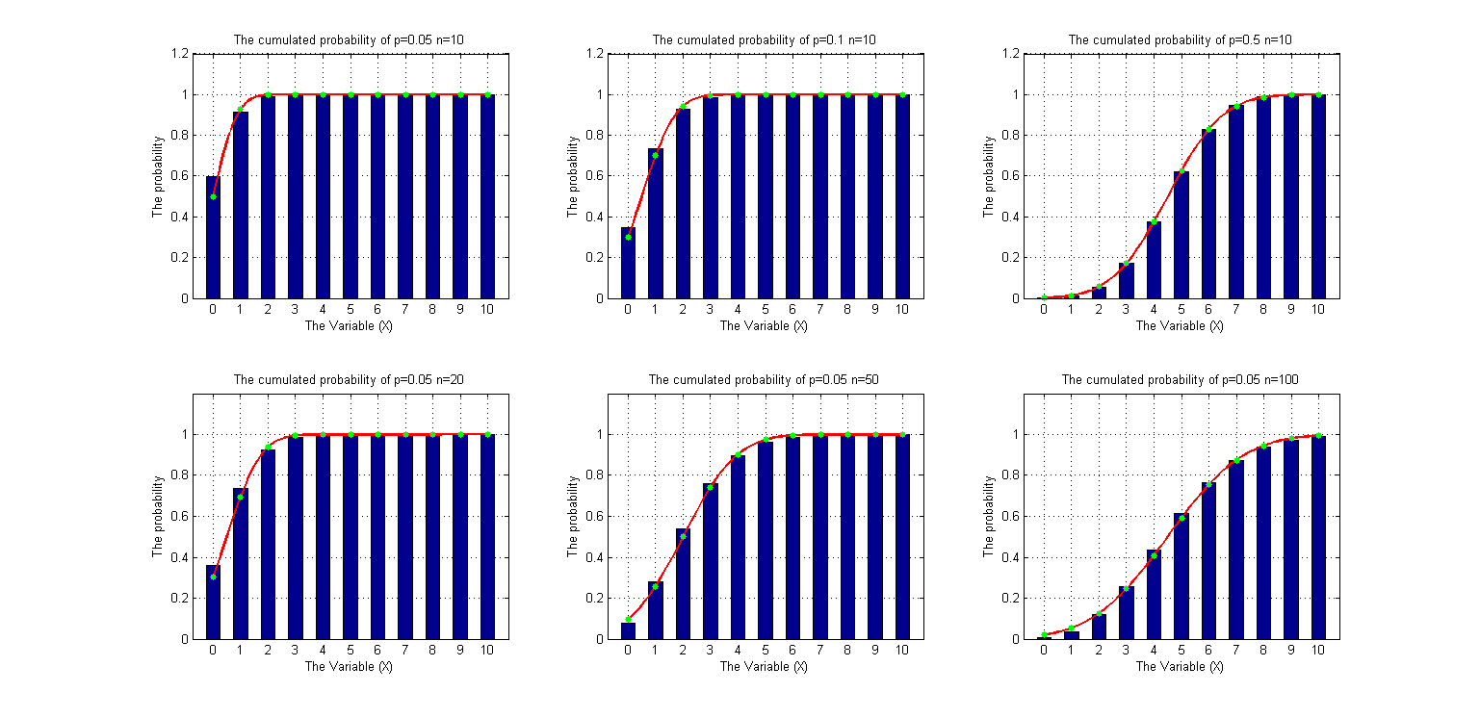

說明:

　　第一張圖是依照課本上畫出Binomial和Normal distribution在六種不同n、p組合的機率累積圖，在上半部是n都為10但是p為0.05、0.1、0.5 ( 由左到右 ) ，下半部則是p=0.05，而n為20、50、100 ( 由左到右 )，第二章圖就是搭配第一張圖的六種組合，長條圖是Binomial cdf值，紅色線和綠色點是Normal cdf值。

　　先看上半部三個set，因為0.05*10=0.5、0.1*10=1 都小於5，所以在第一個set和第二個set Binomial和Normal值相差幾乎都大於0.01，相對於set3，p*n=0.5*10=5，所以Binomial和Normal值相差比較小，差不多是0.001，可由圖2看出第三個最吻合，不過三者都會隨著i變大相差愈小，亦可由圖2看出剛開始長條和綠點相差比較多。

　　在看下半部三個set，一樣因為0.05*20=1、0.05*50=2.5都小於5，所以在第一個set和第二個set Binomial和Normal值相差幾乎都大於0.02，相對於set3，p*n=0.05*100=5，所以Binomial和Normal值相差比較小，差不多是0.01左右，可由圖2看出第三個比較吻合，雖然三者都會隨著i變大差值變小，但是沒有上半部變化的明顯，亦可由圖2看出剛開始長條和綠點相差比較多，且上半部較下半部長條和綠點的吻合程度高。

程式碼:

%table

p1 = 0.05;

p2 = 0.1;

p3 = 0.5;

n1 = 10;

for i = 0:1:10

set1_bino(i+1) = binocdf(i,n1,p1);

set1_norm(i+1) = normcdf((i+0.5-n1*p1)/sqrt(n1*p1*(1-p1)),0,1);

set2_bino(i+1) = binocdf(i,n1,p2);

set2_norm(i+1) = normcdf((i+0.5-n1*p2)/sqrt(n1*p2*(1-p2)),0,1);

set3_bino(i+1) = binocdf(i,n1,p3);

set3_norm(i+1) = normcdf((i+0.5-n1*p3)/sqrt(n1*p3*(1-p3)),0,1);

end

p4 = 0.05;

n2 = 20;

n3 = 50;

n4 = 100;

for i = 0:1:10

set4_bino(i+1) = binocdf(i,n2,p4);

set4_norm(i+1) = normcdf((i+0.5-n2*p4)/sqrt(n2*p4*(1-p4)),0,1);

set5_bino(i+1) = binocdf(i,n3,p4);

set5_norm(i+1) = normcdf((i+0.5-n3*p4)/sqrt(n3*p4*(1-p4)),0,1);

set6_bino(i+1) = binocdf(i,n4,p4);

set6_norm(i+1) = normcdf((i+0.5-n4*p4)/sqrt(n4*p4*(1-p4)),0,1);

end

fprintf ('\t\t\tp=0.05,n=10 p=0.1,n=10 p=0.5,n=10 \n');

fprintf (' r Binomial Normal differ Binomial Normal differ Binomial Normal differ \n');

for i=0:1:10

fprintf (' %2d %.4f %.4f %.4f',i,set1_bino(i+1),set1_norm(i+1),abs(set1_bino(i+1)-set1_norm(i+1)));

fprintf (' %.4f %.4f %.4f',set2_bino(i+1),set2_norm(i+1),abs(set2_bino(i+1)-set2_norm(i+1)));

fprintf (' %.4f %.4f %.4f\n',set3_bino(i+1),set3_norm(i+1),abs(set3_bino(i+1)-set3_norm(i+1)));

end

fprintf('\n');

fprintf(' ---------------------------------------------------------------------------------------\n');

fprintf(' p=0.05\n');

fprintf (' n=20 n=50 n=100 \n');

fprintf (' r Binomial Normal differ Binomial Normal differ Binomial Normal differ \n');

for i=0:1:10

fprintf (' %2d %.4f %.4f %.4f',i,set4_bino(i+1),set4_norm(i+1),abs(set4_bino(i+1)-set4_norm(i+1)));

fprintf (' %.4f %.4f %.4f',set5_bino(i+1),set5_norm(i+1),abs(set5_bino(i+1)-set5_norm(i+1)));

fprintf (' %.4f %.4f %.4f\n',set6_bino(i+1),set6_norm(i+1),abs(set6_bino(i+1)-set6_norm(i+1)));

end

i = 0:1:10;

h = 0:0.1:10;

%plot set1

subplot(231);

bar(i,set1_bino,0.5);

hold on;

chart1 = plot(h,normcdf((h+0.5-n1*p1)/sqrt(n1*p1*(1-p1)),0,1),'r');

set(chart1,'LineWidth',2);

chart11 = plot(i,set1_norm,'g.');

set(chart11,'markerSize',15);

grid on;

xlabel('The Variable (X)');

ylabel('The probability');

title('The cumulated probability of p=0.05 n=10');

axis([-0.75 10.75 0 1.2]);

hold off;

%plot set2

subplot(232);

bar(i,set2_bino,0.5);

hold on;

chart2 = plot(h,normcdf((h+0.5-n1*p2)/sqrt(n1*p2*(1-p2)),0,1),'r');

set(chart2,'LineWidth',2);

chart22 = plot(i,set2_norm,'g.');

set(chart22,'markerSize',15);

grid on;

xlabel('The Variable (X)');

ylabel('The probability');

title('The cumulated probability of p=0.1 n=10');

axis([-0.75 10.75 0 1.2]);

hold off;

%plot set3

subplot(233);

bar(i,set3_bino,0.5);

hold on;

chart3 = plot(h,normcdf((h+0.5-n1*p3)/sqrt(n1*p3*(1-p3)),0,1),'r');

set(chart3,'LineWidth',2);

chart33 = plot(i,set3_norm,'g.');

set(chart33,'markerSize',15);

grid on;

xlabel('The Variable (X)');

ylabel('The probability');

title('The cumulated probability of p=0.5 n=10');

axis([-0.75 10.75 0 1.2]);

hold off;

%plot set4

subplot(234);

bar(i,set4_bino,0.5);

hold on;

chart4 = plot(h,normcdf((h+0.5-n2*p4)/sqrt(n2*p4*(1-p4)),0,1),'r');

set(chart4,'LineWidth',2);

chart44 = plot(i,set4_norm,'g.');

set(chart44,'markerSize',15);

grid on;

xlabel('The Variable (X)');

ylabel('The probability');

title('The cumulated probability of p=0.05 n=20');

axis([-0.75 10.75 0 1.2]);

hold off;

%plot set5

subplot(235);

bar(i,set5_bino,0.5);

hold on;

chart5 = plot(h,normcdf((h+0.5-n3*p4)/sqrt(n3*p4*(1-p4)),0,1),'r');

set(chart5,'LineWidth',2);

chart55 = plot(i,set5_norm,'g.');

set(chart55,'markerSize',15);

grid on;

xlabel('The Variable (X)');

ylabel('The probability');

title('The cumulated probability of p=0.05 n=50');

axis([-0.75 10.75 0 1.2]);

hold off;

%plot set6

subplot(236);

bar(i,set6_bino,0.5);

hold on;

chart6 = plot(h,normcdf((h+0.5-n4*p4)/sqrt(n4*p4*(1-p4)),0,1),'r');

set(chart6,'LineWidth',2);

chart66 = plot(i,set6_norm,'g.');

set(chart66,'markerSize',15);

grid on;

xlabel('The Variable (X)');

ylabel('The probability');

title('The cumulated probability of p=0.05 n=100');

axis([-0.75 10.75 0 1.2]);

hold off;