**Experiment -1 Microsoft Excel with dataset for creation of various Graph**

**AIM:** To enhance data visualization skills by creating and analyzing different types of graphs such as bar charts, line graphs, pie charts, and scatter plots in Excel.

**OUTPUT:**

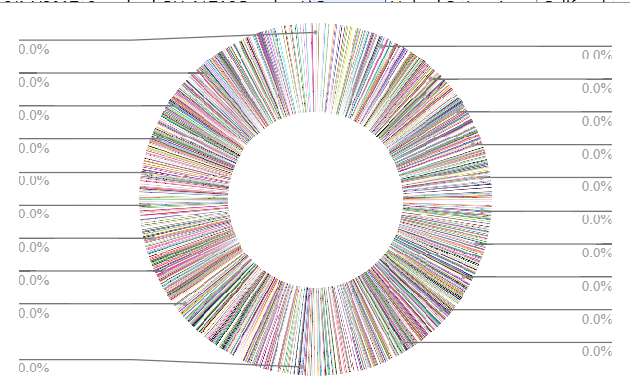

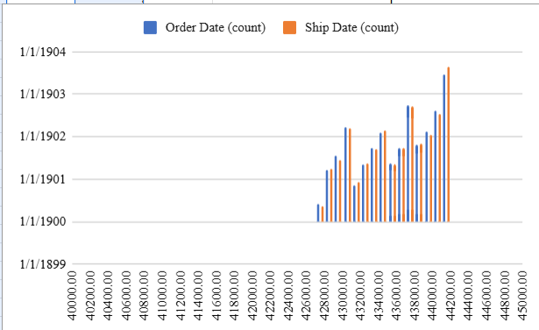

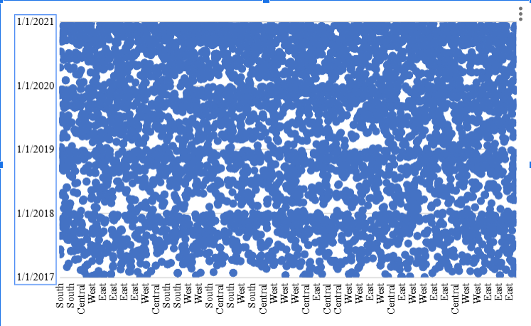

**RESULT:** The experiment is executed successfully