**Experiment -2 Tableau, Salesforce Inc with dataset for**

**creation of various Graph**

**AIM:** To explore the integration of Salesforce datasets with Tableau for generating dynamic and interactive data visualizations.

**OUTPUT:**

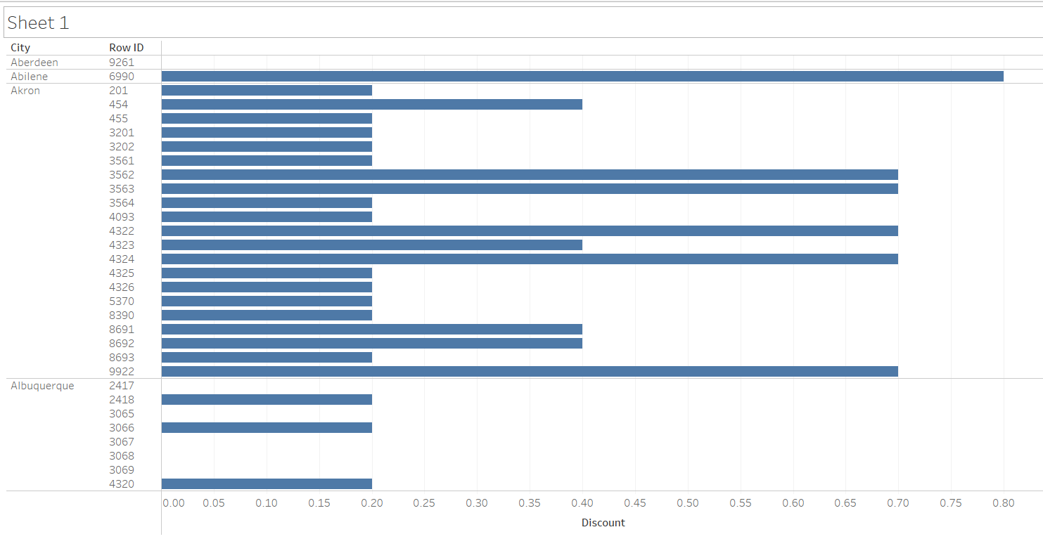

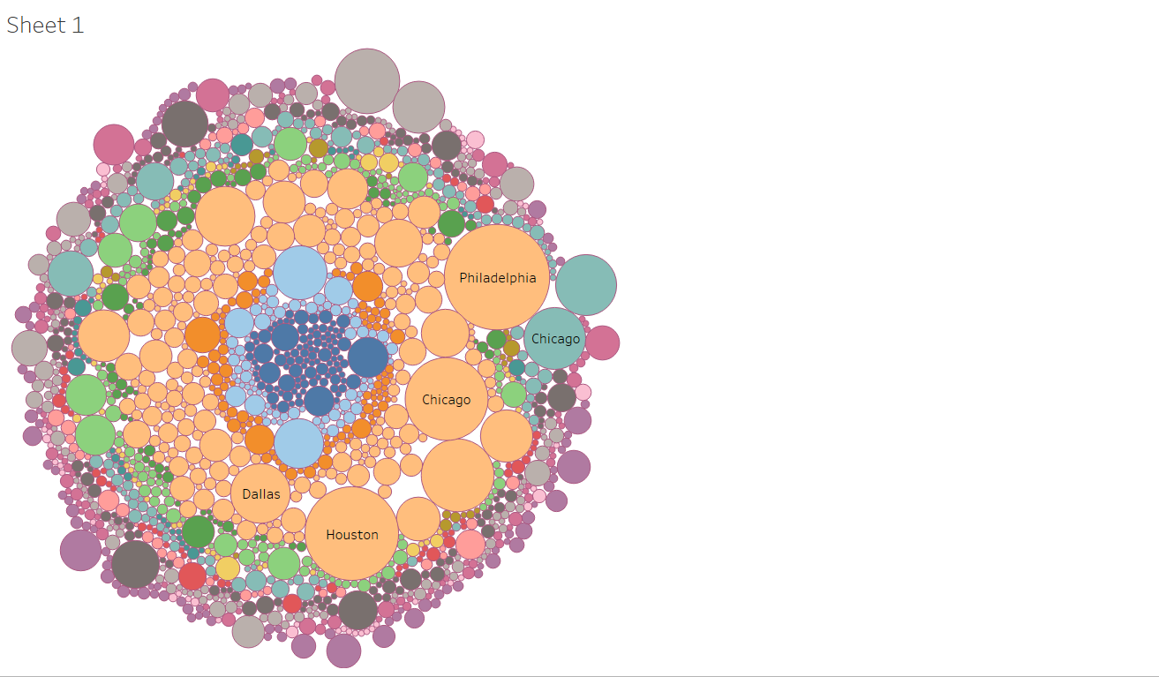

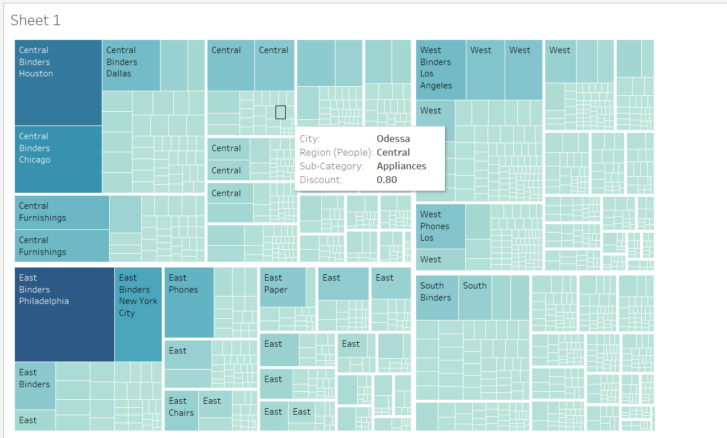

**RESULT:** The experiment is executed successfully