**Experiment -4 Using Table Calculations to Create Data Visualization for a Dataset**

**AIM:** To utilize table calculations for transforming and analyzing dataset values, enabling the creation of dynamic and insightful data visualizations.

**OUTPUT:**

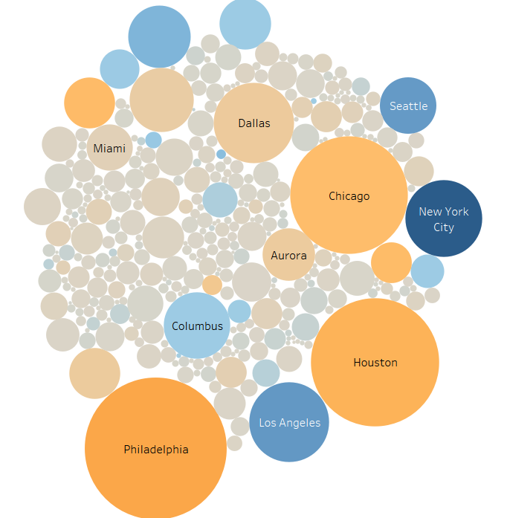

**Orders and returns :**

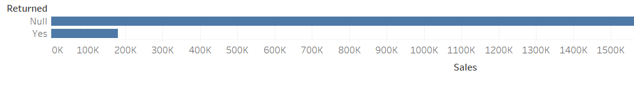

**Profit and Quantity:**

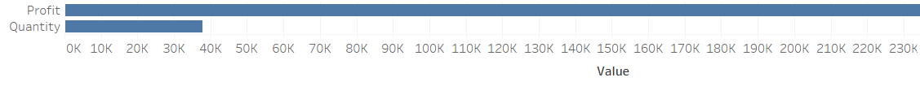

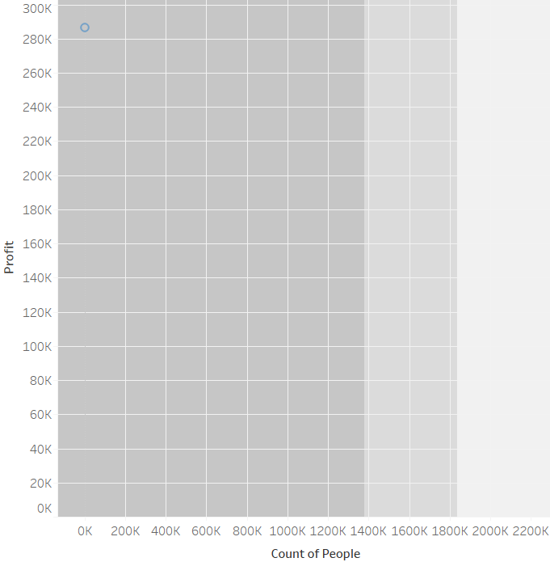

**RESULT:** The experiment is executed successfully