**Experiment -6 Examine More Advanced Chart Types Using Multiple Source Tables**

**AIM:** To explore and construct advanced chart types by integrating and analyzing data from multiple source tables.

**OUTPUT:**

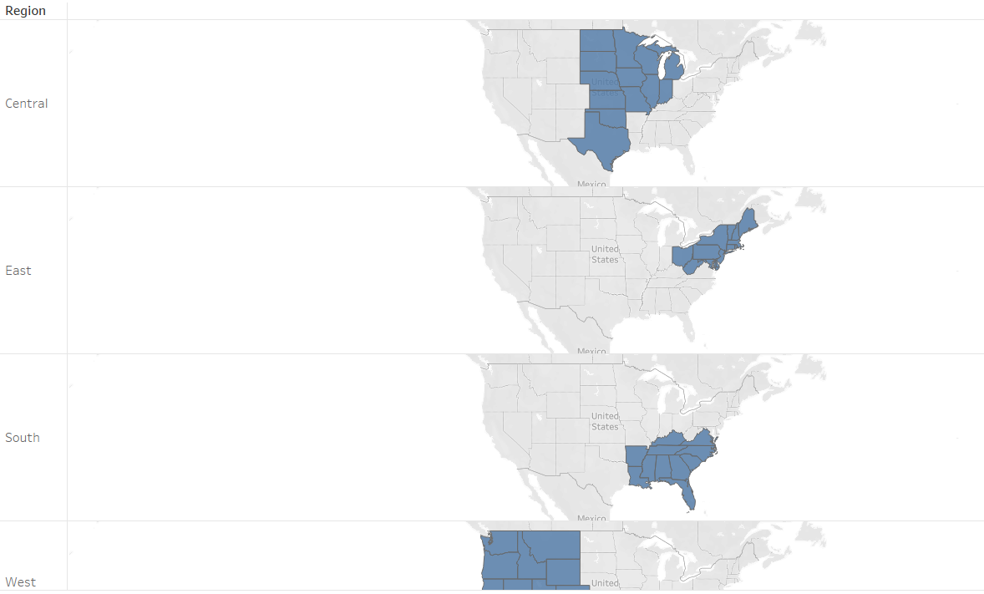

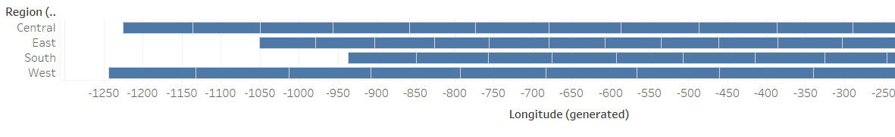

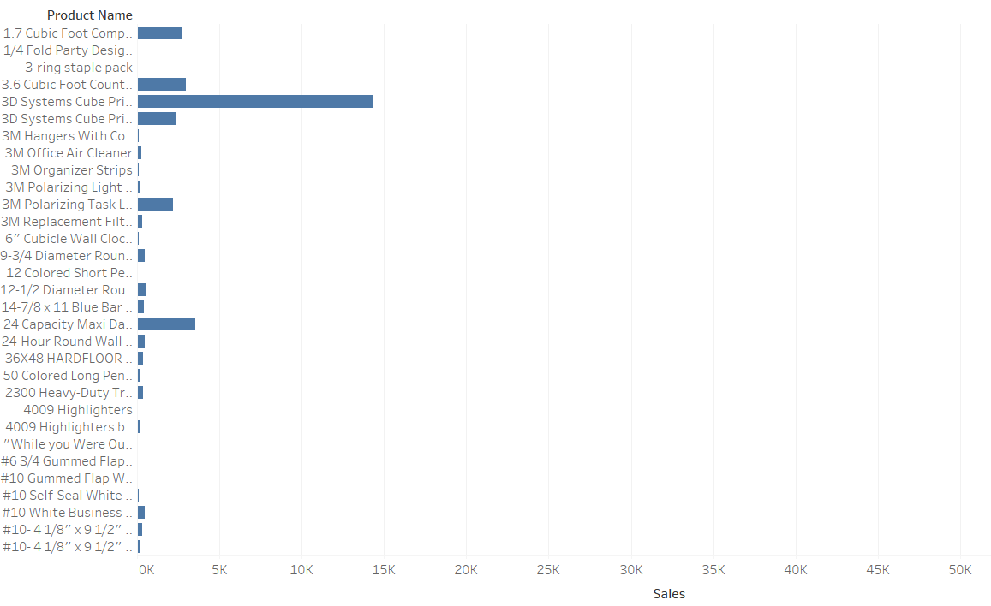

**RESULT:** The experiment is executed successfully