**Experiment -7 Study of Data Storytelling - Creating a Data Story in Tableau**

**AIM:** To study the principles of data storytelling and apply them to create an engaging and informative data story using Tableau.

**OUTPUT:**

**Story 1:**

**Sales and returns**

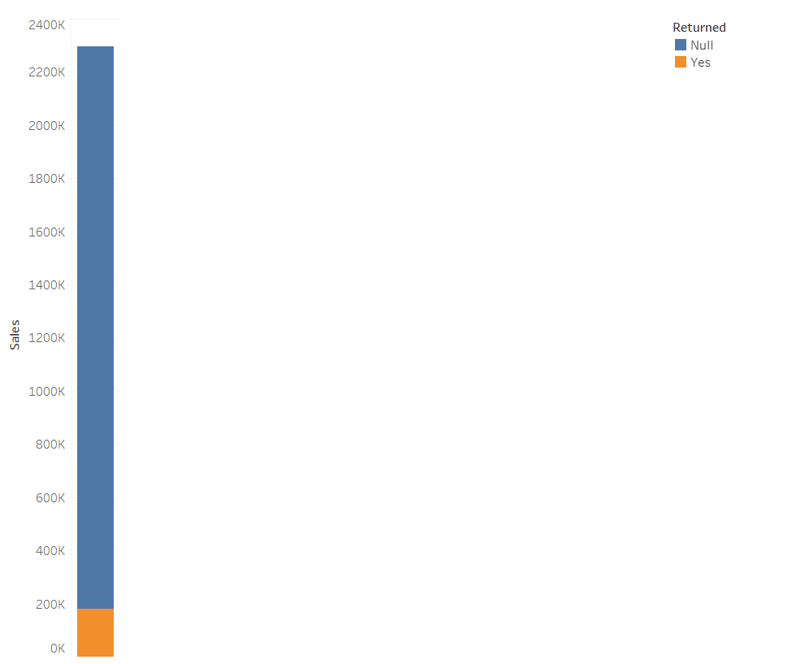

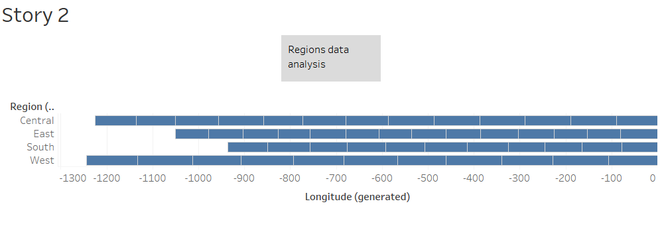

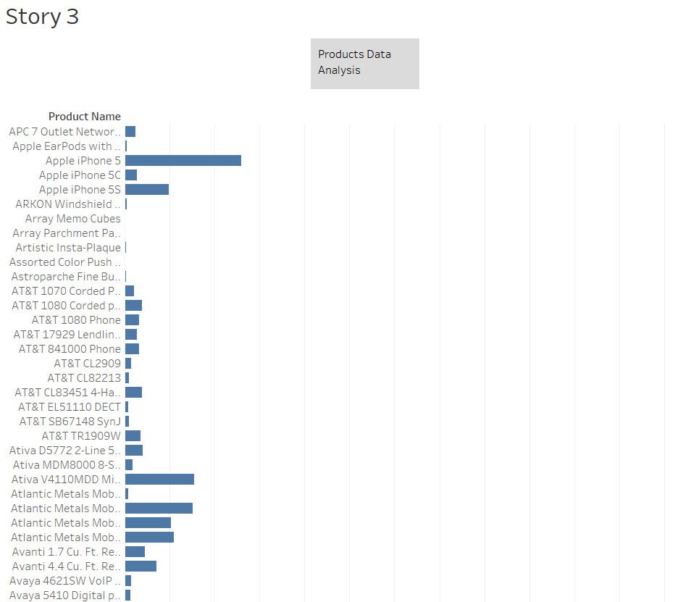

**RESULT:** The experiment is executed successfully