D:\work\OpenCV\caffe> scripts\build_win.cmd

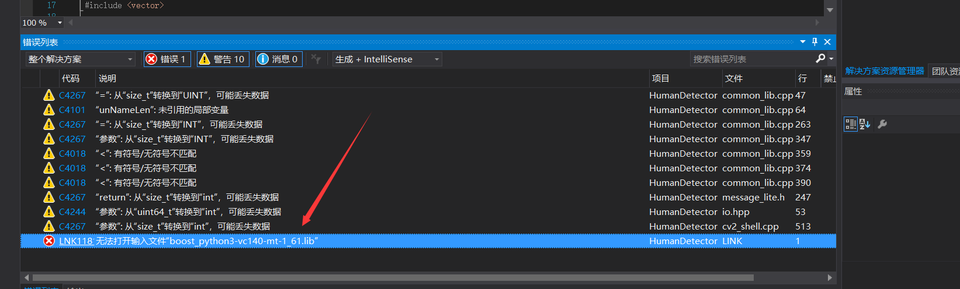

无法打开输入文件“boost_python3-vc140-mt-1_61.lib”

到D:\work\OpenCV\下安装boost_1_61_0-msvc-14.0-64，然后将相关包

libboost_date_time-vc140-mt-1_61.lib

libboost_date_time-vc140-mt-gd-1_61.lib

libboost_filesystem-vc140-mt-1_61.lib

libboost_filesystem-vc140-mt-gd-1_61.lib

copy到C:\Users\marss\.caffe\dependencies\libraries_v140_x64_py27_1.1.0\libraries\lib下即可。

像这样的问题：

W0609 10:54:34.663405 28660 memory_data_layer.cpp:90] MemoryData does not transform array data on Reset()

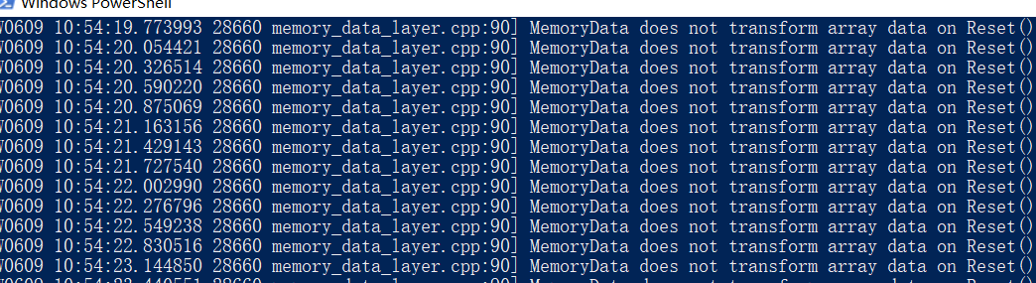

修改caffe源码：

