Rentify Website – Documentation

Website is developed using MERN stack – React JS for frontend , NodeJS,ExpressJS,MongoDB for backend

Login Page with proper form validation .Also contains link to registration page for new user.

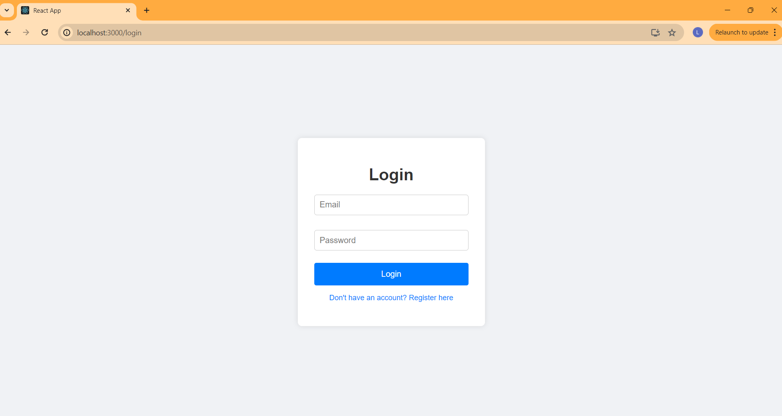

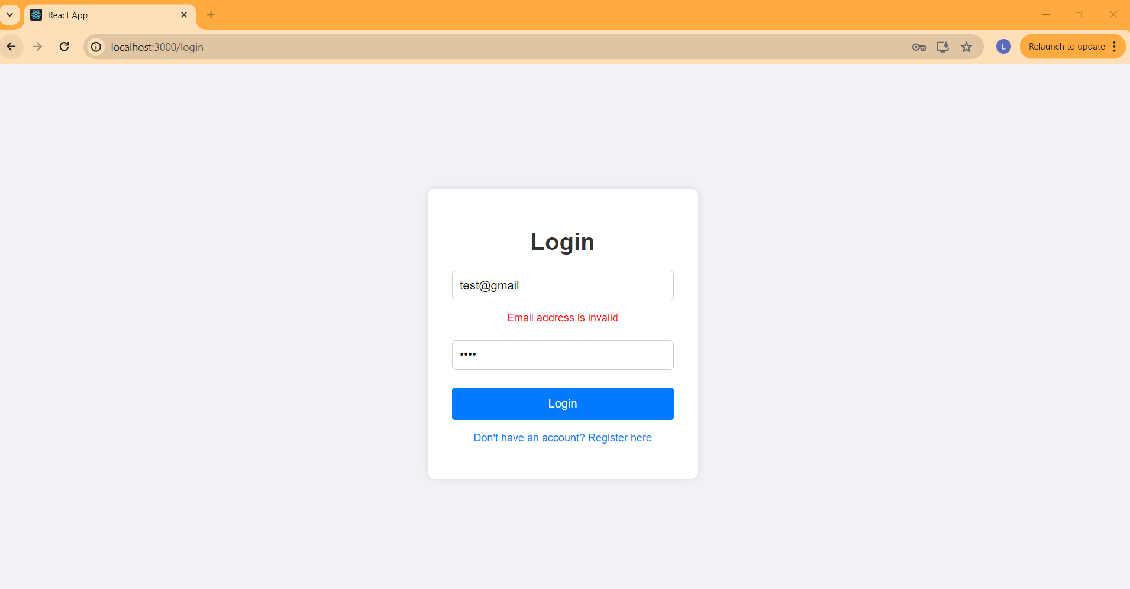

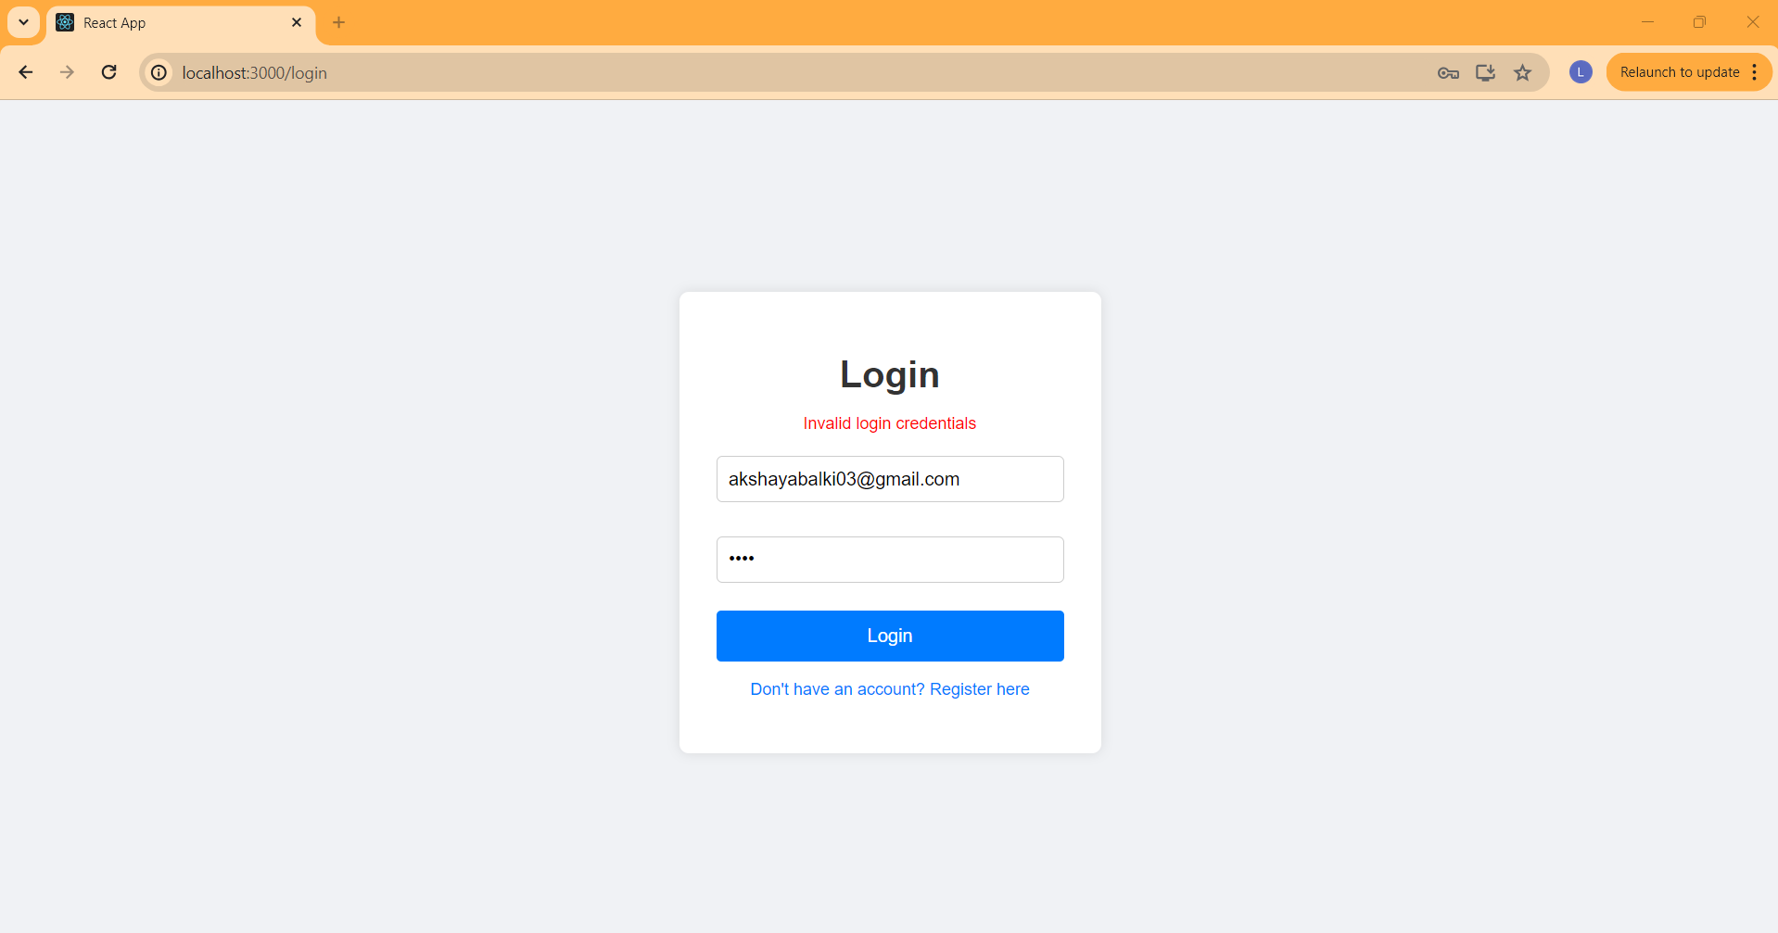

Register Page with proper form validation .It contains the option to register as Buyer or Seller.

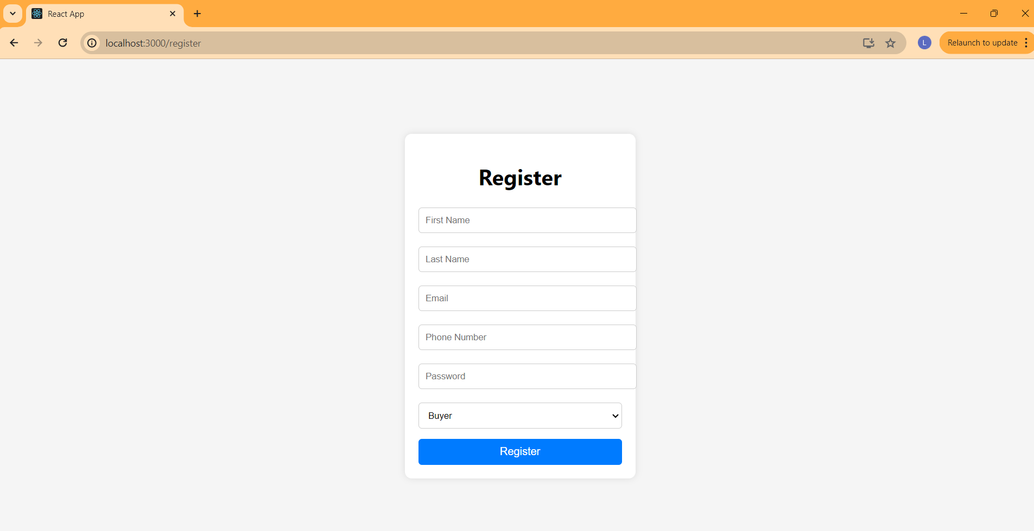

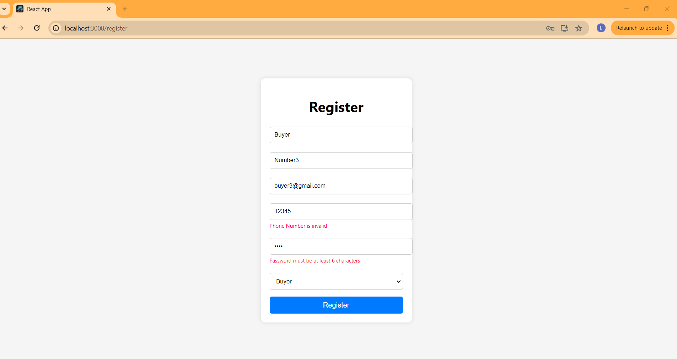

If the user is registered as Buyer ,he will be redirected to Buyer-dashboard upon login

Buyer dashboard contains - List of all Properties posted , Like button and Like count to keep live track of likes(one user can click the like button of one property only once – when the user clicks on the like button of the same property twice ,the count will not be incremented )

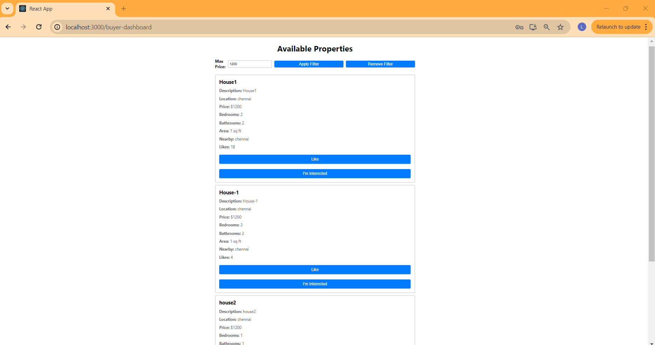

Properties can be filtered based on the maximum price entered and when the filter button is clicked only the properties within the price of max prize will be displayed ,upon clicking remove filter all the properties will be displayed. 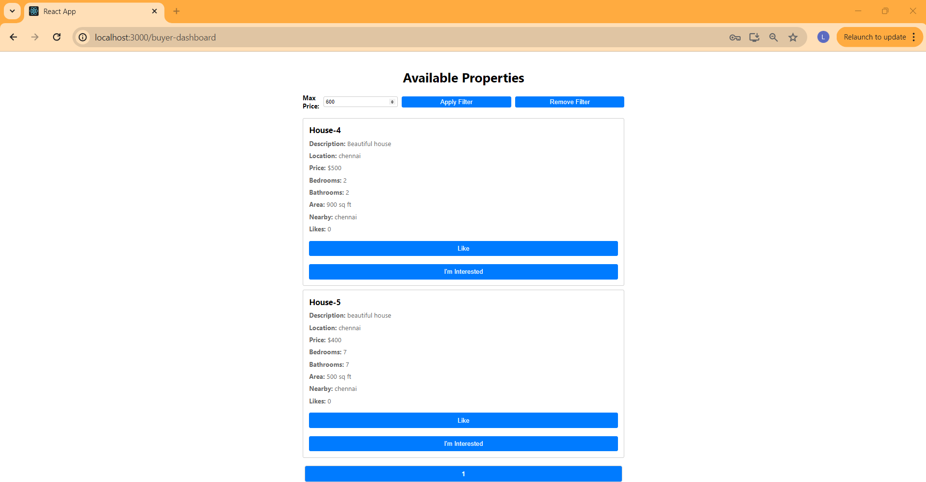

I’m Interested Button – upon clicking I’m interested button an alert will be shown displaying the seller contact ,along with that mail alert will also be sent to both buyer and seller.

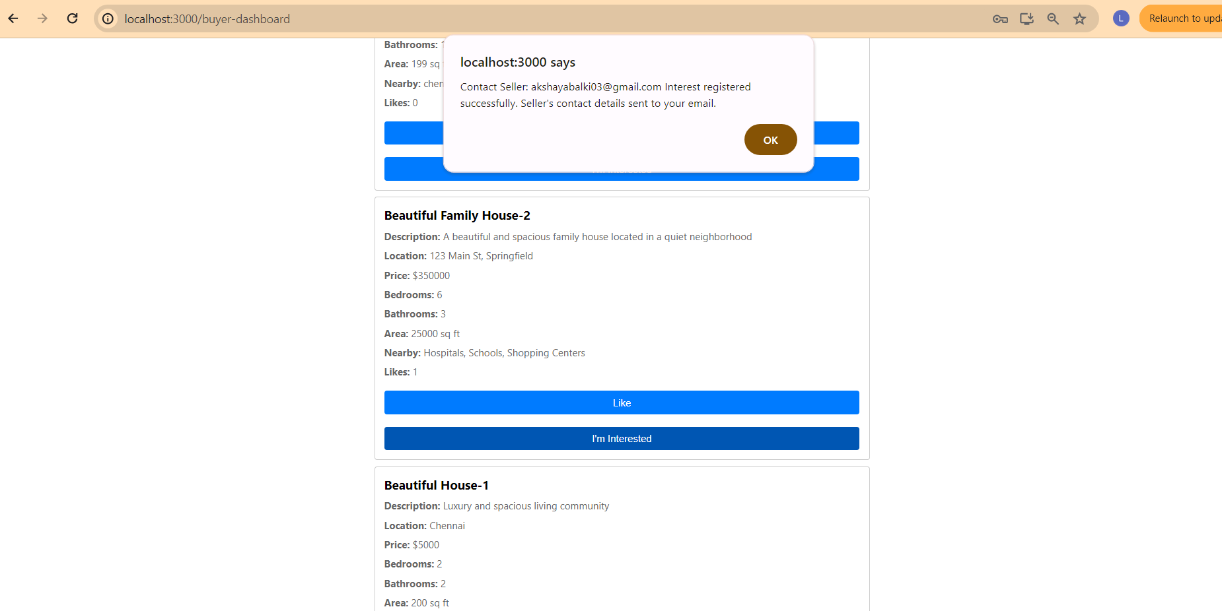

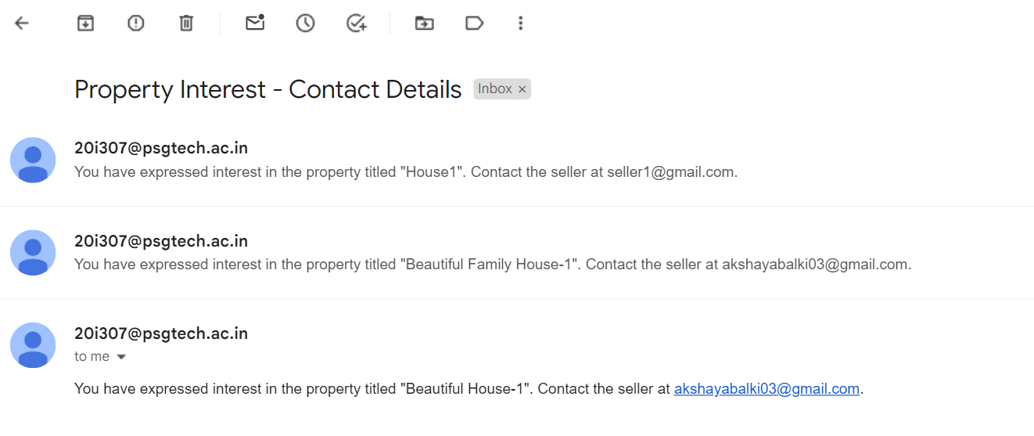

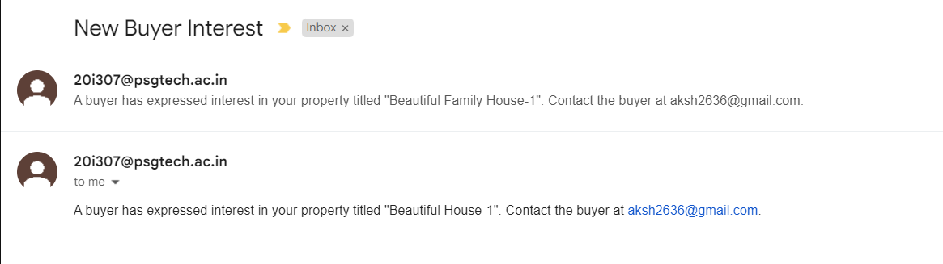

Proper Pagination is also handled:

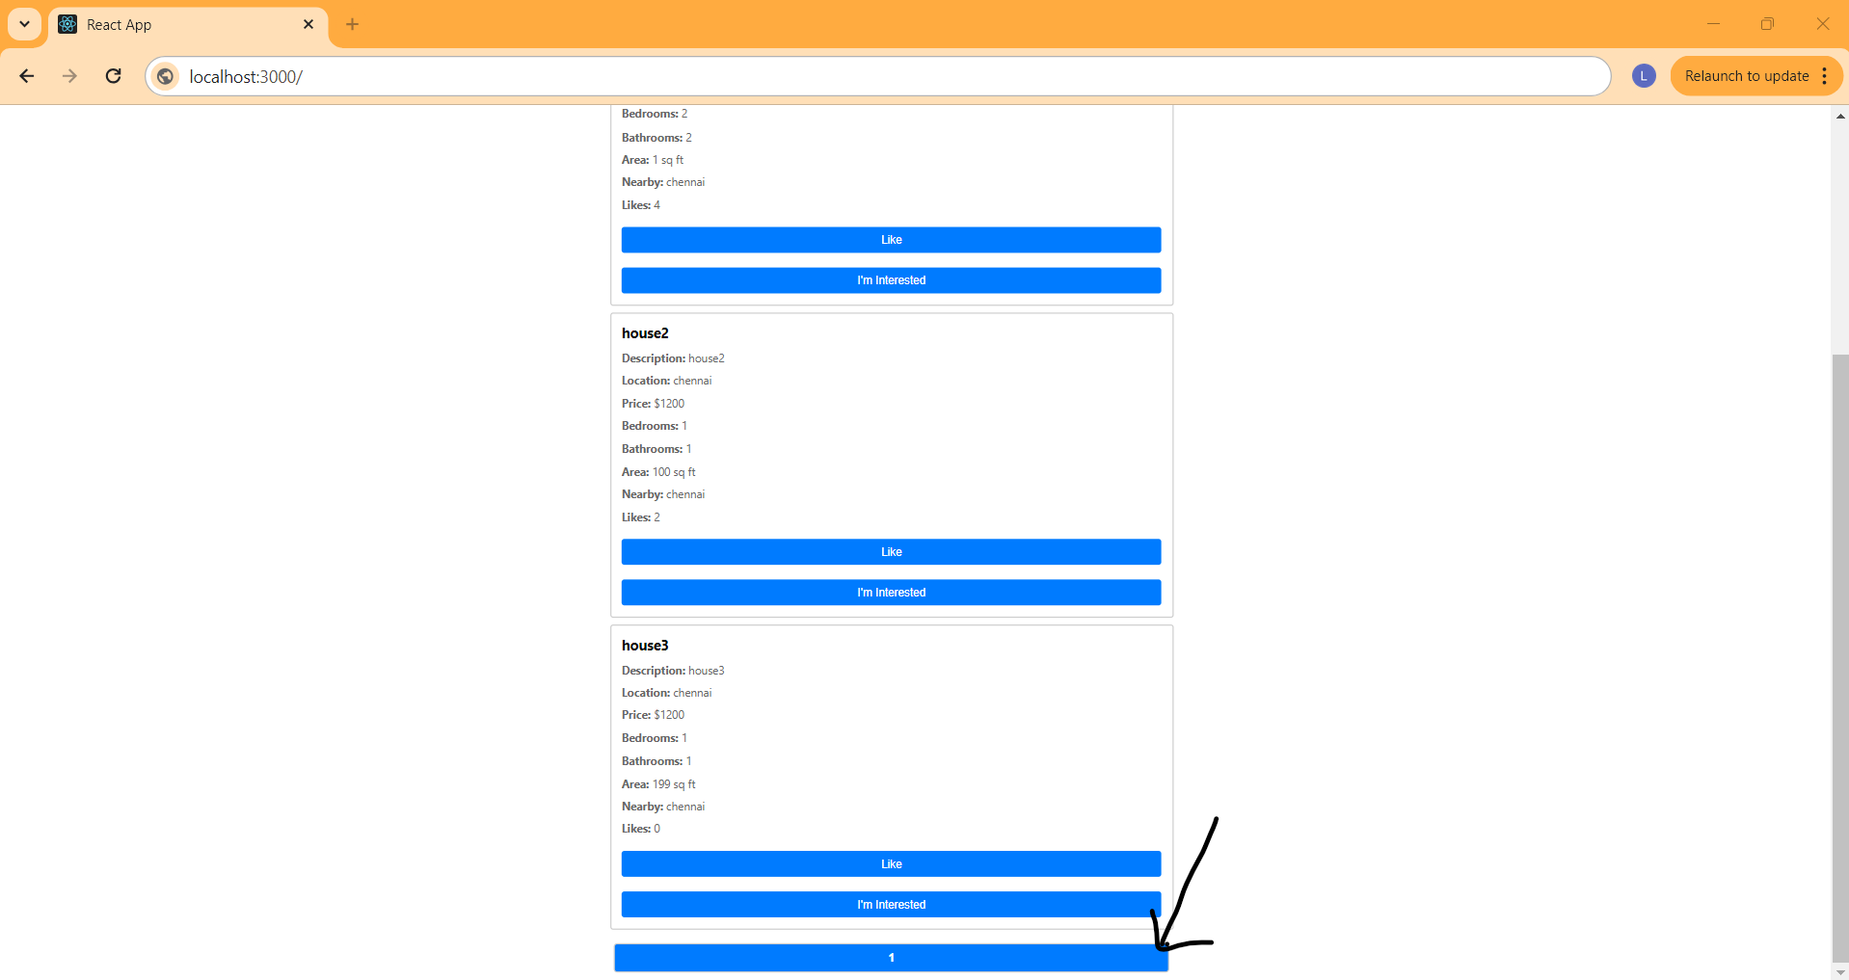

If the user is registered as Seller, he will be redirected to Seller-dashboard upon login.

Seller Dashboard displays all the properties posted by the logged in seller.

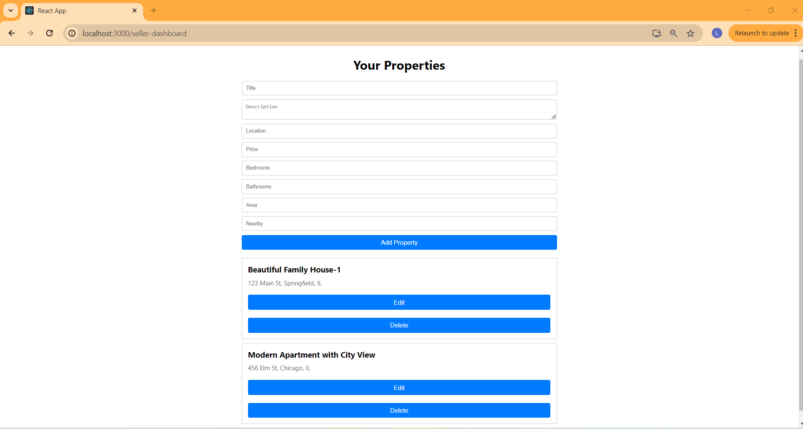

Seller can fill up the details in the form and click on Add Property to add a new property.

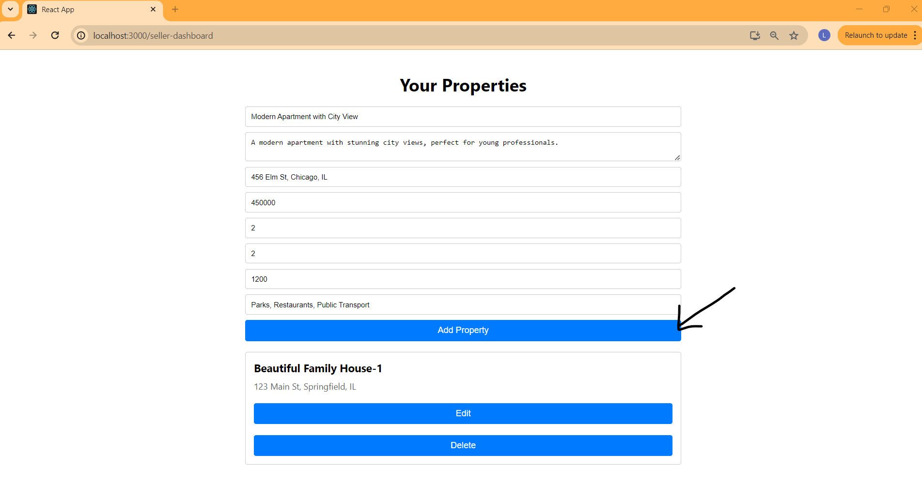

Seller can click on edit button to edit a property and click on save button to save his changes or click on cancel button to remove the editing. 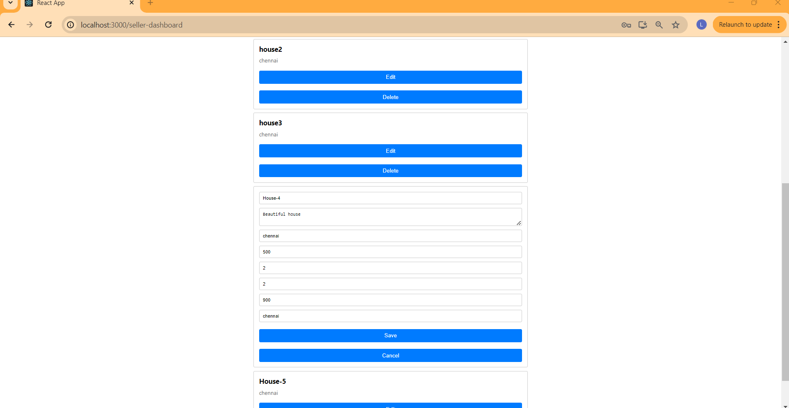

Seller can also click on delete button to delete a property (in this case house-4 is deleted)

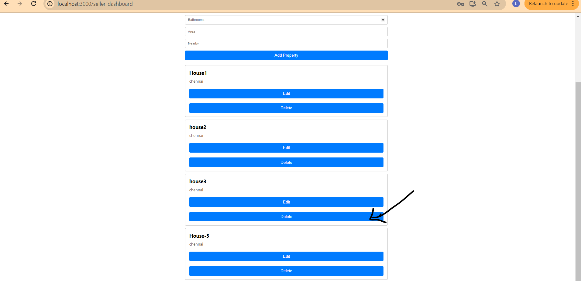

Database snapshot – contains user and property model.

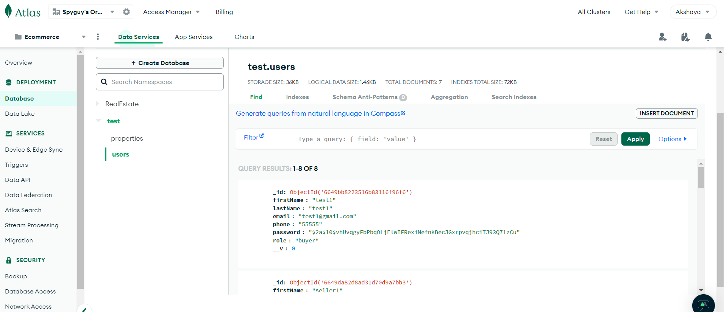

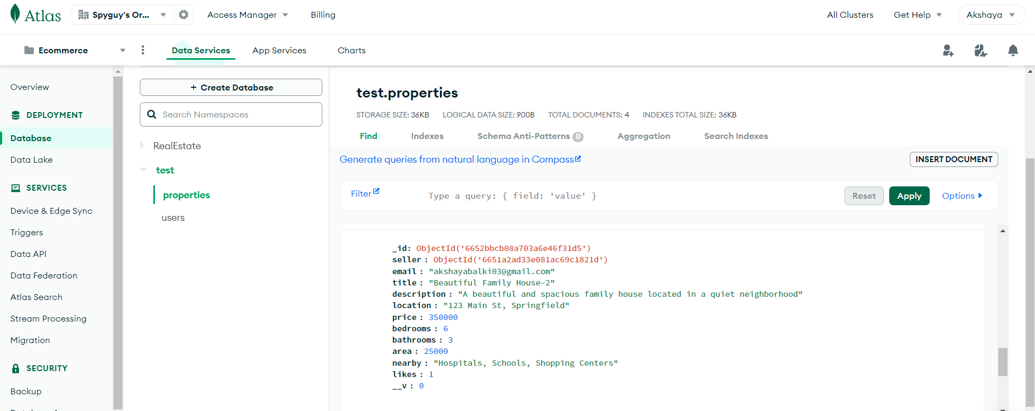

Folder Structure of source code:

