GST Saathi — Project Report
Course project (AI course)
Team: Aksh Juneja, Shruti Agnihotri
Repository: https://github.com/Aksh28/gst-saathi
Submission date: 25 October 2026

1. Executive Summary
GST Saathi is an AI-powered tool that explains Indian GST (Goods and Services Tax) filings, invoices, and department notices in plain, jargon-free language for small shopkeepers. This submission is v1 (Explainer): a working prototype that takes GST-related text and returns a plain-language explanation. A second mode, Auditor (cross-checking a filing against a shopkeeper’s real invoices to catch errors), is scoped as future work and is intentionally not part of this build — the reasoning for that scope line is in Section 6.
The long-term goal is not purely academic: the problem is real, evidence of it is strong, and the intention is to keep building this into a product small shopkeepers would actually pay for, beyond the course deadline.

2. Problem Statement
Small and medium shopkeepers in India are legally required to file GST returns, but almost none of them do it themselves. They hire a Chartered Accountant (CA) to handle the filing and have no independent way to verify what was filed in their name, whether it was filed correctly, or what it actually means for their money.
This is not a hypothetical problem. Industry reporting on small-business GST compliance (a study of small-business practices around Bengaluru CA firms) found that 77% of small businesses depend entirely on their accountant for GST, with no verification step of their own, and that reconciling Input Tax Credit (ITC) — the credit a business can claim back on tax it already paid to its suppliers — is consistently the single hardest part of the process for them to understand. GST rule changes (such as the September 2025 rate-cut pass-through) have also generated visible waves of consumer and small-business confusion and complaints.
The core failure is not that filing tools don’t exist — it’s that existing tools solve the wrong side of the problem.

3. Market and Target Users
Primary user: a small shopkeeper or micro-business owner in India who files GST exclusively through a CA and cannot read, verify, or make sense of the filing documents themselves.
Market size context: India has tens of millions of GST-registered small businesses, the overwhelming majority of which are CA-dependent for compliance (per the 77% figure above). This is a large, recurring-need market — GST filing happens monthly, not once.

Existing competition and why it doesn’t solve this
Tool | What it solves | What it doesn’t solve
ClearTax, Zoho Books, Tally | Filing mechanics for the CA/business | Whether the shopkeeper understands or trusts what was filed
Generic chatbots / search | General tax Q&A | Explaining this specific filing document, in context
Insurance-claim-dispute startups (Insurance Samadhan, ClaimBuddy, etc.) | A similar “person vs. confusing paperwork” problem, but in insurance | Different domain; already well-funded and saturated — validated the pattern, not a competitor here
Government scheme-discovery tools (Haqdarshak, etc.) | Benefit discovery for individuals | Different domain (welfare, not GST); also validated the pattern

No existing product was found that sits on the shopkeeper’s side of the GST relationship and simply explains, in their own language, what their accountant filed. That is the specific gap GST Saathi targets.

Commercialization path (long-term, beyond this course submission)
B2C/freemium to shopkeepers directly, with a plausible future B2B channel (CA firms offering it to their own clients as a transparency/trust feature). No real pilot users have been engaged yet — the next concrete step after this submission is finding 2–3 real shopkeepers or CAs to validate with.

4. Solution Overview

v1 — Explainer (built, this submission)
- User pastes GST filing / invoice / department-notice text, or selects one of three pre-loaded synthetic sample documents (a GSTR-3B monthly return, a B2B purchase invoice, and a department discrepancy notice).
- An LLM (Anthropic Claude, with an OpenAI fallback path already wired) returns a plain-language explanation: what the document is, what it means for the shopkeeper’s money, and what’s worth double-checking with their accountant.
- The tool explains. It does not audit, verify, or certify the filing, and it never asserts that a filing or an accountant is right or wrong.

v2 — Auditor (future work, not built here)
- Cross-check a CA’s actual filing against the shopkeeper’s real invoices and sales records, and flag mismatches, missed ITC claims, or possible overbilling.
- Deliberately excluded from this submission (see Section 6).

5. Technical Approach
- Stack: Next.js (App Router) + TypeScript + Tailwind CSS, deployed as a single web app with one API route.
- AI layer: /api/explain route accepts the document text, an optional provider selection (Anthropic or OpenAI), and an optional user-supplied API key; it calls the corresponding LLM with a system prompt that constrains the model to explain only (explicitly instructed never to judge correctness or accuse anyone of error).
- Frontend: a single page with a disclaimer banner, three pre-loaded sample documents, a free-text input, and a plain-language output panel. A provider/API-key toggle (Anthropic vs. OpenAI, optional personal key) was added as a second, independent feature.
- Data handling: the prototype does not persist, log, or transmit uploaded documents beyond the active session. No real shopkeeper or CA data was used anywhere in building or testing this version — all sample documents are synthetic.
- Why this architecture: it needed to be demoable without any real third-party financial documents (none were available yet), which is why explainer-mode-on-synthetic-data was chosen as the buildable slice for this submission, with auditor mode (which requires real documents) deferred.

6. Scope Decisions and Why
Two modes were considered from the start: Explainer and Auditor. Building both in the time available for this submission was deliberately rejected, for two reasons:
- Risk of an unfinished demo. Auditor mode requires real invoices and filings to be meaningful, which the team does not yet have access to (no CA or shopkeeper contacts have been established). Attempting it now would have produced a half-working feature instead of one solid one.
- A distinct compliance question. Auditor mode would implicitly critique a licensed professional’s (the CA’s) filed work. Before that ships against real data, it needs: confidence-scored, “discrepancy not accusation” framing (to avoid defamation-adjacent claims about a real person’s professional work); compliance with India’s DPDP Act 2023 once real invoices/PII are involved; the CA’s own consent before their work product is processed; and stronger liability terms before any real financial decision could ride on the tool’s output. None of this blocks explainer mode on synthetic data, so it was tracked for later rather than treated as a blocker now.

7. Disclaimers and Limitations
This prototype uses synthetic GST data for demonstration only. It is an AI explainer, not a compliance or audit tool, and does not replace a qualified Chartered Accountant.
Displayed in-app as:
“This is an educational tool using sample data. It explains filings in plain language — it is not tax, legal, or financial advice. Always verify with a registered tax professional before acting.”
Known limitations: LLM output can be wrong or incomplete; the tool has not been tested against real filings; GST rules and rates change over time and the model’s knowledge may not reflect the latest changes.

8. Team Contributions
- Aksh Juneja: problem research, architecture, backend/API integration (LLM explainer route, prompt design), core UI, deployment, and this report.
- Shruti Agnihotri: provider/API-key toggle feature (frontend), allowing the explainer to run against either Anthropic or OpenAI with an optional user-supplied key.
Individual commits are visible in the GitHub history at the repository link above.

9. Future Work
- Validate the problem with 2–3 real shopkeepers/CAs (not yet done).
- Build Auditor mode once real documents and the compliance prerequisites in Section 6 are in place.
- Expand language support (regional languages beyond English).
- Explore a B2B channel through CA firms as a client-transparency feature.

10. How to Run
git clone https://github.com/Aksh28/gst-saathi.git
cd gst-saathi
npm install
# create .env.local with: ANTHROPIC_API_KEY=your-key-here
npm run dev
Open http://localhost:3000.

11. Submission Checklist
Item | Status
GitHub repository (public) | Done
Working prototype (v1 Explainer) | Done
README with setup instructions | Done
This report | Done
Internal design/scope doc (docs/design-doc-v1.md) | Done
Screenshots of the app in use | Included in Section 12

12. Screenshots — MVP in Action
The screenshots below were captured directly from the running application (npm run dev) on 25 October 2026, demonstrating the core v1 Explainer flow end to end.

12.1 Home screen
The landing page shows the compliance disclaimer banner, the three pre-loaded synthetic sample documents, and the free-text input area.
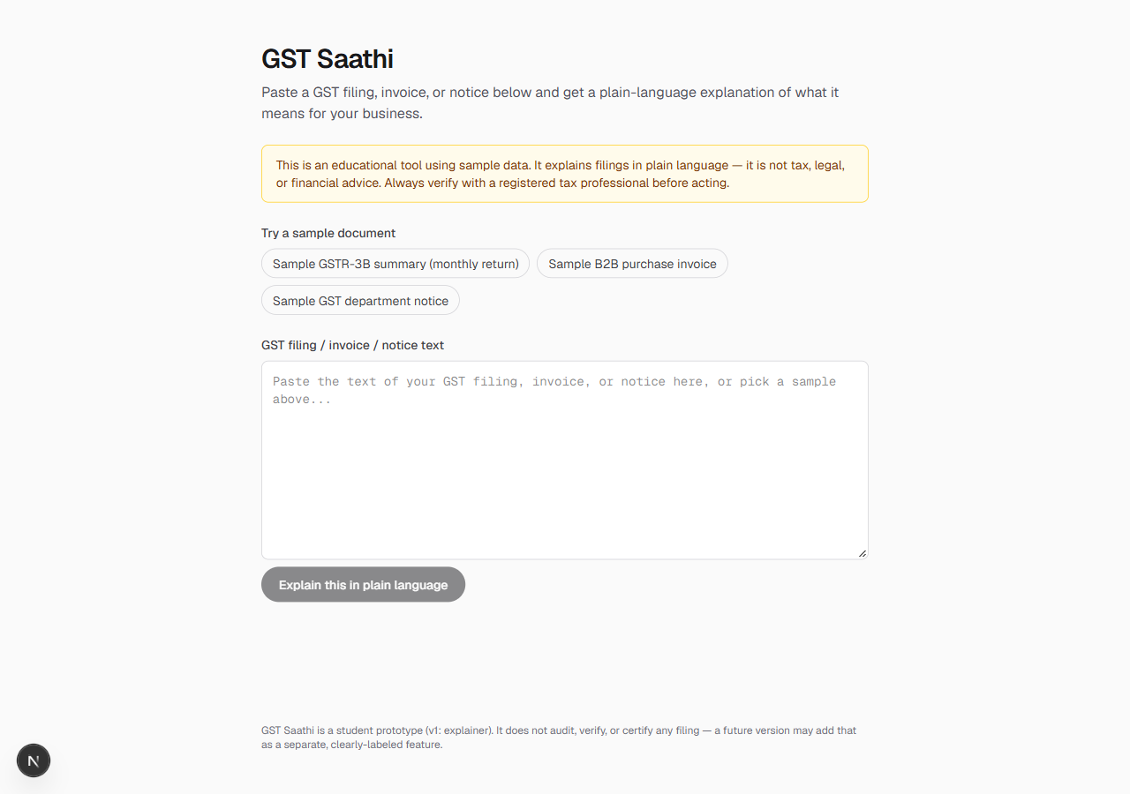
Figure 1: GST Saathi home screen with disclaimer banner and sample-document picker.

12.2 Sample document loaded
Selecting a sample (here, the GSTR-3B monthly return) populates the input box with realistic synthetic filing text, ready to be explained.
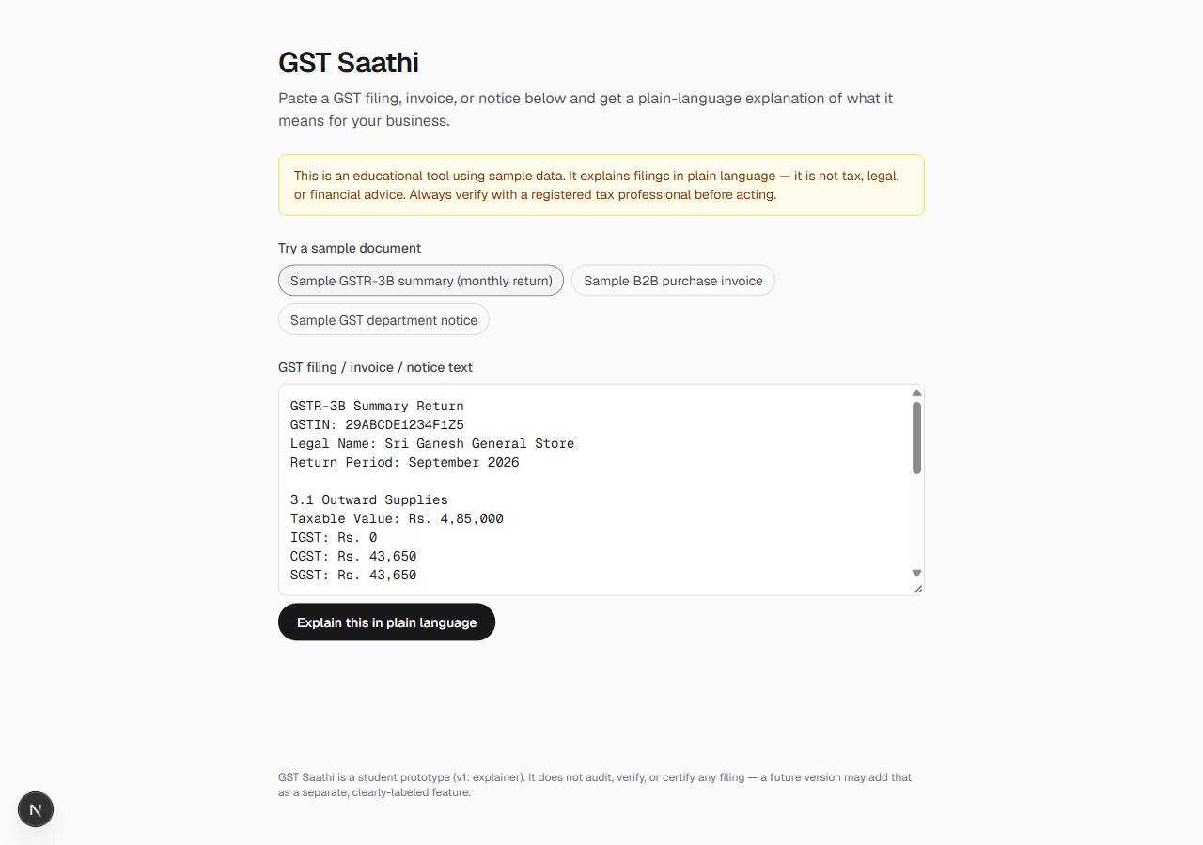
Figure 2: Synthetic GSTR-3B sample loaded into the explainer input.
Note: generating the plain-language explanation itself requires an ANTHROPIC_API_KEY (or OPENAI_API_KEY) in .env.local, which is kept out of version control for security and was not configured on the machine used to capture these screenshots. The explain pipeline (prompt, provider call, error handling) is implemented and code-reviewed in app/api/explain/route.ts; running npm run dev with a key set reproduces the full flow, including the output panel shown in the UI.

