**Neural Network Implementation with Keras**

This project required the implementation of three different Neural Network models using the Keras library within Python. Keras is an open-source library designed to be user-friendly, extensible, and modularto aid in rapid neural network model development and iteration. First released in 2015, Keras was integrated into the Tensorflow suite in 2017. It is currently one of the more popular neural network APIs available. 1

**Deep Neutral Network**

The standard neural network model is the Deep Neural Network (DNN) model which includes a number of tunable parameters including the number of nodes, hidden layers and activation functions. By selecting a different tunable parameter in each case, it is possible to develop multiple DNN models. Our team utilized this approach for two of the three models we developed, selecting XXX as our variable parameter in the first model and YYY as our variable parameter in the second model. For each model, we performed cross validation on the selected parameter to determine the optimal value.

**Convolutional Neural Network2**

For our third model, we elected to try a different approach, this time implementing a Convolutional Neural Network (CNN). The CNN model is a subset of DNNs commonly applied to image processing. In a CNN model, an image is converted into a digital matrix, often at the pixel level, and then a filter or kernel is applied via matrix multiplication to calculate the next layer in the network as shown in Figure 13. The filter is applied as a sliding window which is passed over every element of the image in strides. The result is the image pixels are aggregated at each level reducing the overall matrix size while highlighting certain features of the original image. This process can be used to detect edges and curves within the image which makes it very effective at handwriting analysis.

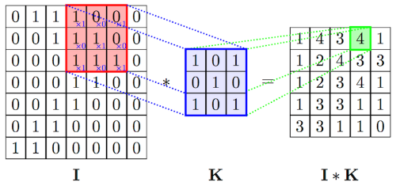

**Figure 1.** Application of the kernel to the image matrix during a convolution.

**Results and Discussion**

Blah blah blah

**References:**

1. [https://en.wikipedia.org/wiki/ Keras](https://en.wikipedia.org/wiki/BERT_(language_model))
2. <https://ujjwalkarn.me/2016/08/11/intuitive-explanation-convnets/>
3. <https://people.minesparis.psl.eu/fabien.moutarde/ES_MachineLearning/TP_convNets/convnet-notebook.html>