**Practical 1**

**Aim: 1. Implement and analyze the algorithms given below.**

**1.1 Factorial of a given number (Iterative and Recursive)**

**1.2 Fibonacci Series (Iterative and Recursive)**

**1.3 Linear Search (Iterative and Recursive)**

**Programs:** 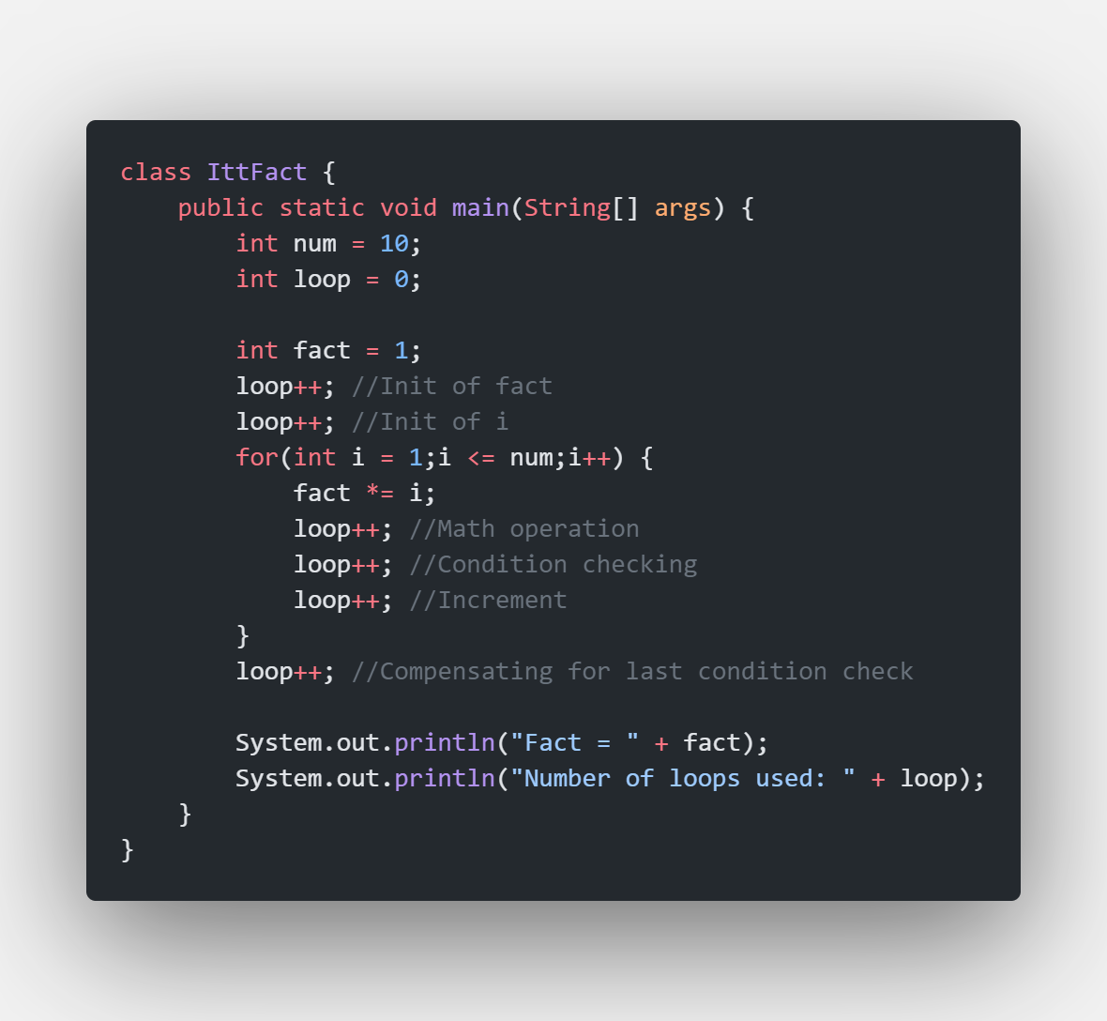 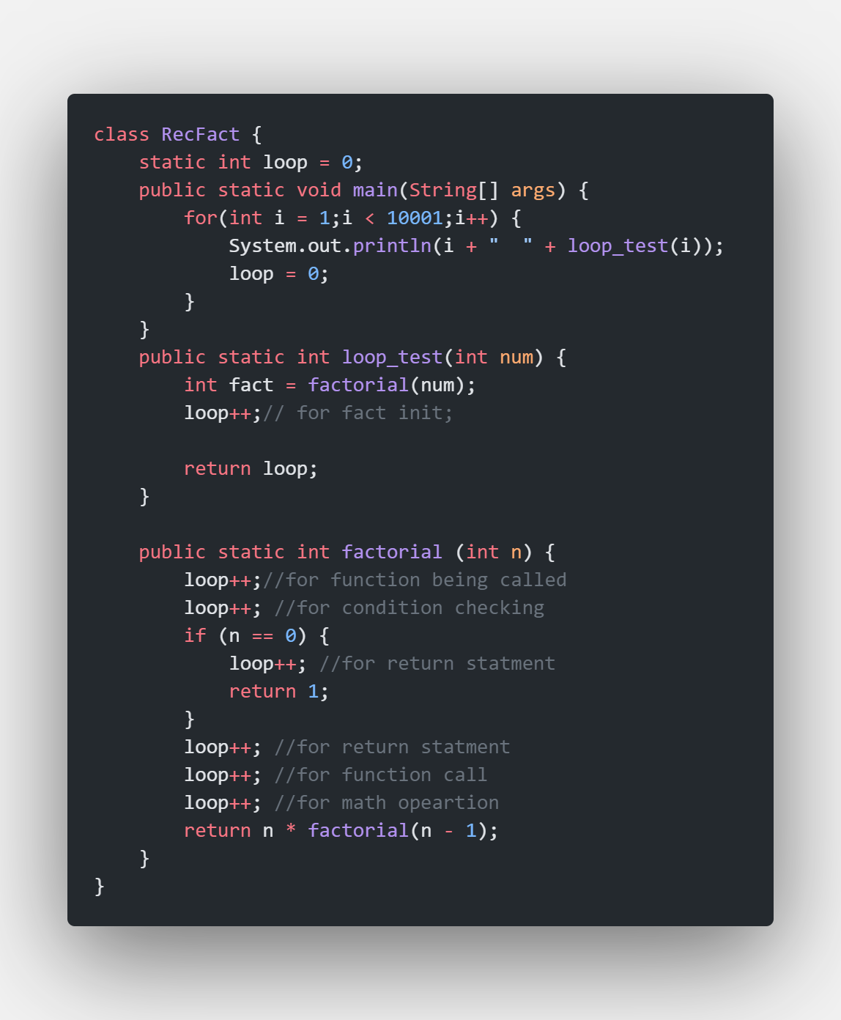

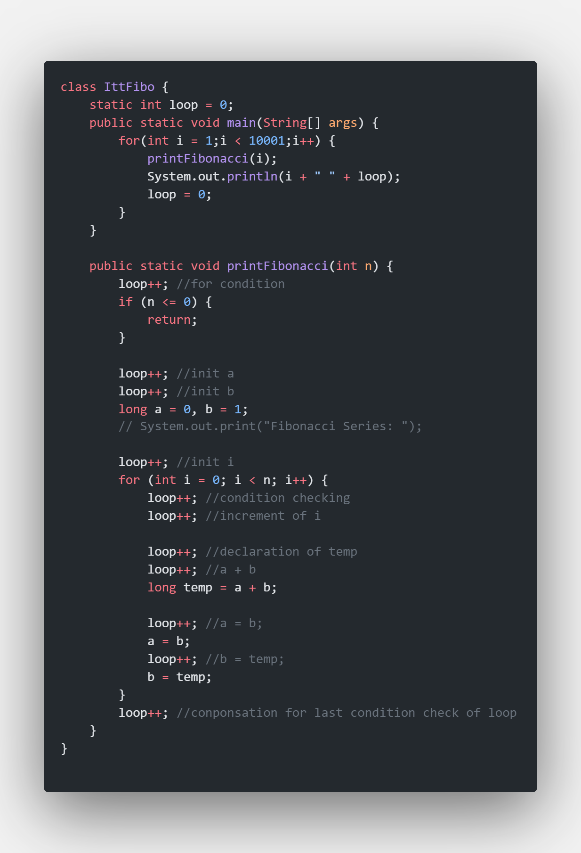

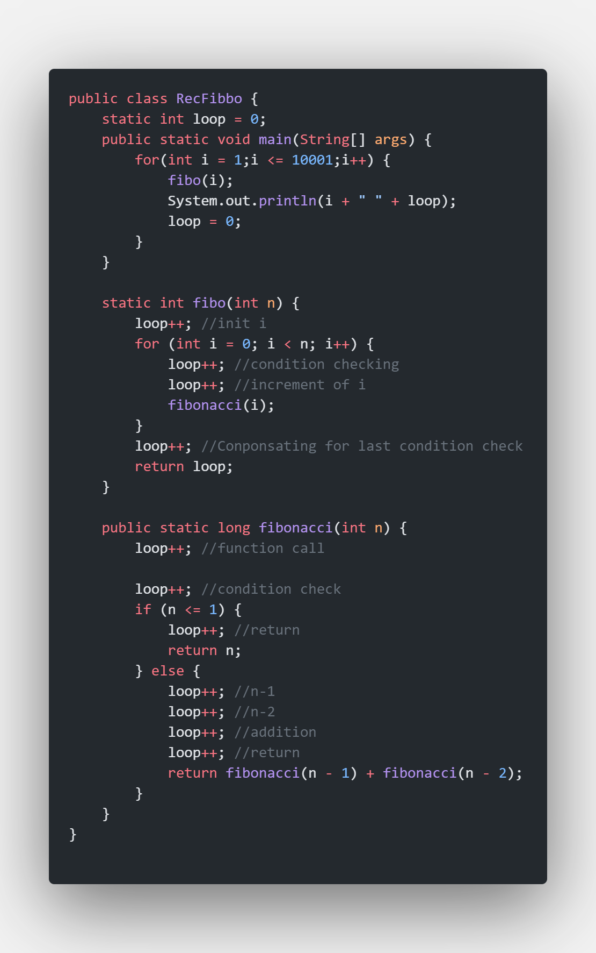

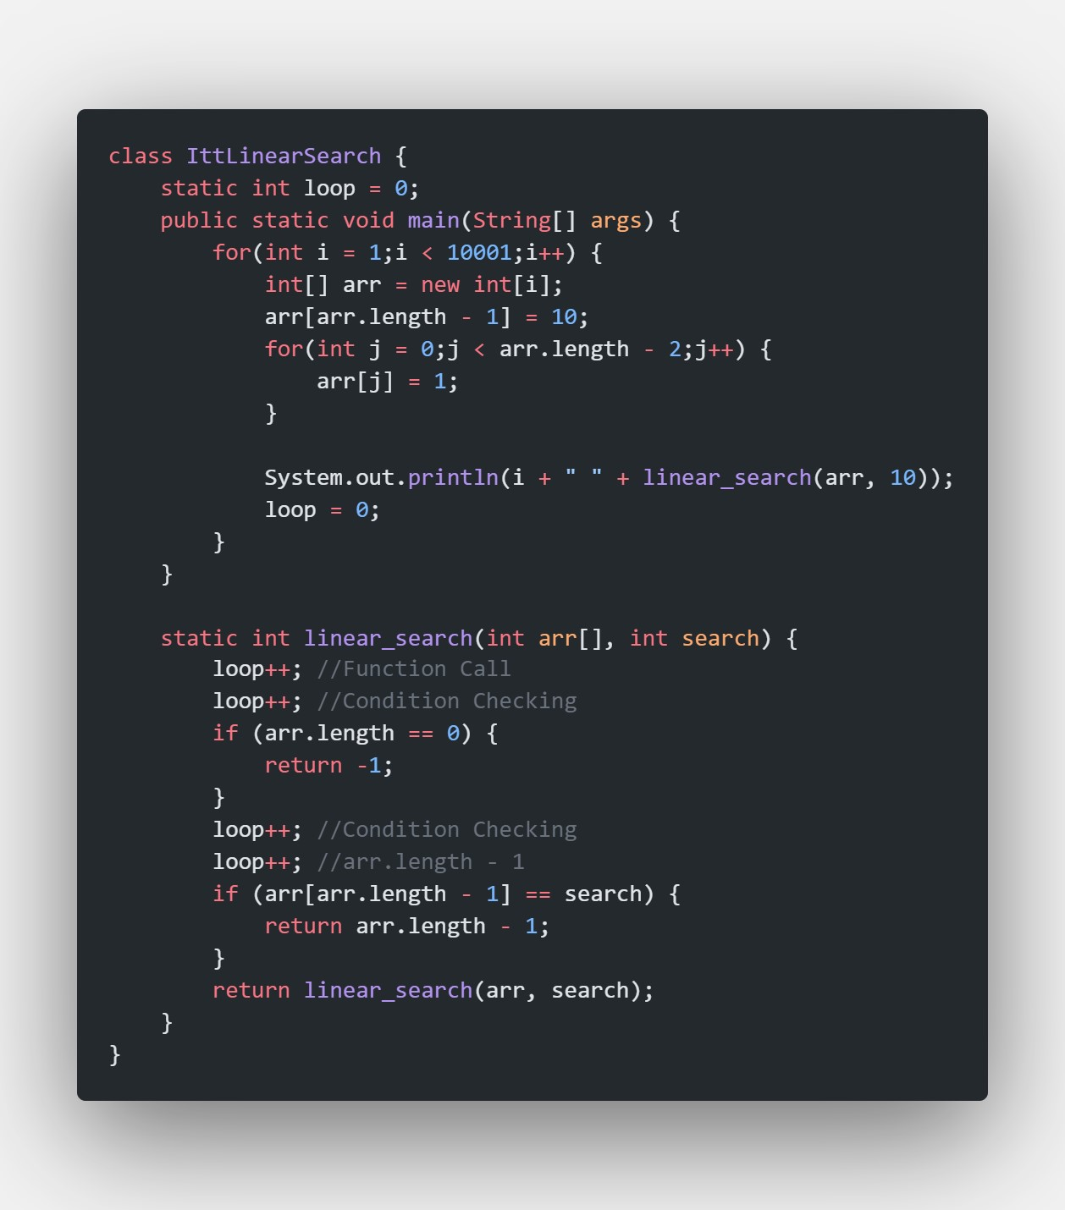

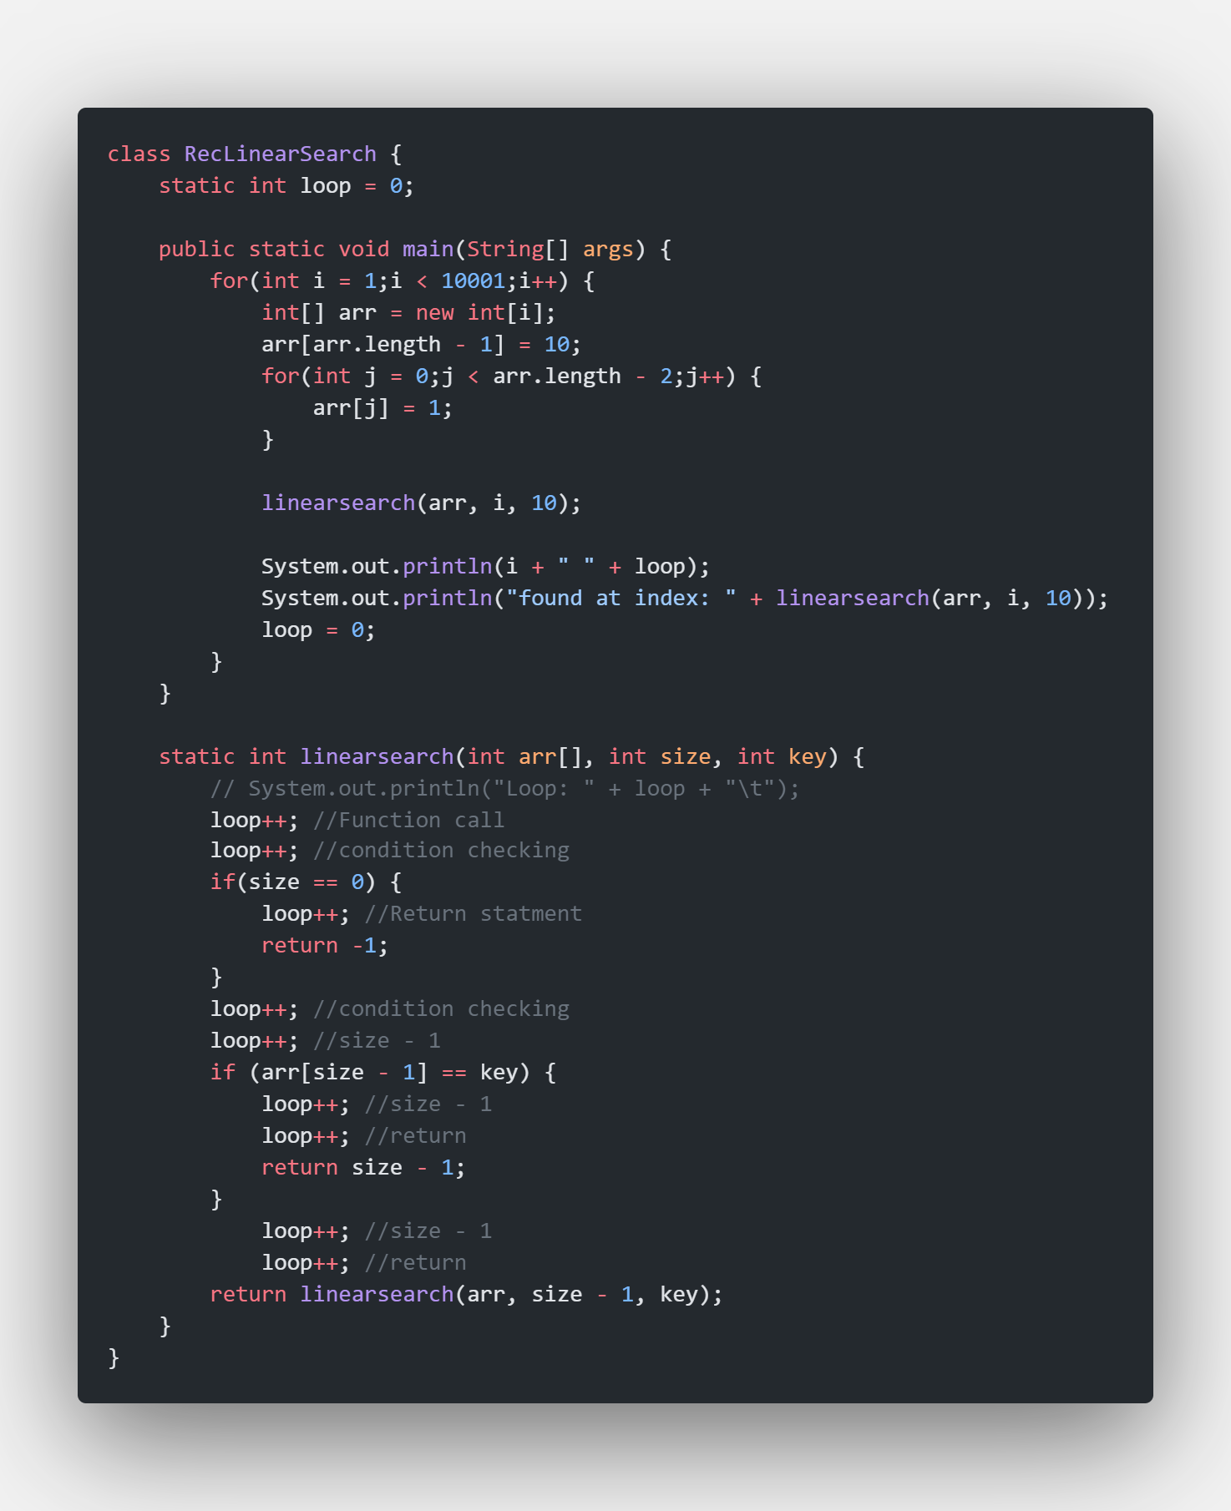

**Graphs:**

**Conclusion: After the experiment, it is concluded that Iterative is most often better then recursive (often exponentially so) but, there might exist a scenario where the recursive method shall be rather preferred over the iterative method as seen while implementing linear search using the two methods.**