Network Traffic Analysis Report
Elevate Labs Internship — Task 5
Tool: Wireshark | Interface: eth0 | OS: Kali Linux | Date: 07 June 2026

1. Objective
Capture live network packets on a Kali Linux machine using Wireshark, generate traffic using standard tools (ping, curl, nslookup), and analyze the captured packets to identify different protocols and traffic types.

2. Tools & Environment
- Tool: Wireshark (free, open-source packet analyzer)
- OS: Kali Linux (running in Oracle VirtualBox)
- Network Interface: eth0
- Traffic generators: ping, curl, nslookup
- Total packets captured: 180

3. Methodology
The following steps were performed to capture and analyze network traffic:
- Opened Wireshark and started live capture on the eth0 interface
- Ran: ping -c 10 8.8.8.8 → generates ICMP traffic
- Ran: curl http://example.com → generates HTTP + DNS + TCP traffic
- Ran: nslookup google.com → generates additional DNS traffic
- Stopped capture after traffic generation completed (180 packets total)
- Applied protocol-specific display filters: http, dns, tcp, icmp
- Exported capture as .pcap file for submission

4. Protocols Identified
Four distinct protocols were identified from the capture:

Protocol | Port/Type | Traffic Observed | Filter Used
HTTP | TCP Port 80 | GET / HTTP/1.1 → example.com  HTTP 200 OK response | http
DNS | UDP Port 53 | A/AAAA queries for example.com & google.com | dns
TCP | Port 51056→80 | SYN, SYN-ACK, ACK handshake + FIN teardown | tcp
ICMP | Type 8/0 | 10x Echo request/reply to 8.8.8.8 (ping) | icmp

5. Packet Analysis with Screenshots

5.1 HTTP — Filter: http
Captured 2 HTTP packets (1.1% of total). Shows the complete request-response cycle for curl http://example.com:
- Packet 148: GET / HTTP/1.1 — Src: 192.168.1.7 → Dst: 172.66.147.243 (Port 80)
- Packet 151: HTTP/1.1 200 OK (text/html) — response from server
- Packet details reveal: Host header = example.com, User-Agent = curl/8.19.0

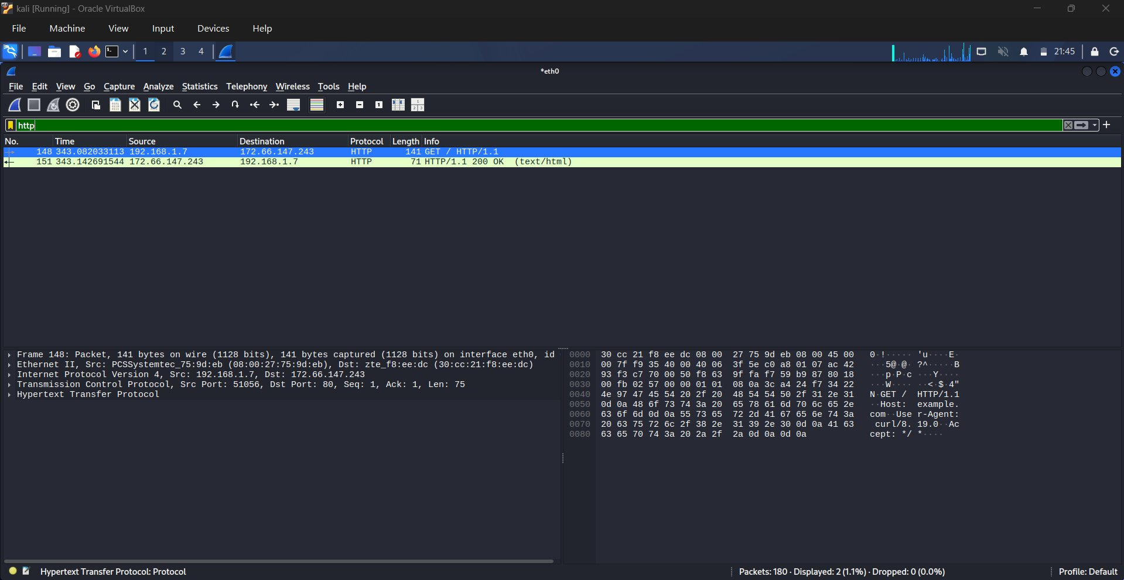
Figure 1: HTTP filter showing GET request and 200 OK response

5.2 DNS — Filter: dns
Captured 8 DNS packets (4.4% of total). DNS runs over UDP Port 53 and resolves domain names to IP addresses:
- Packets 141-144: A and AAAA queries/responses for example.com → resolved to 172.66.147.243 (IPv4) and 2606:4700:: (IPv6)
- Packets 167-170: A and AAAA queries/responses for google.com → multiple IPs returned (142.250.134.x range)
- DNS server used: 192.168.1.1 (local router/gateway)

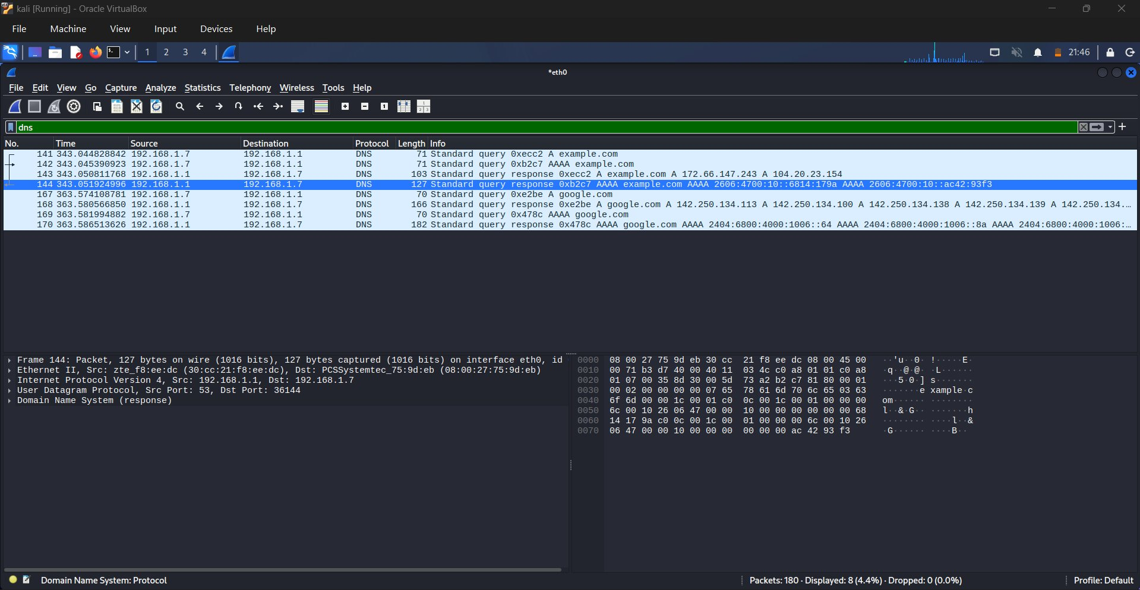
Figure 2: DNS filter showing A/AAAA queries for example.com and google.com

5.3 TCP — Filter: tcp
Captured 14 TCP packets (7.8% of total). TCP provides reliable, ordered delivery. The full three-way handshake is visible:
- Packet 145: SYN — connection initiation from 192.168.1.7:51056 → 172.66.147.243:80
- Packet 146: SYN-ACK — server acknowledges and responds
- Packet 147: ACK — handshake complete
- Packets 148-154: Data transfer (HTTP request/response over TCP)
- Packets 157-158: FIN/ACK — graceful connection teardown

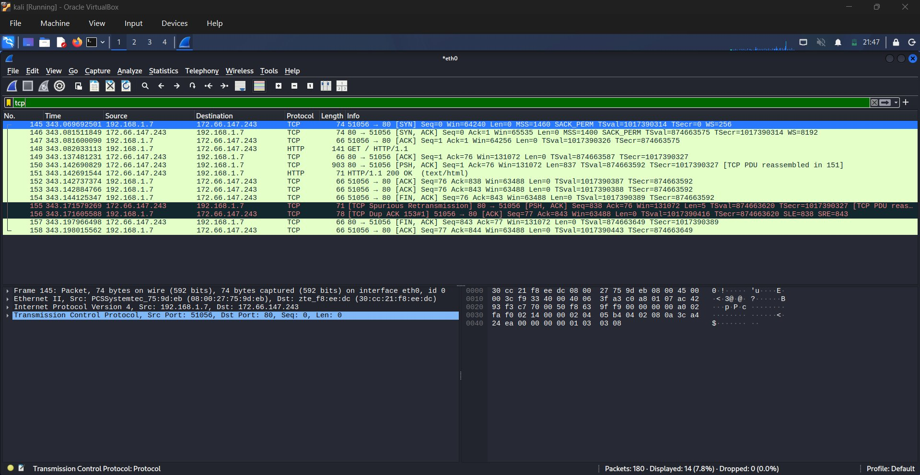
Figure 3: TCP filter showing full 3-way handshake, data transfer, and FIN teardown

5.4 ICMP — Filter: icmp
Captured 20 ICMP packets (11.1% of total) from ping -c 10 8.8.8.8. ICMP is used for network diagnostics:
- Source: 192.168.1.7 → Destination: 8.8.8.8 (Google DNS)
- 10 Echo Request packets (Type 8) and 10 Echo Reply packets (Type 0)
- TTL = 117 on replies — indicates ~7 hops from Google's server
- Sequence numbers increment: seq=1/256, 2/512, 3/768 ... 10/2560
- All 10 pings received replies — 0% packet loss

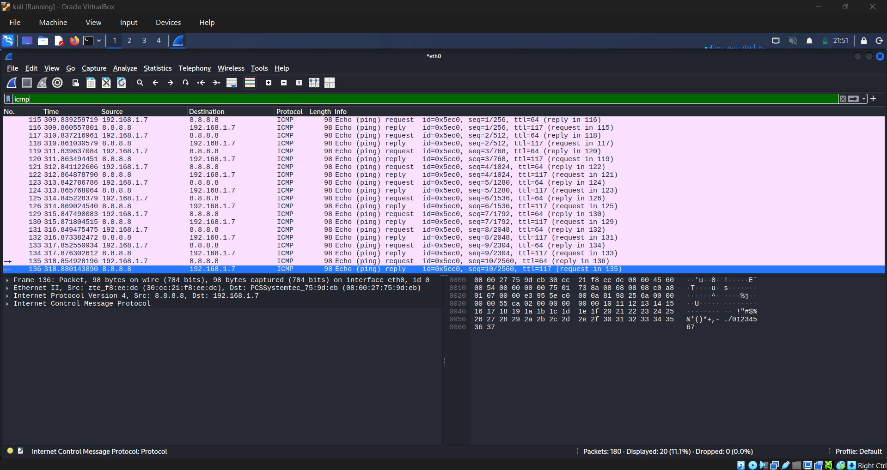
Figure 4: ICMP filter showing ping echo requests and replies to 8.8.8.8

6. Key Findings & Summary
Total packets captured: 180 over eth0 interface on Kali Linux.

- HTTP (Port 80): Unencrypted web traffic fully visible — method, host, user-agent, response code all readable in plaintext. Demonstrates why HTTPS is critical.
- DNS (UDP 53): Every domain lookup generates DNS queries before any connection. DNS is unencrypted by default — ISPs/attackers can see every domain visited.
- TCP: Three-way handshake (SYN→SYN-ACK→ACK) clearly captured. TCP ensures reliable delivery and graceful teardown via FIN/ACK.
- ICMP: All 10 pings to 8.8.8.8 received replies, confirming network reachability. TTL=117 indicates packet traversed approximately 7 network hops.

7. Conclusion
Wireshark successfully captured and displayed live network traffic on the eth0 interface. Four protocols were identified and analyzed: HTTP, DNS, TCP, and ICMP. The exercise demonstrated how packet analysis tools can reveal detailed information about network communication including unencrypted data, connection states, and routing details. The .pcap file has been exported for submission.

Submitted by: Aksh | Elevate Labs Cybersecurity Internship | Task 5

