Task 4 : Setup and Use a Firewall on Windows/Linux
Objective: Configure and test basic firewall rules to allow or block traffic.
Tools: Windows Firewall / UFW (Uncomplicated Firewall) on Linux.
Deliverables: Screenshot/configuration file showing firewall rules applied.

Hints/Mini Guide:
1.Open firewall configuration tool (Windows Firewall or terminal for UFW).
2.List current firewall rules.
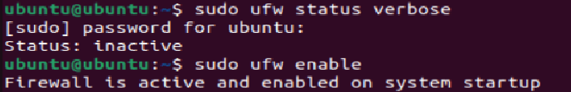
3.Add a rule to block inbound traffic on a specific port (e.g., 23 for Telnet).
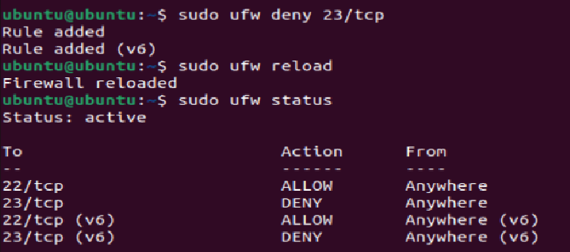
4.Test the rule by attempting to connect to that port locally or remotely.
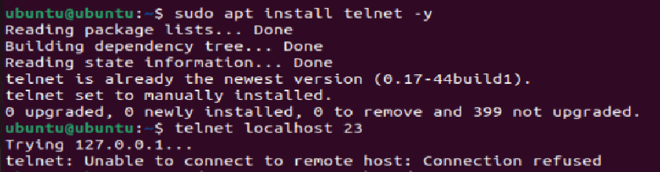
5.Add rule to allow SSH (port 22) if on Linux. 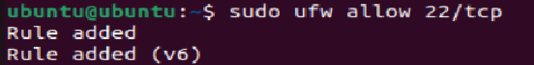
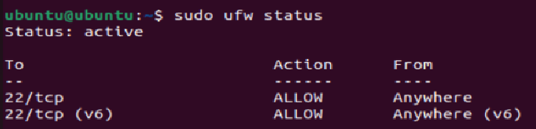
6.Remove the test block rule to restore original state.
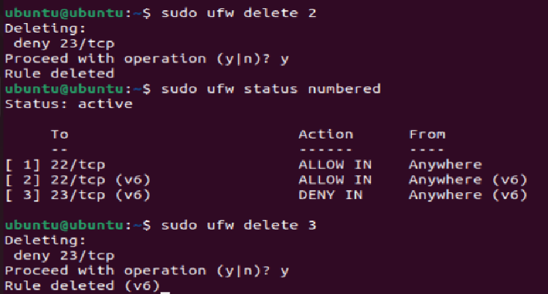
8.Summarize how firewall filters traffic.

How Firewall Filters Traffic
Firewall = traffic gatekeeper. Checks every packet against ruleset.
Flow: Packet arrives → Check rules top to bottom → First match → Allow / Deny / Reject → No match → Default policy (usually DENY)
Rule Components:
- Direction: INBOUND / OUTBOUND
- Protocol: TCP / UDP / ICMP
- Port: 22, 23, 80, 443
- Source/Dest: Anywhere / specific IP
- Action: ALLOW / DENY / REJECT
DENY vs REJECT:
- DENY = silent drop. Attacker gets no response. Safer.
- REJECT = send error back. Faster for legitimate users.
UFW Default Behavior:
- Inbound → DENY all (unless rule says allow)
- Outbound → ALLOW all (unless rule says block)
Real Example from Task:
- Port 22 → ALLOW ✓ SSH works
- Port 23 → DENY ✗ Telnet blocked, packet dropped silently

Why It Matters: Firewall stops unauthorized access, blocks old/insecure protocols (Telnet sends data as plain text with no encryption), and limits attack surface. Only open ports you need. Block everything else.
Firewall Interview Questions & Answers
1. What is a firewall? A firewall is a network security device (hardware or software) that monitors and controls incoming and outgoing network traffic based on predefined security rules. It acts as a barrier between a trusted internal network and an untrusted external network like the internet.

2. Difference between Stateful and Stateless Firewall?
 | Stateful | Stateless
Tracks Connection | Yes | No
Checks | Packet + context | Packet only
Speed | Slower | Faster
Security | Higher | Lower
Example | Modern firewalls | Old routers/ACLs
Stateful firewall remembers whether a connection was established and makes decisions based on context. Stateless firewall checks each packet independently with no memory of previous packets.

3. What are Inbound and Outbound Rules?
- Inbound Rules = control traffic coming INTO your system (e.g. allow SSH on port 22, block Telnet on port 23)
- Outbound Rules = control traffic going OUT from your system (e.g. block access to malicious IPs)
- Inbound rules protect against external attacks. Outbound rules prevent data leakage and malware communication.

4. How does UFW simplify firewall management? UFW (Uncomplicated Firewall) is a frontend for iptables. Raw iptables commands are long and complex. UFW wraps them into simple human-readable commands like ufw allow 22/tcp instead of lengthy iptables syntax. Makes firewall management easy for beginners without deep networking knowledge.

5. Why block port 23 (Telnet)? Telnet transmits all data including usernames and passwords in plain text with zero encryption. Anyone sniffing the network can capture credentials easily. SSH (port 22) is the secure replacement — it encrypts all communication. Blocking port 23 eliminates this vulnerability and forces use of secure alternatives.

6. What are common firewall mistakes?
- Allowing all outbound traffic without restriction
- Using overly broad rules like "allow all from anywhere"
- Not blocking unused open ports
- Forgetting to allow SSH before enabling firewall (causes lockout)
- Not logging denied traffic (miss attack patterns)
- Never reviewing or updating rules
- Relying only on firewall and ignoring other security layers

7. How does a firewall improve network security?
- Blocks unauthorized access to systems and services
- Filters malicious traffic before it reaches the system
- Limits attack surface by closing unnecessary ports
- Prevents exploitation of vulnerable services
- Logs suspicious traffic for analysis
- Enforces network segmentation between zones
- Acts as first line of defense in a layered security model

8. What is NAT in firewalls? NAT (Network Address Translation) translates private internal IP addresses to a single public IP address when traffic goes to the internet. Firewall performs NAT to hide internal network structure from outside world. Benefits:
- Hides real internal IPs (security through obscurity)
- Conserves public IP addresses
- Prevents direct external access to internal machines
- All internal devices share one public IP through the firewall

